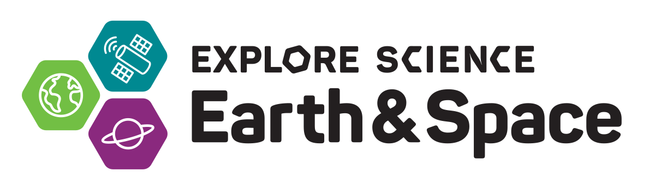
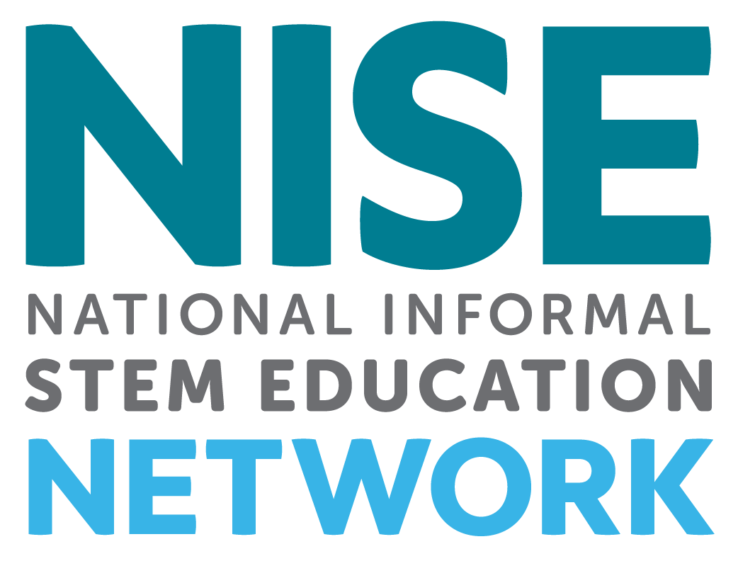

Toolkit Application Overview
________________________________________________________________________________

Revised 8-29-16

The National Informal STEM Education Network (NISE Net) is pleased to offer free Explore Science: Earth & Space 2017 toolkits to new and existing eligible partners in the United States.
In collaboration with NASA, the NISE Network has assembled a new set of engaging, hands-on Earth and space science experiences with connections to science, technology, and society.

________________________________________________________________________________

TOOLKIT CONTENTS & AUDIENCES
Two hundred and fifty (250) free Explore Science: Earth & Space physical 2017 toolkits will be awarded to successful applicants from eligible organizations.
- Activities are designed for use in children’s museums, science centers, science museums, public planetariums and observatories, and NASA visitor centers in the United States.
- Activities are designed for family audiences with a range of experiences appropriate for visitors ages 4 through adult.
Explore Science: Earth & Space toolkits will include:
- Eight to ten hands-on activities to engage the public in Earth and space sciences including: heliophysics, Earth science, planetary science, astrophysics, and their connections to society
- Professional development materials including activity training videos
- Event planning guides
- Marketing and promotional materials

In addition to the physical toolkits, all digital materials will be available online for free download. The NISE Network will also be hosting a series of one-hour online workshops featuring a variety of topics as well as a three-week online training on engaging visitors in Earth and space programming using the toolkits. All online workshops will be recorded and archived.
________________________________________________________________________________

TIMELINE
- September 1, 2016: Online application opens to apply for a free physical toolkit
- November 4, 2016: Deadline to submit application
- December 2016: Notification of award decisions
- January 2017: Toolkits delivered to successful applicants
- March - May 2017: Successful applicants host required public event(s)
- June 15, 2017: Event reports due online (note: in additional to the required report,
the project evaluators will also be conducting additional surveys)
Future years: In addition to the 2017 toolkit, we anticipate a series of toolkits with different content available each year over the following three years (for a total of four toolkits).

________________________________________________________________________________

ELIGIBILITY
The physical toolkit is designed for informal science education public events and outreach. To be eligible to receive a physical toolkit, organizations must be:
- Located in the United States
- Public informal science outreach and education institutions such as:
  - science museums and science centers,
  - children’s museums,
  - natural history museums,
  - public planetariums and observatories, and
  - NASA visitor centers.
Please note that K-12 schools, afterschool programs, libraries, parks, and astronomy clubs are not eligible to receive physical toolkits. Consider downloading a digital toolkit if your organization does not meet eligibility criteria. Digital toolkits will be available for download in February 2017 at
http://www.nisenet.org/earthspacekit

________________________________________________________________________________

APPLICATION PROCESS
Applications for the physical 2017 toolkits must be submitted online using SurveyGizmo by November 4, 2016:
http://www.surveygizmo.com/s3/2935641/Earth-Space-Toolkit-2017-Application

Please note that it is NOT possible to save your work in the SurveyGizmo online form and return for additional edits. Reports left idle for too long will go blank when you progress to the next screen. Please plan to complete the online report in one session. You may want to write your responses in a Word doc, save, and then cut and paste that information into this report. You may download the application in PDF and Word document formats here:
http://www.nisenet.org/earthspacekit-apply

________________________________________________________________________________

SELECTION PROCESS
A total of 250 toolkits will be awarded through a competitive award process. The NISE Network project team will review the toolkit applications and award toolkits only to organizations that meet the eligibility criteria. Proposals will undergo a peer review process by project representatives. Successful applications will demonstrate strong alignment with the project purpose, comply with the project terms, reach local underserved audiences, and help the project achieve geographic diversity. If multiple applications are received from the same geographic location, applicants will likely be asked to collaborate on an event and to share a toolkit. Applicants will be informed of award status in December 2016.

________________________________________________________________________________

REQUIREMENTS

Organizations receiving toolkits are required to:
- Host an event in March - May 2017:
Host at least one public engagement event using your toolkit.
Public events can be stand-alone events OR you can incorporate your event into existing STEM events such as:
  - World Water Day, March 22, 2017: www.worldwaterday.org
  - Earth Hour, March 2015, 2017: www.earthhour.org
  - Global Astronomy Month, April: http://www.gam-awb.org/
  - Yuri's Night, April 12, 2017: https://yurisnight.net
  - Earth Day, April 22, 2017: http://www.earthday.org
  - National Environmental Education Week, week of Earth Day https://www.neefusa.org/greening-stem/environmental-education-week
  - Astronomy Day (Spring), April 29, 2017: https://www.astroleague.org/al/astroday/astrodayform.html
  - Astronomy Week (Spring), April 24-30, 2017:
https://www.astroleague.org/al/astroday/astrodayform.html
- Report on the use of the toolkit: Physical toolkit recipients are required to complete a short online report describing their experiences with the toolkit. Successful applicants will be provided with a link to the final report. Reports will include optional evaluation questions to capture the impacts of the project activities on the public. Required reports must be submitted online by June 15, 2017.
In additional to the required report, we encourage you to participate in partner surveys conducted by project evaluators.

Additional opportunities (not required but encouraged):

- Attending Professional Development online workshops for informal science educators: The NISE Network will offer a variety of free one-hour online workshops featuring a variety of topics as well as a three-week online training on engaging visitors in Earth and space programming using the toolkits. All online workshops will be recorded and archived. More information will be available through the NISE Network newsletter: http://www.nisenet.org/newsletter

- Collaborating with local experts: We encourage you to collaborate with both local scientists (Earth and space science professionals) and local enthusiasts (e.g. amateur astronomy clubs)

- Collaborating locally to reach underserved audiences: Partnerships with K-12 schools, afterschool programs, local chapters of national youth-serving organizations, libraries, and local community groups can help your event reach underserved audiences. Tips for collaboration can be found here: http://www.nisenet.org/collaboration-guide
________________________________________________________________________________

USING YOUR TOOLKIT ALL YEAR LONG

We also encourage you to use your toolkit all year round, during celestial events, STEM educational events, and other programming for public audiences:

Solar eclipse August 21, 2017:
  - http://eclipse2017.nasa.gov
  - https://informal.jpl.nasa.gov/museum/content/eclipse-2017
Celestial events: Meteor showers, lunar eclipses, full moons, planetary events, and more:
- http://earthsky.org/tonight
- https://in-the-sky.org/newscal.php
- https://nightsky.jpl.nasa.gov/planner.cfm
- https://stardate.org/nightsky
- http://www.timeanddate.com/astronomy
- http://www.skyandtelescope.com/observing/sky-at-a-glance/
Earth and space science events:
  - World Water Day, March 22, 2017: www.worldwaterday.org
  - Earth Hour, March 25, 2017: www.earthhour.org
  - Global Astronomy Month, April: http://www.gam-awb.org/
  - Yuri's Night, April 12, 2017: https://yurisnight.net
  - Earth Day, April 22, 2017: http://www.earthday.org
  - National Environmental Education Week, week of Earth Day
https://www.neefusa.org/greening-stem/environmental-education-week
  - Astronomy Day (Spring), April 29, 2017: https://www.astroleague.org/al/astroday/astrodayform.html
  - Astronomy Week (Spring), April 24-30, 2017:
https://www.astroleague.org/al/astroday/astrodayform.html
  - World Oceans Day, June 8, 2017: http://www.worldoceansday.org/
  - Asteroid Day, June 30, 2017: http://asteroidday.org
  - International Observe the Moon Night, July 15, 2017: http://observethemoonnight.org
  - Astronomy Day (Fall), September 30, 2017:
https://www.astroleague.org/al/astroday/astrodayform.html
  - Astronomy Week (Fall), September 25-October 1, 2017: https://www.astroleague.org/al/astroday/astrodayform.html
  - World Space Week, October 4-10, 2017: http://www.worldspaceweek.org
  - Earth Science Week, October 8-14, 2017: http://www.earthsciweek.org/
More STEM related-events: http://www.nisenet.org/seasons
________________________________________________________________________________

COLLABORATIONS & FINDING LOCAL EXPERTS

We strongly encourage you to collaborate with local experts consisting of both Earth and space science professionals and science enthusiasts in your area. Volunteer experts are a key ingredient to many successful public engagement efforts.

It is up to your organization to choose your local collaborators. Regional hub leaders can assist you in finding local partners in your geographic area. Toolkits will include training and orientation materials to help prepare your event volunteers and staff for using the activities.
Volunteer networks focused on astronomy and space include: 1) The Solar System Ambassadors Program (SSA), 2) The Night Sky Network, and 3) AAS Astronomy Ambassadors; these volunteer networks can be searched by state and city to find a possible volunteer nearest you. Local colleges and universities can also provide expertise in Earth and space sciences.

1) The Solar System Ambassadors Program (SSA) is a public outreach program designed to work with motivated volunteers across the nation. These volunteers communicate the excitement of the Jet Propulsion Lab’s (JPL) space exploration missions and information about recent discoveries to people in their local communities. For 2016, there are 700 Ambassadors in 50 states, Washington DC, Puerto Rico, US Virgin Islands, and Guam. Volunteer ambassadors bring the excitement of space to the public. Ambassadors are space enthusiasts from various walks of life who are interested in providing greater service and inspiration to the community at large.
https://solarsystem.nasa.gov/ssa/home.cfm

2) The Night Sky Network is a nationwide coalition of amateur astronomy clubs bringing the science, technology, and inspiration of NASA's missions to the general public. Night Sky Network members share their time and telescopes to provide you with unique astronomy experiences at science museums, observatories, classrooms, and under the real night sky.
https://nightsky.jpl.nasa.gov/index.cfm

3) AAS Astronomy Ambassadors: The American Astronomical Society (AAS), in partnership with the Astronomical Society of the Pacific (ASP), members of the Center for Astronomy Education (CAE), and other organizations active in science education and public outreach (EPO), has launched a series of professional development workshops and a community of practice designed to help improve early-career astronomers’ ability to effectively communicate with students and the public. Called Astronomy Ambassadors, the program provides mentoring and training experiences for young astronomers, from advanced undergraduates to new faculty. It also provides access to resources and a network of contacts within the astronomy EPO community.
https://aas.org/outreach/roster-aas-astronomy-ambassadors

4) Colleges and Universities: Many colleges and universities have astronomy and Earth science departments. Others may have clubs or local chapters of professional societies. Once you connect with a faculty or staff member they should be able to also suggest undergraduate and graduate students who could volunteer at your event.

________________________________________________________________________________

FINDING ADDITIONAL VOLUNTEERS

In addition to finding subject matter experts, you will probably need to recruit other volunteers to help with your event. Potential sources of volunteers may include:
  - College students, classes, or clubs with community service requirements
  - High school science clubs, or students suggested by local high school science teachers
  - Local chapters of professional science and engineering groups that are often associated with local colleges, such as:
  - National Action Council for Minorities in Engineering: http://www.nacme.org
  - National Society of Black Engineers (NSBE): http://www.nsbe.org/home.aspx
  - National Organization of Gay and Lesbian Scientists and Technical Professionals: http://www.noglstp.org
  - Society for Advancement of Chicanos and Native Americans in Science (SACNAS): http://sacnas.org
  - Society of Asian Scientists and Engineers: http://www.saseconnect.org
  - MAES - Latinos in Science and Engineering: http://mymaes.org
  - Society of Hispanic Professional Engineers: http://shpe.org
  - Society of Women Engineers (SWE): http://societyofwomenengineers.swe.org
  - Drama and theater students
  - Local industry staff and retirees
________________________________________________________________________________

MORE NASA RESOURCES

- NASA Wavelength Digital Library: NASA Wavelength is your pathway into a digital collection of Earth and space science resources for educators of all levels – from elementary to college, to out-of-school programs. These resources, developed through funding from the NASA Science Mission Directorate (SMD), have undergone a peer-review process through which educators and scientists ensure the content is accurate and useful in an educational setting. http://nasawavelength.org
- NASA Museum Alliance: The Museum Alliance is a community of practice comprising informal science educators at museums, science centers, planetariums, NASA Visitor Centers, Challenger Learning Centers, observatories, zoos, aquariums, parks, and nature centers who wish to share NASA information with their visitors. It is intended to bring current NASA Science and Technology to visitors through professional development of the museums’ staff, advance notice of NASA events, and provision of materials such as visualizations, access to NASA experts, educational materials, etc. https://informal.jpl.nasa.gov/museum/
- NASA solar eclipse 2017 resources:
http://eclipse2017.nasa.gov
NASA Museum Alliance eclipse resources: https://informal.jpl.nasa.gov/museum/content/eclipse-2017
________________________________________________________________________________

MORE INFORMATION
For project questions and inquiries, please contact your regional hub leader listed below.

________________________________________________________________________________

REGIONAL HUB LEADERS
Regional hub leaders will be able to help connect you with experts in your area and answer other questions about the project:

- NORTHEAST
Northeast: NY, VT, NH, ME, RI, CT, and MA
Mid-Atlantic: PA, NJ, MD, DC, DE, OH, and WV
Ali Jackson, ajackson@sciencenter.org, Sciencenter, Ithaca, NY, 607-272-0600x144

- SOUTHEAST
Southeast, VA, NC, SC, KY, TN, LA, MS, AL, GA, FL, and Puerto Rico
South: TX, AR, and OK
Brad Herring, bradh@ncmls.org, Museum of Life and Science, Durham, NC,
919-220-5429x360

- MIDWEST
ND, SD, NE, KS, MN, IA, MO, WI, IL, MI, and IN
Christina Leavell, cleavell@smm.org, Science Museum of Minnesota, St. Paul, MN,
651-221-9434

- WEST
Southwest: CA, NV, AZ, and HI.
West: AK, WA, OR, ID, MT, WY, CO, UT, and NM
Frank Kusiak, frank_kusiak@berkeley.edu, Lawrence Hall of Science, Berkeley, CA,
510-643-7827

________________________________________________________________________________

ACKNOWLEDGEMENTS
This material is based upon work supported by NASA under cooperative agreement award number NNX16AC67A. Any opinions, findings, and conclusions or recommendations expressed in this material are those of the author(s) and do not necessarily reflect the view of the National Aeronautics and Space Administration (NASA).

