Data Collection Using Carousel Sheets

Prepared by Amy Grack Nelson

Carousel sheets is a participatory data collection method that allows you to quickly gather a lot of information from a group of individuals about the object (program, exhibit, etc.) you are evaluating (King, 2009).

Materials
- Pens for everyone
- Colored markers for each small group
- Timer
- Post-it notes – a unique color and type (lined or unlined) per person.
- Easel paper with questions written in the middle of the paper – one question per sheet. These sheets are referred to as the “question sheets”.

Step 1: Data collection
- Identify the questions you want answered using this data collection method. Write one question in the middle of each sheet of easel paper.
- Each person is given a unique pad of post-its (color, blank, lined, etc).
- Split people into small groups (groups of 3 – 5 works best).
- Each group will get a question sheet with one of the questions on it. Have people sit around the question sheet as shown in the image below. If you have more groups than the number of questions you have, you can give some groups the same question.
- Read the questions aloud and explain that each question sheet has a different question. Explain that they will have one and a half minutes to answer the question in front of them.
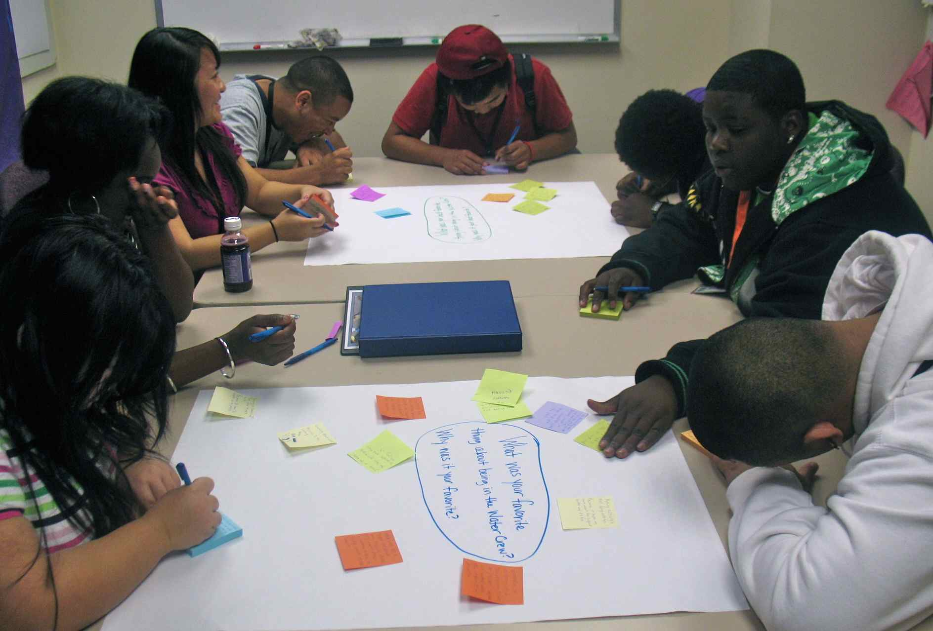
- Individuals write their responses on the post-it notes with one response or idea per post-it. After they write an idea on a post-it, they will place the post-it on the question sheet, it doesn’t matter where they place it on the sheet (see image below).

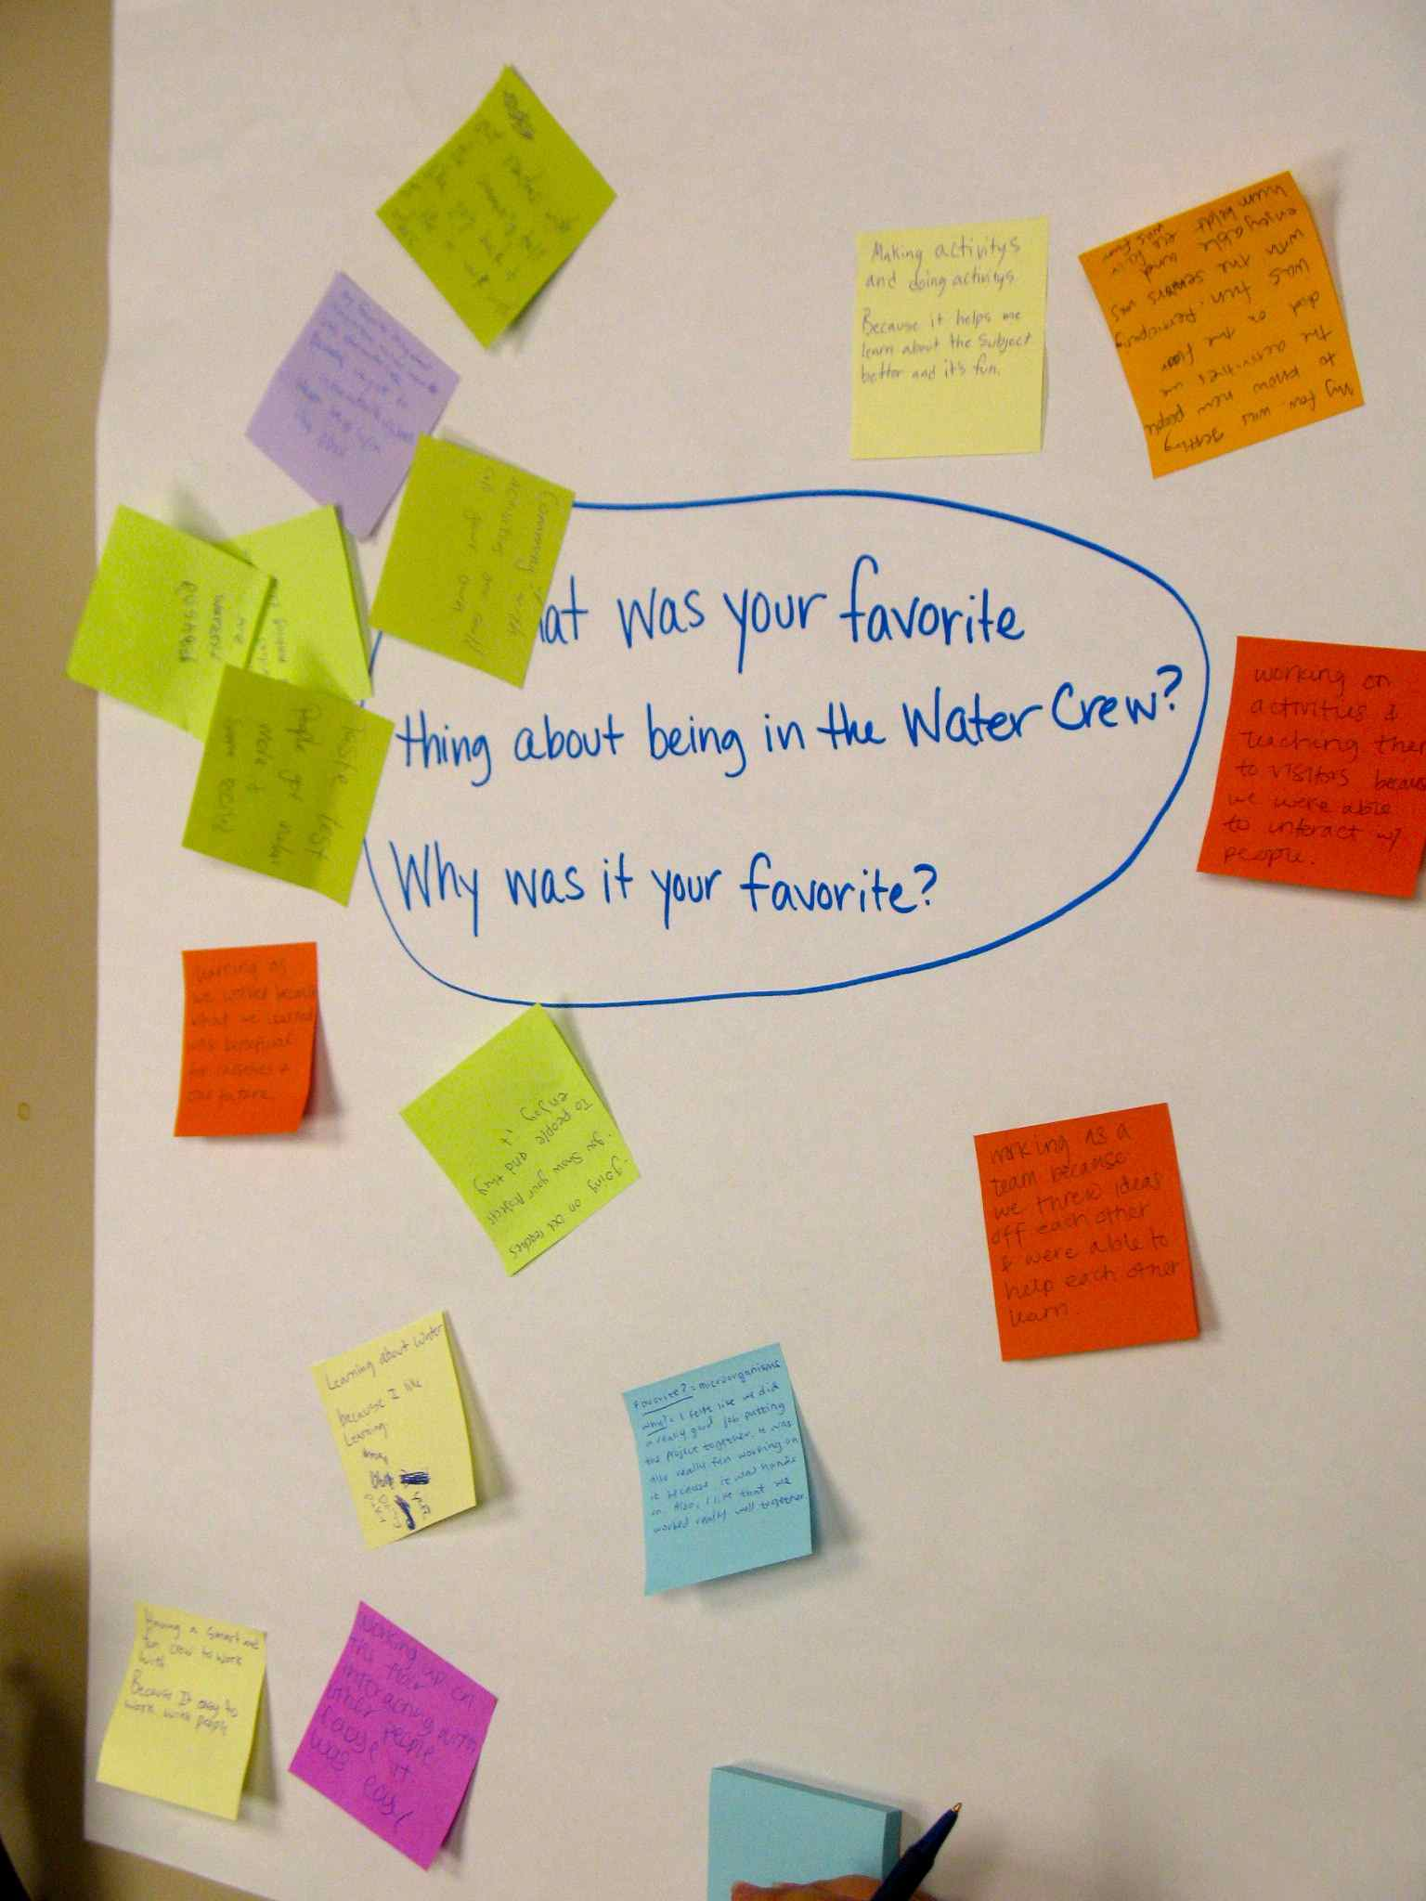

- Use a timer to give them a minute and a half on the question in front of them. After a minute and a half, have each group pass their question sheet clockwise to the next group. Keep repeating this process so everyone has a chance to answer all of the questions.
- People are working on their post-its individually so encourage them not to look at what others have already written and posted on the question sheet. It is okay if people end up saying similar things because you want to know if people have similar responses. If you want to make sure people don’t look at other’s responses, you can have them turn the question sheet over as they write their responses, then they can turn it over, place their post-its on the sheet and pass the sheet on.

Step 2: Creating Themes
- After everyone has completed all of the questions, the groups will take the question sheet they ended with and analyze the responses. If you have more than one question sheet with the same question on it, you can have those groups combine all of their post-its and work together.
- Each group will work together to move the post-its around to create themes that emerge from the data. As they group the similar post-its together, they will draw a circle around the post-its and write a name for that theme (see image on next page). Encourage them to use one word or short phrases to name the themes. In many cases there are instances where post-its don’t fit into a theme. In this case, tell people to create a theme called “other” and place those post-its there.
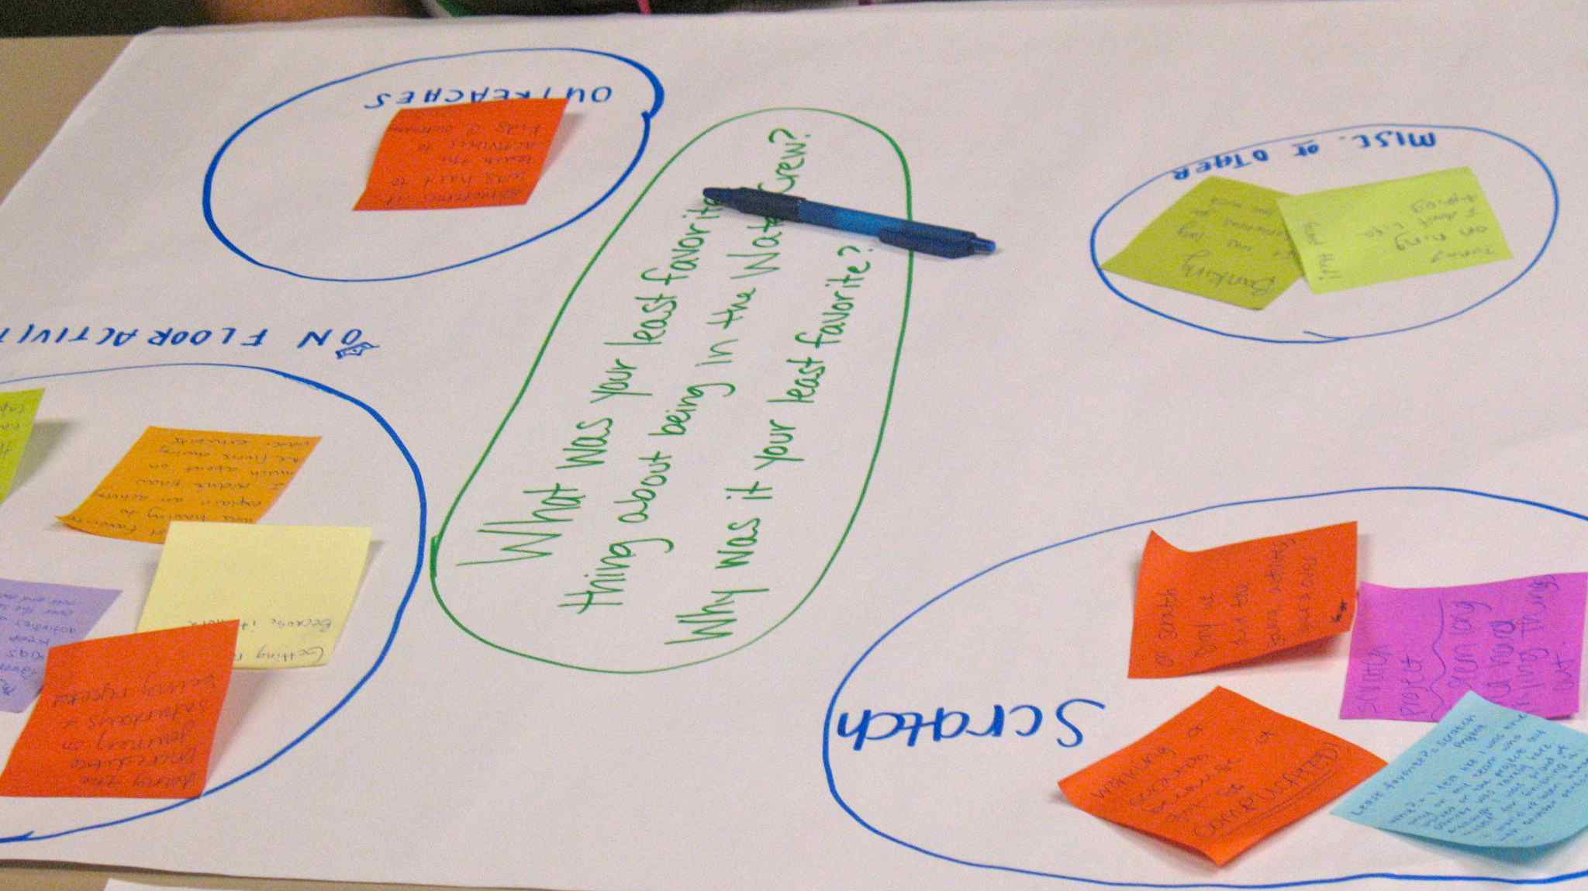

- You will more than likely have to give groups additional sheets of easel paper to fit all their themes on. Make sure if they use additional sheets of easel paper, they write their question somewhere on it so you know what question the themes are for.

Step 3: Report Out
- After groups have created their themes, they will share their results with the group. Tell people to share their themes and offer any additional explanation if needed to make sense of the theme. Have groups with similar questions follow each other so they can build off of what the other group said.

Reference
King, J. A. (2009, March). Interactive evaluation practice. Session presented at the Minnesota Evaluation Studies Institute, Bloomington, MN.

