Aerogel


Organization: Oregon Museum of Science and Industry

Contact person: Anders Liljeholm

Contact information: aliljeholm@omsi.edu, 503-797-4606

General Description

Cart demo

This cart demonstration introduces the nanomaterial aerogel, a glass nanofoam. Visitors learn how aerogel is made, how well it insulates, and learn about its other unique properties. They see real aerogel and feel how well it insulates.

Program Objectives

Big idea:
Aerogels use tiny spheres of glass to trap air, giving the material amazing new properties.

Learning goals:
Visitors should learn that:
1. Aerogel is a product of nanotechnology.
2. Aerogel is a great insulator, used in a few special applications.
3. Aerogel was invented in the 1930s, but wasn’t used much until new applications were developed.

NISE Main Messages:
[ ] 1. Nanoscale effects occur in many places. Some are natural, everyday occurrences; others are the result of cutting-edge research.
[ X ] 2. Many materials exhibit startling properties at the nanoscale.
[ X ] 3. Nanotechnology means working at small size scales, manipulating materials to exhibit new properties.
[ X ] 4. Nanoscale research is a people story.
[ ] 5. No one knows what nanoscale research may discover, or how it may be applied.
[ ] 6. How will nano affect you?

Aerogel

Table of Contents
General Description 1
Program Objectives 1
Time Required 1
Table of Contents 2
Background Information 3
Materials 4
Set Up 5
Step 1: 5
Step 2: 5
Program Delivery 5
Safety: 5
Procedure and Discussion: 6
Tips and Troubleshooting: 6
Common Visitor Questions 7
Going Further… 7
Clean Up 7

NOTICE: You're welcome to alter this program to suit your needs. In fact, we encourage it! Change it around, and if you find something that works let us know. Post your revisions on www.nisenet.org.

Time Required

Set-up Program Clean Up
2 minutes 5 minutes 2 minutes

Background Information

Definition of terms

Nano is the scientific term meaning one-billionth. (1/1,000,000,000) It comes from a Greek word meaning “dwarf.”
A nanometer is one one-billionth of a meter. One inch equals 25.4 million nanometers. A sheet of paper is about 100,000 nanometers thick. A human hair measures roughly 50,000 to 100,000 nanometers across. Your fingernails grow one nanometer every second.
(Other units can also be divided by one billion. A single blink of an eye is about one-billionth of a year. An eyeblink is to a year what a nanometer is to a meter –roughly a yardstick.)
Nanoscale refers to measurements of 1 – 100 nanometers. A virus is about 70 nm long. A cell membrane is about 9 nm thick. Ten hydrogen atoms are about 1 nm.
At the nanoscale, many common materials exhibit unusual properties, such as remarkably lower resistance to electricity, or faster chemical reactions.
Nanotechnology is the manipulation of material at the nanoscale to take advantage of these properties. This often means working with individual molecules.
Nanoscience, nanoengineering and other such terms refer to those activities applied to the nanoscale. “Nano,” by itself, is often used as short-hand to refer to any or all of these activities.

Program-specific background

Aerogels (AIR-oh-jells) are glass foam, made of tiny silica spheres connected in long chains. They weigh only slightly more than air—in fact, aerogels are 95% air. The pockets of air and the silica spheres are nanoscale, about 10 nm wide. About 8,000 of these air bubbles would fit across a single human hair. If one of these bubbles were a grain of sand, a human hair would be the size of a skyscraper.

Because heat only transfers through the silica and not through the trapped air, aerogels are a fantastic insulator. Aerogel insulates 39 times better than fiberglass, the pink stuff many people have in their houses.

Because it is mostly air, aerogel is also incredibly light weight. Aerogel has a density of 3 kg/m³ (about 3 oz/ft³, or 5 lbs/yd³), compared to air’s density of 1.2 kg/m³ (about 1.2 oz/ft³, or 2 lbs/yd³) (Styrofoam, which we all think of as pretty light, is typically 40 kg/m³--about 40 oz/ft³, or 67.4 lbs/yd³)

Labs make aerogels by suspending silica in alcohol and water, and replacing the fluid with air under high temperature and pressure, leaving an eerie solid behind. This long, complicated process makes aerogels expensive to produce. (The powerpoint slide leaves out details of the process. A complete explanation would read:
- Mix silicon alkoxide with water and alcohol to form a gel.
- Remove liquid with carbon dioxide under high pressure and temperature.)

The size of the air bubbles gives aerogel a distinctive bluish tint. Just like air molecules in the sky and air pockets in glaciers, aerogel scatters blue light more than red light, making it look blue.

Aerogel was invented by chemical engineer Steven Kistler in the 1920s. Monsanto marketed it for several years, but high cost and low demand led them to discontinue the product in the 1970s. In recent years, however, the space program has begun using aerogels. Aerogel insulation makes rocket payloads lighter, and thus require less fuel. NASA refined aerogel technology at the turn of the 21st century, making it more practical for some uses. http://www.time.com/time/2002/inventions/rob_aerogel.html

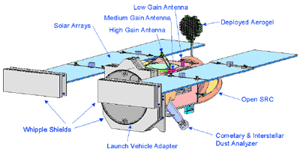
Aerogel not only insulates spacecraft. It was also used to gather comet dust in project Stardust, the mission which probed the comet Wild 2. Most particles of comet and interstellar dust are very small--about 10 microns (1/2,500 inch), the size of a red blood cell. But they move so fast they are destroyed when they touch a surface. Aerogel’s light structure gently slows down those dust particles without damage. The probe, launched in 1999, collected comet dust in 2004 and landed in January of 2006.

Computers cannot distinguish between cracks in the aerogel and tracks made by comet particles. Human eyes are needed to tell the difference. Since August 2006, laypeople have been able to participate in the Stardust mission, analyzing images of samples of aerogel at: http://stardustathome.ssl.berkeley.edu/

Dr. Donald Brownlee of the University of Washington is the lead scientist for the Stardust mission. http://stardust.jpl.nasa.gov/news/bio_dbrownlee.html

Aerogel also has some novelty building uses where its translucent properties are interesting,

Engineers may find additional uses for aerogel as nanotechnology progresses. For example, Eric Mazur at Harvard University has been developing extremely small nanofibers of glass, which may someday process data inside a computer at the speed of light. Unfortunately, the fibers don’t work if they touch a conducting surface. But place them on aerogel, and they work fine.
http://mazur-www.harvard.edu/research/detailspage.php?rowid=11

Materials

A piece of aerogel to show the audience (United Nuclear sells chunks of various sizes, $25 for a small sample good for people to look at. http://www.unitednuclear.com/aerogel.htm)
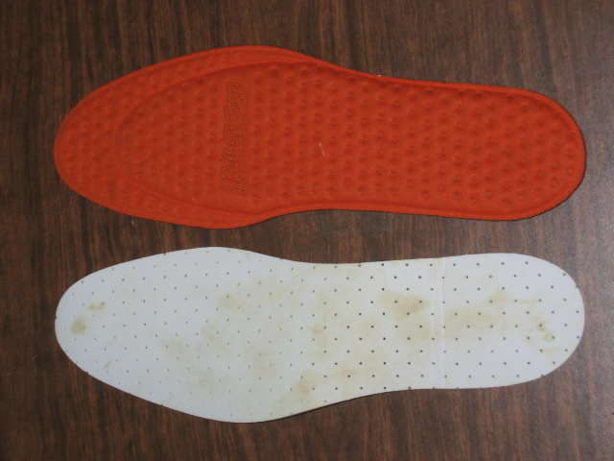

Toastyfeet insoles with aerogel lining
(Less than $15 at http://www.polarwrap.com/productinfo.aspx?pid=1&product=25)
Generic shoe insoles

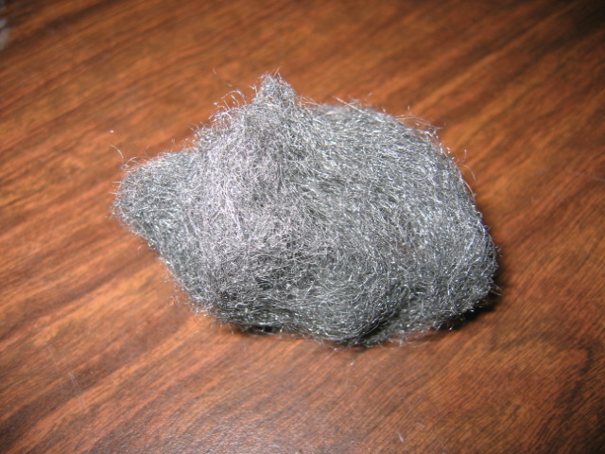
A small ball of steel wool and/or quilt stuffing

A frozen 2-liter bottle of water (frozen before the demo).
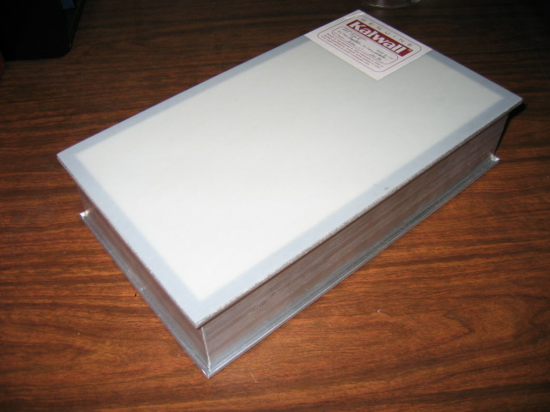
A sample panel of Kalwall or Profilit aerogel-filled skylight (Call Kalwall at 800-258-9777 or Profilit at 800-426-0279 to find local distributors.)

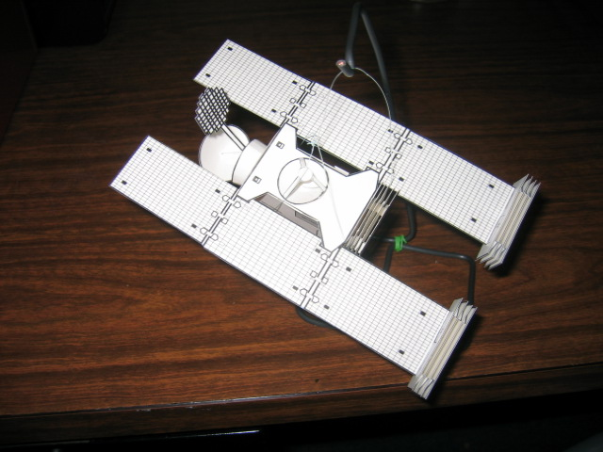
Cardboard model of the Stardust probe: http://stardust.jpl.nasa.gov/classroom/model/index.html

Assorted relevant photos or powerpoint presentation and projector.
A desk lamp or other light source.

Optional: Cookie sheet of ice and hospital booties. Superman cape for flair.

Set Up

Time: 2 minutes

Step 1:
Thoroughly freeze the bottle of water in advance of the demonstration.

Step 2:
Set out all your props and related pictures.

Program Delivery

Time: 5 minutes

Safety:

Be gentle with aerogel. It’s very easy to crush into an expensive fine powder. The powder is inert silica, so there are no major health concerns. The fine powder would easily irritate someone with asthma or another breathing disorder, but it’s not toxic. (Related MSDSs are at: http://www.aerogel.com/products/overview.html)

Don’t let visitors lick the ice.

Procedure and Discussion:

Note: This presentation is extremely non-linear. Visitors’ questions will go in many different directions. Be ready to show whichever picture illustrates the topic you’re talking about with them. Here are some talking points:

- Ask visitors if they’d like to learn about aerogel.
- Show the microscope images of aerogel, and explain that it’s a glass foam with tiny nanoscale bubbles of air. That means really really tiny—so small that a single human hair is about 8,000 times thicker than one sphere of glass foam.
- Show the skylight sample, and explain that it insulates much better than normal windows, and still lets light through. If your facility is like OMSI and has aerogel skylights, point them out.
- When you talk about how well aerogel insulates, let visitors hold the bottle of ice using the insoles. Have them put one hand under the regular insole and one hand under the aerogel insole. Talk about what they feel. Show powerpoint photos of aerogel blocking flames.
- Mention how relatively strong aerogel is. It holds 1,000 times its own weight, but it doesn’t weigh much. Two grams of aerogel—less than 1/10th of an ounce—can hold up a brick weighing 2.5 kg – about 5.5 lbs. Eighty-five grams (3 ounces) of aerogel can support 85 kg (187 pounds)—about the weight of a grown man.
- Talk about the Stardust probe, and explain how aerogel was involved. Since aerogel is so light, it’s great in space. And it stops comet dust without destroying it. Now visitors can get involved by looking at comet dust on the internet. Show the images from the website.
- Discuss how aerogel was invented long before it was useful. In the 1970s, Monsanto stopped manufacturing aerogel because it was too expensive and there was no market for it. Only with the development of spaceflight did aerogel become more than an expensive novelty.

Tips and Troubleshooting:

NOTICE: Feel free to alter this program to suit your needs. If you find something that works, share it with the rest of the community by posting your revisions on www.nisenet.org.

Visitors will want to touch the aerogel. Don’t let them. It’s really easy to crush, and very expensive. A cautionary tale: OMSI received a chunk of aerogel in a container. A few small slivers of gel, each the size of a Rice Krispie cereal bit, stuck to the lid by static electricity. A staff person (OK, it was me) picked up one of the slivers, and couldn’t feel its weight at all. He gently squeezed it–it felt like styrofoam, and squeaked a bit. Then the aerogel sliver “disappeared.” He had squeezed just a little bit harder, and destroyed the sliver, leaving nothing but a little bit of glass dust on his fingers.
Whenever OMSI educators show visitors the aerogel, they make sure to use their ninja-like reflexes to keep visitors from touching the aerogel.

While the Toastyfeet insole insulates your hand from dry ice, we use regular frozen water because it’s much safer. Not only is dry ice dangerous for visitors to touch, the Toastyfeet insole cracked after contact with dry ice, and some of the inert powdered aerogel goo fell out.

OMSI’s aerogel filled ceiling panel insulated very well, even when on fire. While experimenting with an alcohol lamp, we got one side of the panel to smolder. The other side was just slightly warmer.

Make sure you explicitly and repeatedly mention the fact that the skylight panel contains aerogel. You can’t see it, and because it’s so lightweight, many people think it’s simply empty.

Red lasers sometimes don’t penetrate some samples of aerogel, while some green lasers go right through. Experiment with different lasers and LEDs to see if they act differently.

For extra flair, put on a superhero cape and walk on ice while wearing hospital booties with aerogel insoles.

Eugene Dillenburg of the Science Museum of Minnesota suggests this optional demonstration: Get a heat lamp. Let it warm up safely. Place a piece of standard window glass in front of it. Let visitors feel how much heat gets through. Put aerogel in front of it. Let visitors feel how little heat gets through. Perhaps try other materials as well.

Common Visitor Questions

Why don’t we use aerogel in all buildings for insulation?
Even though aerogel is a very effective insulator, it’s very, very expensive. It’s only in spaceflight, where the extreme low weight of aerogel saves money on rocket fuel, that it becomes a good choice for insulation. Aerogel costs about $5 a square foot, while fiberglass insulation is less than $1 per square foot.

Going Further…
Here are some resources you can share with your visitors:
NASA’s information page about aerogel:
http://www.jpl.nasa.gov/news/features.cfm?feature=490

More from NASA on how aerogel is used:
http://stardust.jpl.nasa.gov/tech/aerogel.html

Awesome history of aerogel page:
http://eetd.lbl.gov/ECS/aerogels/kistler-early.html

Another excellent overview:
http://homepages.cae.wisc.edu/~aerogel/aboutaerogel.html

Stardust@home: People looking at samples of aerogel to find space rocks.
http://stardustathome.ssl.berkeley.edu/

An especially cool-looking sample image:
http://stardustathome.ssl.berkeley.edu/ss_tutorial.php?schedule_number=10

Clean Up

Time: 2 minutes
Put aerogel fragments back in protective packaging.
Put ice back in freezer.
Store everything.

Universal Design

This program has been designed to be inclusive of visitors, including visitors of different ages, backgrounds, and different physical and cognitive abilities.

The following features of the program’s design make it accessible:

[ ] 1. Repeat and reinforce main ideas and concepts
<Describe specific features or modifications>

[ X ] 2. Provide multiple entry points and multiple ways of engagement
<Describe specific features or modifications>

[ ] 3. Provide physical and sensory access to all aspects of the
program
<Describe specific features or modifications>
To give an inclusive presentation of this program:

For audiences with low vision, be sure to describe the images on the slides.


This project was supported by the
National Science Foundation under Grant No. ESI-0532536.

