

Exploring Forces—Gravity

Try this!  - Fill the full-size cup by dipping it in the water.  - Try to pour the water back into the container. What happens?  - Now fill the miniature cup with water. Can you pour the water back out?  What’s going on? | 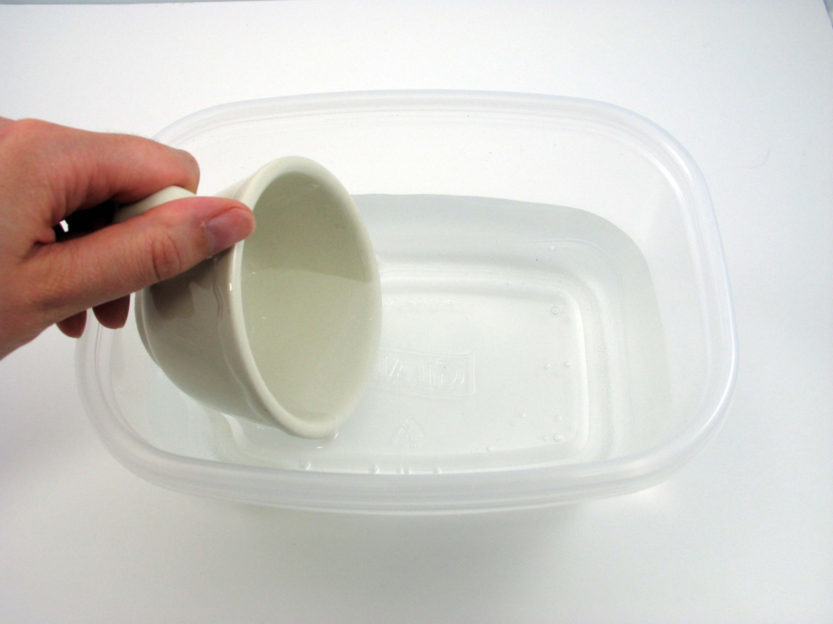 | 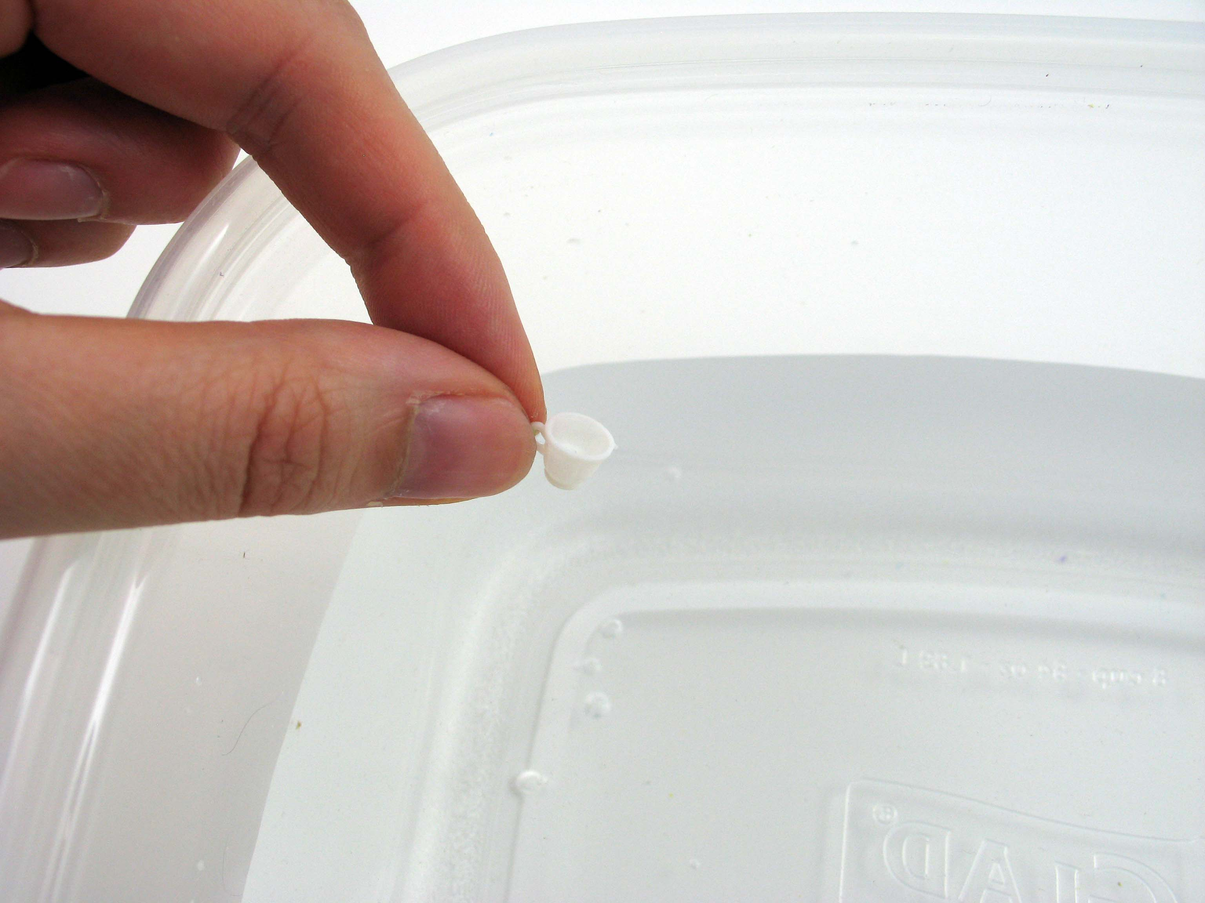
It’s easy to pour water out of a full-size cup, but not out of a miniature cup. That’s because size can affect the way a material behaves. The size of the cup—and the amount of water it holds—determines which force is more important, gravity or surface tension.
When you tip a cup of water upside down, the two forces are at work against each other. Gravity works to pull the water down and out of the cup. Surface tension (the natural tendency of water molecules to stick together) works to hold the water together inside the cup.  With a regular-size cup, the force of gravity is much stronger than surface tension, so the water falls out of the cup. But in a miniature cup, there’s a lot less water, and surface tension is strong enough to hold it together.  So when you tip the miniature cup, surface tension beats out gravity and the water stays in the cup. You also see surface tension at work when water beads up into droplets. | 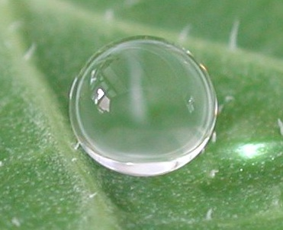  Water droplet on a nasturtium leaf
How is this nano?
A material can act differently when it’s nanometer-sized. Different physical forces dominate when things get very, very small. For example, gravity is very apparent to us on the macroscale, but it’s hardly noticeable at the nanoscale.

The miniature cup is tiny, but it’s still much, much bigger than things measured in nanometers. A nanometer is a billionth of a meter.

Nanotechnology takes advantage of the different physical forces at the nanoscale to make new materials and tiny devices. Nanotechnology allows scientists and engineers to make things like smaller, faster computer chips and new medicines to treat diseases like cancer.

Learning objectives
- A material can act differently when it’s nanometer-sized.
- Different physical forces dominate when things get very, very small.

Materials
- Regular teacup
- Miniature teacup
- Container for water

Miniature teacups are available at dollhouse suppliers. One source is www.dollhousesandmore.com (#CB2719).

Note to the presenter
Before beginning this activity, fill the container with water.

Related educational resources
The NISE Network online catalog (www.nisenet.org/catalog) contains additional resources to introduce visitors to the fundamentals of nanoscale science and technology:
- Public programs include Intro to Nano, Nano Dreams and Nano Nightmares, Surface Area, and Wheel of the Future.
- NanoDays activities include Exploring Forces—Static Electricity and Exploring Properties—Surface Area.
- Media include the Intro to Nanotechnology video.
- Exhibits include At the Nanoscale, Three Drops, and Unexpected Properties.

Credits and rights
This activity was adapted from “Shrinking Cups: Changes in the Behavior of Materials at the Nanoscale,” in Nanoscale Science: Activities for Grades 6-12 by M. Gail Jones, Michael R. Falvo, Amy R. Taylor, and Bethany P. Broadwell. pp. 89-94. Arlington, VA: NSTA Press.

Photo of water droplet courtesy A. Otten and S. Herminghaus, Göttingen, Germany.

 | This project was supported by the National Science Foundation under Award No. ESI-0532536. Any opinions, findings, and conclusions or recommendations expressed in this program are those of the author and do not necessarily reflect the views of the Foundation.

Copyright 2010, Sciencenter, Ithaca, NY. Published under a Creative Commons Attribution-Noncommercial-ShareAlike license: http://creativecommons.org/licenses/by-nc-sa/3.0/us/

