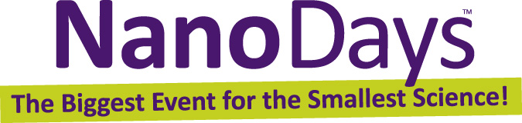

Exploring Size—Scented Solutions
Try this!  - Can you sort the bottles of grape drink, from the most concentrated to the most dilute? Use your eyes to look at the color, and your nose to sniff the scent.  - How many containers could you get in order? When could you no longer tell the difference among the bottles?  What’s going on?  Using your eyes, it’s pretty hard to sort the bottles past the third bottle, which is one part grape drink per 100 parts water. But using your nose, you might even be able to detect a whiff of scent in the fifth bottle, which is one part grape drink per 10,000 parts water. | 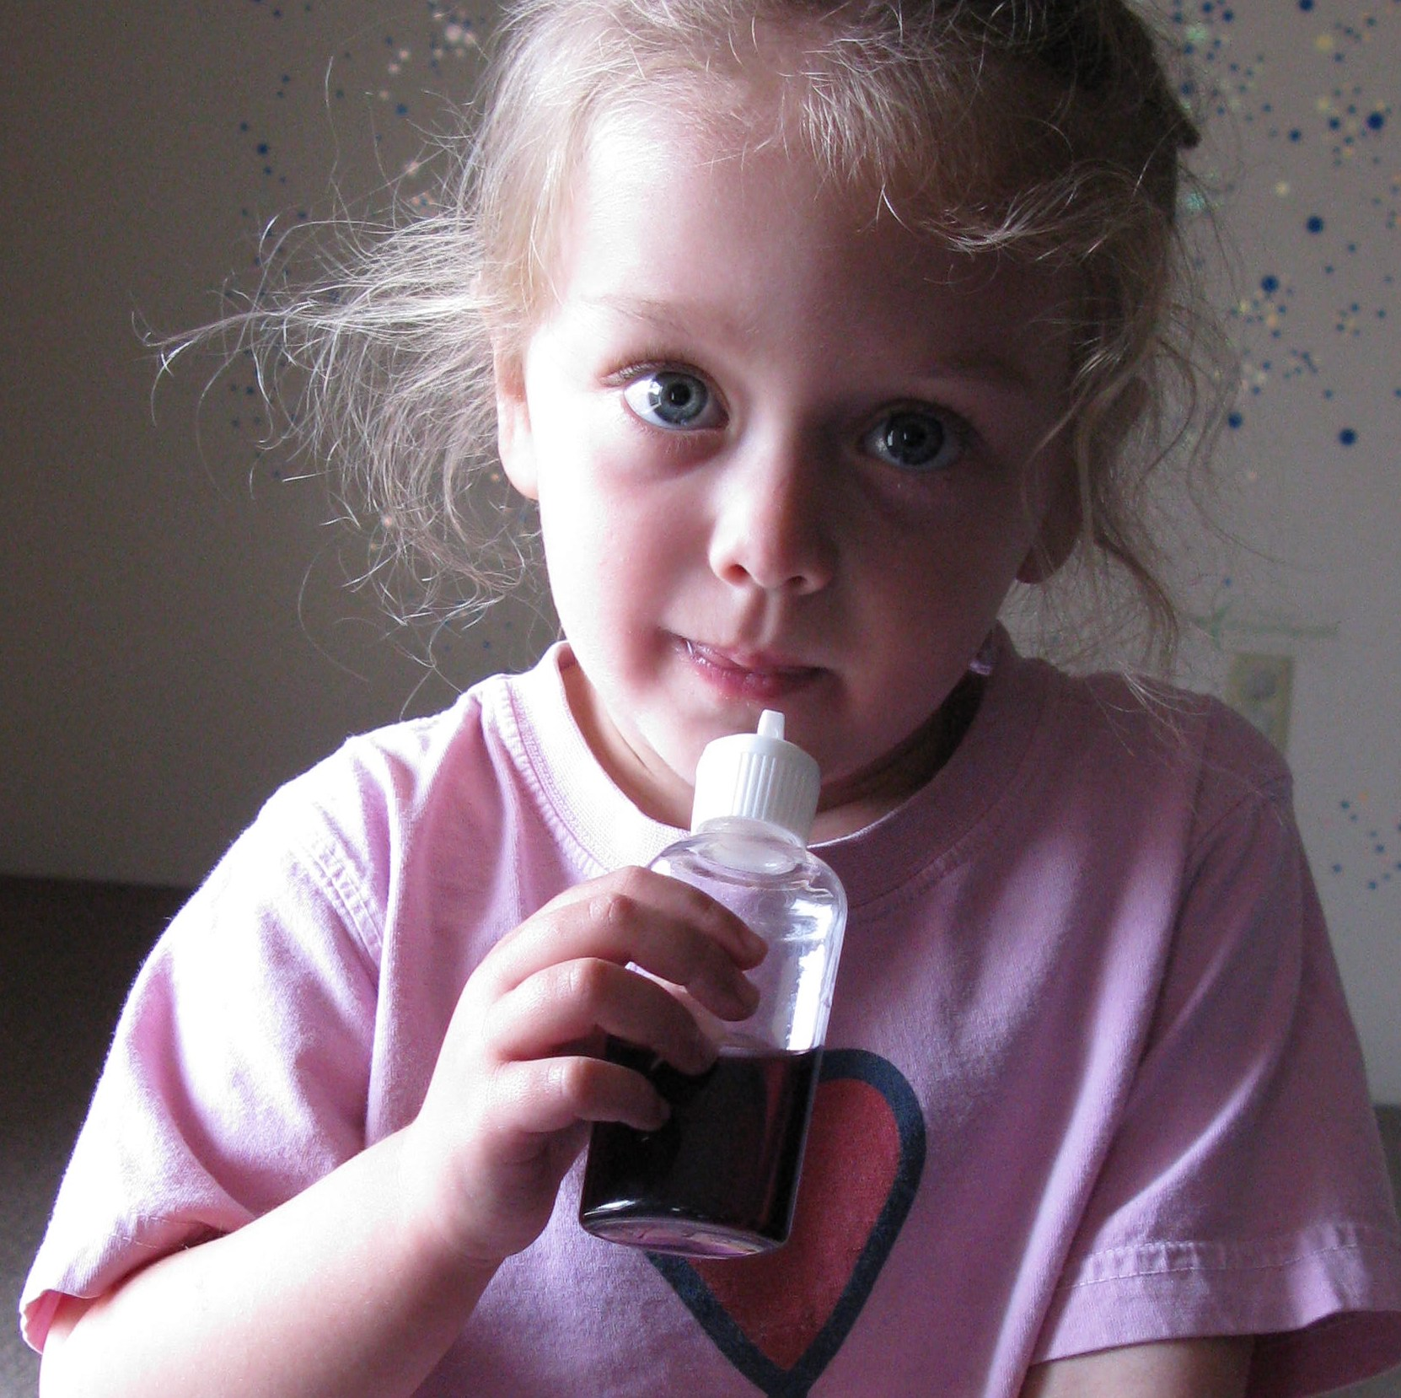
Many people find that they can detect differences in concentration better with their nose (smelling) than with their eyes (seeing). Our sense of smell allows us to experience nanometer-sized things—scent molecules—that are too small to see with our eyes.

How is this nano?
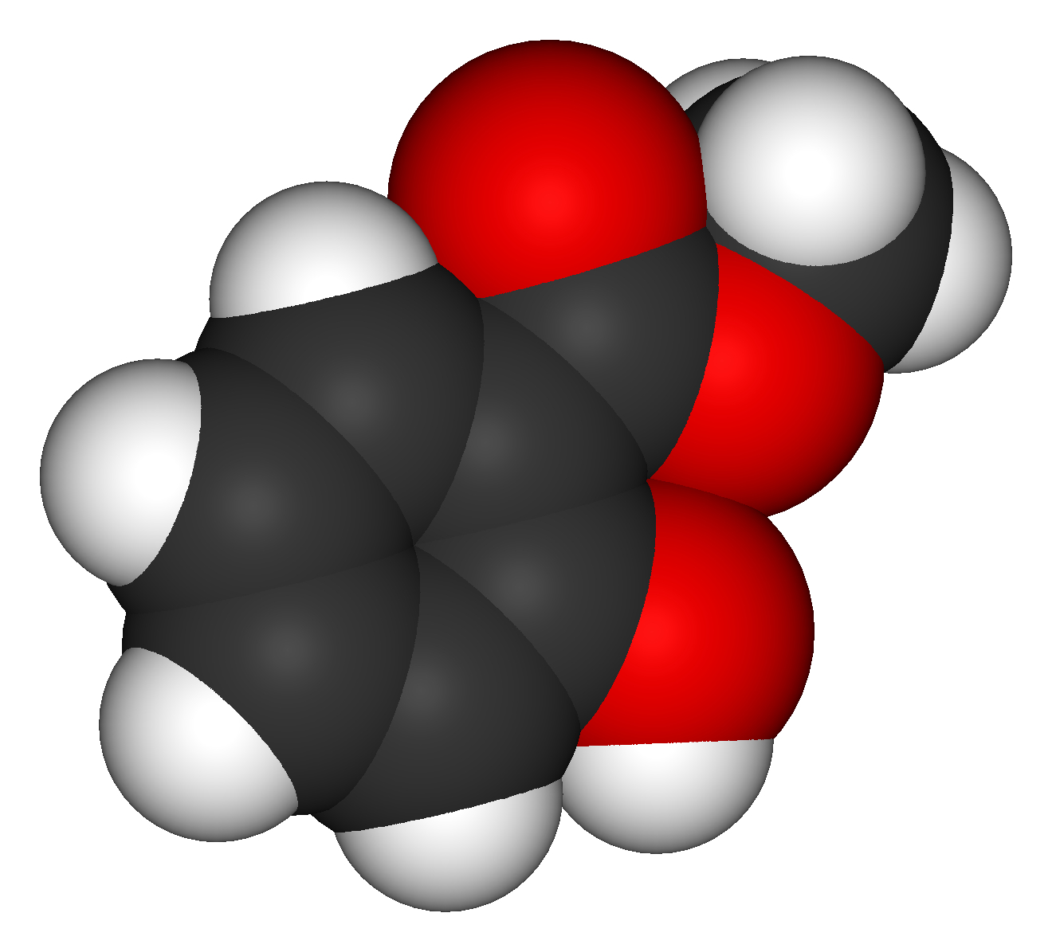  Molecular model of wintergreen oil | A nanometer is a billionth of a meter. That’s very, very small—too small to see with just your eyes. We can use our sense of smell to explore the world on the nanoscale, because we can smell some things that are too small to see.  Nanoscale science focuses on the building blocks of our world, atoms and molecules. Scientists use special tools and equipment to detect and manipulate tiny, nanometer-sized particles.  In the field of nanotechnology, scientists and engineers make new materials and tiny devices. Nanotechnology allows them to make things like smaller, faster computer chips and new medicines to treat diseases like cancer.
Learning objective
A nanometer is a billionth of a meter.

Materials
- Squeeze bottles filled with grape drink (see below for preparation instructions)

Preparing the bottles

A set of five bottles is needed for this activity. If you’d like the final bottle to be one part per billion, however, you should make a set of ten. The first bottle in your set should be filled with full strength grape drink (prepared from a powdered mix). Each subsequent bottle should be diluted with water by a power of ten:
Bottle 1: Full strength grape drink  Bottle 2: 10% solution  Bottle 3: 1% solution  Bottle 4: 0.1% solution  Bottle 5: 0.01% solution (one part per ten thousand) | Bottle 6: 0.001% solution  Bottle 7: 0.0001% solution  Bottle 8: 0.00001% solution  Bottle 9: 0.000001% solution  Bottle 10: 0.0000001% solution (one part per billion)

Notes to the presenter
SAFETY: Flush eyes with water immediately if solution gets in them. The diluted grape drink is nontoxic, but visitors should not taste the contents of the bottles.
Visitors should squeeze the bottles gently as they sniff them.
It will be easier for visitors to sort the bottles by color if they rest on a white surface. You can use a laminated sheet of white paper if your tabletop is a dark color.

Related educational resources
The NISE Network online catalog (www.nisenet.org/catalog) contains additional resources to introduce visitors to the nanoscale and nanometers:
- Public programs include Cutting it Down to Nano and Shrinking Robots!
- NanoDays activities include Exploring Size—Measure Yourself, Exploring Size—Memory Game, Exploring Size—Powers of Ten Game, Exploring Size—Scented Balloons, Exploring Size—StretchAbility Game, and Exploring Size—Tiny Ruler.
- Media include the poster and book How Small is Nano?, Image Scaler Software, Intro to Nano, Multimedia Zoom into a Human Hand, Multimedia Zoom into a Nasturtium Leaf, Scale Ladder, Zoom into a Butterfly Wing, Zoom into a Computer Chip, and Zoom into the Human Bloodstream.
- Exhibits include At the Nanoscale and Three Drops.

Credits and rights
This activity was adapted from “Nanotechnology Activity Guides: NanoSolutions,” developed by the National Science Foundation-supported Internships in Public Science Education (IPSE) Educator Resources, Materials Research Science and Engineering Center on Nanostructured Materials and Interfaces at the University of Wisconsin-Madison. The original activity is available at: mrsec.wisc.edu/Edetc/IPSE/educators/activities/nanoSolutions.html

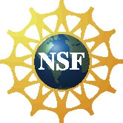 | This project was supported by the National Science Foundation under Award No. ESI-0532536. Any opinions, findings, and conclusions or recommendations expressed in this program are those of the author and do not necessarily reflect the views of the Foundation.
Copyright 2010, Sciencenter, Ithaca, NY. Published under a Creative Commons Attribution-Noncommercial-ShareAlike license: http://creativecommons.org/licenses/by-nc-sa/3.0/us/

