

Exploring Size—Tiny Ruler

Try this!
- Take a paper ruler. It’s 20 centimeters long—a fifth of a meter. Do you think you can cut it down to a nanometer in size?  - Cut the ruler in half so you have a piece that’s 10 centimeters long.  - Take the 10 centimeter piece and cut it in half.  - Keep cutting the halves in half. How small a piece can you get before you can’t cut it any more?  What’s going on? | 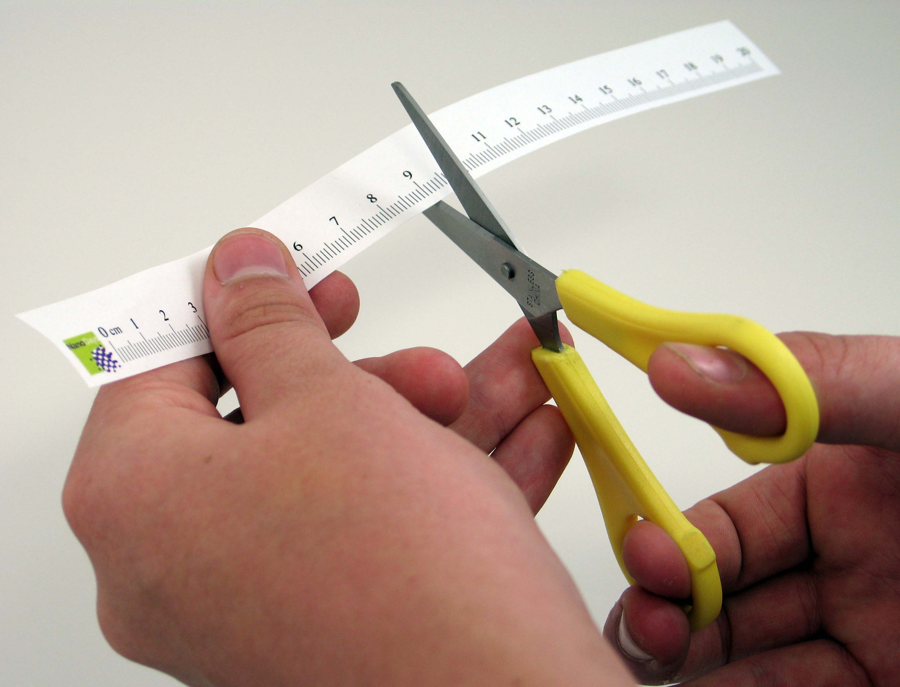
You probably didn’t manage to cut the paper ruler down to a nanometer. A nanometer is a billionth of a meter. That’s really small!

Most people can’t cut the paper smaller than about a millimeter. (The lines on the ruler mark millimeters.)
A nanometer is a million times smaller than that!

How is this nano?
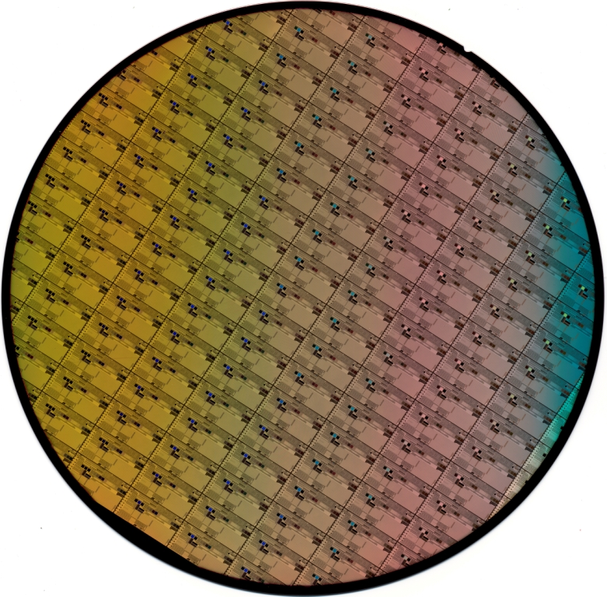  Silicon wafer patterned  with computer chips | A nanometer is a billionth of a meter. That’s way too small to see, and definitely smaller than you can cut a piece of paper!  Nanoscale science focuses on things that are measured in nanometers, including atoms and molecules, the basic building blocks of our world. Scientists need special tools and equipment to work on the nanoscale. Regular tools like scissors are too big!  In the field of nanotechnology, scientists and engineers study the world of the nanometer and make new materials and tiny devices. Nanotechnology allows them to make things like smaller, faster computer chips and new medicines to treat diseases like cancer.

Learning objective
A nanometer is a billionth of a meter.

Materials
- Paper rulers
- Safety scissors

A photocopy master for the paper rulers can be downloaded from www.nisenet.org/catalog/

Note to the presenter
To make the paper rulers, photocopy the master and use a paper cutter to make individual paper rulers.

Related educational resources
The NISE Network online catalog (www.nisenet.org/catalog) contains additional resources to introduce visitors to the nanoscale and nanometers:
- Public programs include Cutting it Down to Nano and Shrinking Robots!
- NanoDays activities include Exploring Size—Measure Yourself, Exploring Size—Memory Game, Exploring Size—Powers of Ten Game, Exploring Size—Scented Balloons, Exploring Size—Scented Solutions, and Exploring Size—StretchAbility Game.
- Media include the poster and book How Small is Nano?, Image Scaler Software, Intro to Nano, Multimedia Zoom into a Human Hand, Multimedia Zoom into a Nasturtium Leaf, Scale Ladder, Zoom into a Butterfly Wing, Zoom into a Computer Chip, and Zoom into the Human Bloodstream.
- Exhibits include At the Nanoscale and Three Drops.

Credits and rights
This activity was adapted from “Cutting It Down to Nano Outreach Activity,” developed by the National Science Foundation-supported Internships in Public Science Education (IPSE) Program at the Materials Research Science and Engineering Center (MRSEC) on Nanostructured Materials and Interfaces at the University of Wisconsin-Madison. The original activity is available at mrsec.wisc.edu/Edetc/EExpo/cutting/index.html

 | This project was supported by the National Science Foundation under Award No. ESI-0532536. Any opinions, findings, and conclusions or recommendations expressed in this program are those of the author and do not necessarily reflect the views of the Foundation.

Copyright 2010, Sciencenter, Ithaca, NY. Published under a Creative Commons Attribution-Noncommercial-ShareAlike license: http://creativecommons.org/licenses/by-nc-sa/3.0/us/

