Biobarcodes: Antibodies and nanosensors


Organization: Oregon Museum of Science and Industry

Contact person: Anders Liljeholm

Contact information: aliljeholm@omsi.edu or 503-797-4606

General Description

Cart demo

This cart demo is about Biobarcodes, a nanomedical technology that allows for massively parallel testing for disease diagnosis. Visitors learn about antibodies, how each antibody binds to a unique protein, and how biobarcoding uses nanoparticles, antibodies, DNA and magnetism to detect diseases earlier than we could detect before. Visitors assemble a jigsaw puzzle that models how Biobarcodes™ work.

Program Objectives

Big idea:
Medical labs use nanoparticles to identify microbes quickly and accurately.

Learning goals:
As a result of participating in this program, visitors will:
1. be able to say that antibodies help us stay healthy, and that scientists use antibodies to detect viruses.
2. learn that nanoparticles let us detect things more quickly than before, and at much lower levels than before.

NISE Main Messages covered:
[ ] 1. Nanoscale effects occur in many places. Some are natural, everyday occurrences; others are the result of cutting-edge research.
[ ] 2. Many materials exhibit startling properties at the nanoscale.
[ X ] 3. Nanotechnology means working at small size scales, manipulating materials to exhibit new properties.
[ X ] 4. Nanoscale research is a people story.
[ ] 5. No one knows what nanoscale research may discover, or how it may be applied.
[ ] 6. How will nano affect you?

Biobarcoding: Antibodies and Nanosensors

Table of Contents
General Description 1
Program Objectives 1
Time Required 1
Table of Contents 2
Background Information 3
Materials 3
Set Up 3
Step 1: 3
Program Delivery 3
Safety: 3
Procedure and Discussion: 3
Tips and Troubleshooting: 3
Common Visitor Questions 3
Going Further… 3
Clean Up 3

Time Required

Set-up Program Clean Up
5 minutes 10 minutes 2 minutes

Background Information

Definition of terms

Nano is the scientific term meaning one-billionth. (1/1,000,000,000) It comes from a Greek word meaning “dwarf.”
A nanometer is one one-billionth of a meter. One inch equals 25.4 million nanometers. A sheet of paper is about 100,000 nanometers thick. A human hair measures roughly 50,000 to 100,000 nanometers across. Your fingernails grow one nanometer every second.
(Other units can also be divided by one billion. A single blink of an eye is about one-billionth of a year. An eyeblink is to a year what a nanometer is to a yardstick.)
Nanoscale refers to measurements of 1 – 100 nanometers. A virus is about 70 nm long. A cell membrane is about 9 nm thick. Ten hydrogen atoms are about 1 nm.

At the nanoscale, many common materials exhibit unusual properties, such as remarkably lower resistance to electricity, or faster chemical reactions.
Nanotechnology is the manipulation of material at the nanoscale to take advantage of these properties. This often means working with individual molecules.
Nanoscience, nanoengineering and other such terms refer to those activities applied to the nanoscale. “Nano,” by itself, is often used as short-hand to refer to any or all of these activities.

Program-specific background

Biobarcoding™ is a new kind of biological sensing technology that uses nanoscale gold particles and microscale magnetic particles to identify microbes. The gold nanoparticles have antibodies attached to their surfaces, which in turn will stick to the specific substance you want to detect. The nanoparticles are also coated with many copies of marker DNA, the so-called biobarcode. The marker DNA can be any sequence that is easily reproduced. Having lots of marker DNA on the surface of the nanoparticles makes them easy to detect.

Meanwhile, the magnetic microparticles also have antibodies stuck to their surfaces. Lab technicians mix both kinds of particles in a sample, where they stick to the target substance (a germ or a protein). The technicians remove all the magnetic microparticles with a magnet. If there were any target proteins in the sample, they will be removed, too, stuck to the microparticles because of the antibodies.

However, the magnet removes all magnetic particles, whether they picked up a target protein or not. That’s where the gold particles come in. They should also stick to the target protein, which was stuck to the magnetic particle, which gets removed. The lab techs now can test for the presence of the marker DNA, which, because there’s so much of it on every gold particle, is much easier to find than a single protein or virus. Biobarcoding enables doctors to detect illness far sooner, both at lower levels which were undetectable until now, and in hours instead of days waiting for a test to finish.

The technology is very flexible, and able to detect anything that antibodies can be made for. (They can also make nanoparticles with strands of DNA that bind to complementary strands of target DNA that you want to detect.) In June 2006, tests had been established for anthrax and prostate cancer. The Mirkin group is trying to use this technique to create the first-ever test for Alzheimer’s disease. Early detection of these conditions allow treatment to begin far sooner than ever before. It could lead to a test to detect mad cow disease without an autopsy, which is currently required, and a real bummer for the patient.

Materials

The set of biobarcode jigsaw pieces. (3 pairs of proteins and antibodies, 3 germs, 3 magnetic nanoparticles, 3 dna marker nanoparticles)

Heart shaped object is anthrax, Green star is flu, Blue space station is AIDS. The protrusions of each disease are the proteins, and the shapes that fit around them are the antibodies.
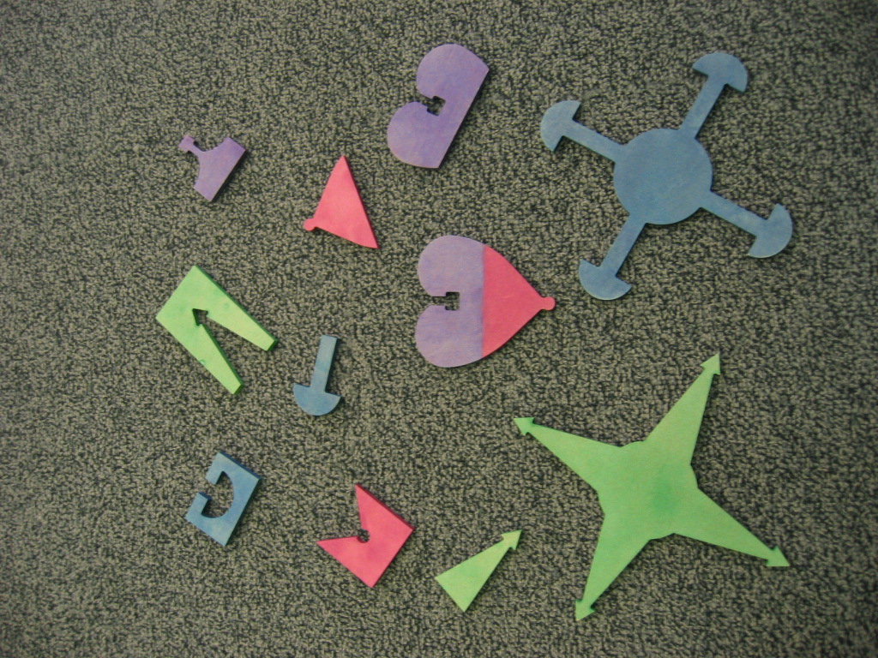

Nanoparticles: Yellow represents gold nanoparticle, different colored antibodies are on the outside. Yarn symbolizes marker DNA. Magnets are embedded in the center of other particles.
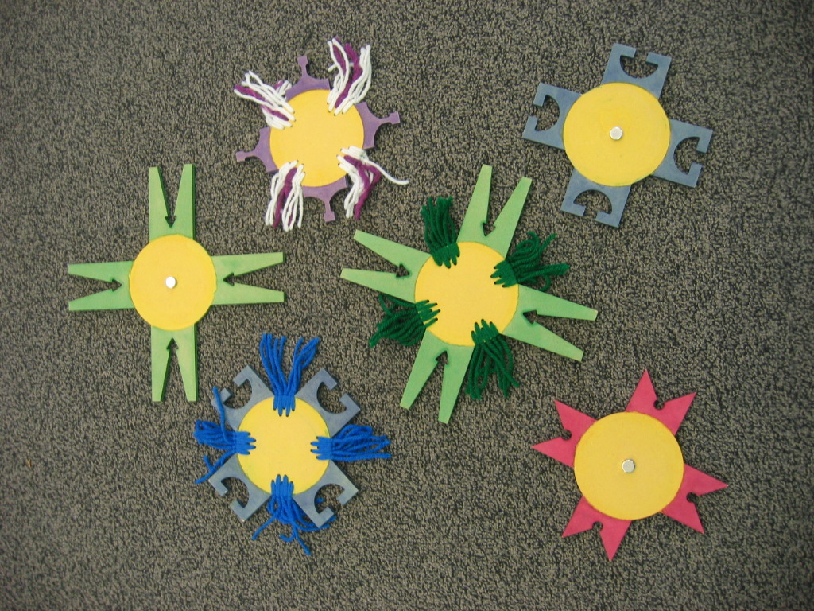
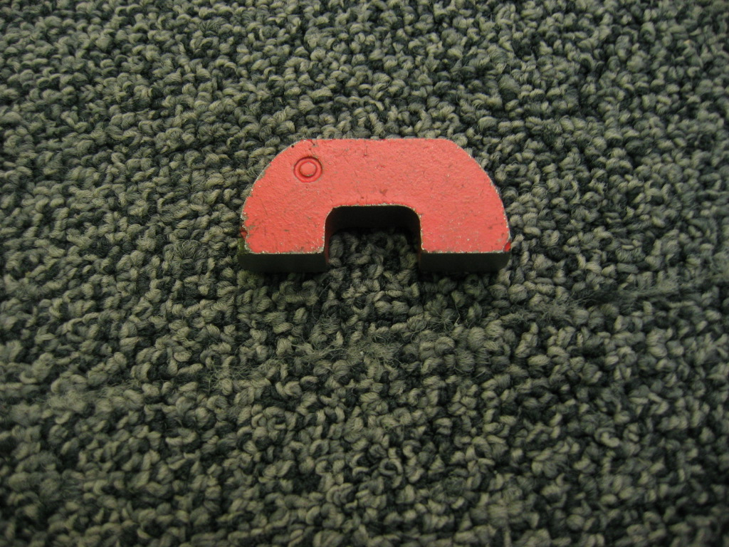
One magnet strong enough to lift all 3 magnetic "nanoparticles"

Set Up

Time: 5 minutes

Step 1:
Set out the antibody/protein pieces on the table.

Program Delivery

Time: 10 minutes

Safety:
Don’t let small children remove the magnets from the jigsaw and choke on them.

The magnets could be a pinch hazard.

Procedure and Discussion:

[Put out the small proteins and antibodies.]
Do you notice anything about these shapes? Do any of the shapes fit together?
These are models of antibodies. Have you ever heard of antibodies? Antibodies are molecules our body makes to help us fight disease. There is one kind of antibody for each kind of germ. Each antibody only sticks to its germ, and it doesn’t stick to any others.

[Show the model germs.]
Germs have particular shapes on their outsides, called proteins. Antibodies match those shapes and stick to the proteins, and the germ-fighting parts of our bodies--the white blood cells--look for the antibodies to figure out which germs to attack. Do you see how the different antibodies stick to the different germs?

Now scientists have invented a way to use antibodies to test for different diseases. If we wanted to test to see if someone had a particular germ, we could take a sample of their blood, put it in a test tube, and mix in something called nanoparticles.

[Take out nanoparticles.]
Nanoparticles are very tiny, the same size as viruses. You can fit 80,000 of them across a single hair. Scientists put antibodies on the surface of gold nanoparticles, so they stick to the germs. Can you make our nanoparticles stick to our germ?

[Have the visitor assemble the puzzle.]
OK, great! But we’ve got a problem—the particles are still in the blood sample. We have to get them out in order to see if they’ve attached themselves to any germs.

Some of the nanoparticles have a magnetic core. So we take a magnet, and pull the particle and the germ out of the blood.

[Move the assembled puzzle to the edge of the table with a magnet.]
We took this other particle with us! It has lots of pieces of yarn. The yarn represents DNA. This nanoparticle has thousands of copies of marker DNA, as well as the antibodies. So, once we use the magnet to pull out the magnetic particles, we can then do a test to see if they picked up any marker DNA particles. If they did, then we know we’ve got the germ!

It’s a lot easier for us to detect thousands of pieces of DNA than to detect one little germ or protein. Not only is it easier, it’s also much faster than older tests.

[Repeat the magnet gesture without the virus.]
Now, what would happen if the blood sample didn't have the disease we were looking for? In that case, the particles with the marker DNA wouldn't have anything to stick to. So when the magnet pulled out the magnetic particles, all the marker DNA particles would get left behind. Our test would show no markers, which we know means: no germs.

The magnetic particles come out every time, but the DNA particle only comes out when there’s a virus for all the pieces to stick to. You can see that if the germ isn’t there, the marker DNA particle stays behind.

[Put away all but one germ. Put out all the nanoparticles.]
One of the exciting things about this kind of test is that you can look for several things at the same time! Let’s say someone had the flu, but you weren’t sure which type of flu they had. You could mix a test tube of their blood with several different sets of nanoparticles, each with different antibodies and marker DNA.

Which nanoparticles are going to stick to this germ? Are any other nanoparticles going to stick to the germ?

As you see, several of the nanoparticles are magnetic, so when I move a magnet over them, all the magnetic nanoparticles stick to my magnet.

[Use the magnet to pick up all the magnetic nanoparticles, and carefully bring the virus and DNA marker nanoparticle.]
The virus stuck to the magnetic nanoparticles that had the right antibodies, and one of the marker DNA nanoparticles then stuck to the virus. Each marker nanoparticle has a different kind of DNA, so it’s really easy for us to tell which kind of marker gets pulled out, and thus which kind of germ is in there.

Would you like to try it again with a different virus?

[Put a different germ out, and then reintroduce the nanoparticles. Explain again how using two nanoparticles means that marker DNA is detected only if the target virus or protein is there for the antibodies to stick to.]
Do you have any questions?

Tips and Troubleshooting:
The magnet may not pick up all the magnetic nanoparticles. If necessary, pick them up one at a time.

Common Visitor Questions

When will this be used?
Some similar tests from the same company have already been approved for use by the FDA. Since this technique happens in a test tube, it should be very safe, and could be used very soon.

Going Further…
Here are some resources you can share with your visitors:
News on the company:
http://www.smalltimes.com/articles/article_display.cfm?Section=ARCHI&C=Finan&ARTICLE_ID=311069
http://www.smalltimes.com/Articles/Article_Display.cfm?ARTICLE_ID=268231&p=109

How it works, from the company selling it:
http://www.nanosphere-inc.com/UltrasensitiveProteinDetection_4402.aspx

From Korea, more detail on how biobarcoding works (pages 1-3, 28-30):
http://www.inchem.hanyang.ac.kr/lab/prlab/lecture/nano/nanoparticle(3).pdf

Chad Mirkin at Northwestern University supervised the initial research. (About halfway down the page)
http://www.chem.northwestern.edu/~mkngrp/BioNanomaterials2003rev1.htm

Nam, J.-M.; Park, S.-J.; Mirkin, C. A. Bio-barcodes based on oligonucleotide-modified nanoparticles, J. Am. Chem. Soc.2002, 124, 3820-3821.

Nam, J.-M.; Thaxton, C. S.; Mirkin, C. A. Nanoparticle-based bio-bar codes for the ultrasensitive detection of proteins, Science 2003, 301, 1884-1886.

Other scientists are exploring the possibilities:
http://www.pnas.org/cgi/content/full/102/7/2263

Clean Up

Time: 2 minutes
Put material back in the box.

Universal Design

This program has been designed to be inclusive of visitors, including visitors of different ages, backgrounds, and different physical and cognitive abilities.

The following features of the program’s design make it accessible:

[ ] 1. Repeat and reinforce main ideas and concepts
The basic idea is repeated multiple times so visitors have several opportunities to grasp the concept.

[ ] 2. Provide multiple entry points and multiple ways of engagement

[ X ] 3. Provide physical and sensory access to all aspects of the
program
Color and texture make this demo accessible both to sight and touch.
To give an inclusive presentation of this program:

Repeat the procedure of detecting a virus several times in slightly different ways, so visitors can understand the process.

Describe verbally what is happening, to reinforce what visitors see and feel, and for visitors with low vision.

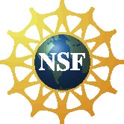
This project was supported by the
National Science Foundation under Grant No. ESI-0532536.

