Inkjet Printer


Organization: Oregon Museum of Science and Industry

Contact person: Anders Liljeholm

Contact information: 503-797-4606, aliljeholm@omsi.edu

General Description

Demonstration

Through hands-on activities, visitors learn how inkjet printers produce tiny, precise drops of ink. They examine printed paper with magnifying glasses, see a few demonstrations of how liquids behave differently at the small scale, and see an explosive demonstration of how ink is forced out of an ink cartridge.

Program Objectives

Big idea:
Inkjet printers take advantage of novel properties to print pictures and text.

Learning goals:
Visitors will learn that:
1. Inkjet printers use tiny technology.
2. Water and ink act differently on very small scales.
3. Many inkjet printers boil ink to make it move.
4. Nanoscale effects occur in many places. Some are natural, everyday
occurrences; others are the result of cutting-edge research.

NISE Main Messages covered:
[ X ] 1. Nanoscale effects occur in many places. Some are natural, everyday occurrences; others are the result of cutting-edge research.
[ X ] 2. Many materials exhibit startling properties at the nanoscale.
[ X ] 3. Nanotechnology means working at small size scales, manipulating materials to exhibit new properties and create new devices.
[ ] 4. Nanoscale research is a people story.
[ ] 5. No one knows what nanoscale research may discover, or how it may be applied.
[ ] 6. How will nano affect you?

Inkjet Printer

Table of Contents
General Description 1
Program Objectives 1
Time Required 1
Table of Contents 2
Background Information 3
Materials 3
Set Up 5
Step 1: 5
Program Delivery 5
Safety: 5
Procedure and Discussion: 5
Tips and Troubleshooting: 7
Common Visitor Questions 8
Going Further… 8
Clean Up 9
Universal Design 12

NOTICE: You're welcome to alter this program to suit your needs. In fact, we encourage it! Change it around, and if you find something that works let us know. Post your revisions on www.nisenet.org.

Time Required

Set-up Program Clean Up
10 minutes 20 minutes 10 minutes

Background Information

Definition of terms

Nano is the scientific term meaning one-billionth. (1/1,000,000,000) It comes from a Greek word meaning “dwarf.”
A nanometer is one one-billionth of a meter. One inch equals 25.4 million nanometers. A sheet of paper is about 100,000 nanometers thick. A human hair measures roughly 50,000 to 100,000 nanometers across. Your fingernails grow one nanometer every second.
(Other units can also be divided by one billion. A single blink of an eye is about one-billionth of a year. An eyeblink is to a year what a nanometer is to a yardstick.)
Nanoscale refers to measurements of 1 – 100 nanometers. A virus is about 70 nm long. A cell membrane is about 9 nm thick. Ten hydrogen atoms are about 1 nm.

At the nanoscale, many common materials exhibit unusual properties, such as remarkably lower resistance to electricity, or faster chemical reactions.
Nanotechnology is the manipulation of material at the nanoscale to take advantage of these properties. This often means working with individual molecules.
Nanoscience, nanoengineering and other such terms refer to those activities applied to the nanoscale. “Nano,” by itself, is often used as short-hand to refer to any or all of these activities.

Program-specific background

Inkjet printers use tiny technology. Microscopic channels carry ink to nozzles which squirt out picoliter sized drops (3-25 picoliters), 6,000 times a second. A picoliter is one-trillionth of a liter. There are almost five billion picoliters in a teaspoon.

According to engineering legend, inkjet technology was discovered when someone accidentally touched the needle of a syringe of ink with a hot soldering iron, causing the ink to bubble and squirt out. This phenomenon only works in capillary tubes—those with an extremely small diameter. This illustrates a basic idea of nanotechnology, that things behave differently at very small scales. However, this phenomenon is not strictly nano, since a picoliter sized drop is 50,000 nanometers wide.

HP and Canon inkjet printers use this dramatic heat-based technology. There are also carpet factories that use inkjet printers to print patterns onto their carpets.

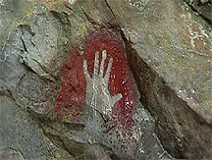
In prehistoric times, people painted in caves by blowing ink out of tubes, making silhouettes of their hands. Caves with a variety of different paintings can be found in France. Some of these paintings are roughly 30,000 years old.

A similar technique called “stencil painting” was used in Australia around this same time. The exact dates and the issue of “who was first” are extremely contentious topics in archaeology.

Materials
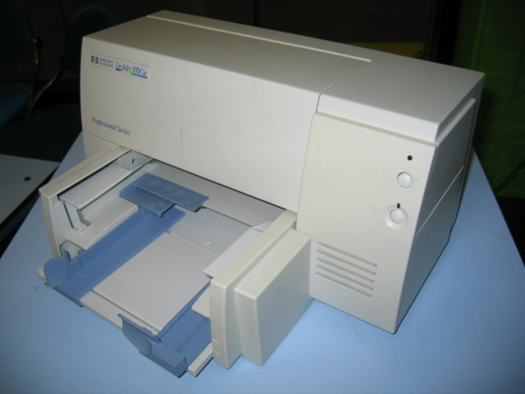
A broken inkjet printer with empty ink cartridges

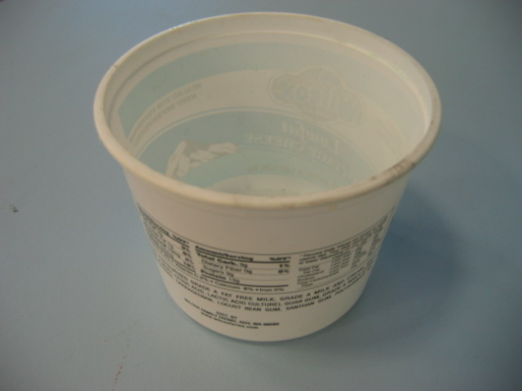

Bucket of water (clear bucket is best)

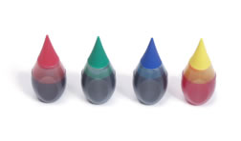
Washable watercolor paint or food coloring

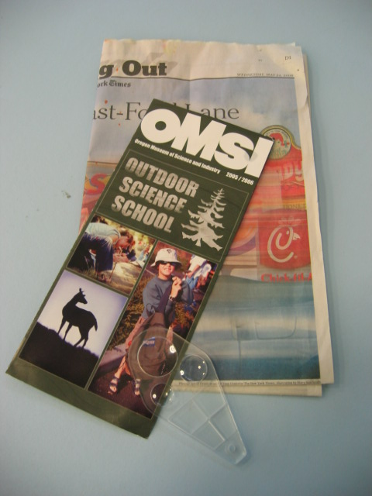

Magnifying glass
Flyers printed in color, especially with photos

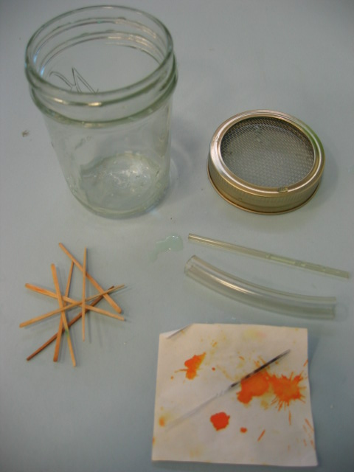
Glass capillary tubes (Medical supply or http://wardsci.com/product.asp_Q_pn_E_IG0005532_A_Melting+Point+Capillary+Tubes)
Mason jar
Wire screen cut to fit mason jar lid (screen with holes 2 mm wide at most)
Wide tube that doesn't show capillary action (meniscus)
Toothpicks

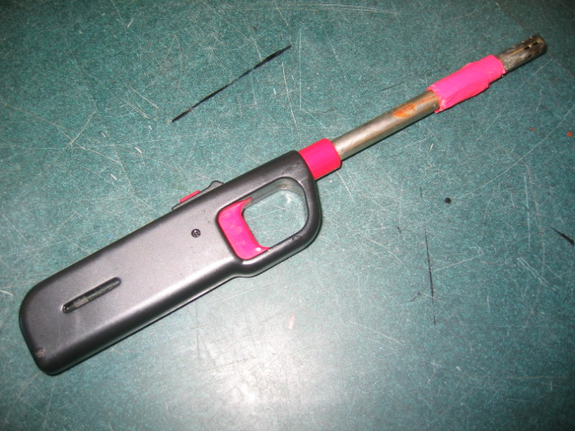
Butane lighter or matches

Scrap paper

Assorted relevant photos or powerpoint presentation and projector.

Possible extension: Xyron Design Runner handheld printer http://www.xyron.com/enUS/Products/Xyron_Design_Runner.html

Set Up

Time: 10 minutes

Step 1:
Set out all your supplies. Put a few drops of food coloring in the bucket of water.

Test the inkjet printer kit.

Test the butane lighter.

Program Delivery

Time: 20 minutes

Safety:

The demonstration involves fire—use appropriate caution.

Always dip the pipette in water after heating.

Take care not to get cut on broken glass.

Don’t let the glass melt onto you and burn you.

The exploding ink shoots out of both ends of the tube. Make sure you hold the tube parallel to the audience, so the ink hits neither you nor them.

Procedure and Discussion:

Start inviting visitors to join you to learn about how printers work.
Dots
Ask if they’ve seen inkjet printers before. Maybe they have one at home, work or school.
Show visitors the sample printed materials. Invite visitors to examine the materials with the magnifying glass. Encourage them to see the pattern of dots that make up the picture.
Explain that the dots of ink that come out of printers are ridiculously tiny. Inkjet printers squirt picoliters of ink onto paper. A picoliter is 1 trillionth of a liter. Five billion picoliters fit in a teaspoon.
Show the visitors one drop of water. One drop of water is 10 million picoliters. One ordinary drop of blood holds 1 billion red blood cells; one picoliter of blood holds about 100 red blood cells.

Surface Tension
Explain that ink and water act differently on such a small scale.
• Ask the visitors if they have seen or heard of surface tension. Water is sticky: molecules of water stick to objects and to each other.
• Dip the large tube in the water and show how it gets wet, but the tube doesn't stay full of water.
• Dip a capillary tube in the water and explain how the water sticks to the side of the tube and climbs up the tube.
• Float the capillary tube on the surface of the water, showing the surface tension holding the tube up.

Show how surface tension acts differently on the small scale with the mason jar.
• Fill the mason jar with water.
• Explain that you have a jar with a metal screen with small holes covering the opening.
• Cover the top of the jar with your hand, turn it upside down, and slowly remove your hand. The water should stay in the jar.
• Keeping the jar level, insert a toothpick through the screen, to demonstrate that the water is holding itself with surface tension, and you didn’t put any other barrier over it.
Remind the visitors that water and ink behave differently when they get small. If we want to build printers that squirt out picoliters of ink, we have to invent new techniques to get the ink to flow.
Bubble printers
HP and Canon inkjet printers use bubbles to move the ink. Behind the tiny tube of ink in these printers lies a miniature electric heater. The heater boils the ink, forming a bubble which forces the ink out of the tube.
Boil ink in a tube
• Ask for a volunteer to help demonstrate this.
• Have the volunteer hold a piece of scrap paper vertically in the air, with the paper facing squarely stage left and right.
• Dip the capillary tube in undiluted food coloring.
• Line the tube up so it is pointing stage left and right, with the inky end pointing at the paper.
• Hold a flame under the tube, about 1 cm from the end. The ink should shoot out the end in a moment, splattering on the paper.

Inkjet printers can shoot out 6,000 drops of ink a second.

Tips and Troubleshooting:

NOTICE: Feel free to alter this program to suit your needs. If you find something that works, share it with the rest of the community by posting your revisions on www.nisenet.org.

Use very washable watercolor ink or food coloring in the capillary tube. Make sure it doesn’t explode onto people, and that it washes out easily in the unfortunate event of a mess.
If the capillary tube gets hot enough in the lighter flame, the tube can bend. This will not affect the demo, so long as the tube remains intact. Don’t let the glass melt onto you and burn you.
When choosing printed matter for people to look at through a magnifier, check it out first yourself. Newspaper color comics used to have great dots, but the Portland Oregonian and some other papers now use very-high-resolution dots, which are too small to see. Magazines and glossy photographic fliers, as well as newspaper photographs, are still quite visible. Printed packaging, like cereal boxes, usually has visible halftone dots.
When doing the wire screen surface tension trick, it works much better if you ease your hand off the jar. Taking your hand off too quickly often results in the water pouring out. Keep the screen level for best results.

Awesome extensions of this demonstration could include:
• Printing on paper with the handheld Design Runner. Explain that printers have several nozzles that all shoot drops of ink out simultaneously, and the cartridge moves back and forth across the paper to create a picture. Demonstrate this with the hand-held printer.
You have to move the printer across the paper as you print.
Visitors also enjoy seeing the dots flying onto the paper without making words. If you hold the printer in place, moving in a small circle, you see individual dots appear in a big blob. To see what this style of printing looks like go to:
http://www.parallax.com/dl/mm/video/SXhandheldprinter.MOV (2.2 MB file)
• set up an inkjet head in operation with a strobe light and a video microscope so you can see the inkjet droplets in midair.
• If you have the technical ability, a giant version of the printing head would help visitors understand how the picture is formed. In the style of The Secret Life of Machines, a row of paintball guns, ketchup bottles or other large paint nozzles would squirt in the correct pattern as you move it slowly across a sheet of butcher paper, slowly spelling out letters.

Common Visitor Questions

Why is inkjet ink so expensive? Is “recycled” ink a good buy?

There are two reasons. (Well, three if you include supply and demand.) First, chemical engineers have to design the inks to fairly rigid specifications, which requires an elaborate, expensive process. Second, you are not just buying the ink; you are also buying the cartridge, with a new nozzle for a sharper image.

You could, if you wanted, refill a cartridge up to two times, though image quality may start to degrade if the nozzle gets too worn. Also, refill inks are often of a lower quality.

Ink for an inkjet printer costs about $2,500/gallon. That’s a lot! But it’s not the most expensive liquid on the planet. High-end perfume, like Chanel #5, can cost 10 times as much. And scorpion venom costs $38 million/gallon!

(There is a whole other class of inkjet printers that use a slightly different technology to squeeze out drops of ink. Piezoelectric printers use crystals that stretch when you run electricity through them to pump ink through the tubes. Piezoelectric printer ink can cost less, because you don't buy a new printing head with every cartridge of ink. Piezo print heads are more expensive to manufacture, but they last much longer.)

Do laser printers work the same way?
No. In laser printers and copy machines, a rotating drum is charged with static electricity. The image being copied—words, pictures, whatever--is shone on the drum (or the laser shines on the drum in the right spots.) This light removes the static charge from those parts of the drum, but leaves it on others. Then the drum passes through powdered toner, which is basically colored dust. The toner sticks to the drum wherever there is static charge left—in other words, where there was a dark spot in the image. The toner is transferred to a piece of paper, again using static electricity. The paper then passes through a heater which melts the toner to the paper.

For a great illustrated explanation of how laser printers work:
http://computer.howstuffworks.com/laser-printer.htm

There is a VERY LARGE video file of a TV show explaining lots about photocopy technology here:
http://spoz.kolaiah.net/slom/slom3/Secret%20Life%20Of%20Machines%20305%20The%20Photocopier.avi

Going Further…
Here are some resources about inkjet printers:
How Stuff Works’ “How an Inkjet Printer Works”:
http://computer.howstuffworks.com/inkjet-printer.htm

Future printers may print nano-circuitry:
http://www.physicsweb.org/articles/world/19/1/4/1
http://www.businessweek.com/technology/content/feb2005/tc2005021_8453.htm

Or we may print human flesh:
http://www.theregister.com/2005/01/21/human_skin_printer/
http://dsc.discovery.com/news/2007/01/09/boneprinter_tec.html?category=health&guid=20070109140030
http://www.newscientist.com/article/mg19025474.300-print-me-a-heart-and-a-set-of-arteries.html
http://organprint.missouri.edu/

Or just books really fast:
http://dsc.discovery.com/news/2006/10/30/printer_tec.html?category=technology&guid=20061030091500

A couple good factual pages:
http://www.inkjet-cartridges.net/inkjet_cartridges.htm
http://www.pctechguide.com/53Inkjets.htm
http://www.color-printing.com/inkjet-simple-answers.html

The Price of a Gallon: how much per gallon do various fluids cost? Chanel #5 is $25,000/gallon, compared with inkjet ink at $2,500/gallon.
www.cockeyed.com/science/gallon/liquid.html

A page of claims about blood, including the claim that 1 billion red blood cells are in a drop of blood:
http://www.bloodbook.com/facts.html

If a red blood cell is about 5 microns wide (as shown in this awesome animation):
http://www.cellsalive.com/howbig.htm
Then a picoliter of blood could hold 500 red blood cells. And probably fewer, since there’s other stuff in the blood. Thus the 100 cells in a pL figure.

OMSI has a digital lab about pixellated images:
http://www.omsi.edu/visit/tech/resolution.cfm

Clean Up

Time: 10 minutes

Pack everything up.
Make sure wet things get dried off.
Make sure to safely dispose of any burnt matches or broken glass.

Universal Design

This program has been designed to be inclusive of visitors, including visitors of different ages, backgrounds, and different physical and cognitive abilities.

The following features of the program’s design make it accessible:

[ ] 1. Repeat and reinforce main ideas and concepts

[ X ] 2. Provide multiple entry points and multiple ways of engagement
Multiple activities illustrating different points, multiple volunteers assisting.

[ ] 3. Provide physical and sensory access to all aspects of the
program
Information in tactile, visual and audio forms.
To give an inclusive presentation of this program:

Be sure to verbally describe all your actions, props and images for visitors with low vision.


This project was supported by the
National Science Foundation under Grant No. ESI-0532536.

