Surface Area


Organization: Oregon Museum of Science and Industry

Contact person: Anders Liljeholm

Contact information: (503)797-4606, aliljeholm@omsi.edu

General Description

Tabletop small group demonstration

This is a cart demo about how nanoparticles behave differently, in part because they have a high surface area:volume ratio. Visitors learn that smaller particles have a much higher proportion of their atoms on the surface. Visitors unfold paper cubes, drop alka-seltzer in water, turn potatoes black with iodine, and see fireballs to understand how surface area changes as you get small.

Program Objectives

Big idea: Nanoparticles have much more surface area than macro-particles, giving them different properties.

Learning goals: Visitors will understand that:
- Nanotechnology is very small.
- Nanomaterials have different properties than other materials.
- One reason for these different properties is an increase in surface area.

NISE Network Main Messages:
[ ] 1. Nanoscale effects occur in many places. Some are natural, everyday occurrences; others are the result of cutting-edge research.
[ x ] 2. Many materials exhibit startling properties at the nanoscale.
[ x ] 3. Nanotechnology means working at small size scales, manipulating materials to exhibit new properties.
[ ] 4. Nanoscale research is a people story.
[ ] 5. No one knows what nanoscale research may discover, or how it may be applied.
[ ] 6. How will nano affect you?

Surface Area

Table of Contents
Surface Area 1
General Description 1
Program Objectives 1
NISE Network Main Messages: 1
Surface Area 2
Table of Contents 2
Time Required 3
Background Information 3
Materials 5
Set Up 8
Step 1: 8
Step 2: 8
Step 3: 8
Step 4: 8
Step 5: 8
Step 5: 8
Program Delivery 8
Safety: 8
Procedure and Discussion: 9
Tips and Troubleshooting: 12
Common Visitor Questions 13
Going Further… 14
Clean Up 14
Universal Design 14

NOTICE: You're welcome to alter this program to suit your needs. In fact, we encourage it! Change it around, and if you find something that works let us know. Post your revisions on www.nisenet.org.

Time Required

Set-up Program Clean Up
10 minutes 15 minutes 15 minutes

Background Information

Definition of terms
Nano is the scientific term meaning one-billionth (1/1,000,000,000). It comes from a Greek word meaning “dwarf.”
A nanometer is one one-billionth of a meter. One inch equals 25.4 million nanometers. A sheet of paper is about 100,000 nanometers thick. A human hair measures roughly 50,000 to 100,000 nanometers across. Your fingernails grow one nanometer every second.
(Other units can also be divided by one billion. A single blink of an eye is about one-billionth of a year. An eyeblink is to a year what a nanometer is to a yardstick.)
Nanoscale refers to measurements of 1 – 100 nanometers. A virus is about 70 nm long. A cell membrane is about 9 nm thick. Ten hydrogen atoms are about 1 nm.
At the nanoscale, many common materials exhibit unusual properties, such as remarkably lower resistance to electricity, or faster chemical reactions.
Nanotechnology is the manipulation of material at the nanoscale to take advantage of these properties. This often means working with individual molecules.
Nanoscience, nanoengineering and other such terms refer to those activities applied to the nanoscale. “Nano,” by itself, is often used as short-hand to refer to any or all of these activities.

Program-specific background
At the nanoscale, materials can take on strange, new properties. Metals change color, insulators become conductors, things that don’t burn suddenly do.
One of the reasons that properties change at the nanoscale is the amount of available surface area. Chemical reactions take place between the atoms on the surface of objects. A particle 10 nanometers wide contains only a few dozen atoms, instead of the millions or billions in a larger object. However, most of the atoms of a nanoparticle are on the surface, available to react. In a typical visible object, the vast majority of atoms are hidden inside. By making nanoparticles, we can drastically increase the amount of the material that is available to react. This can increase the rate and strength of the reaction. It can also save on material costs, because you need a much smaller amount of material to get the desired result.
Geckos stick to walls thanks to nanoscale “hairs” on their toes. The electrons in the hairs stick to the atoms in the wall with a kind of static electricity called Van Der Waals forces. This is only possible because the enormous number of hairs on the toe greatly increases the surface area available to stick to the wall.
Medical implants are another example of surface area creating new properties. Thomas Webster and others at Brown University have found that nanobumps of titanium dioxide on the surface of metal joint implants can reduce infection and increase bone growth. The nano bumps increase the surface area of the joint tremendously, and make it easier for bone to grow around the implant. http://www.primidi.com/2003/11/05.html
At the nanoscale, aluminum oxide becomes flammable. This is also partly due to the increased surface area.
Working at the nanoscale allows us to use less of a material to get the same effect. For example, silver, though expensive, has valuable antibiotic properties. Several companies use nanoparticles of silver in bandages, socks, cutting boards and more to prevent bacteria from growing.
Tiny nanoparticles can get to places that larger particles can’t. Iron can clean up some toxic waste, and nanoparticles of iron are much more effective, traveling further in underground aquifers than larger particles.
One dramatic example of new properties at the nanoscale is the false negative of nanotubes in a toxicity test. In this test, chemicals are mixed with cells in a dish. A color-changing chemical is added to detect if the cells have died. However, nanotubes stuck to the molecules of the color changing chemical, preventing the reaction. The cells in this test were alive, but the test looked as if they all had died. http://www.newscientisttech.com/channel/tech/mg19025546.600-how-toxic-nanotubes-were-faking-it.html

Materials

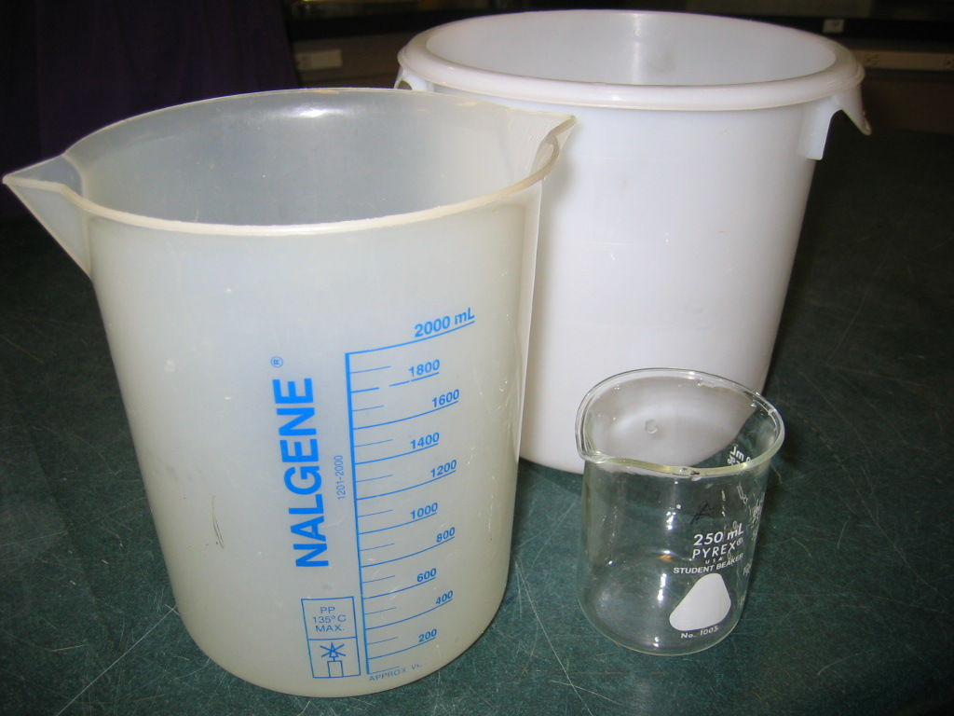
2 buckets--white is best—one filled with water (for dousing hot and burning material)
1 transparent beaker about 250 ml (about 1 cup)
2 narrow containers, graduated cylinders or the like, about 100 ml (about ½ cup)
2 cups to hold about 50 ml water each (about ¼ cup)
1 tray
2 tablets alka-seltzer per demo, 1 tablet crushed per demo
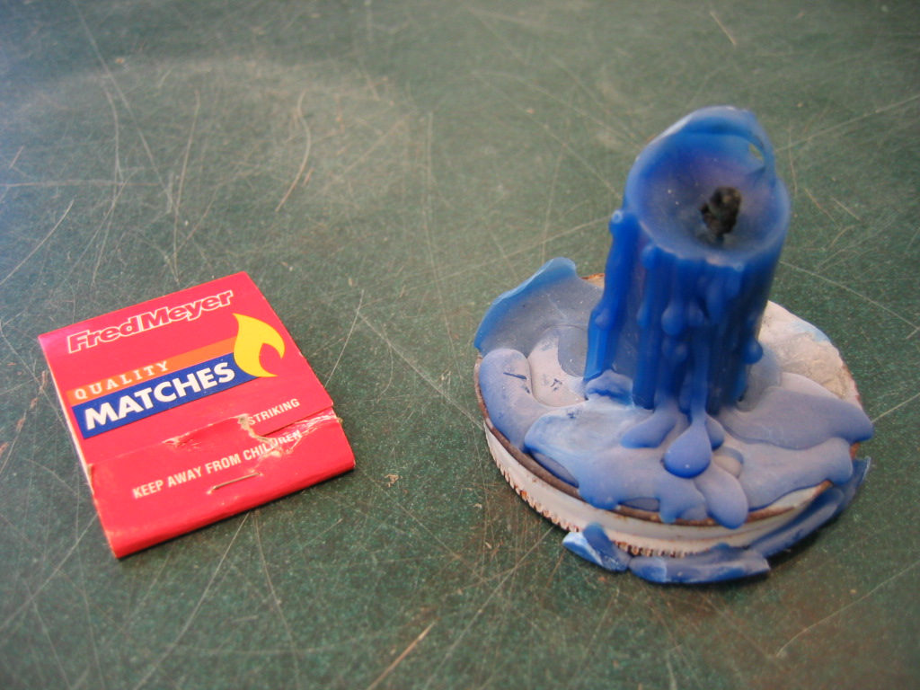
1 candle
matches or lighter

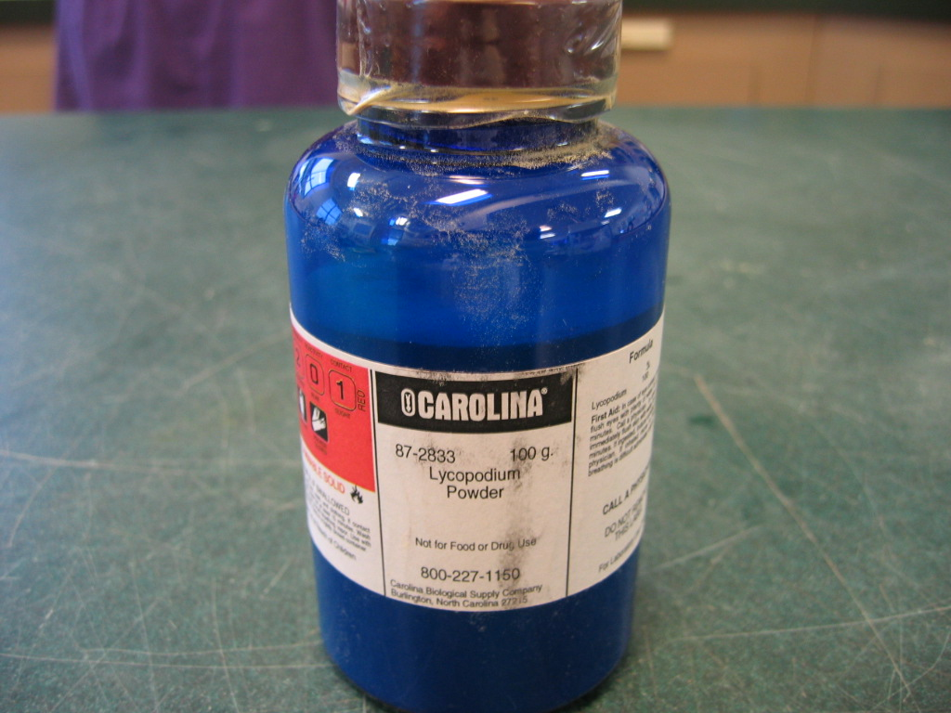
lycopodium spore powder (Flinn Scientific or Carolina Biological or ScienceKit.com. NOTE: This hazardous, flammable material will require direct payment from and shipping to a school or museum.)
teaspoon

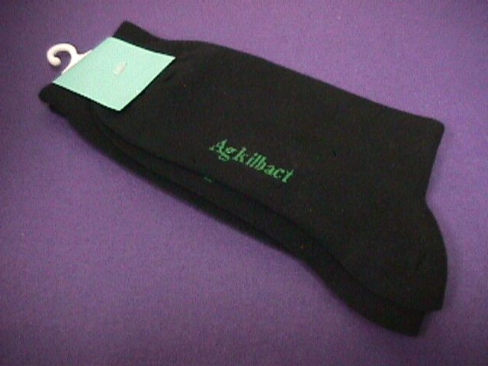
Nano silver anti-odor socks
(http://www.jrnanotech.com/socks.html or http://www.amazon.com/Wigwam-Ultimax-Silver-Lite-Socks/dp/B000GDS71K)

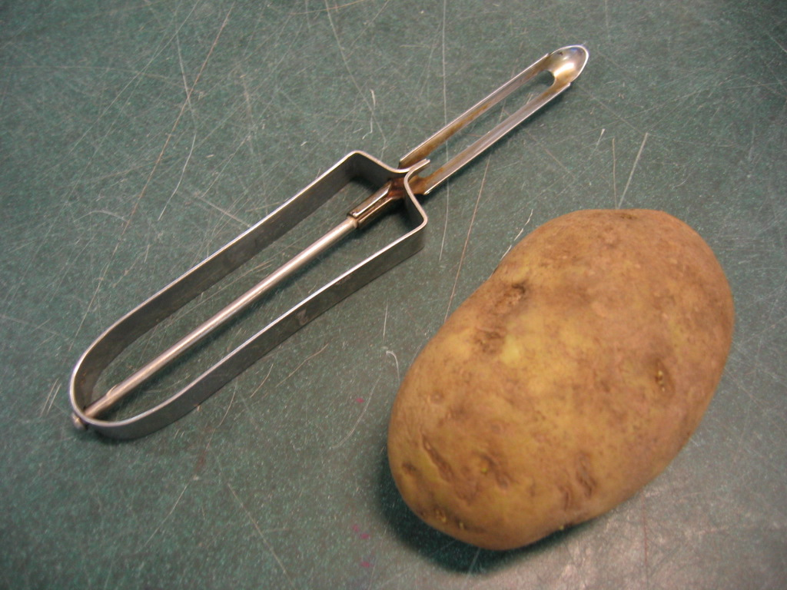
1 potato
potato peeler

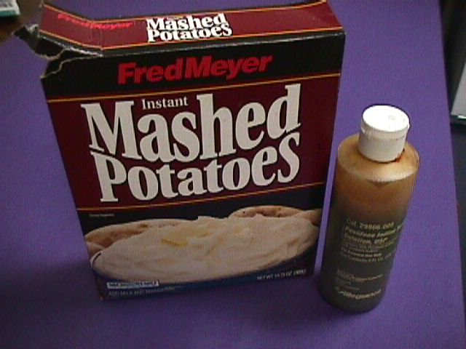
potato flakes
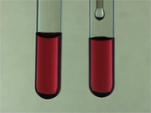
Iodine solution (medical supply)
A scoop or spoon for adding flakes to solution
Eyedropper for adding iodine

Sample of colloidal gold (http://mrsec.wisc.edu/Edetc/nanolab/gold/index.html)

35 wooden cubes. 8 cubes are completely painted silver. 27 cubes are painted so that they assemble into a 3x3x3 supercube with all exterior surfaces painted and no interior surfaces painted. Each cube has holes, for pegs and Brio nails.
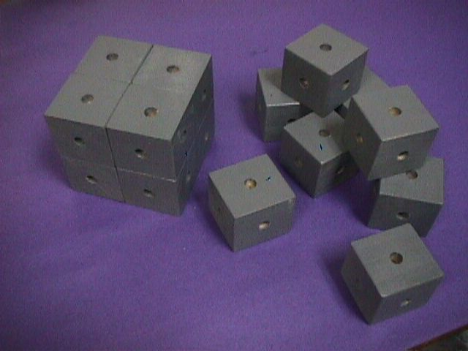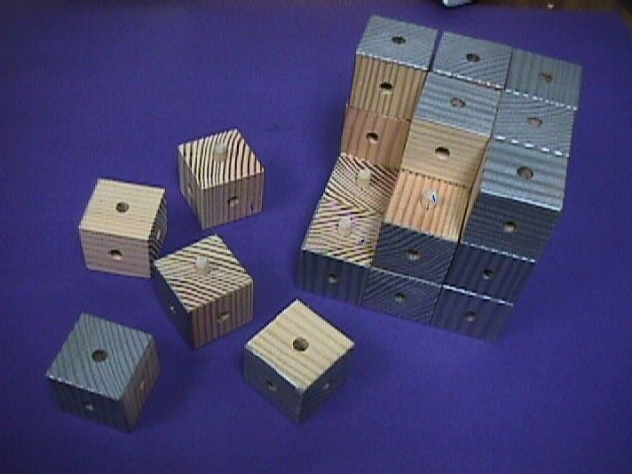

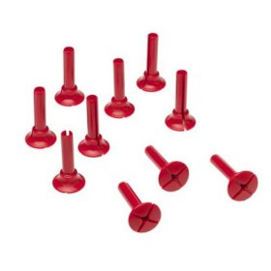
70 Brio nails
(http://www.amazon.com/Brio-Scanditoy-Corp-34621-Nails/dp/B00000IUW7).

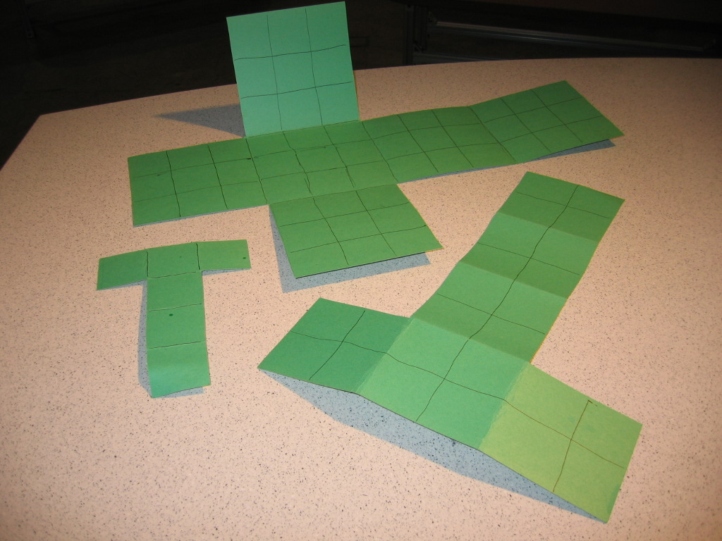
Paper cube cutouts to cover two 2-inch cubes, one 4 inch cube, and one 6 inch cube. Make the two small folding cubes in different colors, one matching the medium cube and one matching the large one. Raised lines are ideal.

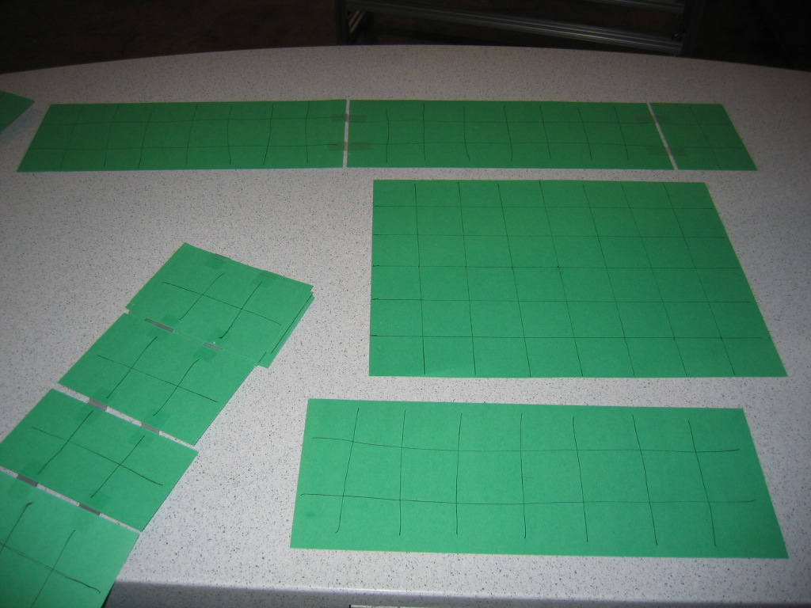
Paper displays of cube surface area, in matching colors

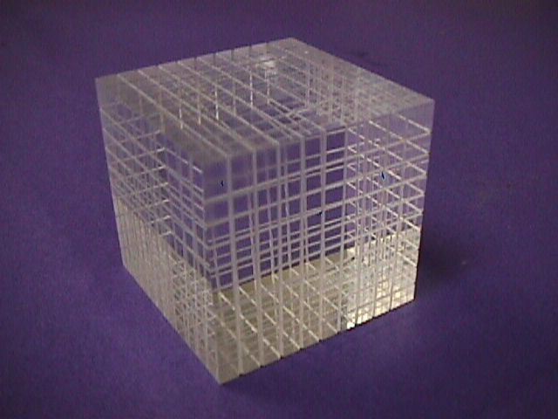
One acrylic cube, scored to show 1,000 divisions (http://www.enasco.com/product/TB17321T)

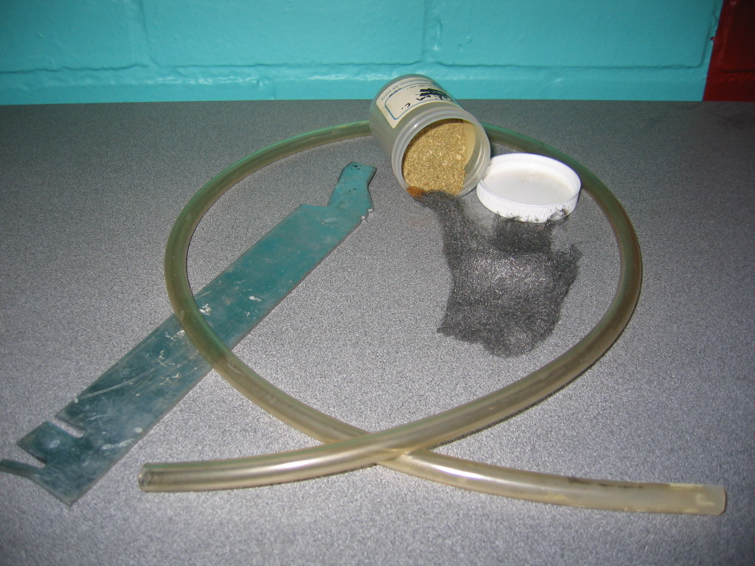
Aluminum bar
Steel wool
Tongs
Flexible tubing
Bulk lycopodium moss (such as at http://www.zooscape.com/cgi-bin/maitred/GreenCanyon/questp511740/r04)
Water

Food coloring

Set Up

Time: 10 minutes

Step 1:
Peel the potato.

Step 2:
Fill one bucket with 1 liter of water (about 1 quart).

Step 3:
Put water in cups for alka-seltzer demo. Add food coloring.

Step 4:
Retrieve flammables from safe flammable storage.

Step 5:
Crush one Alka-Seltzer tablet with your fingers.

Step 5:
Set out supplies on the table.

Program Delivery

Time: 15 minutes

Safety:

Lycopodium
- Lycopodium is extremely flammable. Take standard fire safety precautions.
- Take great care when demonstrating with it. Make sure the audience is a safe distance away.
- Practice the flame effect in advance so you know what to expect.
- Showing bulk lycopodium not burning is possible, but extremely tricky. It's best to just do the fireball.
- When you put a teaspoon of lycopodium powder in a tube, then blow the powder through a candle flame, you get a brief fireball, ranging in diameter from 40 to 150 cm (1 to 5 ft). There's a flash of light and heat, and a slightly sweet smell. It's often used by magicians because there's no ash. There are minor health/allergy hazards with lycopodium as well.
- Avoid inhaling the powder.
- Don't try to mail lycopodium, or take it on a plane. It's heavily restricted. If you need to do the demo somewhere you can't drive, you can either show the video from: http://www.angelo.edu/faculty/kboudrea/demos/lycopodium/lycopodium.htm or have your remote location order it for you.
- It's cheap, but very difficult to ship legally.

Iodine
- Iodine solution is not safe to ingest.
- If someone accidentally drinks iodine solution, call poison control immediately.
It also can irritate eyes and skin and stain clothing.

Procedure and Discussion:

Introduce nanotechnology

Scientists are making really small particles that act differently than bigger particles. How small? About one-billionth of a meter. (A meter is about one yard.)

And how small is one-billionth?
- One blink of your eye is about one-billionth of a year.
- A marble is about one-billionth the size of the Earth.

So, one-billionth of a meter is pretty darn small!
- Your fingernails grow 1 nanometer every second.
- A nanometer is about the length of 10 hydrogen atoms, laid end-to-end

A tiny nanoparticle acts differently because most of the atoms are on the outside.

Chemistry happens on the outside of solids, not on the inside. The more outside you have, the more things can react. The reason some nanotechnologies work well is because when you break a big object down into tiny parts, you get much much, much more surface area for the same amount of matter. Nanoparticles have about half their atoms on the outside, while larger particles have nearly all their atoms inside.

[Show the 8-block model.] For example, let’s say that these blocks are silver. Now, silver kills germs. Let’s pretend that these red pegs are germs. [Invite visitors to put germs in the holes, killing them.] How many germs did the silver block kill? [The 2x2x2 block holds 24 pegs—kills 24 germs.] Now let’s break the silver up into smaller particles. How many germs does it kill now?

[Use the paper cubes to count how many germs a block of "silver" kills.} Show how many squares are on each side of each cube, then show the cardboard that totals up the amount. The same amount of silver that killed 24 germs when it was one big block, now kills 48 germs when we break it apart.

[Show 3x3x3 model.] You can see how it works on this larger model. We painted the outside silver, and you can see there are 54 holes. But when you break it apart, you can see there are a lot more holes inside. These only become available for reaction when you break it down into smaller particles.

[Repeat cardboard counting for 3x3x3 block] It kills 54 germs when put together, but 162 when separated.

[Show the acrylic cube.] If you cut the piece of “silver” into 1,000 pieces, it would kill 10 times as many germs.

With nano-silver, you can use much less silver to kill the same number of germs. Six ounces (170 g) of nanoparticles kill as many germs as one ton (over 900,000 g) of microparticles.

[Let visitors see the nano socks.] These socks have nanoscale pieces of silver in them, which help kill germs that make feet smell. The military uses bandages with nano silver, to keep wounds from being infected.

There are silver food containers, too. FresherLonger brand containers from The Sharper Image use nanosilver “specially treated” plastic.

And finally, while nanosilver may be useful in some circumstances, overdose of silver internally leads to argyria (ar-JIE-ree-uh), a condition where you turn permanently blue.

Nanoscale affects color, too

[Show a dram of colloidal gold.] The red in stained glass comes from nanoscale gold particles. When light hits a large metal object, the electromagnetic light wave is mostly absorbed by the big stack of atoms. Nanoparticles of metal, however, have very little inside to absorb light with. The light wave bounces around the outsides of the small lump of atoms. Different-sized particles resonate with different wavelengths, reflecting different colors of light.

Potato starch and iodine demonstration
- Hold up the potato and iodine.
- Explain that iodine is red, but turns blue/purple with starch. (After repeat performances, show the dump bucket with reacted iodine as an example.)
- Remind the audience that potatoes are full of starch.
- Put 100 ml (1/2 cup) of water and 20 drops of iodine in a 250 ml (1 cup) beaker.
- Ask the audience to predict what will happen if you put the potato in iodine solution.
- Put the potato in the iodine.
- Observe that nothing happens.
- Ask the audience for explanations.
- Explain that almost all of the starch is inside the potato. (If you leave a potato in iodine for 10-15 minutes small blue dots appear on the surface of the potato. If this happens in the demo, you can cut the potato in half to expose new surface.)
- Pour about 2 Tbsp. (30 ml) of potato flakes into your hand.
- Explain that the flakes are potato as well, but they’re small particles instead of one big potato. Most of the starch in the flakes is on the outside; very little is trapped inside. The flakes have much more surface area for the same amount of potato.
- Put the flakes in the iodine and stir. Behold the color change.

Alka Seltzer

Have two narrow cylinders on a tray. Put one whole alka seltzer tab in one cylinders. Grind up another tablet and place it in the other cylinder. Have visitors pour equal amounts of colored water from the cups into the cylinders. Observe the difference in reaction from the large and the small forms.

Fire

- [Hold the aluminum bar in a candle flame.] Large chunks of aluminum don’t burn, but nanoparticles of aluminum are explosive. Tiny particles of aluminum oxide may be used in jet fuel someday.
- [Set some steel wool on fire. Use tongs to hold the steel wool, and have water handy.] Steel wool is also metal, but because it has more surface area, it will burn.
- [Show lycopodium.] Lycopodium is a moss that grows in forests around the world. It has exceptionally tiny spores.
- [Put some lycopodium spores in a tube, and safely blow them through the candle flame.] Because of their small size, the spores have lots of surface area and burn easily.

Conclusion

Thank the audience and invite questions. Bring up possible dangers with new behavior. Materials we thought were safe may become dangerous at the nano scale, and things we thought were toxic may be safe. One excellent example is the false positive toxicity test mentioned in New Scientist. Carbon nanotubes were tested to see if they're poisonous. At first, the test indicated they were very toxic. But after further inspection, it turned out that the nanotubes themselves had interfered with the chemical reaction at the heart of the test, creating an incorrect result.

Tips and Troubleshooting:

NOTICE: Feel free to alter this program to suit your needs. If you find something that works, share it with the rest of the community by posting your revisions on www.nisenet.org.
Potato flakes were chosen because they are cheap and easy to use, and extend the metaphor of tiny bits of the same material. Cornstarch also works to trigger the color change of iodine, but since it’s corn and not potato, the metaphor isn’t as good. Finely chopped potato has a similar effect, but is much more work to prepare.

To make your own iodine solution, dissolve 1 g of iodine and 2 g of potassium iodide in 100 mL of water.

Cornstarch can also substitute of lycopodium, but we don’t recommend it—the effect is much less impressive. Also, while lycopodium is dangerous, it can be lit with a candle. Cornstarch requires a much more robust--and hazardous--flame.

If your facility won’t let you perform lycopodium or other fire demonstrations, a decent alternative is the video on this website:
http://www.angelo.edu/faculty/kboudrea/demos/lycopodium/lycopodium.htm

For this activity, show only one color of gold nanoparticles. The fact that different sizes are different colors is amazing, but tangential to this demo’s story. In testing, we found that multiple colors distracted visitors from the topic of surface area.

If wanted, you could add a visual of foot fungus, to complement the silver sock. Showing the actual germ that silver kills may increase visitor engagement. One option would be the plush germ:
http://www.giantmicrobes.com/us/products/athletesfoot.html

If possible, make lots of copies of the single folding cubes, and let visitors take one home. Or make a handout which they can cut out and fold, like this one:
http://mathforum.org/alejandre/workshops/cube.net.html

Another possible extension involves ice cubes – ever notice how some restaurants serve ice cubes with holes in them? That’s to increase the surface area, and cool down the drink faster. This also makes the cubes melt faster, and the carbonation leaves the soda more quickly. You can demonstrate this with 2 or 3 glasses of ice and 2 or 3 cans of soda. If you pour soda into an empty glass, a glass with ice cubes, and a glass with crushed ice, you'll see markedly different amounts of bubbles. And the soda in the crushed ice glass will taste flat faster, because of extra surface area of the ice.

The Science Museum of Minnesota developed a way of making lumps of baking soda, which produce a similar effect. If you have plentiful volunteer staff time and need cheaper supplies, the baking soda pellets are a good alternative. Shari Hartshorn has the recipe: shartshorn@smm.org.

You can also add bromothymol blue to the water. You end up with a neutral green color giving a color indication of when the reaction is done.

The Science Museum of Minnesota also developed an activity that could expand this demonstration. Get two containers of equal volume, like plastic eggs or cigar boxes. Get two pieces of fabric of extremely different thickness. Cut the fabric into squares which stuff into the containers, filling the containers completely. You should end up with 2 pieces of fabric which ball up into the same volume, but which unfold into very different amounts of surface area.

Common Visitor Questions

Are nanoparticles safe?
We don’t know. Silver is an effective antibiotic, but it’s bad for marine life. Too much silver can give you argyria – turn your skin blue. And the tests we use to measure chemical safety don’t necessarily work with nanoparticles, because nanoparticles of something act differently, sometimes making our tests fail.
The EPA would regulate the silver food containers, but Sharper Image has stopped advertising the nanosilver. The EPA will only regulate claims of germ killing. http://www.smalltimes.com/display_article/281852/109/ARTCL/none/none/EPA-regulates-nano-product,-not-nano-industry/
http://www.nrdc.org/media/pressreleases/061127.asp

How much silver will turn me blue? Why do you turn blue?
It takes a lot of silver to turn a person blue, 4-40 grams (1/10th of an oz. to 1 ½ oz.). Ingest enough silver and it can kill you -- 50-500 mg/kg of body weight (1/10 oz. to 1 oz. per 100 lbs.) The silver accumulates in the skin, giving the skin a silver/bluish tint.
http://www.emedicine.com/derm/topic595.htm
How does silver kill germs? Do they stick to the silver like the pegs stick to the blocks?
Silver destroys the cell wall of germs, causing them to burst open and die. We use these pegs because they help us count how many more germs are killed with tiny things.

Doesn’t the silver make the socks expensive? Can I buy a bunch of socks, take out the silver, and get rich?
A pair of silver socks costs about $10. One of the key things about nanotechnology is that these particles are very small. It takes a very small amount of nanoparticles to have a big effect, because most of the atoms are on the outside, instead of trapped on the inside.

Going Further…
Additional information you can share with your visitors:
Lycopodium explosions are similar to flour mill and sugar plant explosions, where very fine dust in the air can burn much more easily and explosively than bulk masses of the same substance. http://www.cnn.com/2008/US/02/08/refinery.blast
Sharper Image's nano-silver food containers:
http://www.sharperimage.com/us/en/catalog/product/sku__ZN036

Clean Up

Time: 15 minutes
Between performances, empty the contents of the beaker into the third bucket.
Be certain to safely store all flammable equipment and supplies between presentations. Lycopodium is extremely reactive.

Universal Design

This program has been designed to be inclusive of visitors, including visitors of different ages, backgrounds, and different physical and cognitive abilities.

The following features of the program’s design make it accessible:

[ X ] 1. Repeat and reinforce main ideas and concepts
Several demonstrations illustrate the same main idea.

[ ] 2. Provide multiple entry points and multiple ways of engagement

[ X ] 3. Provide physical and sensory access to all aspects of the
program

Food coloring in the alka-seltzer demo greatly increases visibility.

Raised lines on the paper cubes make the activity more accessible for low vision visitors. Puffy paint or even white glue can create raised lines.
To give an inclusive presentation of this program:

Make sure to describe the different props with language that makes the props clear to visitors who have difficulty seeing.
Repeat the main idea of the demonstration every time it comes up.

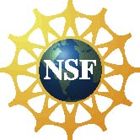

This project was supported by the
National Science Foundation under Grant No. ESI-0532536.

