Sizing Things Down

5

4

3

2

1

0

-1

-2

-3

-4

-5

-6

-7

-8

-9

-10

-11

-12

-13

-14

-15

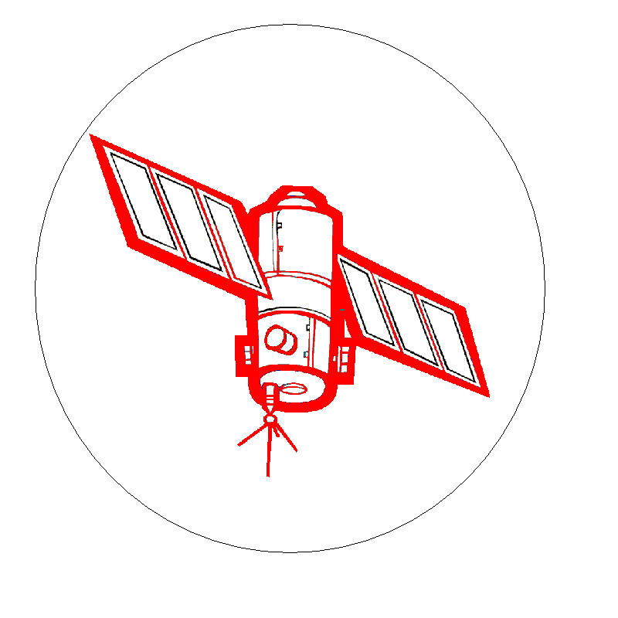
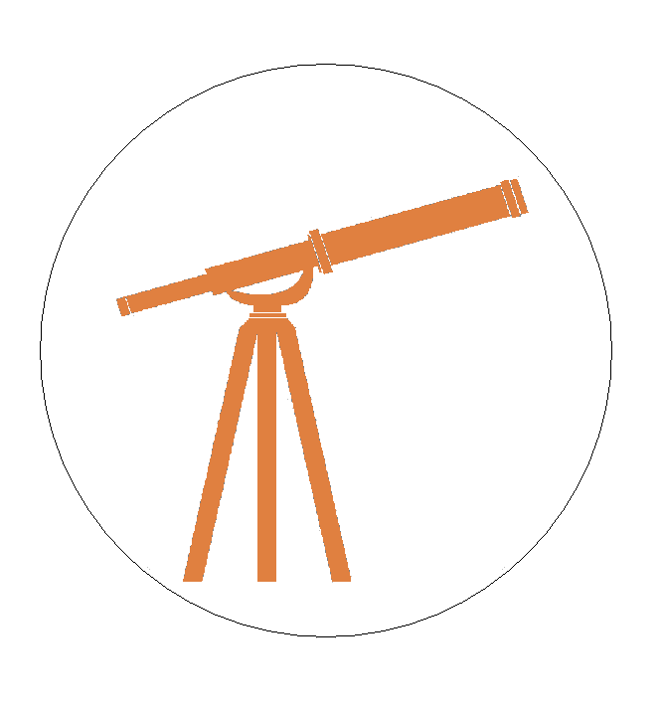
Bigger
You have 5 cards.

Add something bigger or smaller to a column.

You can’t go in between.
You can’t play the same number.

Whoever gets rid of all their cards wins!

Big

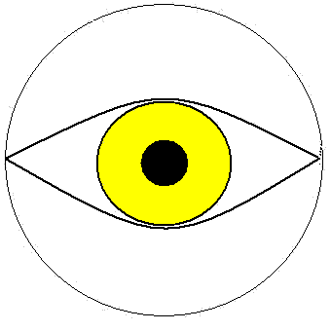
Medium

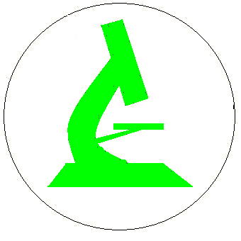
Small

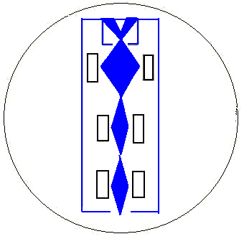
Smaller
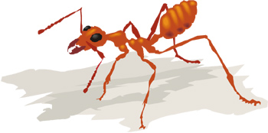
Sun

Tree

Pirate

Ant

-3
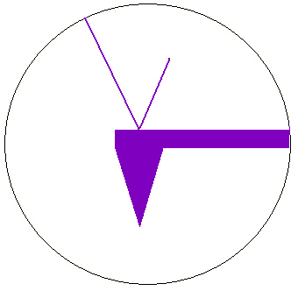

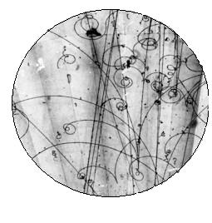
Smallest

5

4

3

2

1

0

-1

-2

-3

-4

-5

-6

-7

-8

-9

-10

-11

-12

-13

-14

-15
Orders of Magnitude
10²⁴ | yottameter (Ym) |  | Satellites
10²¹ | zettameter (Zm) |  | Satellites
10¹⁸ | exameter (Em) |  | Satellites
10¹⁵ | petameter (Pm) |  | Satellites
10¹² | terameter (Tm) |  | Satellites
10⁹ | gigameter (Gm) |  | Optical telescope
10⁶ | megameter (Mm) |  | Optical telescope
10³ | kilometer (km) |  | Your eye
10⁰ | meter (m) |  | Your eye
10⁻³ | millimeter (mm) |  | Optical microscope
10⁻⁶ | micrometer (μm) |  | Optical microscope
10⁻⁹ | nanometer (nm) |  | Scanning Electron Microscope (SEM)
10⁻¹² | picometer (pm) |  | Atomic Force Microscope (AFM)
10⁻¹⁵ | femtometer (fm) |  | Particle collider  


