

Extracting DNA

Break down the cell membrane  - Squirt about a teaspoon of split pea mixture into a vial.  - Squeeze about 10 drops of buffer solution into the vial.  - Swirl or rock the vial to combine the buffer solution and pea mixture. | 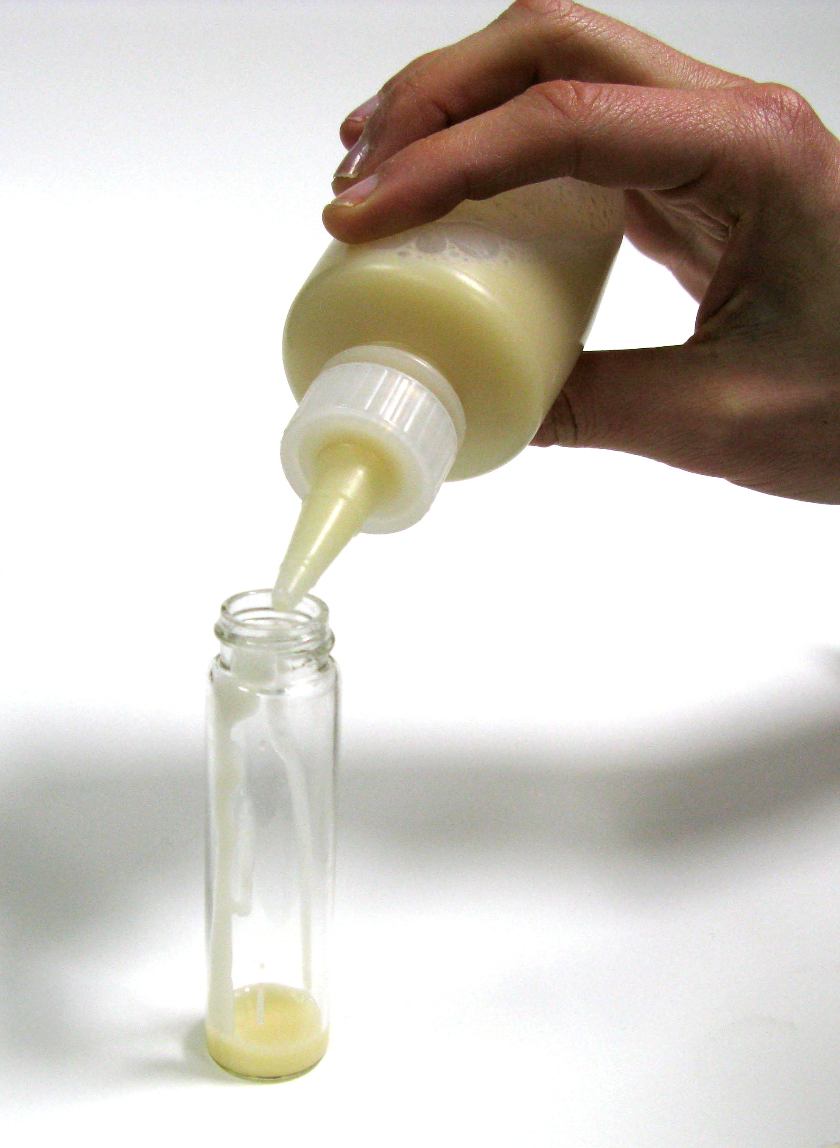 | 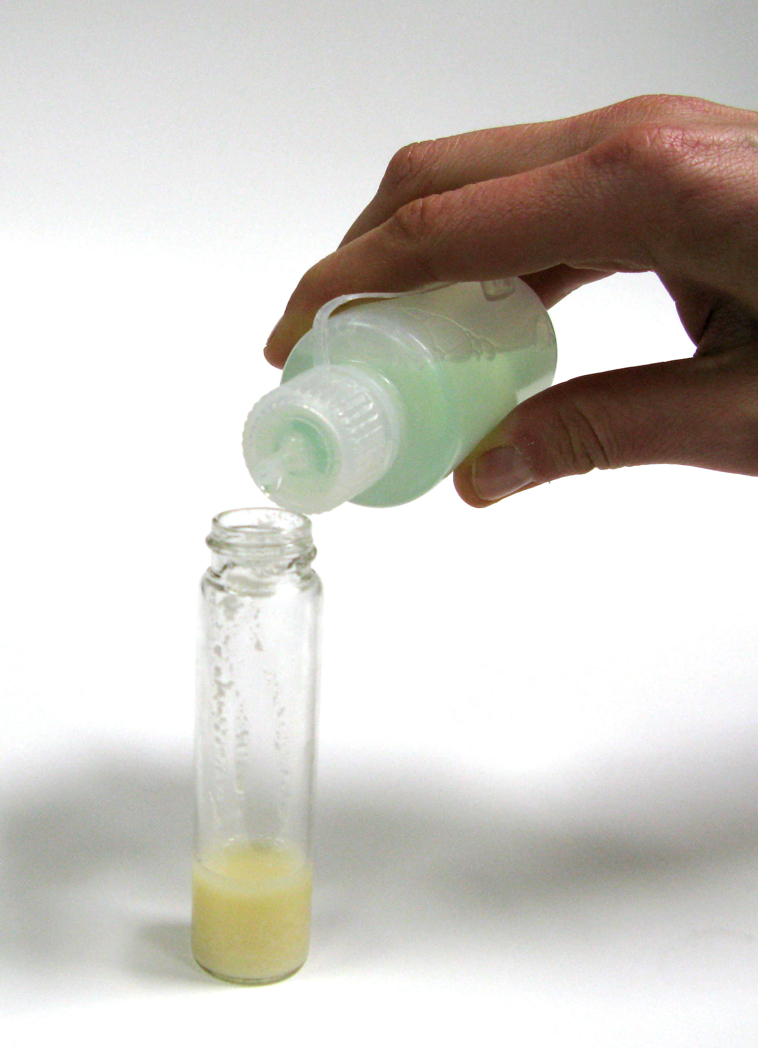
Precipitate the DNA  - Tilt the vial and squirt about a half teaspoon of alcohol down the inside.  - The alcohol will form a clear layer on top of the pea mixture.  - DNA will gradually rise out of the pea layer into the alcohol layer. It’s whitish and looks like mucus.  - Very gently swirl or rock the tube to help the DNA rise and clump together. | 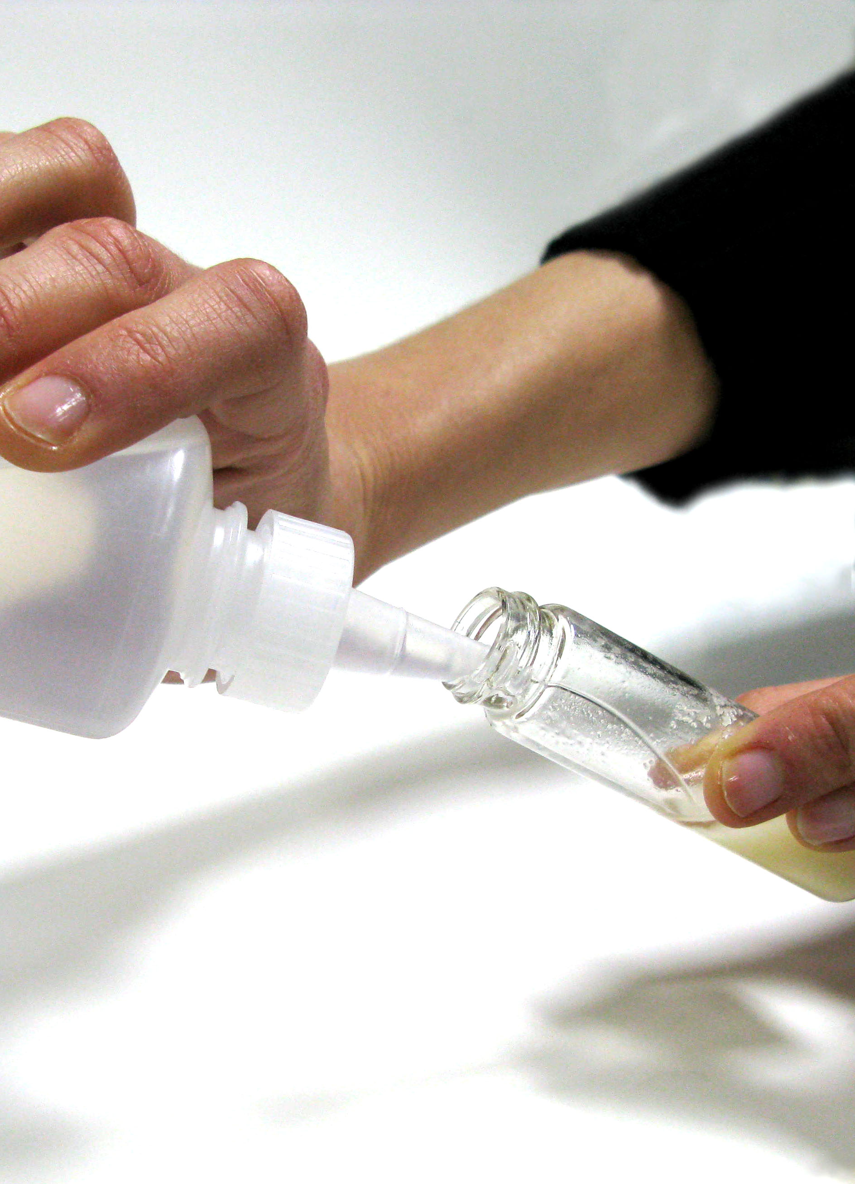 | 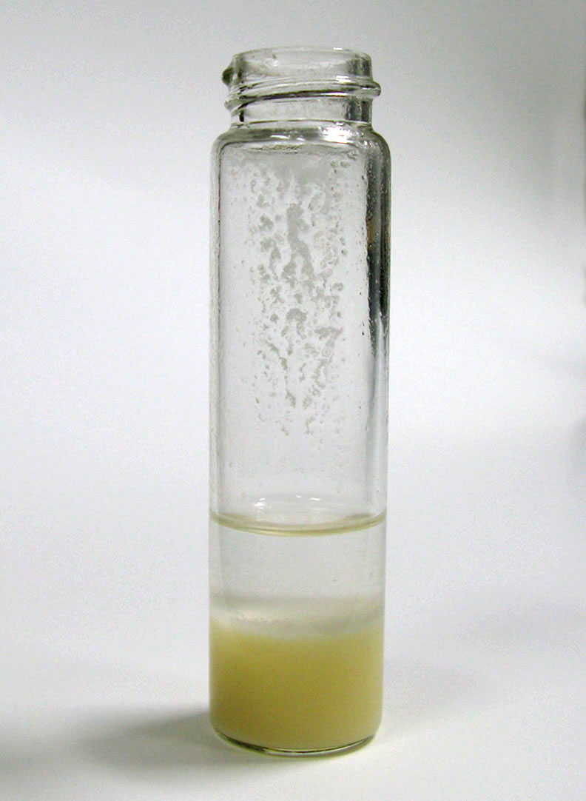
Make a necklace  - Carefully pour the top layer (alcohol and DNA) from the vial into an Eppendorf tube.  - Slip a length of yarn over the connector between the cap and tube.  - Snap the cap shut.  - Tie the yarn around your neck or wrist. Be careful not to make it too tight! | 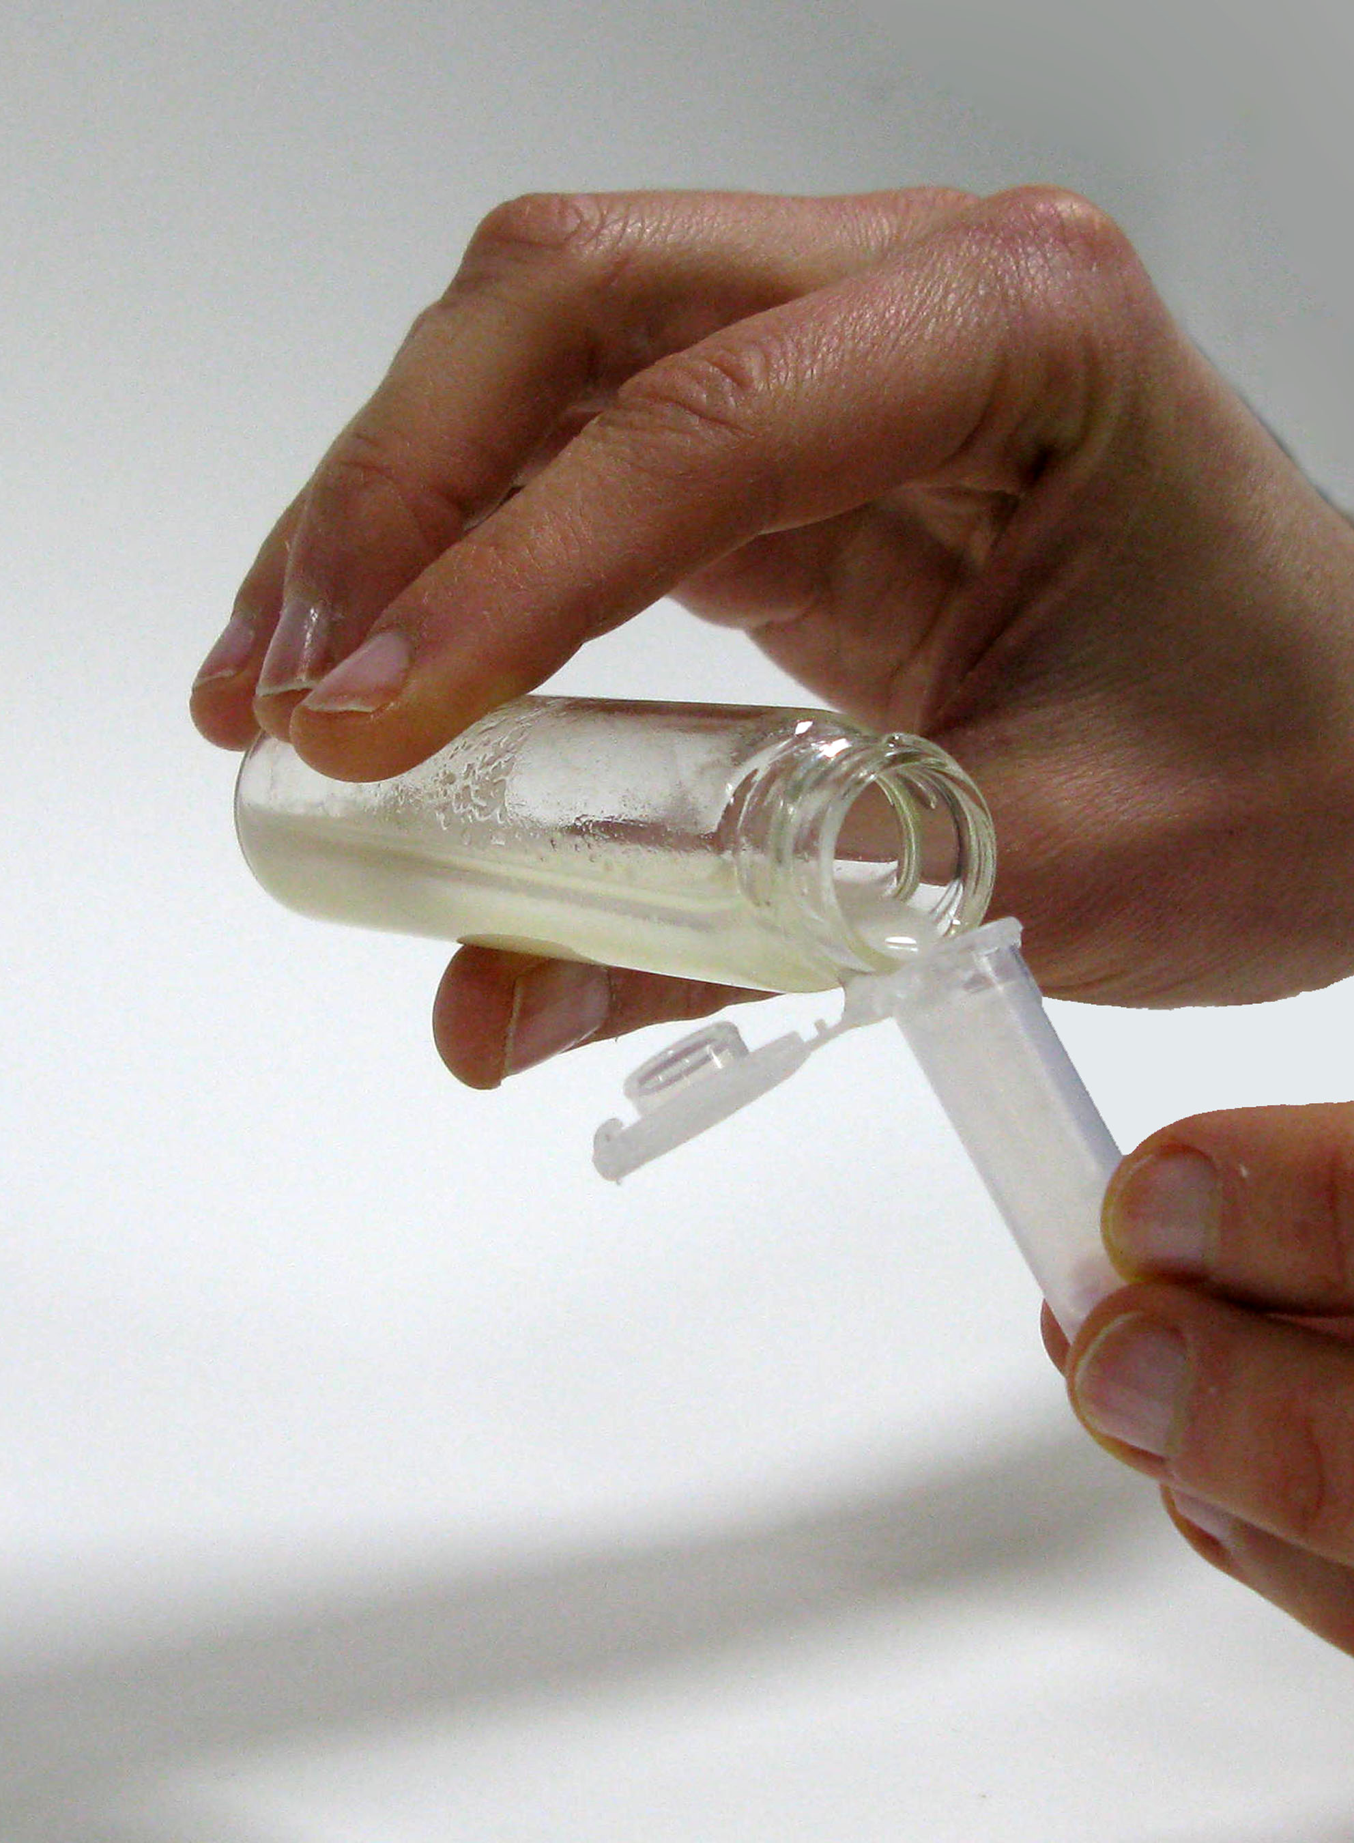 | 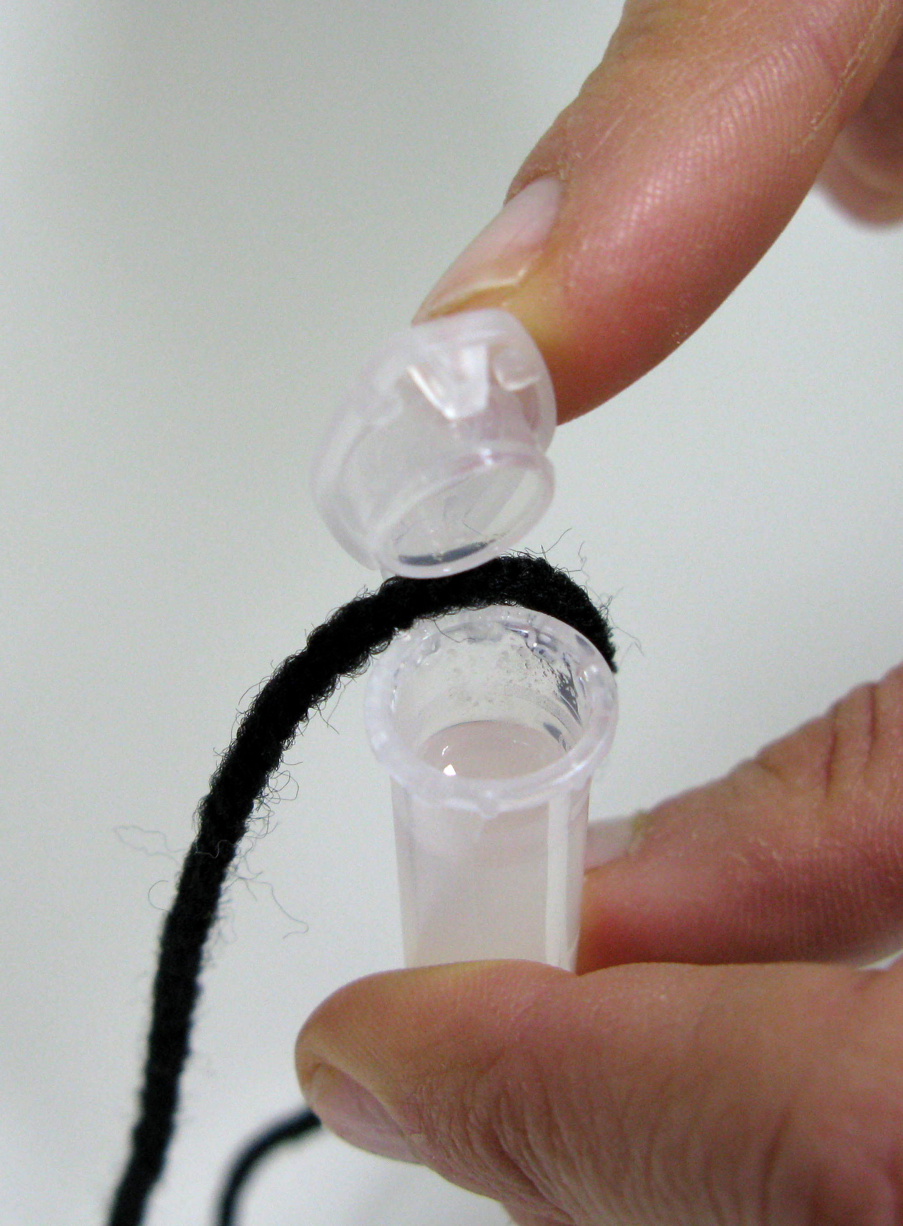

Extracting DNA

Materials
- Pea mixture in labeled squirt bottles
- Buffer solution in labeled dropper bottles
- Alcohol in labeled squirt bottles
- Glass vials
- Eppendorf tubes
- Yarn
- Scissors
- Safety glasses
- Paper towels

Credits and rights
This DNA extraction protocol was adapted from:
- “How to Extract DNA from Anything Living,” developed by the Genetic Science Learning Center at the University of Utah. The original activity is available at: learn.genetics.utah.edu/content/labs/extraction/howto/index.html
- “Delicious DNA,” developed by the Pfizer Foundation Biochemistry Discovery Lab at the New York Hall of Science. The original activity is available at: www.nyscience.org/media/file/Pfizer_Activity_Guide.pdf

 | This project was supported by the National Science Foundation under Grant No. ESI-0532536.  Any opinions, findings, and conclusions or recommendations expressed in this program are those of the author and do not necessarily reflect the views of the Foundation.

Copyright 2008, Sciencenter, Ithaca, NY.

