

Exploring Size—Measure Yourself
Try this!  - Mark your height on the wall chart.  - How tall are you in nanometers?  - Are you super tall? Or is a nanometer super small?  Then try this!  - Trace your hand on a worksheet.  - How many nanometers long is it?  - Is your hand really big? Or is a nanometer really tiny? | Measure yourself in nanometers!    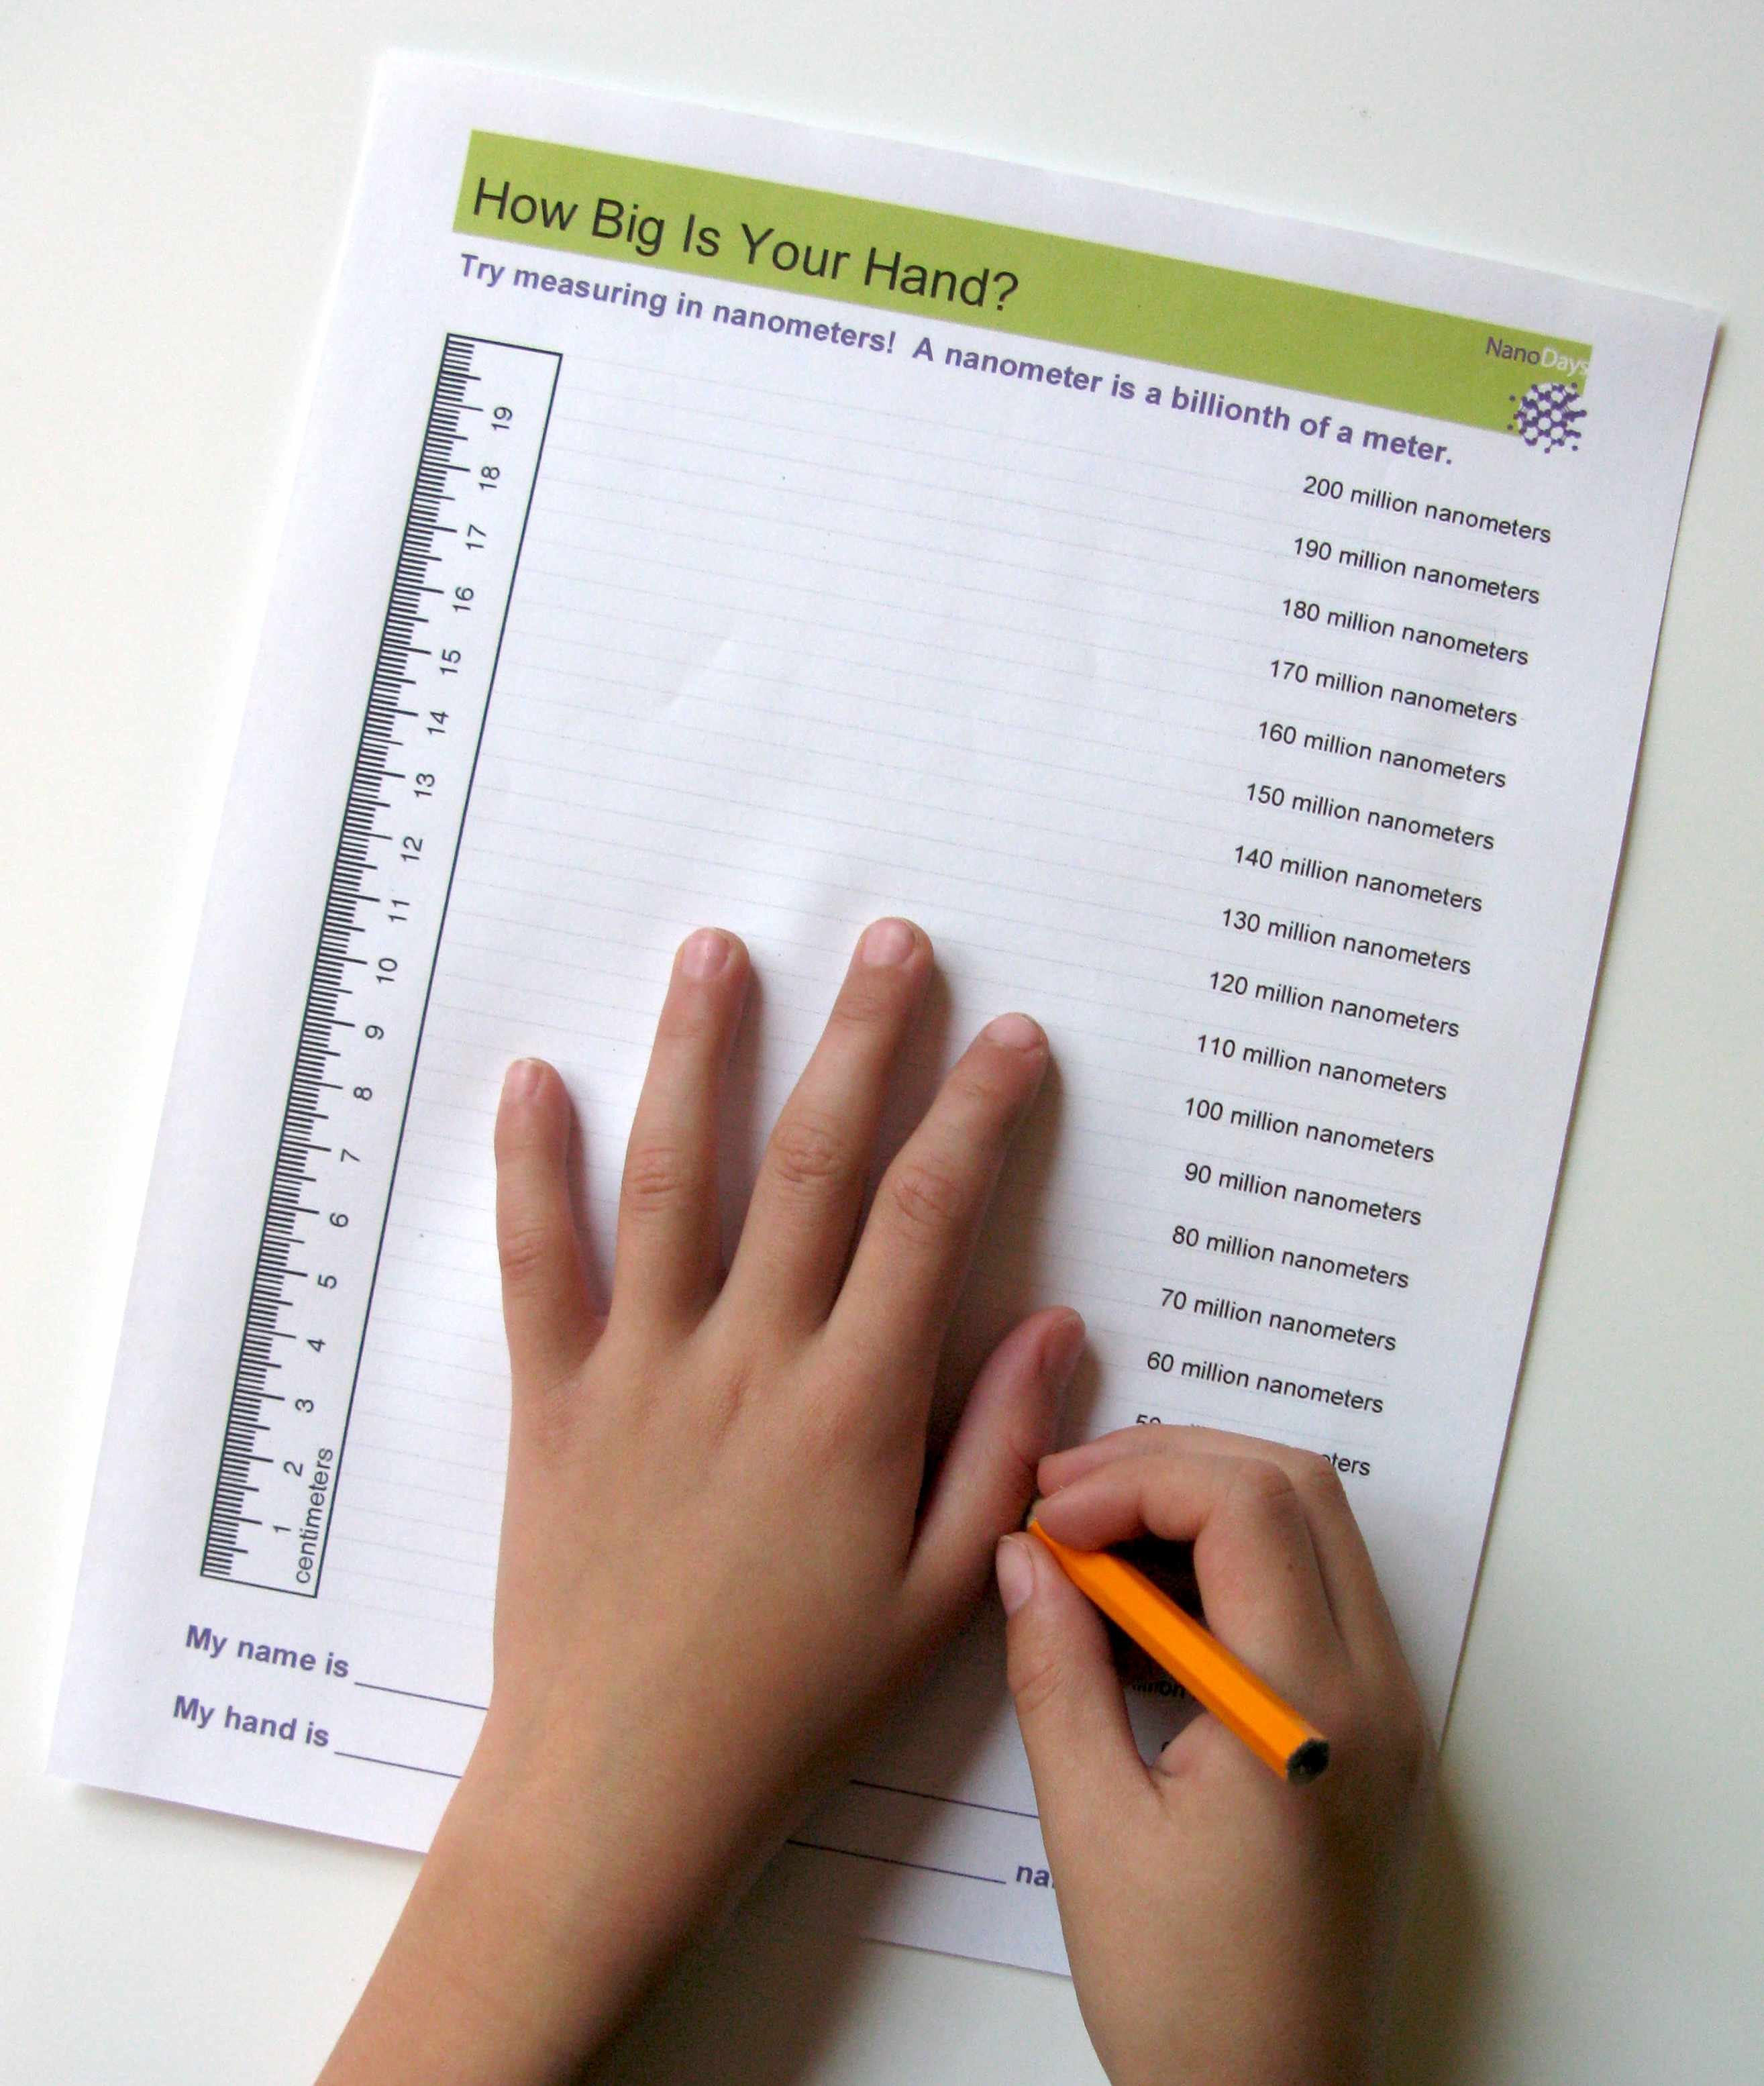
What’s going on?
One meter is a billion nanometers. (A meter is a little longer than a yard.) So a kid who is a little over three feet tall measures one billion nanometers! Saying that you’re a billion nanometers tall sounds pretty impressive, but it doesn’t mean that you’re super tall—it means that a nanometer is super small.
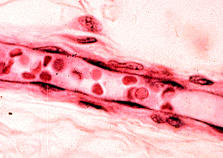  Image of a human blood vessel | Here are some other ways to think about how small a nanometer is:  - The ridges in your fingerprints are around 250,000 nanometers wide.  - A strand of your hair is around 75,000 nanometers wide.  - Your fingernails grow one nanometer every second.

How is this nano?
A nanometer is a billionth of a meter. That’s really, really tiny! Nanometers are used to measure things that are too small to see. It takes a lot of nanometers to measure something relatively big, like your body.  Nanoscale science focuses on things that are measured in nanometers, anything between 1-100 nanometers in size. Scientists use special tools and equipment to work with nanometer-sized things. Regular tools like rulers are too big!  In the field of nanotechnology, scientists and engineers make tiny devices, new materials, faster computer chips, new medicines to treat diseases like cancer, and thin, flexible solar panels to capture energy from the sun. | 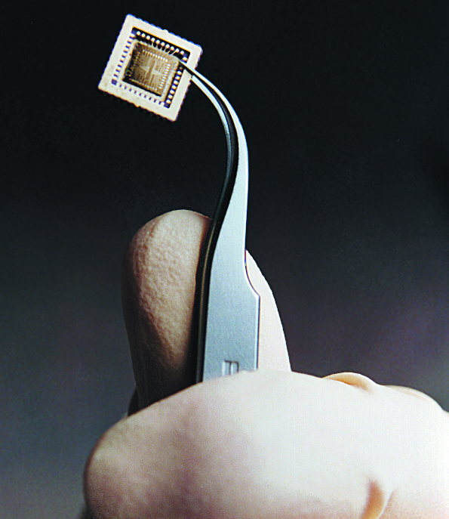  Computer chip

Learning objectives
- A nanometer is a billionth of a meter.

Materials
- “How Tall Are You?” height chart
- “How Big is Your Hand?” work sheet
- Masking tape

The height chart can be downloaded from the www.nisenet.org/catalog/. The height chart requires a large format printer.

Notes to the presenter
Before beginning this activity, adhere the height chart to a wall. Make sure you choose a location where visitors can easily stand in front of it to measure themselves. The bottom of the chart should touch the floor.

If you print the height chart or worksheet from the digital file, be sure you don’t allow page scaling.

Related educational resources
The NISE Network online catalog (www.nisenet.org/catalog) contains additional resources to introduce visitors to the fundamentals of nanoscale science and technology:
- Public programs include Nanotechnology: Small Science, Big Deal!, Horton Hears a Who, and Wheel of the Future.
- NanoDays activities include Exploring Size – Powers of Ten Game, Exploring Size – Memory Game, Exploring Size – StretchAbility, and Exploring Size – Scented Balloons
- Media include the Intro to Nanotechnology video, the Mr. O video series, and the Nano and Me video series.
- Exhibits include the Nano mini-exhibition and At the Nanoscale.

Credits and rights
This activity is a revised version of the Exploring Size—Measure Yourself NanoDays activity developed by the Sciencenter for the NISE Net.
The original version was adapted from “How Many Nanometers Tall Are You?” from It’s a Nano World, a traveling exhibition funded by the National Science Foundation and developed by the Sciencenter in Ithaca, NY, the Nanobiotechnology Center at Cornell University, and Painted Universe Inc.
Photo of human blood vessel courtesy of Roger Wagner, University of Delaware.

 | This project was supported by the National Science Foundation under Award No. 0940143. Any opinions, findings, and conclusions or recommendations expressed in this program are those of the author and do not necessarily reflect the views of the Foundation.
Copyright 2013, Sciencenter, Ithaca, NY. Published under a Creative Commons Attribution-Noncommercial-ShareAlike license: http://creativecommons.org/licenses/by-nc-sa/3.0.

