

Exploring Tools—Special Microscopes

Try this!  - Take a magnet. You’re going to pretend it’s a scanning probe microscope, a tool that “feels” a surface to find out what it’s like.  - Remove the “probe strip” from the side of the magnet. | 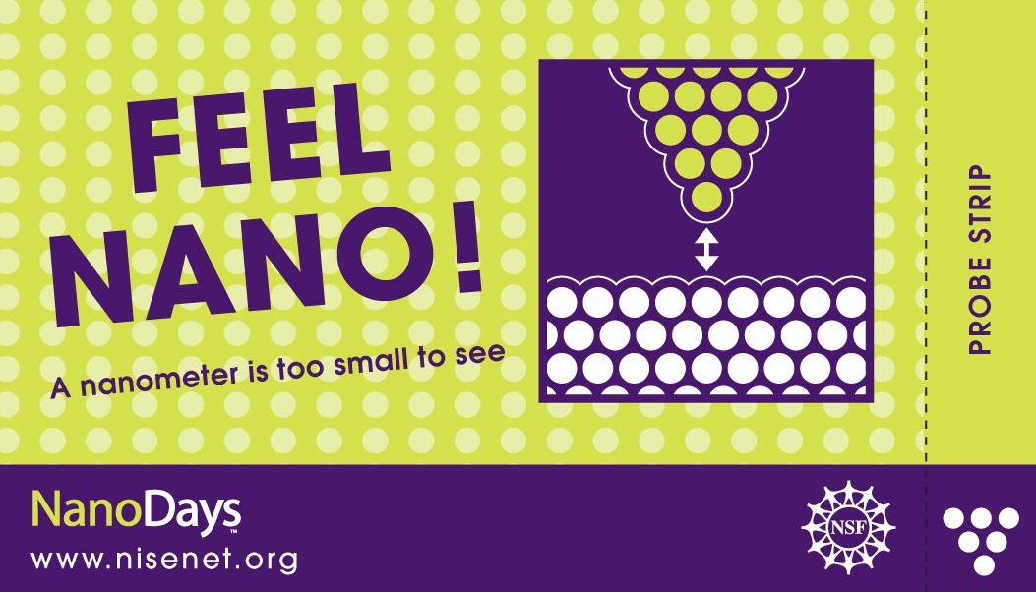
- Turn the magnet over so it’s black side up. This is the surface you’re going to feel.  - Hold the probe strip the way it’s shown in the picture, and pull it slowly across the magnet from left to right. What do you feel?  - Now pull the strip across the magnet from top to bottom, again holding it the way it’s shown in the picture. Does it feel different? |   Left to right | 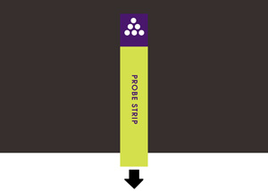  Top to bottom
What’s going on?
The magnet is a model for how a special tool, called a scanning probe microscope (SPM), works. It lets you “feel” something that you can’t see: in this case, a magnetic field. The north and south poles run in alternating bands across the magnet.
You feel the strip bump across the surface when it’s pulled across the bands, because it’s alternately attracted to and repelled by the poles it encounters. When the strip is pulled parallel to the bands, you don’t feel the bumps because it’s always attracted to the surface.
A scanning probe microscope similarly works by “feeling” something you can’t see with your eyes. But in addition to detecting magnetic fields, an SPM can also detect lots of other kinds of things about a surface: nanometer-sized hills and valleys, atoms, conductivity, friction, stiffness, and more.
SPMs use a super-sharp tip to move across a nanoscale surface. By dragging this tip around on different surfaces and recording the bumps and grooves, scientists are able to piece together what a surface looks like at the atomic level.  These tools can even detect and make images of individual atoms, which are much too small to be seen with a regular microscope.  How is this nano? | 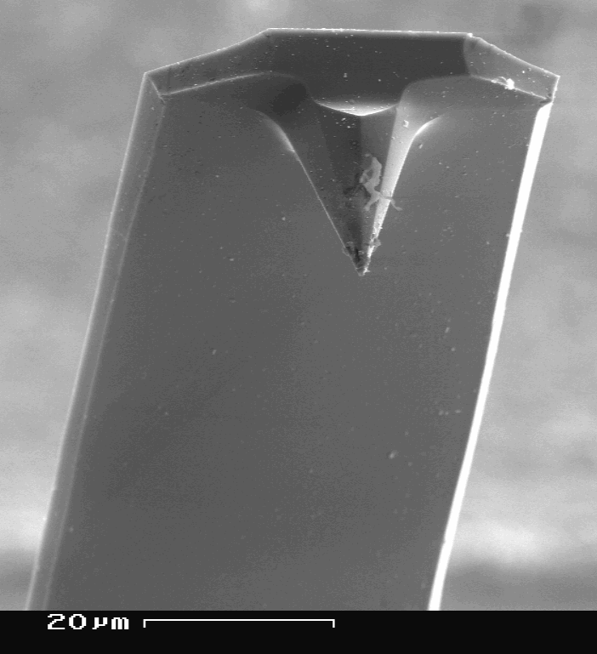  Tip of an SPM, magnified 1000x
Scientists use special tools and equipment to work on the nanoscale. Scanning probe microscopes allow researchers to detect and make images of individual atoms and other things that are too small to see.

The invention of scanning probe microscopy was a great breakthrough in the field of nanotechnology. Once scientists could make pictures of individual atoms and the world of the nanometer, they could begin to manipulate and study things at this super-tiny scale. (A nanometer is a billionth of a meter.) Without the SPM, nanotechnology wouldn’t be where it is today!

Learning objective
Scientists use special tools and equipment to work on the nanoscale.

Materials
- Small magnets
- Large demonstration magnet (optional)
- “Magnetic Field” sheet

The NanoDays “Feel Nano” magnets are available from Off the Wall Magnetics (www.4thefridge.com). The artwork is on file—just ask for the nano magnets. NISE Network partners may use the artwork free of charge as long as the magnets are used for educational, non-commercial purposes.

(You can do this activity with almost any flexible magnet, but the magnetic field may be oriented differently than the ones created for this activity. If you try different magnets, experiment with them ahead of time—you may need to cut the “probe strip” from the long end of the magnet rather than the short end.)

Notes to the presenter
In order to feel the “bumps” using the NanoDays magnets, visitors need to hold the probe strip and magnet as shown in the instructions and move the strip slowly across the surface. The large magnet can be used to demonstrate how to move the probe strip over the magnet.

There are two versions of the magnetic field illustration. You can show visitors the single illustration of how the magnetic field is arranged in this magnet, or you can show them the illustration with two different possibilities and ask them to figure out which one best represents the magnetic field.
Extensions
You can engage visitors in other models of how SPMs work:
- Ask visitors to close their eyes, make a fist, and run a fingertip over their knuckles. Their finger is a model for how an SPM tip moves over a surface, going up and down as it encounters nanometer-sized hills and valleys.
- Ask several visitors to line up shoulder to shoulder. Close your eyes, and run your hand along the tops of their heads. Your hand is a model for an SPM tip.
Related educational resources
The NISE Network online catalog (www.nisenet.org/catalog) contains additional resources to introduce visitors to nanotechnology and the tools researchers use to study and make things that are too small to see:
- Public programs include Attack of the Nanoscientist, Cutting it Down to Nano, Intro to Nano, Ready, Set, Self-Assemble, and Tiny Particles, Big Trouble!
- NanoDays activities include Exploring Size—Powers of Ten Game and Exploring Tools—Mitten Challenge.
- Media include the video What Happens in a Nano Lab?
- Exhibits include Creating Nanomaterials and NanoLab.

SPM Background Information

What are scanning probe microscopes?
Scanning probe microscopes (SPMs) are a family of tools used to make images of nanoscale surfaces and structures, including atoms. They use a physical probe to scan back and forth over the surface of a sample. During this scanning process, data are gathered that are used to generate a three-dimensional image of the surface. In addition to visualizing nanoscale structures, some kinds of SPMs can be used to manipulate individual atoms and move them around.

SPMs are different from other kinds of microscopes because the user doesn’t “see” the surface directly. Instead, the tool “feels” the surface and creates an image to represent it.
How do they work?  SPMs are very powerful microscopes, sometimes with a resolution of less than a nanometer. (A nanometer is a billionth of a meter.)  An atomic force microscope, or AFM, is a specific kind of SPM. An AFM has a probe tip mounted on the end of a cantilever. The tip can be as sharp as a single atom. It can be moved precisely and accurately back and forth across the surface, even atom by atom.  When the tip is near the sample surface, the cantilever is deflected by a force. AFMs can measure deflections caused by many kinds of forces, including mechanical contact, electrostatic forces, magnetic forces, chemical bonding, van der Waals forces, and capillary forces.  The distance of the deflection is measured by a laser that is reflected off the top of the cantilever and into an array of photodiodes. AFMs can detect differences in height that are a fraction of a nanometer! | 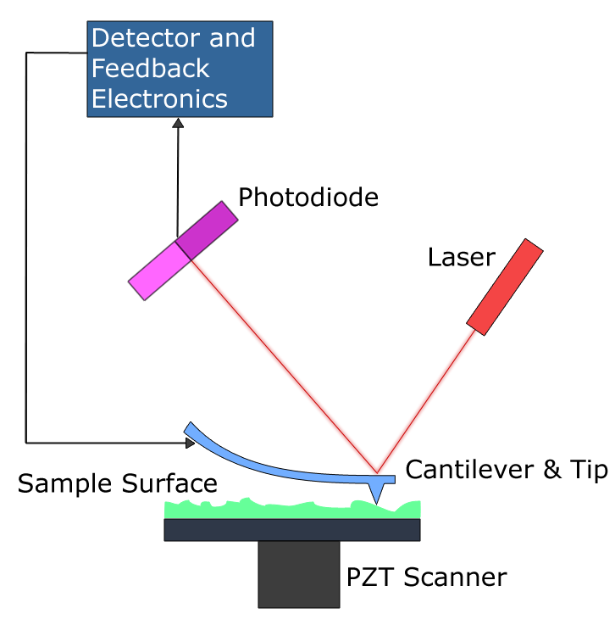  Atomic force microscope
Scientists use AFMs in a number of different ways, depending on the information they’re trying to gather from a surface. An AFM can operate in many modes. The two primary modes are contact mode and tapping mode. In contact mode, the force between the tip and the surface is kept constant. This allows a scientist to quickly image a surface. In tapping mode, the cantilever oscillates, intermittently touching the surface. Tapping mode is especially useful when a scientist is imaging a soft surface.

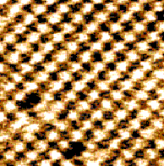  AFM image  of salt (NaCl) | The tip of an AFM is moved across the sample many times. A computer combines the data to create an image.  AFM images are inherently black and white. They are often colorized, with different colors representing differences in height along the surface.

Credits and rights
This activity was adapted from “Quick Reference Activity Guide: Refrigerator Magnet,” developed by the National Science Foundation-supported Materials Research Science and Engineering Center (MRSEC) on Nanostructured Materials and Interfaces at the University of Wisconsin-Madison. The original activity is available at mrsec.wisc.edu/Edetc/supplies/ActivityGuides/Refrig_Magnet_Guide_2005.pdf

Image of SPM tip by SecretDisc. Illustration of AFM by Askewmind. Image of sodium chloride courtesy of Ernst Meyer, University of Basel. All from Wikimedia Commons.

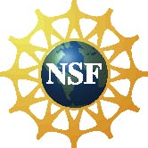 | This project was supported by the National Science Foundation under Award No. ESI-0532536. Any opinions, findings, and conclusions or recommendations expressed in this program are those of the author and do not necessarily reflect the views of the Foundation.

Copyright 2010, Sciencenter, Ithaca, NY. Published under a Creative Commons Attribution-Noncommercial-ShareAlike license: http://creativecommons.org/licenses/by-nc-sa/3.0/us/

