

Magnetic Field
The magnetic field in the NanoDays magnet is arranged with north and south poles in horizontal bands.

When you pull the strip from top to bottom—across the bands of poles—it’s alternately attracted to and repelled by the poles it encounters. That causes the bumps you feel. When you pull the strip parallel to the bands, you don’t feel the bumps because it’s always attracted to the surface.

(Magnets have north and south poles. Like poles push away from each other, while unlike poles pull toward each other.)

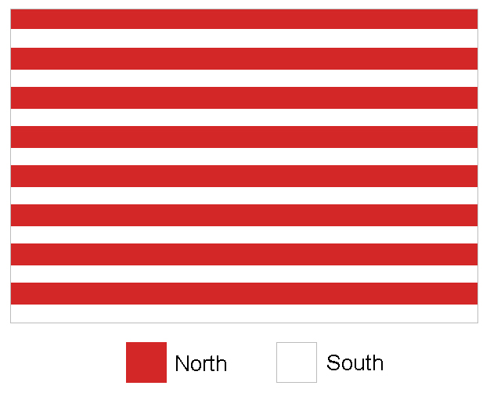

Magnetic Field
Can you figure out how the magnetic field is arranged in the NanoDays magnet?
- Hint: When you pull the strip across the bands of poles, it’s alternately attracted to and repelled by the poles it encounters. That causes the bumps you feel. When you pull the strip parallel to the bands, you don’t feel the bumps because it’s always attracted to the surface.

(Remember that magnets have north and south poles. Like poles push away from each other, while unlike poles pull toward each other.)

Are the north and south poles arranged in alternating vertical bands, or alternating horizontal bands?

