Ready, Set, Self-Assemble


Organization: Children's Museum of Houston

Contact person: Krystal Willeby

Contact information: 713-535-7232 or
kwilleby@cmhouston.org

General Description

Facilitated Activity
“Ready, Set, Self-Assemble” is a full-body program which introduces visitors to the concept of self-assembly in a fun and energetic way. Through the use of three full-body, interactive games, visitors explore the phenomenon of self-assembly and its possible uses in nanotechnology.

Program Objectives

Big idea: The natural process of self-assembly can be used to manufacture large quantities of very, very small things.

Learning goals:
- Self-assembly is a process by which molecules and cells form themselves into specific, ordered structures under the right conditions.
- Self-assembly can be used by scientists to create objects on the nano-scale.
- Nano is very, very small.
- Nanoscientists learn about and make things that are too small to see.
- Researchers in the field of nanotechnology are studying self-assembly in order to create new materials and technologies.

NISE Network Main Messages:
[ x ] 1. Nanoscale effects occur in many places. Some are natural, everyday occurrences; others are the result of cutting-edge research.
[ ] 2. Many materials exhibit startling properties at the nanoscale.
[ x ] 3. Nanotechnology means working at small size scales, manipulating materials to exhibit new properties.
[ ] 4. Nanoscale research is a people story.
[ ] 5. No one knows what nanoscale research may discover, or how it may be applied.
[ ] 6. How will nano affect you?

Program/Demo Title

Table of Contents
General Description 1
Program Objectives 1
NISE Network Main Messages: 1
Table of Contents 2
Time Required 3
Background Information 3
Materials 5
Set Up 6
Step 1: 6
Program Delivery 6
Safety: 6
Procedure and Discussion: 6
Tips and Troubleshooting: 11
Common Visitor Questions 11
Going Further… 12
Clean Up 13
Universal Design 13

Time Required

Set-up Program Clean Up
5 minutes 20 minutes 5 minutes

Background Information

Definition of terms
Nano is the scientific term meaning one-billionth (1/1,000,000,000). It comes from a Greek word meaning “dwarf.”
A nanometer is one one-billionth of a meter. One inch equals 25.4 million nanometers. A sheet of paper is about 100,000 nanometers thick. A human hair measures roughly 50,000 to 100,000 nanometers across. Your fingernails grow one nanometer every second.
(Other units can also be divided by one billion. A single blink of an eye is about one-billionth of a year. An eyeblink is to a year what a nanometer is to a yardstick.)
Nanoscale refers to measurements of 1 – 100 nanometers. A virus is about 70 nm long. A cell membrane is about 9 nm thick. Ten hydrogen atoms are about 1 nm.
At the nanoscale, many common materials exhibit unusual properties, such as remarkably lower resistance to electricity, or faster chemical reactions.
Nanotechnology is the manipulation of material at the nanoscale to take advantage of these properties. This often means working with individual molecules.
Nanoscience, nanoengineering and other such terms refer to those activities applied to the nanoscale. “Nano,” by itself, is often used as short-hand to refer to any or all of these activities.

Program-specific background
Through scientific innovation, nanotechnologists now have the ability to move and arrange atoms. Though an amazing feat, this process remains a time-consuming and unpractical solution towards building macroscale quantities of nanoscale objects. To streamline this process, scientists are experimenting with a process called self-assembly.

Common in the natural world, self-assembly is a process by which molecules and cells organize themselves into functional structures. This happens millions of times a day in a variety of ways. In fact, all living things, including human beings, contain structures that are self-assembled. A prime example in humans is the construction of DNA. Genetic codes and sequences guide the process of self-assembly, which occurs under specific conditions.

Nanotechnologists use self-assembly to make the manufacturing of nanomaterials fast and cheap. Nanoscale objects like carbon nanotubes are produced by self assembly, resulting in a building material stronger than concrete. The trick to self-assembly lies in the understanding how specific conditions like temperature and pressure affect how molecules interact as the conditions are often unique to each self-assembly process. Scientists can use molecules’ natural tendencies to bond in very specific patterns under certain conditions to build smaller, more complex, and greater quantities of structures than is possible with traditional technology.

Self-assembly in nanotechnology relies on chemical and physical forces to guide atoms and molecules into arranging themselves into predictable, ordered structures. The final structure is determined by the properties of the atoms and molecules that are used, as well as the controlled environment in which they grow.

Self-assembly is a bottom-up manufacturing technique, meaning that it begins with small pieces and builds them up to a larger structure. This is in contrast to top-down techniques, where larger blocks of materials are pared down to create a smaller structure.

Nanotechnology research into self-assembly of crystals has already resulted in practical applications. IBM has produced a nanocrystal memory device made of arrays of 20 nm silicon nanocrystals, patterned using self-assembly.

Self-assembly is also being used extensively in the creation of nanocapsules. A nanocapsule is any nanoparticle that has an outside shell and a corresponding hollow interior. This interior can be filled with a number of different substances. These nanocapsules, also referred to as “smart drugs,” can be used to create a more targeted drug delivery system. The capsules are created with specific chemical receptors that will only bind to specific cells. This breakthrough allows medicine to go directly to the diseased cells without affecting the healthy cells. It also allows for lower dosages of medicine as it will go directly to the needed source. This could result in as much as a 10,000-fold decrease in drug doses. With such a decrease, the harmful side effects of treatments such as chemotherapy could be greatly minimized.

References:

IBM Research. IBM nanotechnology announcement at IEDM: Nanocrystal memory devices created using self assembly technique.
domino.watson.ibm.com/comm/pr.nsf/pages/rsc.sa-iedm.html
Libbrecht, Kenneth G. Snowcrystals.com: www.its.caltech.edu/~atomic/snowcrystals

Libbrecht, Kenneth G. 2008. “The enigmatic snowflake.” Physicsworld.com (January 3, 2008): physicsworld.com/cws/article/print/32277
Libbrecht, Kenneth G. 2005. “The physics of snow crystals.” Reports on Progress in Physics 68: 855-895.

Maddox, Dianne Maddox. 2005. Science on the Edge: Nanotechnology. Blackbirch Press.

“Nanocapsules and Dendrimers – Properties and Future Applications”: http://www.azonano.com/details.asp?ArticleID=1649

Ostman, Rae. “Snowflakes: Nano at its Coolest.” http://www.nisenet.org/catalog/programs/snowflakes-nano-its-coolest

Williams, Linda and Dr. Wade Adams. 2007. Nanotechnology Demystified. The McGraw-Hill Companies.
Wikipedia:
Cheerio Effect: http://en.wikipedia.org/wiki/Cheerio_effect
Self-Assembly: http://en.wikipedia.org/wiki/Self-assembly
Snowflake: http://en.wikipedia.org/wiki/Snowflake

Materials

Instruction Sheet
Pattern Images for all three games
Computer Chip Image
12 Blue Gloves
12 Red Gloves

[Note: the gloves can be any two easily distinguished colors. For one-time use gloves, we recommend a non-latex, non-powder variety. For reusable gloves, we recommend magic stretch gloves.]

Set Up

Time: 5 minutes

Step 1: Print out game instructions and review the rules for each structure

Step 2: Arrange gloves and visuals for easy access on a cart or table.

Program Delivery

Time: 20 minutes

Safety:
Very Safe.

Procedure and Discussion:

NOTE: These games are based on rules originally developed by Dr. Douglas Natelson, Associate Professor of Physics and Astronomy and Electrical and Computer Engineering at Rice University.
NOTE: Before starting, chose three children from the participating audience. Give each a child picture of one of the patterns and instruct them to not show it to anyone until instructed. At the end of each game, have the child show the picture to prove that the pattern will always be the same if the rules are followed exactly.
Intro: Hi All. Today we are going to learn about a process called self-assembly. Self-assembly happens millions of times every day, all around us. Self-assembly is a process by which molecules and cells organize themselves into functional structures. Today, we are going to be molecules and experiment with the process. Okay, let’s start with our first game.
[Procedure 1]
Try This!
REQUIREMENTS – Must have an EVEN # of kids for this to work.
Read rules to participants. RULES APPLY TO ALL KIDS:
- You must hold hands. No hand can be left untouched.
- Your right hand must touch someone else’s right hand and your left hand must touch someone else’s left hand.
- You cannot cross your arms.

After they’ve formed their structure, ask them what they see. Is there a pattern?
RESULTS: The kids will be standing in a complete circle with each child alternating the direction they are facing (inside/outside). Have the child with the associated image show it.

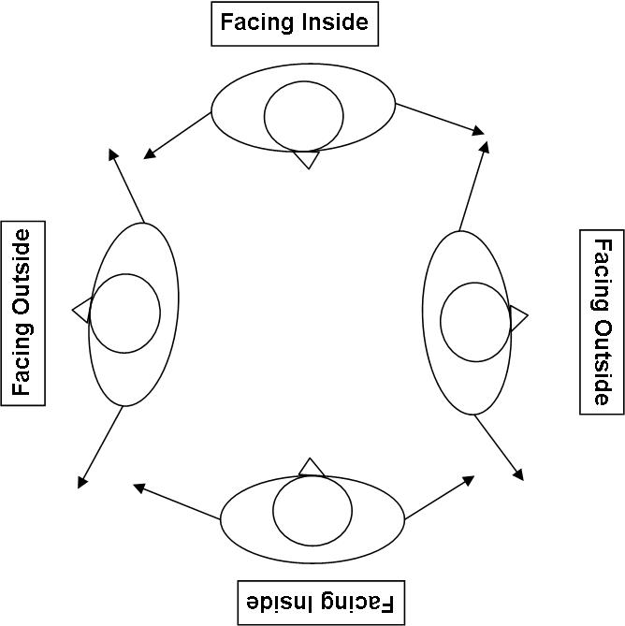

What's Going On?
That was great. We just used self-assembly to form a specific pattern. Scientists are learning how to use a similar approach to make very tiny structures on the nanoscale. Has anyone ever heard of nanotechnology? (Field various answers). Nanotechnology is the study of really, really small things like atoms and molecules. With self-assembly, scientists can make these really, really small things quickly and cheaply. The trick is to figure out the specific conditions that cause certain molecules to bond in certain ways. Molecules will always follow the same patterns if the conditions are exactly the same. Likewise, as long as you all follow the same set of rules above, you will always form the same pattern. Okay, let’s try another self-assembly game.
[Procedure 2]
Try This!
REQUIREMENTS – Must have a total of 15 kids.
PREPARATION:
- Divide the kids into three groups (Group 1 = 3 kids; Group 2 = 6 kids; Group 3 = 6 kids)
- Give each person in Group 1 a pair of red gloves (They need to put a red glove on EACH hand).
- Give each person in Group 2 one blue glove and one red glove. They should have an opposite color glove on each hand. It doesn’t matter which hand has which color.
- Give each person in Group 3 only 1 blue glove (They can put it on either hand).
RULES FOR GROUP 1:
- You must hold hands. No hand can be left untouched.
- You can only hold hands with someone who has the SAME color glove as you.
- You may NOT hold hands with any other members of Group1.
- You may NOT face any other member of Group 1.
- You must touch both your right and left shoulders to the shoulder of someone else in Group 1.

[Once they have formed a small circle facing outwards, move on to Group 2]

RULES FOR GROUP 2:
- You must hold hands. No hand can be left untouched.
- You may NOT hold hands with any other members of Group 2.
- You can only hold hands with someone who has the SAME color glove as you.
- You must hold your arms straight out to the side
[Once they have grabbed the hand of a member of group one and are stretching outward to form 6 “spokes”, move on to Group 3]
RULES FOR GROUP 3:
- You can only hold hands with someone who has the SAME color glove as you.
- You may NOT hold hands with any other members of Group 3.

RESULTS: The kids will make a “star” or “snowflake” pattern. Have the child holding the associated image show it.
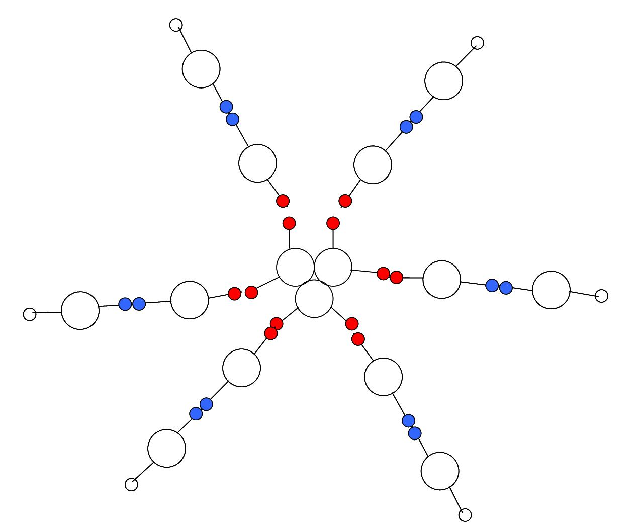

[Note: If more than 15 people are available, add a Group 4 and instruct them that their left hand must hold the hand of an open gloveless hand. If the group includes 30+, two groups can be created. For a smaller amount of people, the third group can be eliminated.]
What's Going On?
This time we made a snowflake. Snowflakes are one of nature’s best examples of self-assembly. Three things are required to grow snowflakes; water vapor (water in a gaseous state), cold (below freezing, 32°F or 0°C) and tiny dust particles that the water vapor can attach to called nucleators. If these three conditions are present, then snowflakes can form. Other conditions such as humidity levels, specific temperature levels and a process called surface melting will then help determine the exact shape the snowflake will take.
Snowflakes are really complex structures studied by scientists all over the world. In fact, there are scientists in labs making artificial snowflakes as we speak. Scientists can grow snowflakes in a lab because they know what conditions matter.
Likewise, scientists can grow other things in a lab, really, really tiny things, as long as they can figure out what conditions to set. If they set the right conditions, they can let the atoms and molecules do the work and form into the specific structures they want. Let’s play one more game which explores a self-assembly example triggered by scientists.
[Procedure 3]
Try This!
PREPARATION:
-Divide the kids into 2 groups (Group 1 = 4 kids; Group 2 = 11 kids…numbers may vary slightly)
RULES FOR GROUP 1:
- You must stand within this defined box (Find a tree, playground equipment, stones on the ground, etc. to define the space). You can move within here but not outside of it.

RULES FOR GROUP 2:
- Everyone must join hands to form 1 straight line.
- Move forward towards Group 1, but don’t let any of them break your chain.
- Try to “engulf” Group 1.

RESULTS: The kids will model a gel-capsule with a few kids surrounded by a ring of kids holding hands. Have the child holding the associated image show it.

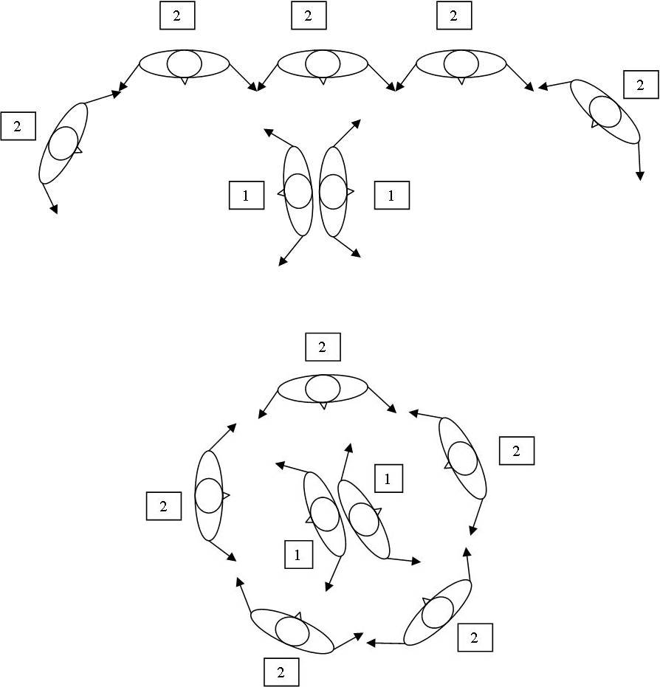
What’s Going On?
Good Job! You just created a gel-filled capsule. Scientists are making these self-assembled capsules in labs right now to try to create more targeted medicine. By encapsulating the medicine, scientists can create a more precise drug delivery system. These “smart” capsules will only bond to the diseased cells and not affect the healthy cells. Likewise, they can contain a lesser amount of medicine as it can be directed to the exact part of the body that needs it.
Conclusion: Scientists are using self-assembly to create a number of different products. Another good example is this tiny computer chip (show image). Computer chips today are so small that scientists can’t use regular tools and techniques to create them. We need new ways to build these really, really small things and self-assembly could be the way to do it. If researchers could set the right conditions to make the molecules form themselves into tiny parts for computer chips, it might be possible to make the chips better, smaller and cheaper than we can today.
What would you like to see created using self-assembly?

Tips and Troubleshooting:

It is often helpful to read ALL rules once before the visitors begin. Read the rules once completely and then allow the visitors to start forming the shapes. You may even want to run a trial version with other staff members.
For younger audiences, it may be necessary to focus on the pattern-making aspect of the program instead of molecular behavior. Emphasize that we are following specific rules to create a specific pattern. If we follow these rules every time, the same pattern will emerge every time. Younger participants may also need to be reminded what is left and what is right.
This program or parts of this program can be added to a number of programs in the NISE Network catalog. The snowflake self-assembly game would be a great companion piece to Snowflakes: Nano at Its Coolest. The third, microcapsule self-assembly game could be successfully linked to a molecular gastronomy or sodium alginate worm program.

This program is meant to be open-ended and evolving as new games are created. If you create another self-assembly game, please post the game and share your idea with the rest of the network.

Common Visitor Questions

What are some more natural examples self-assembly?

Seashells, opals and viruses are all formed by self-assembly. Crystal growth is another example of self-assembly. Scientists can even duplicate crystal growth in a lab using specific conditions. By experimenting with the conditions further, they can even make uniquely shaped crystals. Also, have you ever noticed how your cheerios like to clump together in your bowl? Scientists actually call this phenomenon, the tendency for small wettable floating objects to attract one another, the “cheerio effect”. The bunching of floating objects is another form of self-assembly. Self-assembly is all around us in things both great and small. Take a look around you and see if you can identify any other forms of self-assembly.

What other things can we create with self-assembly?

Self-assembly can also be used to make nanostructures larger. Nanostructures such as carbon nanotubes have special properties that would be very useful on the macroscale, the scale we see with our eyes, but they are very, very small (10 nanometers). Scientists are figuring out how to use self-assembly to make lots of these structures, quickly, but often find that they get different mixtures of carbon nanotubes. If they can separate out a certain type of carbon nanotube, scientists can spin them into fibers that would have the strength to make a space elevator or have electrical properties could allow us to save a lot of energy. The trick is making these tiny, tiny structures big enough to be useable and self-assembly could be the key.

Nanotechnology research into self-assembly of crystals has also resulted in practical applications. The scientists looked at the natural process of crystal growth and figured how to use that phenomenon in a lab. IBM has since produced a nanocrystal memory device made of arrays of 20 nm silicon nanocrystals, patterned using self-assembly.

Going Further…

Recommended Children’s Books that reference self-assembly or self-assembled products:

Maddox, Dianne Maddox. 2005. Science on the Edge: Nanotechnology. Blackbirch Press.

Johnson, Rebecca L. 2006. Nanotechnology. Lerner Publications Company.

Recommended Video Clips of Self-Assembly:

Snowflakes - http://www.its.caltech.edu/~atomic/snowcrystals/movies/movies.htm
Nanocapsules -http://www.youtube.com/watch?v=6Y3YJ_OjRn0&feature=player_embedded
http://nano.cancer.gov/learn/understanding/nanotech_nanoparticles.asp

Clean Up

Time: 5 minutes

Collect gloves from audience. Put visuals and gloves back into kit.

Universal Design

This program has been designed to be inclusive of visitors, including visitors of different ages, backgrounds, and different physical and cognitive abilities.

The following features of the program’s design make it accessible:

[ x ] 1. Repeat and reinforce main ideas and concepts.
- Explicitly state overarching main idea and supporting concepts visually and aurally.
- Actively engage visitors with the content visually, aurally, and tactilely.
- Deliver one core concept at a time.
- Repeat core concepts frequently during the program.
[ x ] 2. Provide multiple entry points and multiple ways of engagement.
- Actively engage audience members in the program.
- Connect the content to a range of prior experience and everyday life examples.
- Engage more than one sense when delivering jokes and special effects.
[ x ] 3. Provide physical and sensory access to all aspects of the program.
- Speak slowly and provide extra time for people to process important ideas.
- Provide auditory descriptions of models and images.

To give an inclusive presentation of this program:
- Make sure your face is visible at all times.
- Pace the program so that visitors can follow the content easily.
- Ask the audience questions, and check in with them along the way to make sure they’re engaged and with you.
- If a participant is unable to fully participate in the self-assembly games, designate them as the pattern arbiter. They receive a picture of the pattern in advance and verify its accuracy.


This project was supported by the National Science Foundation under Grant No. ESI-0532536.

Any opinions, findings, and conclusions or recommendations expressed in this program are those of the author and do not necessarily reflect the views of the Foundation.

