

Exploring Products—Nano Sand
Try this!  - Use a dropper bottle to squeeze water onto the tray of green sand. Tilt the tray gently. What happens?  - Now try dropping water onto the tray of purple sand. Does the same thing happen when you tilt the tray? | 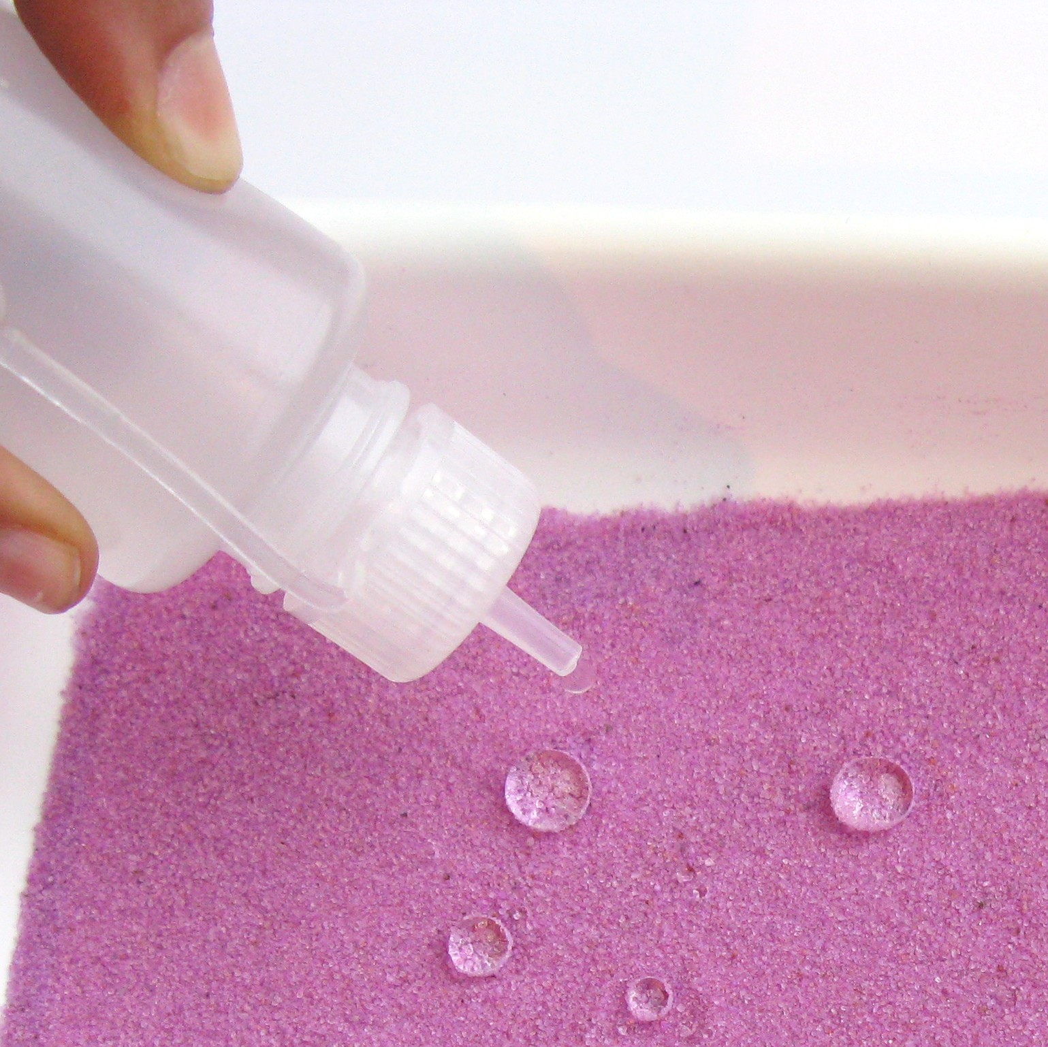
Now try …  - Quickly pour purple sand from the small portion cup into the drinking cup of water. What does the sand do?  - Take a spoon, and scoop the sand back out. Is it wet?  What’s going on? | 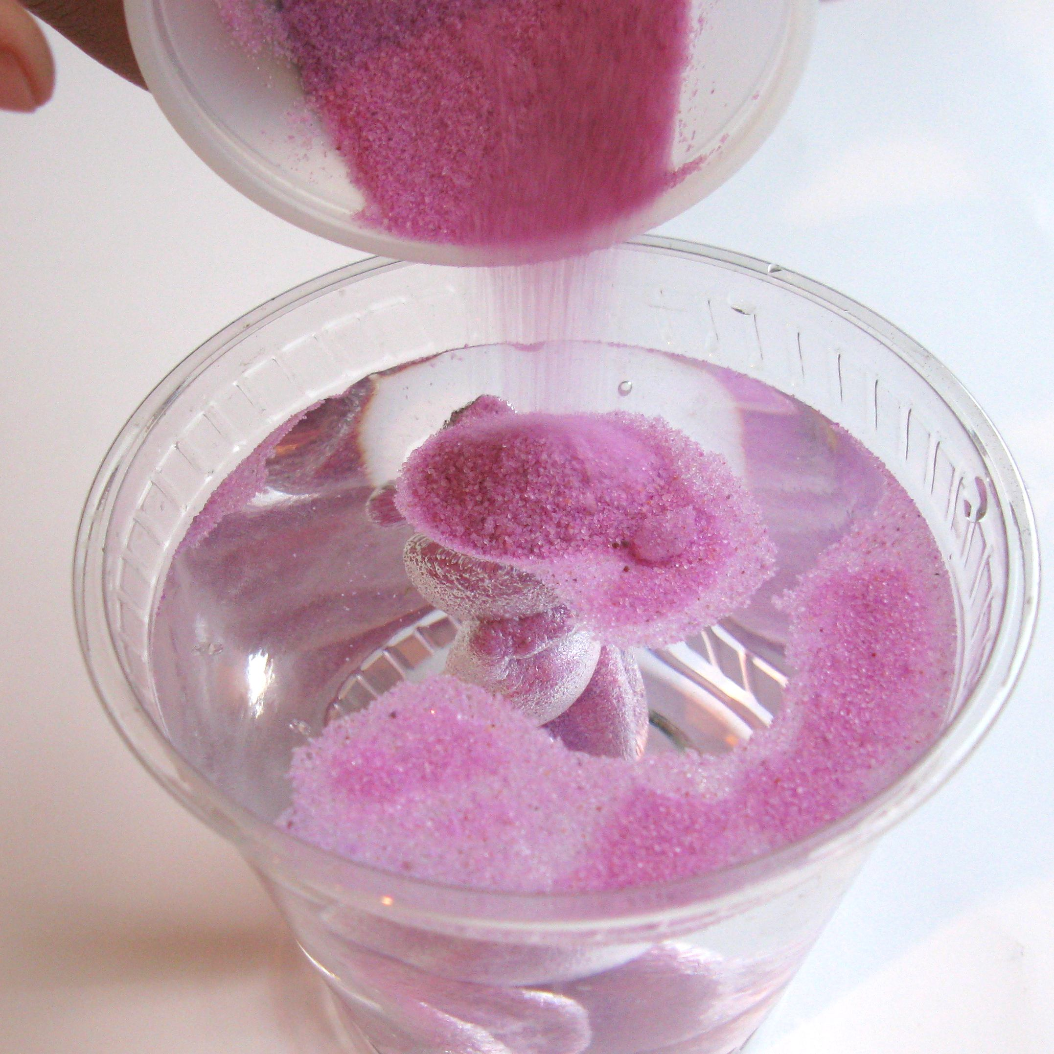
The purple sand is special sand that’s been chemically treated to repel water. This hydrophobic (“water-fearing”) sand is coated with a silicon compound that makes it repel water. The layer is only one nanometer thick, so the coated sand looks and feels like regular sand—but it behaves very differently.
The green sand is just ordinary sand that’s been colored. It acts pretty much like sand you encounter at the beach or playground. Ordinarily, water molecules and sand are attracted to each other, so beach sand gets wet.
Hydrophobic sand was invented to clean up oil spills in water. When the coated sand is poured on a spill, it bonds to the oil (but not the water) and sinks to the bottom, where it can be dredged and treated. Currently, though, hydrophobic sand is too costly to use this way.  Hydrophobic sand has also been used to protect utilities in cold climates. Electrical junction boxes can be covered with a layer of coated sand, then capped with a few inches of soil. The hydrophobic sand can be dug through even when the ground is frozen, making repairs easier. | 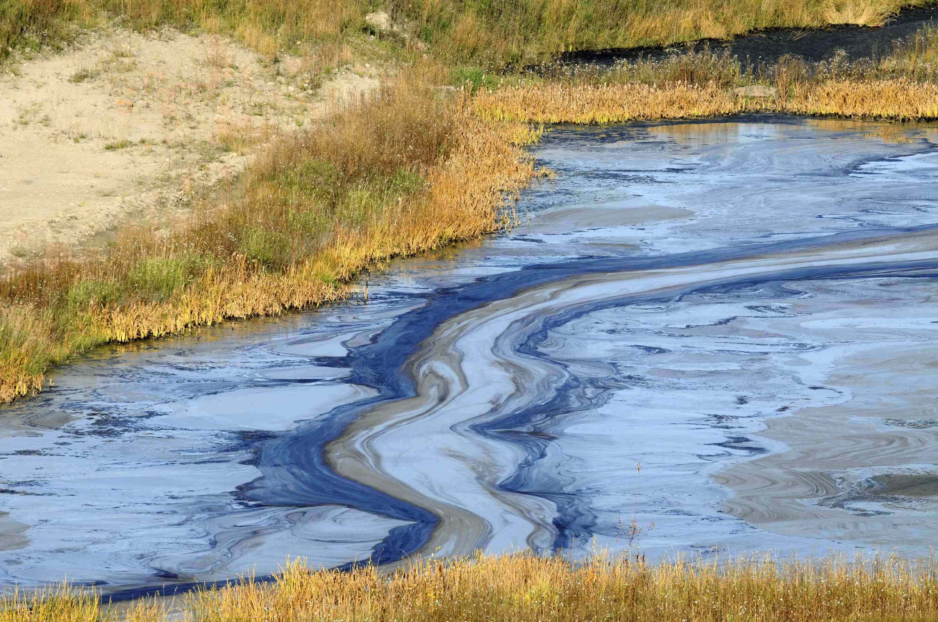  Hydrophobic sand was invented to clean up oil spills

How is this nano?
The way a material behaves on the macroscale is affected by its structure on the nanoscale. You can’t see or feel the nano-layer of silicon compound coating the hydrophobic sand because it’s so thin, but you can observe that it makes the sand act differently from ordinary sand.

Nanotechnology takes advantage of different material properties at the nanoscale to make new materials and tiny devices smaller than 100 nanometers in size. (A nanometer is a billionth of a meter.) Nanotechnology allows scientists and engineers to make things like smaller, faster computer chips and new medicines to treat diseases like cancer.

Learning objectives
- The way a material behaves on the macroscale is affected by its structure on the nanoscale.
- Hydrophobic sand is coated with a nanometer-thick layer of a silicon compound, which makes it repel water.

Materials
- Ordinary, colored sand (green, or another color)
- Hydrophobic sand (purple, or another color)
- Trays (2)
- Dropper bottles (2)
- Small portion cups (2)
- Drinking cups (2)
- Spoons (2)
- “Nano Sand” sheet

Hydrophobic sand is available from www.dunecraft.com (purple #NS-R014 and green #NS-G010).

Notes to the presenter
Before beginning this activity:
- Fill the two trays, one with ordinary sand and one with hydrophobic sand.
- Fill the small portion cups with hydrophobic sand.
- Fill the dropper bottles and drinking cups with water.

To reuse the hydrophobic sand when the activity is over, carefully pour out most the water. Shake the tray and use a sheet of paper towel to absorb the last drops of water. To reuse the ordinary sand, let it dry in the tray.

Extension
Using the spoon, sprinkle nano sand on the surface of the water, so it floats. Gently poke the surface of the sand with your finger. Can you keep your finger dry?

Related educational resources
The NISE Network online catalog (www.nisenet.org/catalog) contains additional resources to introduce visitors to nanomaterials and consumer products enabled by nanotechnology:
- Public programs include Aerogel, Future of Computing, Ink Jet Printer, Magic Sand, Nanoparticle Stained Glass, Sand, Plants and Pants, and Nanosilver: Breakthrough or Biohazard?
- NanoDays activities include Exploring Materials—Ferrofluid, Exploring Materials—Liquid Crystals, Exploring Materials—Thin Films, Exploring Products—Nano Fabrics, and Exploring Products—Sunblock.
- Media include Everything is Made of Atoms, Zoom into a Computer Chip, and Multimedia Zoom into a Nasturtium Leaf.
- Exhibits include Bump and Roll, Changing Colors, and Nanotechnology—Fact or Fiction?

Credits and rights
This activity was adapted from several sources, including:
- Magic Sand, developed by the Materials Research Science and Engineering Center (MRSEC) on Nanostructured Materials and Interfaces at the University of Wisconsin-Madison for the NISE Network. The original program is available at www.nisenet.org/catalog
- “Magic Sand,” JCE Classroom Activity #23, Journal of Chemical Education 77(1): 40A-40B, January 2000. The original activity is available at JChemEd.wisc.edu
 | This project was supported by the National Science Foundation under Award No. ESI-0940143. Any opinions, findings, and conclusions or recommendations expressed in this program are those of the author and do not necessarily reflect the views of the Foundation.

Copyright 2010, Sciencenter, Ithaca, NY. Published under a Creative Commons Attribution-Noncommercial-ShareAlike license: http://creativecommons.org/licenses/by-nc-sa/3.0/us/

