
Exploring Size—Memory Game

Try this!  - Shuffle the cards and arrange them face down on the table. (You can line them up in rows or set them out randomly.)  - Pick two cards and flip them right side up.  - If the cards match, put them to the side and take another turn. If they don’t match, flip them back over and try again.  - Look for matches until you find all the pairs.  What’s going on? | 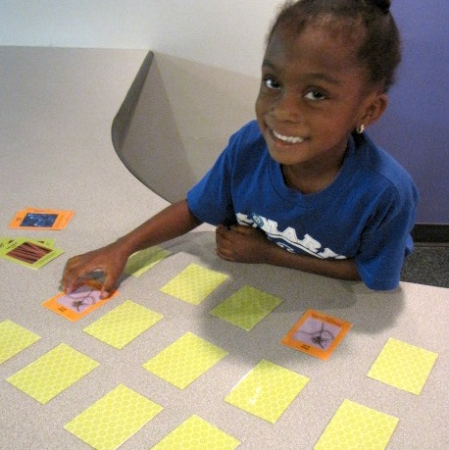
Things come in different sizes—and size is important! We use different scales to measure things that are different sizes. In this game, we explore three different scales: the macroscale, the microscale, and the nanoscale.
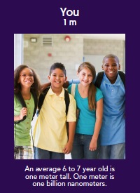 | Macroscale objects are on purple cards  The macroscale includes objects we can see with our eyes. There are lots of ways to measure objects on the macroscale, including meters. (A meter is a little over three feet.) Kids around six or seven years old are about a meter tall.
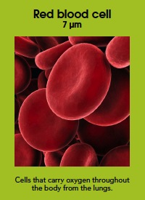 | Microscale objects are on green cards  The next scale down is the microscale. To see microscale things clearly, we need tools like microscopes. Objects on the microscale are measured in micrometers. A micrometer is a millionth of a meter. Red blood cells are measured in micrometers.
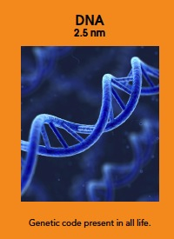 | Nanoscale objects are on orange cards  There’s an even smaller scale: the nanoscale! Nanoscale things are so tiny, we can’t see them with just our eyes. We need special tools to make images of them. Nanoscale objects are measured in nanometers. A nanometer is super small—a billionth of a meter! DNA is measured in nanometers.

How is this nano?
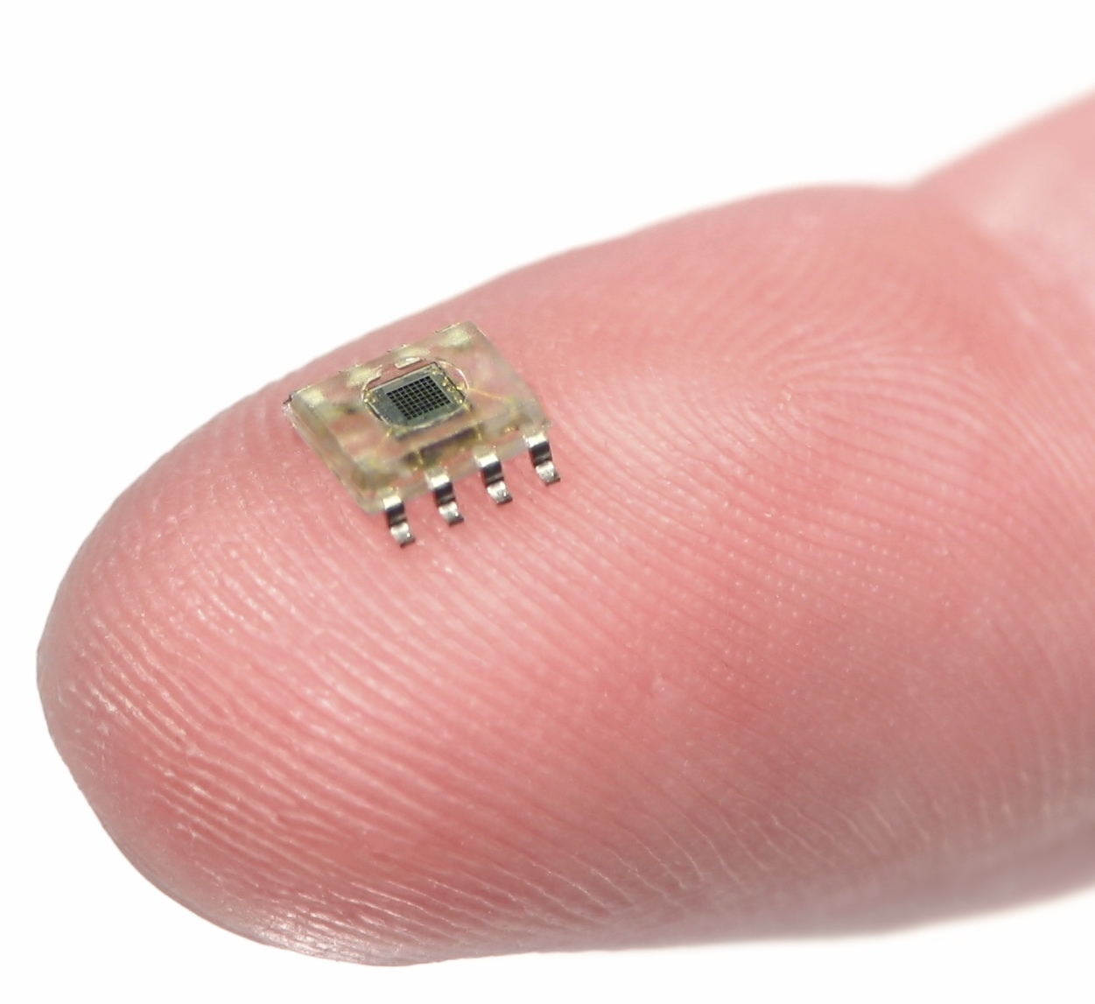  Microchip on finger | A nanometer is a billionth of a meter. That’s really tiny! Nanometers are used to measure things that are too small to see, like atoms and molecules, the basic building blocks of our world.  Nanoscale science focuses on things that are measured in nanometers. Scientists use special tools and equipment to work with things that have nanometer-sized parts, such as microchips.  In the field of nanotechnology, scientists and engineers make new materials and tiny devices. Nanotechnology allows them to make things like smaller, faster computer chips and new medicines to treat diseases like cancer.

Learning objectives
- Things come in different sizes—and size is important!
- A nanometer is a billionth of a meter.

Materials
- “Macro, Micro, Nano” playing cards
- “Making a Match” sheet
- “Macroscale Objects,” “Microscale Objects,” and “Nanoscale Objects” sheets

Notes to the presenter
You can use the “Making a Match” sheet to show visitors how to match pairs, and to explain that the objects on the card are three different size scales: macroscale, microscale, and nanoscale.
Visitors can play this game alone or in groups. Single visitors can see how quickly they can find all the pairs. Groups can take turns looking for matches, competing to get the most pairs.
To reinforce the learning objectives, provide narration as the game progresses. Once a match is made, you can identify the scale and object. (“Great job! You found the buckyball pair. Buckyballs are tiny molecules made of carbon atoms.”)
The game should be played with at least 12 pairs of cards (four pairs from each scale).
To make the game more interesting for older visitors, try letting visitors justify matches other than identical cards. For example, two orange cards could be a match because they are both nanoscale. Or, the macroscale gecko could be matched to the nanoscale structures of the gecko foot, because they’re images of the same object at different scales. (There may be leftover cards with this version of the game.)

Related educational resources
The NISE Network online catalog (www.nisenet.org/catalog) contains additional resources to introduce visitors to the nanoscale and nanometers:
- Public programs include Cutting it Down to Nano and Shrinking Robots!
- NanoDays activities include Exploring Size—Measure Yourself, Exploring Size—Powers of Ten Game, Exploring Size—Scented Balloons, Exploring Size—Scented Solutions, Exploring Size—StretchAbility Game, and Exploring Size—Tiny Ruler.
- Media include the poster and book How Small is Nano?, Image Scaler Software, Intro to Nano, Multimedia Zoom into a Human Hand, Multimedia Zoom into a Nasturtium Leaf, Scale Ladder, Zoom into a Butterfly Wing, Zoom into a Computer Chip, and Zoom into the Human Bloodstream.
- Exhibits include At the Nanoscale and Three Drops.

Credits and rights
This activity was adapted from Macro, Micro and Nano Memory, developed by the Children’s Museum of Houston for the NISE Network. The original program is available at www.nisenet.org/catalog

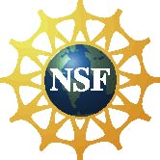 | This project was supported by the National Science Foundation under Award No. ESI-0940143. Any opinions, findings, and conclusions or recommendations expressed in this program are those of the author and do not necessarily reflect the views of the Foundation.

Copyright 2010, Sciencenter, Ithaca, NY. Published under a Creative Commons Attribution-Noncommercial-ShareAlike license: http://creativecommons.org/licenses/by-nc-sa/3.0/us/

