

Macroscale Objects—Memory Game

 | 
A large oak tree  is about 20 meters tall. | A full-size soccer ball is  70 centimeters in diameter.
 | 
Humpback whales are  about 14 meters long. | Blue Morpho butterflies have  a wingspan of about 15 centimeters.
 | 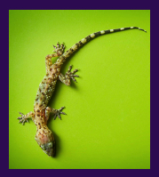
At age 6 or 7, children  are around 1 meter tall. | Gecko lizards are  about 13 centimeters long.

Microscale Objects—Memory Game

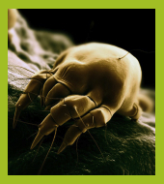 | 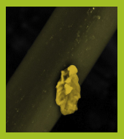
Dust mites, arachnids that eat flakes  of dead skin, are 300 micrometers long. | Tiny feces from dust mites are  about 17 micrometers long.
 | 
The diameter of human hairs  ranges from 50-100 micrometers. | Red blood cells, which carry oxygen from our  lungs to our bodies, are about 7 micrometers across.
 | 
Pollen, which fertilizes seed plants,  can be about 50 micrometers in diameter. | E. coli bacteria, found in our intestines,  are around 2 micrometers long.

Nanoscale Objects—Memory Game

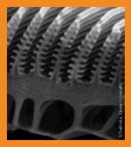 | 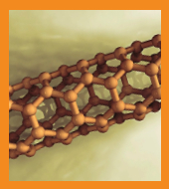
The 400-nanometer microribs in the  Blue Morpho butterfly’s wings reflect  light to create a blue iridescent color. | Carbon nanotubes are tiny  structures made of carbon,  several nanometers in diameter.
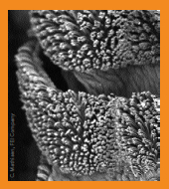 | 
The 200-nanometer hairs on geckos’ feet  temporarily bond with surfaces,  making them really good climbers. | DNA molecules,  which carry genetic code,  are around 2.5 nanometers across.
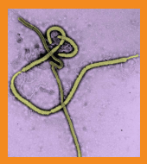 | 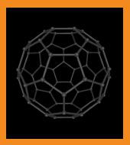
The Ebola virus,  which causes a bleeding disease,  is around 80 nanometers long. | Buckyballs, molecules  made of 60 carbon atoms,  are 1 nanometer in diameter.

