

Exploring Tools—Mitten Challenge

Try this!  - Put on a pair of oven mitts.  - Try to build a house out of the bricks, like the one shown in the picture. (Or build an idea of your own using the bricks.)  - Now try building without the mitts. Is it easier or harder?  What’s going on? | 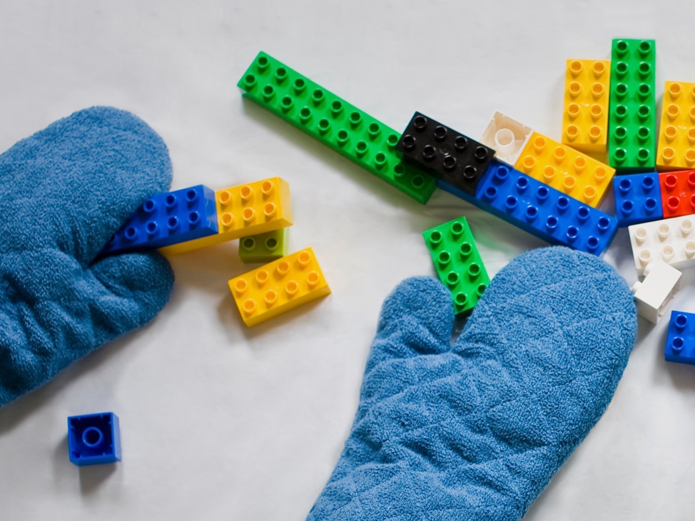
It’s difficult to build small things if your tools are too big! Your fingers are just the right size for building with toy bricks. Oven mitts cover your fingers and make your hands bigger, so you can’t work as easily or precisely wearing them. Like everyone else, scientists and engineers need the right size tools for the job.
In the field of nanotechnology, researchers study and make tiny things that are measured in nanometers. A nanometer is a billionth of a meter. That’s very, very small—the size of atoms and molecules, the building blocks that make up everything in our world.
Moving atoms around with regular tools is kind of like trying to build something out of toy bricks with oven mitts on your hands! As the new field of nanotechnology develops, we may be able to use atoms and molecules just like building blocks, putting them together easily to create tiny structures and machines.
How is this nano?  Scientists use special tools and equipment to work on the nanoscale. Nanoscale science focuses on things that are measured in nanometers, including atoms and molecules, the basic building blocks of our world.  In the field of nanotechnology, researchers study and make tiny things that are measured in nanometers. (A nanometer is a billionth of a meter.) Nanotechnology allows them to make things like smaller, faster computer chips and new medicines to treat diseases like cancer. | 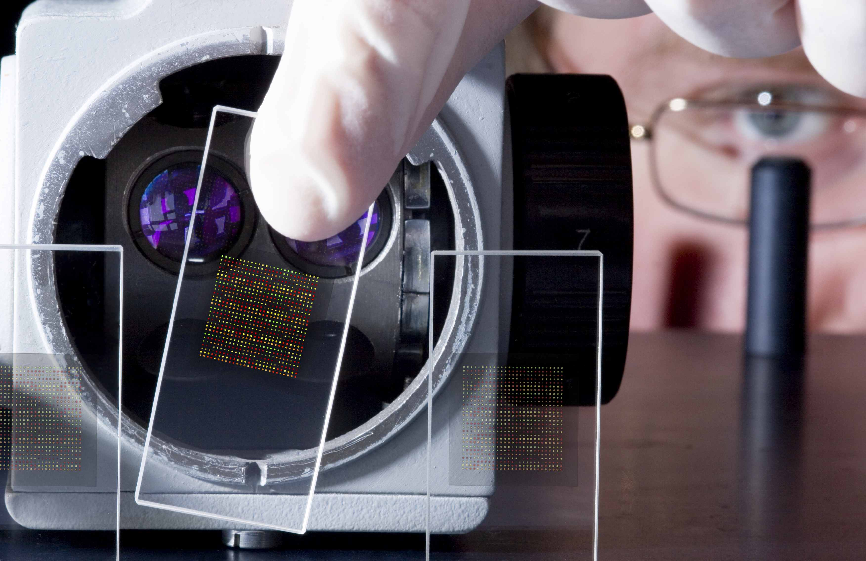  DNA chip used to analyze human genes

Learning objectives
1. Scientists and engineers need special tools and equipment to work on the nanoscale.
2. In the field of nanotechnology, researchers study and make tiny things that are measured in nanometers.

Materials
- Oven mitts (2)
- Brick building set (Lego® Duplo® or similar)
- “Build a House” sheet

Note to the presenter
When presenting to younger audiences, larger building bricks work well. If you like, you can introduce smaller bricks to make this activity more challenging for older audiences.

Related educational resources
The NISE Network online catalog (www.nisenet.org/catalog) contains additional resources to introduce visitors to nanotechnology and the tools researchers use to study and make things that are too small to see:
- Public programs include Attack of the Nanoscientist, Cutting it Down to Nano, Intro to Nano, Ready, Set, Self-Assemble, Sweet Self-Assembly, and Tiny Particles, Big Trouble!
- NanoDays activities include Exploring Size—Powers of Ten Game and Exploring Tools—Special Microscopes.
- Media include the video What Happens in a Nano Lab?
- Exhibits include Creating Nanomaterials and NanoLab.

Credits and rights
This activity was adapted from “Nanoscale Activity: Nanotechnology Mitten Challenge” developed by the National Science Foundation-supported Internships in Public Science Education (IPSE) Program at the Materials Research Science and Engineering Center (MRSEC) on Nanostructured Materials and Interfaces at the University of Wisconsin-Madison. The original activity is available at mrsec.wisc.edu/Edetc/IPSE/educators/mittenChall.html

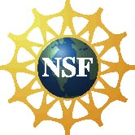 | This project was supported by the National Science Foundation under Award No. ESI-0940143. Any opinions, findings, and conclusions or recommendations expressed in this program are those of the author and do not necessarily reflect the views of the Foundation.

Copyright 2010, Sciencenter, Ithaca, NY. Published under a Creative Commons Attribution-Noncommercial-ShareAlike license: http://creativecommons.org/licenses/by-nc-sa/3.0/us/

