Mentos and Soda Explosion


Organization: OMSI
Contact person: Anders Liljeholm
Contact information: aliljeholm@omsi.edu, 503-797-4606

General Description

Type of program:
Stage presentation – probably best outdoors

Presenter puts Mentos candy into soda to create a soda fountain. This is a dramatic demonstration of the effects of surface area.

This demonstration isn’t heavily focused on nanotechnology,but can be a spectacular finale that you add on to other nano demos like Intro to Nano or Surface Area. (It’s probably best as a substitution for Alka-Seltzer, rather than being performed with it.)
It’s also just a crowd pleasing demo that briefly mentions nano.

Program Objectives

Big idea:
Surface area on mentos makes soda explode.

Learning goals:
As a result of participating in this program, visitors will be able to:

Describe how surface area makes soda explode.

NISE Network content map main ideas:
[ X ] 1. Nanometer-sized things are very small, and often behave differently than larger things do.

[ ] 2. Scientists and engineers have formed the interdisciplinary field of nanotechnology by investigating properties and manipulating matter at the nanoscale.

[ ] 3. Nanoscience, nanotechnology, and nanoengineering lead to new knowledge and innovations that weren’t possible before.

[ ] 4. Nanotechnologies have costs, risks, and benefits that affect our lives in ways we cannot always predict.

National Science Education Standards:
[ ] 1. Science as Inquiry
[ ] K-4: Abilities necessary to do scientific inquiry
[ ] K-4: Understanding about scientific inquiry
[ ] 5-8: Abilities necessary to do scientific inquiry
[ ] 5-8: Understanding about scientific inquiry
[ ] 9-12: Abilities necessary to do scientific inquiry
[ ] 9-12: Understanding about scientific inquiry

[ ] 2. Physical Science
[ x ] K-4: Properties of objects and materials
[ ] K-4: Position and motion of objects
[ ] K-4: Light, heat, electricity, and magnetism
[ x ] 5-8: Properties and changes of properties in matter
[ ] 5-8: Motions and forces
[ ] 5-8: Transfer of energy
[ ] 9-12: Structure of atoms
[ ] 9-12: Structure and properties of matter
[ x ] 9-12: Chemical reactions
[ ] 9-12: Motions and force
[ ] 9-12: Conservation of energy and increase in disorder
[ ] 9-12: Interactions of energy and matter

[ ] 3. Life Science
[ ] K-4: Characteristics of organisms
[ ] K-4: Life cycles of organisms
[ ] K-4: Organisms and environments
[ ] 5-8: Structure and function in living systems
[ ] 5-8: Reproduction and heredity
[ ] 5-8: Regulation and behavior
[ ] 5-8: Populations and ecosystems
[ ] 5-8: Diversity and adaptations of organisms
[ ] 9-12: The cell
[ ] 9-12: Molecular basis of heredity
[ ] 9-12: Biological evolution
[ ] 9-12: Interdependence of organisms
[ ] 9-12: Matter, energy, and organization in living systems
[ ] 9-12: Behavior of organisms

[ ] 4. Earth and Space Science
[ ] K-4: Properties of earth materials
[ ] K-4: Objects in the sky
[ ] K-4: Changes in earth and sky
[ ] 5-8: Structure of the earth system
[ ] 5-8: Earth's history
[ ] 5-8: Earth in the solar system
[ ] 9-12: Energy in the earth system
[ ] 9-12: Geochemical cycles
[ ] 9-12: Origin and evolution of the earth system
[ ] 9-12: Origin and evolution of the universe

[ ] 5. Science and Technology
[ ] K-4: Abilities to distinguish between natural objects and objects made by humans
[ ] K-4: Abilities of technological design
[ ] K-4: Understanding about science and technology
[ ] 5-8: Abilities of technological design
[ ] 5-8: Understanding about science and technology
[ ] 9-12: Abilities of technological design
[ ] 9-12: Understanding about science and technology

[ ] 6. Personal and Social Perspectives
[ ] K-4: Personal health
[ ] K-4: Characteristics and changes in populations
[ ] K-4: Types of resources
[ ] K-4: Changes in environments
[ ] K-4: Science and technology in local challenges
[ ] 5-8: Personal health
[ ] 5-8: Populations, resources, and environments
[ ] 5-8: Natural hazards
[ ] 5-8: Risks and benefits
[ ] 5-8: Science and technology in society
[ ] 9-12: Personal and community health
[ ] 9-12: Population growth
[ ] 9-12: Natural resources
[ ] 9-12: Environmental quality
[ ] 9-12: Natural and human-induced hazards
[ ] 9-12: Science and technology in local, national, and global challenges

[ ] 7. History and Nature of Science
[ ] K-4: Science as a human endeavor
[ ] 5-8: Science as a human endeavor
[ ] 5-8: Nature of science
[ ] 5-8: History of science
[ ] 9-12: Science as a human endeavor
[ ] 9-12: Nature of scientific knowledge
[ ] 9-12: Historical perspective

Table of Contents
General Description 1
Program Objectives 1
Table of Contents 4
Time Required 5
Background Information 5
Definition of terms 5
Program-specific background 5
Materials 6
Set Up 7
Step 1: 7
Step 2: 7
Step 3: 7
Step 4: 7
Program Delivery 7
Safety 7
Talking points and procedure 8
Tips and troubleshooting 9
Common visitor questions 9
Going further… 10
Clean Up 10
Universal Design 10

Time Required

Set-up Program Clean Up

10 minutes 10 minutes 10 minutes

Background Information

Definition of terms

Nano is the scientific term meaning one-billionth (1/1,000,000,000). It comes from a Greek word meaning “dwarf.”
A nanometer is one one-billionth of a meter. One inch equals 25.4 million nanometers. A sheet of paper is about 100,000 nanometers thick. A human hair measures roughly 50,000 to 100,000 nanometers across. Your fingernails grow one nanometer every second.

(Other units can also be divided by one billion. A single blink of an eye is about one-billionth of a year. An eyeblink is to a year what a nanometer is to a yardstick.)

Nanoscale refers to measurements of 1-100 nanometers. A virus is about 70 nm long. A cell membrane is about 9 nm thick. Ten hydrogen atoms are about 1 nm.

At the nanoscale, many common materials exhibit unusual properties, such as remarkably lower resistance to electricity, or faster chemical reactions.
Nanotechnology is the manipulation of material at the nanoscale to take advantage of these properties. This often means working with individual molecules.
Nanoscience, nanoengineering and other such terms refer to those activities applied to the nanoscale. “Nano,” by itself, is often used as short-hand to refer to any or all of these activities.

Program-specific background

Flavor crystals on the surface of Mentos candy act as nucleation sites when dropped into carbonated beverages (ideally, diet caffeinated beverages). While different soda ingredients affect the behavior, it does seem to be a physical reaction, not a chemical one. The different ingredients in the soda affect the density, viscosity and surface tension of the liquid, thus affecting how intensely it foams. (Pure carbonated water releases all its bubbles, but does not build a column of foam at all.)

This dramatic demonstration works great on its own, but can be expanded as the culminating flashy part of a surface area demonstration, or extended into a medium length demonstration about the chemical properties of carbon dioxide.

Materials
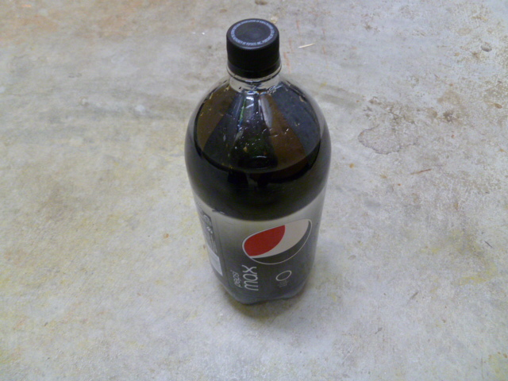
Five 2-liter bottles of caffeinated, diet soda

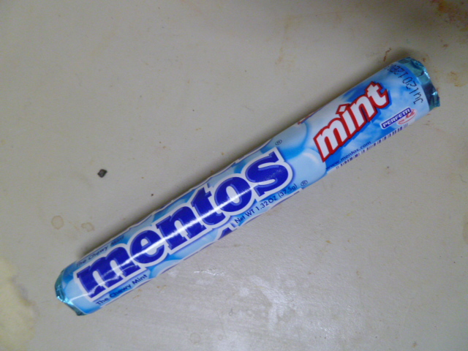
30 Mentos mint candies

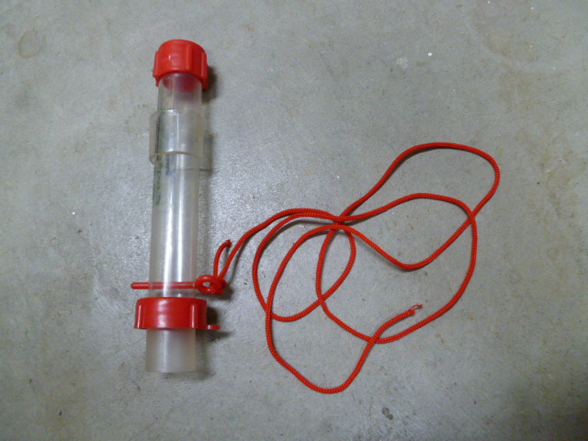
Five Geyser Tubes (Steve Spangler)

http://www.stevespanglerscience.com/product/geyser-tube

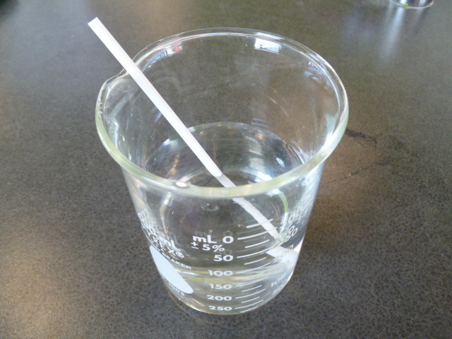
Transparent beaker

200 mL water

Straw

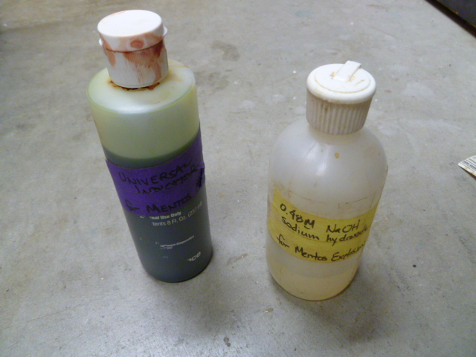
Universal Indicator

Basic solution (like sodium hydroxide)

Dry cloth

Optional:
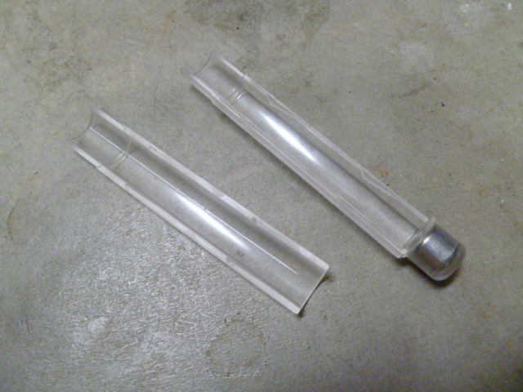
Steve Spangler depth charges, with other granular materials like sand or iron filings.
http://www.stevespanglerscience.com/product/soda-geyser-depth-charge-kit

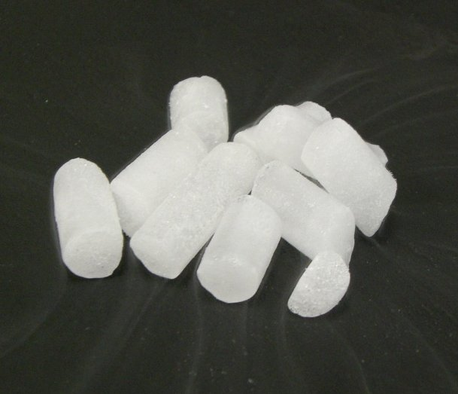
Dry Ice (photo: Richard Wheeler)

Spoon

Set Up

Time: 10 minutes

Step 1:
Gather supplies.

Step 2:
Load mentos into tubes.

Step 3:
Set up presentation cart or stage.

Step 4:
Open bottles of soda and attach tubes.

Program Delivery

Time: 10 minutes

Safety

The core mentos/soda activity is very safe. Don’t do it on a slick surface where spilled soda might cause someone to slip and fall.
If using iron filings, it’s important to not pour iron filings down a drain. If throwing away iron filings, send them to the landfill.
Dry ice demonstrations require some basic safety precautions: don’t touch dry ice with bare skin, never put dry ice in a sealed, closed container, dispose of dry ice safely.

Talking points and procedure

Introduce yourself.

“This is a demonstration of the chemical properties of Carbon Dioxide. Everyone, take a deep breath in…. Breathe out – Look! There’s Carbon Dioxide!
Carbon Dioxide is an invisible gas we make every time we breathe. It has lots of amazing properties. It can put out fires! It can change the climate of the Earth! You can freeze it into blocks of dry ice which turn directly from a solid into a gas, so you can keep your fish fresh without getting them wet! But that’s not all!
If we dissolve Carbon Dioxide into a liquid, it turns that liquid into an acid!

I have here some water, and I’m adding an indicator. This indicator changes color if it’s mixed with an acid or a base. When mixed with water it’s green. Now I need a volunteer with really big lungs. If you could please blow into this straw…the carbon dioxide from her lungs is dissolving into the water, turning it into carbonic acid, turning the indicator from green to yellow. Now I’m going to add a base, which will take the color from yellow to green to blue to purple. Now let’s see if she can make enough carbon dioxide to neutralize the base and make it an acid again.
So why do you care about this? Well, it turns out that this acid is Delicious! We love the tangy flavor of bubbles of carbon dioxide. This is why we carbonate our beverages with carbon dioxide gas, and why flat soda doesn’t taste as good as regular soda.
And our volunteer has turned the water yellow again. A round of applause for our volunteer!
Today I’m going to use these bubbles of carbon dioxide not for deliciousness, but to make the soda explode. I’m going to release all the bubbles of gas all at once, making the soda foam up and shoot out of the bottle. I’m going to release all the bubbles by dropping Mentos into the soda.
Mentos release all the bubbles because they are microscopically rough – they’re covered with millions of tiny bumps and holes, places for the bubbles to form. Anything with lots of surface area that bubbles can form on will cause soda to explode. If you put sand into soda, it will do the same thing you’re about to see.
Scientists are discovering that lots of things act in surprising ways when they have more surface areas. If you turn the aluminum in a soda can into tiny nanoparticles, they become explosive!
And now, without any further ado, if everyone would please help me count down…5, 4, 3, 2, 1 – FWMSSSSH!
Thank you very much, and have a great day!

Tips and troubleshooting

If using the Steve Spangler Geyser Tube, it will often squirt a stream of soda out the holes where the pin was.
Watch this video to see several streams:
http://www.youtube.com/watch?v=yjE9WpEJvFQ&t=8m25s
To prevent this stream ending up in your ear, you can angle the tubes so those holes aim to the side.

The temperature of the soda matters a great deal. Hotter soda explodes much more vigorously than colder soda. If you are doing the demonstration on a cold day, you can soak the soda in hot tap water to give it extra kick. Soda does lose its carbonation over time – after about a year in storage, the explosion becomes very lame, even with hot soda.

If Mentos aren’t in your budget, rock salt, sand or iron filings create an equally awesome reaction. (Steel wool, while it has relatively high surface area, does not have enough surface area to make a strong explosion.) It does take more time to prepare the sand or iron for delivery into the soda. Iron filings can be retrieved with magnets, dried and reused. Steve Spangler’s “depth charge” tubes are an excellent reusable device that makes it relatively easy to deliver sand or iron filings into the bottle.

If you have access to dry ice, classic dry ice demonstrations are an excellent extension at the beginning of the demonstration. Pressing spoons and coins against a piece of dry ice and hearing the scream of escaping gas illustrates how it sublimates from a solid to a gas. Instead of a volunteer changing the color of the water, a piece of dry ice will do this very quickly. Dry ice vapor extinguishing a flame, while dramatic, is very hard to achieve outdoors.

If you do the activity with blowing into universal indicator with a straw, it takes about 10 seconds for most people to turn the water acidic. If adding a base, 2 drops of sodium hydroxide is enough to make your volunteer blow for 20 seconds to neutralize it.

Common visitor questions

Why does it have to be diet soda?
Experimentation demonstrates that diet soda shoots much higher than regular soda. Two ingredients are important to a powerful explosion: sodium benzoate, and the artificial sweetener aspartame. These ingredients affect the viscosity and surface tension of the carbonated water in a way that facilitates releasing of the bubbles.
It’s also the case that sugared soda is much heavier than diet soda. A can of regular soda sinks, while a can of diet soda floats. (You can demonstrate this by putting unopened cans of both types in a container of water like an aquarium.) It’s possible that part of the reason diet soda shoots higher is that it weighs less.
The Mythbusters’ experiments suggest that caffeine has an effect, and some other trials suggest that caffeinated sodas are more explosive, although Tanya Coffee’s paper suggests the effect of caffeine is negligible. You can see a demonstration of the difference caffeine and aspartame (and temperature) make at: http://www.youtube.com/watch?v=aLo8FExLouA

In fact, Diet Dr Pepper is the most energetic soda for this reaction, for reasons unknown. This middle school science fair project proves it: http://www.youtube.com/watch?v=oebu4nMjOrE

Can I drink the soda?
No. I didn’t wash my hands when I loaded the Mentos, so it isn’t food safe.

Going further…

Here are some resources you can share with your visitors:

An article on the science of how it works:
http://www.newscientist.com/article/dn14114-science-of-mentosdiet-coke-explosions-explained.html

A paper about the entire phenomenon, featuring SEM images of the surface of different kinds of mentos:
http://tnst.randolphcollege.edu/apply10/inst_mats/handouts/EnvSc/Coffey08_diet_coke_and_mentos.pdf
Coffey, T. 2008. Diet Coke and Mentos: What is really behind this physical reaction? Am. J. Phys., Vol. 76, No. 6, June 2008. p. 551.

Clean Up

Time: 10 minutes

Pour flat soda down the drain.
Wipe down cart and other materials with a dry cloth.
If geyser tubes will be used again soon, rinse with water.
Return materials to storage. Recycle empty soda bottles.

If using iron filings, it’s important to not pour iron filings down a drain. If throwing away iron filings, send them to the landfill.

Universal Design

This program has been designed to be inclusive of visitors, including visitors of different ages, backgrounds, and different physical and cognitive abilities.

The following features of the program’s design make it accessible:

[ x ] 1. Repeat and reinforce main ideas and concepts

[ ] 2. Provide multiple entry points and multiple ways of engagement

[ ] 3. Provide physical and sensory access to all aspects of the program

To give an inclusive presentation of this program:

Describe what you’re doing for people who can’t see.

 | This project was supported by the National Science Foundation under Award No. 0940143. Any opinions, findings, and conclusions or recommendations expressed in this program are those of the author and do not necessarily reflect the views of the Foundation.
 | Published under a Creative Commons Attribution-Noncommercial-ShareAlike license: http://creativecommons.org/licenses/by-nc-sa/3.0/us/

