Biomimicry: From Nature to Nanotech

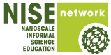
Organization: University of Wisconsin-Madison (UW) Materials Research Science and Engineering Center (MRSEC)

Contact person: Tracy J. Puccinelli
Contact information: tstefonek@wisc.edu

General Description

Table top activity

Visitors will engage in activities showing various natural phenomena that scientists and engineers have emulated to address human problems. Visitors view peacock feathers at different angles to see iridescence, apply drops of water to observe the color changes, and look at other examples of iridescence in nature, such as a blue Morpho butterfly, tropical beetle wings, and abalone shells. Visitors also explore the Lotus Effect by applying drops of water onto Lotusan paint and stain resistant fabrics, two technologies that mimic the Lotus effect. A flip-book shows examples of iridescence and the Lotus effect, as well as microscopic and scanning electron microscope (SEM) images. Visitors can take home a peacock feather and a TryThis! card describing iridescence and an activity to do at home.

Program Objectives
Big idea: Biomimicry is defined as imitating nature’s best ideas to solve human problems. Many advances in nanotechnology and current research use nature as inspiration.

Learning goals:
As a result of participating in this program, visitors will be able to:
- Understand that biomimicry is imitating nature’s best ideas to solve human problems
- Understand that nano means really, really small. So small you cannot see it. Things behave differently when they are this small.
- Understand that nano sized things are in many places, including in nature.
- Understand that numerous nanotechnologies have been inspired by nature. (biomimicry)
- Think of other things in nature that we could use as inspiration to solve a human problem.

NISE Network content map main ideas:
[ X ] 1. Nanometer-sized things are very small, and often behave differently than larger things do.
[ X ] 2. Scientists and engineers have formed the interdisciplinary field of nanotechnology by investigating properties and manipulating matter at the nanoscale.
[ X ] 3. Nanoscience, nanotechnology, and nanoengineering lead to new knowledge and innovations that weren’t possible before.
[ ] 4. Nanotechnologies have costs, risks, and benefits that affect our lives in ways we cannot always predict.

National Science Education Standards:
[ X ] 1. Science as Inquiry
[ X ] K-4: Abilities necessary to do scientific inquiry
[ X ] K-4: Understanding about scientific inquiry
[ X ] 5-8: Abilities necessary to do scientific inquiry
[ X ] 5-8: Understanding about scientific inquiry
[ X ] 9-12: Abilities necessary to do scientific inquiry
[ X ] 9-12: Understanding about scientific inquiry

[ X ] 2. Physical Science
[ X ] K-4: Properties of objects and materials
[ ] K-4: Position and motion of objects
[ ] K-4: Light, heat, electricity, and magnetism
[ X ] 5-8: Properties and changes of properties in matter
[ ] 5-8: Motions and forces
[ ] 5-8: Transfer of energy
[ ] 9-12: Structure of atoms
[ X ] 9-12: Structure and properties of matter
[ ] 9-12: Chemical reactions
[ ] 9-12: Motions and force
[ ] 9-12: Conservation of energy and increase in disorder
[ ] 9-12: Interactions of energy and matter

[ ] 3. Life Science
[ ] K-4: Characteristics of organisms
[ ] K-4: Life cycles of organisms
[ ] K-4: Organisms and environments
[ ] 5-8: Structure and function in living systems
[ ] 5-8: Reproduction and heredity
[ ] 5-8: Regulation and behavior
[ ] 5-8: Populations and ecosystems
[ ] 5-8: Diversity and adaptations of organisms
[ ] 9-12: The cell
[ ] 9-12: Molecular basis of heredity
[ ] 9-12: Biological evolution
[ ] 9-12: Interdependence of organisms
[ ] 9-12: Matter, energy, and organization in living systems
[ ] 9-12: Behavior of organisms

[ ] 4. Earth and Space Science
[ ] K-4: Properties of earth materials
[ ] K-4: Objects in the sky
[ ] K-4: Changes in earth and sky
[ ] 5-8: Structure of the earth system
[ ] 5-8: Earth's history
[ ] 5-8: Earth in the solar system
[ ] 9-12: Energy in the earth system
[ ] 9-12: Geochemical cycles
[ ] 9-12: Origin and evolution of the earth system
[ ] 9-12: Origin and evolution of the universe

[ X ] 5. Science and Technology
[ X ] K-4: Abilities to distinguish between natural objects and objects made by humans
[ X ] K-4: Abilities of technological design
[ X ] K-4: Understanding about science and technology
[ X ] 5-8: Abilities of technological design
[ X ] 5-8: Understanding about science and technology
[ X ] 9-12: Abilities of technological design
[ X ] 9-12: Understanding about science and technology

[ X ] 6. Personal and Social Perspectives
[ ] K-4: Personal health
[ ] K-4: Characteristics and changes in populations
[ ] K-4: Types of resources
[ ] K-4: Changes in environments
[ ] K-4: Science and technology in local challenges
[ ] 5-8: Personal health
[ ] 5-8: Populations, resources, and environments
[ ] 5-8: Natural hazards
[ ] 5-8: Risks and benefits
[ ] 5-8: Science and technology in society
[ ] 9-12: Personal and community health
[ ] 9-12: Population growth
[ ] 9-12: Natural resources
[ ] 9-12: Environmental quality
[ ] 9-12: Natural and human-induced hazards
[ X ] 9-12: Science and technology in local, national, and global challenges

[ ] 7. History and Nature of Science
[ ] K-4: Science as a human endeavor
[ ] 5-8: Science as a human endeavor
[ ] 5-8: Nature of science
[ ] 5-8: History of science
[ ] 9-12: Science as a human endeavor
[ ] 9-12: Nature of scientific knowledge
[ ] 9-12: Historical perspective

Table of Contents
General Description 1
Program Objectives 1
National Science Education Standards: 2
Table of Contents 4
Time Required 5
Background Information 5
Materials 8
Set Up 9
Step 1: 9
Step 2: 9
Step 3: 9
Step 4: 9
Step 5: 10
Step 6: 10
Program Delivery 10
Safety: 10
Procedure and Discussion—Table Top: 10
Step 1: 10
Step 2: 10
Step 3: 10
Step 4: 11
Step 5: 11
Step 6: 12
Step 7: 12
Step 8: 12
Tips and Troubleshooting: 12
Common Visitor Questions 12
Going Further… 12
Clean Up 13
Universal Design 14

Time Required

Set-up Program Clean Up

5 minutes 5 minutes 5 minutes

Background Information
Definition of terms
Nano is the scientific term meaning one-billionth (1/1,000,000,000). It comes from a Greek word meaning “dwarf.”
A nanometer is one one-billionth of a meter. One inch equals 25.4 million nanometers. A sheet of paper is about 100,000 nanometers thick. A human hair measures roughly 50,000 to 100,000 nanometers across. Your fingernails grow one nanometer every second.
(Other units can also be divided by one billion. A single blink of an eye is about one-billionth of a year. An eyeblink is to a year what a nanometer is to a yardstick.)
Nanoscale refers to measurements of 1 – 100 nanometers. A virus is about 70 nm long. A cell membrane is about 9 nm thick. Ten hydrogen atoms are about 1 nm.
At the nanoscale, many common materials exhibit unusual properties, such as remarkably lower resistance to electricity, or faster chemical reactions.
Nanotechnology is the manipulation of material at the nanoscale to take advantage of these properties. This often means working with individual molecules.
Nanoscience, nanoengineering and other such terms refer to those activities applied to the nanoscale. “Nano,” by itself, is often used as short-hand to refer to any or all of these activities.
Program-specific background
Biomimicry
Biomimicry is imitating nature’s best ideas to address human problems. The activities in this program highlight a few of the natural processes that scientists and engineers in industry have already mimicked. Numerous phenomena in nature have the potential to be emulated to solve other human problems.

Iridescence
Iridescence is a rainbow-like coloration that changes colors when you look at it from different angles. Iridescence can be found naturally in plants and animals for camouflage, attracting mates, and attracting pollinators. This iridescence results from micro and nanoscopic, translucent repeating structures that selectively filter and reflect light. The spacing between structures determines the color that is reflected back and that we see. When we view an iridescent object at different angles, we see different colors because light reflects back to us at different angles.

The colors in many plants and animals result from underlying pigment, which is a substance that selectively absorbs light at some wavelengths and reflects it in others. (Visible white light is made up of different colors that correspond to specific wavelengths. More information on visible light is in the “Going Further” section near the end.) However, colors that are only pigment-based do not change when we view them from different angles. A simple method to show the difference between pigment and iridescence is to compare a real Morpho butterfly and/or peacock feather to a laminated picture of a Morpho butterfly and/or peacock feather. The real object shows iridescence (structural color), but the picture is only pigment. The actual iridescent example (butterfly or feather) will change color when you view it at different angles. The pigmented photo will not change color when you view it at different angles.

Examples of iridescence in nature include some flower petals (such as Blue Bedder), some butterflies (such as the blue Morpho) and moth wings, beetle wing cases, and the feathers of hummingbirds, peacocks, and birds of paradise.

Through biomimicry of iridescence, scientists have enhanced their study of photonics and created holographic images. In fact, iridescence found in nature is said to be natural photonic crystals. Photonic crystals created in the lab by scientists also have repeating nanostructures and can selectively filter light. Holographic images are commonly used on currency for security purposes (the images cannot be photocopied), and photonic engineering is used in a variety of applications, including newer computer screens. Current and future potential nanotechnologies inspired by iridescence include:

- Manipulating nanowires with holographics
- Numerous photonics applications such as computer screens, light sources, optical sensors, electronic devices, semiconductors, thin film optics
- Thermochromatic paints (Paints that change color at different temperatures)
- Various liquid crystal applications, such as electronic displays (LCDs—liquid crystal displays, thermometers, semiconductors, lasers)

The Lotus Effect
Another phenomenon in nature is the Lotus Effect. The lotus leaf surface has nano and micro scale features, along with a waxy non-polar coating. Together these create a superhydrophobic (very water repelling) surface. The lotus leaf is said to be “self-cleaning” because as droplets of water roll off, they take dirt particles with them. Going further, this portion of the program can also be used to explain the terms hydrophilic, hydrophobic, and superhydrophobic. (See below)

Biomimicry of the Lotus Effect has inspired several new nanotechnologies with a variety of applications. For example, the following are broad categories of potential use for nano surfaces that mimic the Lotus Effect:

- Antibacterial materials
- Stain resistance
- Water repelling materials
- Self-cleaning materials
- Anti-adhesive materials
- Protection against scratching
- Protection against weathering

Examples of biomimicry of the Lotus Effect currently on the market include a self-cleaning exterior paint (Lotusan), and fabrics, such as Nanotex. The manufacturers of these claim that nanotechnology is used to create their products. Recently, Avon has created a new hair product (Lotus Shield) that claims to mimic the Lotus effect and prevent frizziness. (However, Avon does not claim the product specifically results from nanotechnology.)

Interaction of water on surfaces
Hydrophilic means water “loving”, and refers to surfaces that are polar. Water droplets are flat or less rounded, and will sometimes spread very thin or even absorb into the material. Water on hydrophilic surfaces often leaves a streak of water when rolling off the surface.

Hydrophobic means water “fearing”, and refers to surfaces that repel water and are non-polar. Water droplets on hydrophobic surfaces bead up and stay rounded.

Superhydrophobic means VERY water “fearing”, and refers to surfaces that are non-polar and may have nanoscale surface features. Water droplets on superhydrophobic surfaces roll off when the surface is at a 10° or greater angle. Water droplets are also very rounded and have a contact angle greater than 150°. The Lotus leaf is an example of a superhydrophobic surface found in nature.

References
Agarwal R, Ladavac K, Roichman Y, Yu G, Lieber C, Grier D. Manipulation and assembly of nanowires with holographic optical traps. Opt Express. 2005;13(22):8906-12.

Dragonfly TV nano, Educator’s Guide Season 7.

Forbes, Peter. Self-cleaning materials. Scientific American 299(2) (2008). http://insurftech.com/docs/links/Related-Papers/Article-1-Scientific-American-Self-Cleaning-Materals-Lotus-Effect.pdf.

Maia R, Caetano JV, Bao SN, Macedo RH. Iridescent structural colour production in male blue-black grassquit feather barbules: the role of keratin and melanin. J R Soc Interface. 2009;6 Suppl 2:S203-11.

Whitney, Heather M. et al. Floral Iridescence Acts As a Cue for Animal Pollinators, Produced by Diffractive Optics,Science 323, 130 (2009); DOI: 10.1126/science.1166256.

Materials

Flip book:
- Flip book, Office supply stores
- Images (see “Biomimicry_flipbook_final.pptx” in separate file)
- Color printer/paper

Iridescence demo:
- Shells, beetle wings, and blue morpho butterfly
  - Abalone shells: http://www.seashellcity.com/seashells/pearlized_iridescent_shells.html
  - Burnie's Rock Shop Inc., 901 E. Johnson Street, Madison, WI 53703-1621, www.burniesrockshop.com, Phone: (608) 251-2601, Fax: (608) 268-1259, burniesrockshop@gmail.com.
  - Can also try eBay or other rock and mineral shops
- Peacock feathers
  - Lamplight feather Inc, http://www.tonyhill.net/, natural Short Stalk Peacock Eyes (can set up a wholesale account to save a few cents per feather if purchasing in bulk)
- Small cup
- Water
- Plastic pipettes (1-2)
- Paper towels
- Try This! Card—print 2-sided on cardstock using file: TryThis_iridescence final.pptx

Lotus effect demo:
- Lotusan and latex paint samples (Can request samples from: Sto Corp. StoCoat Lotusan®: The Exterior coating with Lotus-Effect®. http://www.stocorp.com) If you are unable to obtain samples, can show pictures in flip book instead.
- Cotton cloth, cut into small squares
  - White men’s undershirts work very well, look for 100% cotton
- Stain resistant cotton cloth, cut into small squares
  - Department stores (e.g.,, Kohl’s) that carry stain-resistant pants (cut
the pants into small squares)
  - http://www.nano-tex.com/company/brand_partners.html lists where Nanotex fabrics can be purchased
- Various plant materials (optional, not easy to travel with)
  - To show Lotus effect: Elephant Ear leaves, broccoli leaves, nasturtium leaves, kale, or collard greens
  - Compare to: Lettuces
- 2 Small cups
- Water
- Plastic pipettes (2-3)
- Paper towels

Set Up

Time: 5 minutes (once materials are gathered and printing completed)

Step 1:
Print desired images, place into plastic protectors in flipbook and set up on one end of the table. (Images in PowerPoint.) Can also laminate color photos of peacock feathers for comparison of pigment vs. iridescence. (For a photo to laminate, see separate file “peacock feather eye.jpg”.) Print TryThis! cards.

Step 2:
Set up examples of iridescence together as a group. (shells, tropical beetle wings, blue Morpho butterfly, peacock feather, laminated color picture of peacock feather)

Step 3:
Set up one peacock feather, one laminated picture of a peacock feather, one plastic pipette, one small glass of water.

Step 4:
Optional: Set up one sample of acrylic paint, one sample of Lotusan paint, one plastic pipette, and one small glass of water. We have found that Lotusan paint does not consistently exhibit superhydrophobicity. This can be an opportunity for discussion. (Note: for classroom use, this step should be eliminated due to small quantities of samples.)

Step 5:
Set up one piece of cotton fabric, one piece of stain-resistant fabric, one plastic pipette, and one small glass of water. (Plant materials can be set up here, too.)

Step 6:
Place a stack of TryThis! cards at end of table away from water.

Program Delivery

Time: 5 minutes

Safety:
Ask your audience if anyone is allergic to feathers.

Procedure and Discussion—Table Top:

Step 1:
Engage visitors! The peacock feathers draw people in, as does the beautiful blue Morpho butterfly. When visitors approach, start by finding out their backgrounds, e.g., do they know what iridescence is?

Hand your examples of iridescence found in nature to the visitors to examine. (shells, tropical beetle wings, blue Morpho butterfly, peacock feather)

Step 2:
To explain iridescence (while the visitors are looking at the examples), describe it as a rainbow-like color where the colors change depending on the angle you look at it. If you have a particularly science-savvy audience, you could also say that the iridescence is due to micro and nanoscopic, translucent structures that selectively filter and reflect light. The spacing between the structures determines the color that is reflected back and that we see.

Start going through the flipbook with them, showing the first few pages on iridescence. (This should be very quick with an emphasis on examining the hands-on examples.)

Step 3:
Have your visitor pick up the peacock feather and ask them to observe what happens when they look at the feather from different angles. (Sometimes it helps if you pick up another feather and show them how to look at it at the same time.) Guide them toward an answer close to iridescence. Explain iridescence once again, and that nano structures determine the colors we see, not pigment.

Step 4:
Use the flipbook pictures to explain iridescence further and show examples of biomimicry. Refer to the SEM image of peacock feathers in the flipbook to show nanostructures. Also, compare the real peacock feather to the color photo of it in the flipbook. Ask the visitor to look at the two feathers (real and photocopies) from different angles and make observations. Work toward a discussion with them that the real feather is iridescent, but the color photo of the feather is pigment only and therefore does not have the nanostructures required for iridescence. (The same can be done with the Blue Morpho butterfly.) Relate this to holographic images for security purposes on currency. Structural 3D images cannot be photocopied.

Step 5:
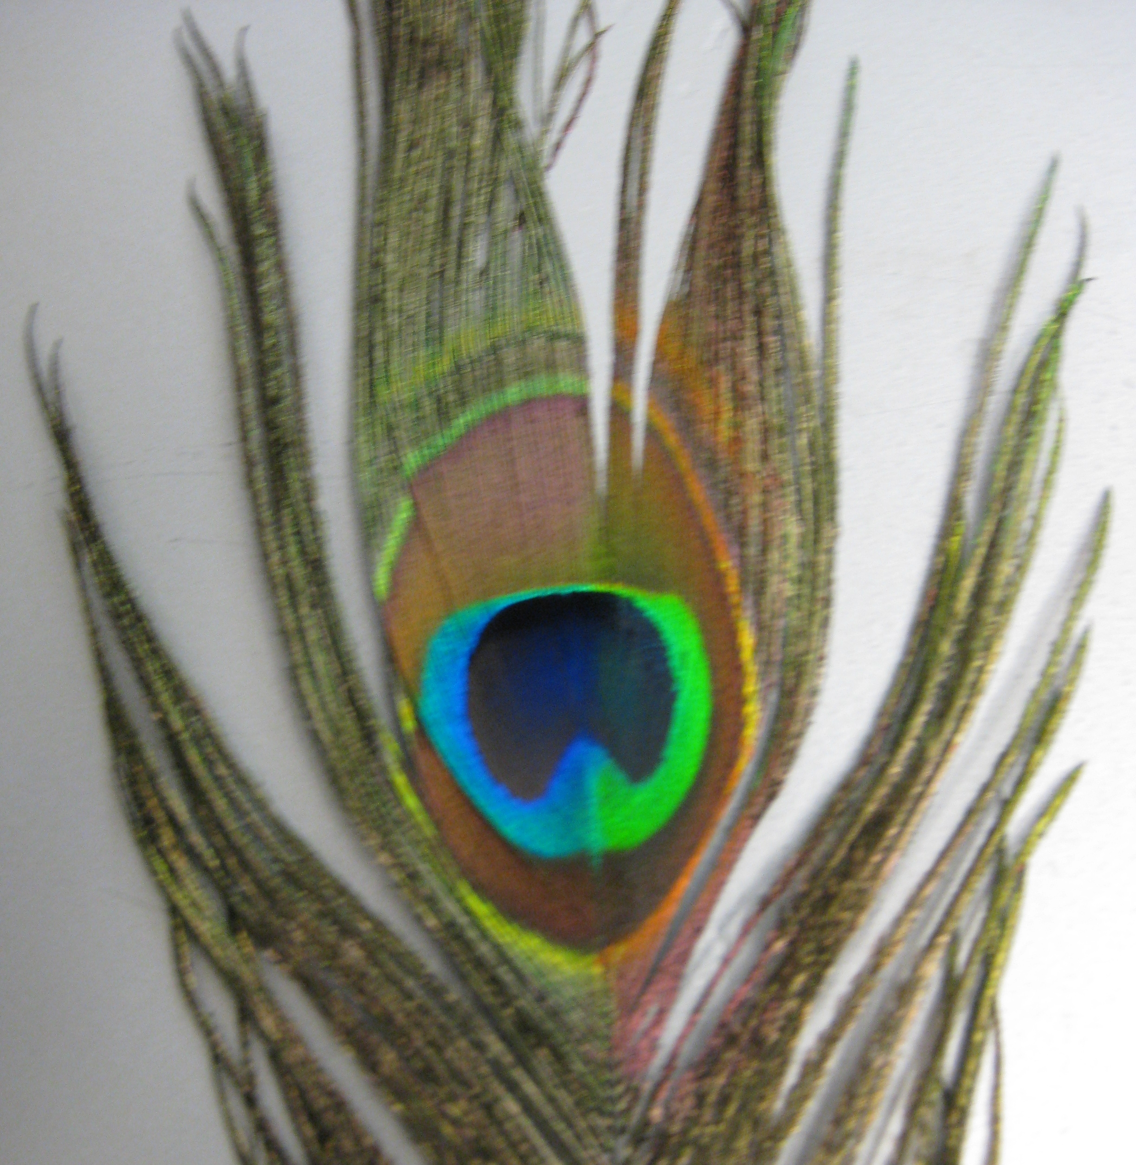
Have them draw up a small amount of water into the pipette, and drop a few drops on only one half of the eye of the peacock feather. (Pipettes are new for many visitors, so you might need to demonstrate how to use a one.) Tell them to gently wipe the water down that half of the feather. Ask them what they see. This is what you should see (the right side is wet):

Is there a difference in color? Why? For comparison, visitors can also drop water on a laminated color photo of a peacock feather (or use the flip book photo). NOTE: Scientists are currently conducting experiments to determine what exactly happens when water is dropped onto peacock feathers. For now, they generally theorize that water fills the spaces between the structures, slightly changing the angle that light is reflected back, and thus the color.

Depending on time, and the visitor’s interest level and science background, you could explain what visible light is and that the water changes the way the light reflects back at us. (It is reflecting back at a different angle.) This changes the color we see. Also explain how this is different from just pigment. Pigments alone do not change color when viewed from different angles. A pigment absorbs all colors of light except the one it reflects back, which is the color we see. You can show a piece of paper with color printing, or color paper with crayons to illustrate pigment. (If you have laminated color pictures, those can also be used here.)

Step 6:
Have the visitor drop one drop of water on the acrylic paint sample and one drop of water on the Lotusan paint sample. Ask them to look closely at the shape of the water drop. Do they see a difference? Lotusan paint claims to be self-cleaning, similar to the lotus leaf. Do you agree with their claim? Hold the samples at an angle. Does the water roll off either sample? Share the remainder of the flipbook describing the Lotus Effect with the visitor. (If you were able to bring plant materials, have the visitor put drops of water on various plant materials. To show the Lotus effect use: Elephant Ear leaves, broccoli leaves, nasturtium leaves, kale, or collard greens, and compare to lettuces.)

Step 7:
Have the visitor drop one drop of water on the piece of cotton and one drop of water on the stain resistant cotton fabric. Tell them that both fabrics are cotton. Have them look closely at the shape of the water drop. Do they see a difference? Ask them to grasp the edges of each piece of fabric and move it around. What happens? What does that remind the visitor of? Does the stain resistant fabric mimic the Lotus effect?

Step 8:
Give your visitor the peacock feather they dropped water onto and one TryThis! card. Explain that the TryThis! card is an iridescence activity they can try at home.

Tips and Troubleshooting:
To be more efficient with large groups, set out stations apart from one another so that multiple visitors can engage simultaneously.

Only set out one peacock feather, one sample of cotton, and one sample of stain-resistant fabric at a time. Replace with fresh dry materials as needed.

The paint samples can be blotted dry with paper towel in between visitors.

Common Visitor Questions

How many peacocks were sacrificed so you could obtain feathers?
None, peacocks naturally shed their feathers once per year.

Will the peacock feather return to its original color once it dries?
Yes, water does not permanently change the structure of the feather.

Going Further…
To encourage inquiry, ask visitors what they have seen in nature that we could potentially mimic to solve a human problem. Take a nature walk and collect materials, then brainstorm ideas. Point out that burrs were the inspiration for the invention of Velcro. (More biomimicry examples are listed in the flip book.)
Newton’s color wheel can be a good tool to explain how visible light and color work if your visitor is interested, and/or time permitting. The color wheel has seven wedges showing the colors in the visible light spectrum (see picture on the left). Spinning the wheel effectively “mixes” the colors (see picture on right), and our eyes can no longer distinguish the different colors. Thus, we see all the colors together as white.
Newton’s Color Wheel
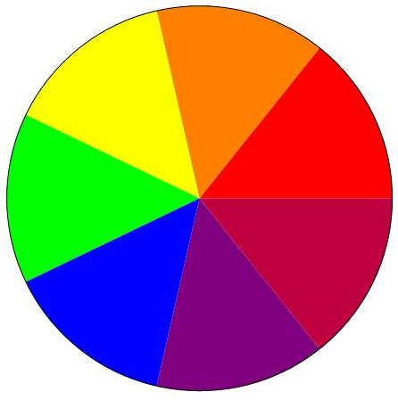
Stationary Spinning
Pictures from Wolfram’s Demonstration Project http://demonstrations.wolfram.com/NewtonsColorWheel/
Here are some resources you can share with your visitors:
Solar photovoltaic holographic technology
http://www.advancedsolarphotonics.com/technology/holographic-technology/

Clean Up

Time: 5-10 minutes

Carefully place everything back into a dedicated bin, wrapping breakable items (such as shells, butterfly wings). Discard leftover water (or pour back into water bottle) and dry the cups. Leave wet fabric, peacock feathers, and pipettes out to dry before putting away.

Universal Design

This program has been designed to be inclusive of visitors, including visitors of different ages, backgrounds, and different physical and cognitive abilities.

To give an inclusive presentation of this program:
1. This program has been designed to be inclusive of visitors, including visitors of different ages, backgrounds, and different physical and cognitive abilities.

2. Supplies for the hands-on activities should be arranged to accommodate visitors of all abilities.

3. Print outs of presentation slides/flip book graphics can be provided to the visitors.

The following features of the program’s design make it accessible:

[X] 1. Repeat and reinforce main ideas and concepts

a. The overarching main idea is presented at the beginning of the program, and reinforced by the hands-on activities.

b. The program provides verbal, visual and tactile entry points into the program’s main message and learning objectives.

c. The presenter provides a verbal and visual explanation of the nanoscale and the connection of biomimicry and nanotechnology. The hands-on activities provide a tactile explanation of the connections between nanotechnology and biomimicry.

d. The size of the nanoscale is conveyed verbally and visually during the presentation through interpersonal interactions and graphics on the slides.

e. The differences in how nanoscale things behave are explained verbally and visually (in the presentation slides and through the comparison of pigmented photos vs. nano-structured color in nature).

f. The take-away card reinforces the main ideas and concepts visually and verbally.

[X] 2. Provide multiple entry points and multiple ways of engagement.

a. The program engages visitors with two (or more) hands-on activities, and a guided discussion that helps them understand biomimicry.

[X] 3. Provide physical and sensory access to all aspects of the program.

a. The presenter verbally explains and physically demonstrates all aspects of the hands-on activities.

b. The presenter can vary the pace of the program to suit the audience, providing extra time for working or additional discussion when necessary.

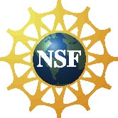 | This project was supported by the National Science Foundation under Awards Nos. 0940143 (NISE Net) and 0520527 (UW MRSEC). Any opinions, findings, and conclusions or recommendations expressed in this program are those of the author and do not necessarily reflect the views of the Foundation.
 | Published under a Creative Commons Attribution-Noncommercial-ShareAlike license: http://creativecommons.org/licenses/by-nc-sa/3.0/us/

