

Exploring Materials—Graphene
Try this!
- Take a piece of tape about 3 inches long. Fold over the two ends so you have small, non-sticky tabs to hold.  - Use the tweezers to put a flake of graphite on the sticky side of the tape.  - Fold the tape in half over the graphite and peel it apart again. Do this several more times.  - Stick your tape onto a white card. What do you see? | 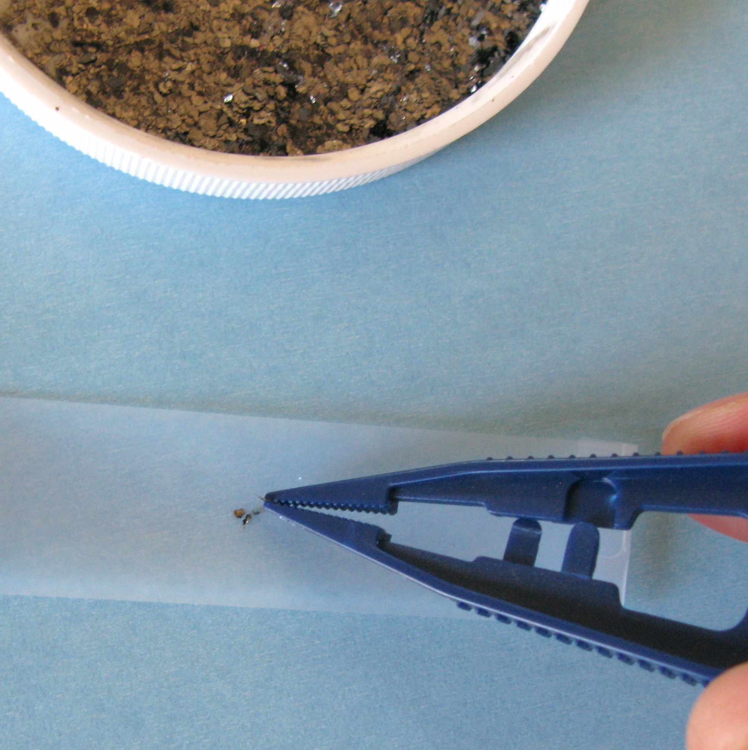 | 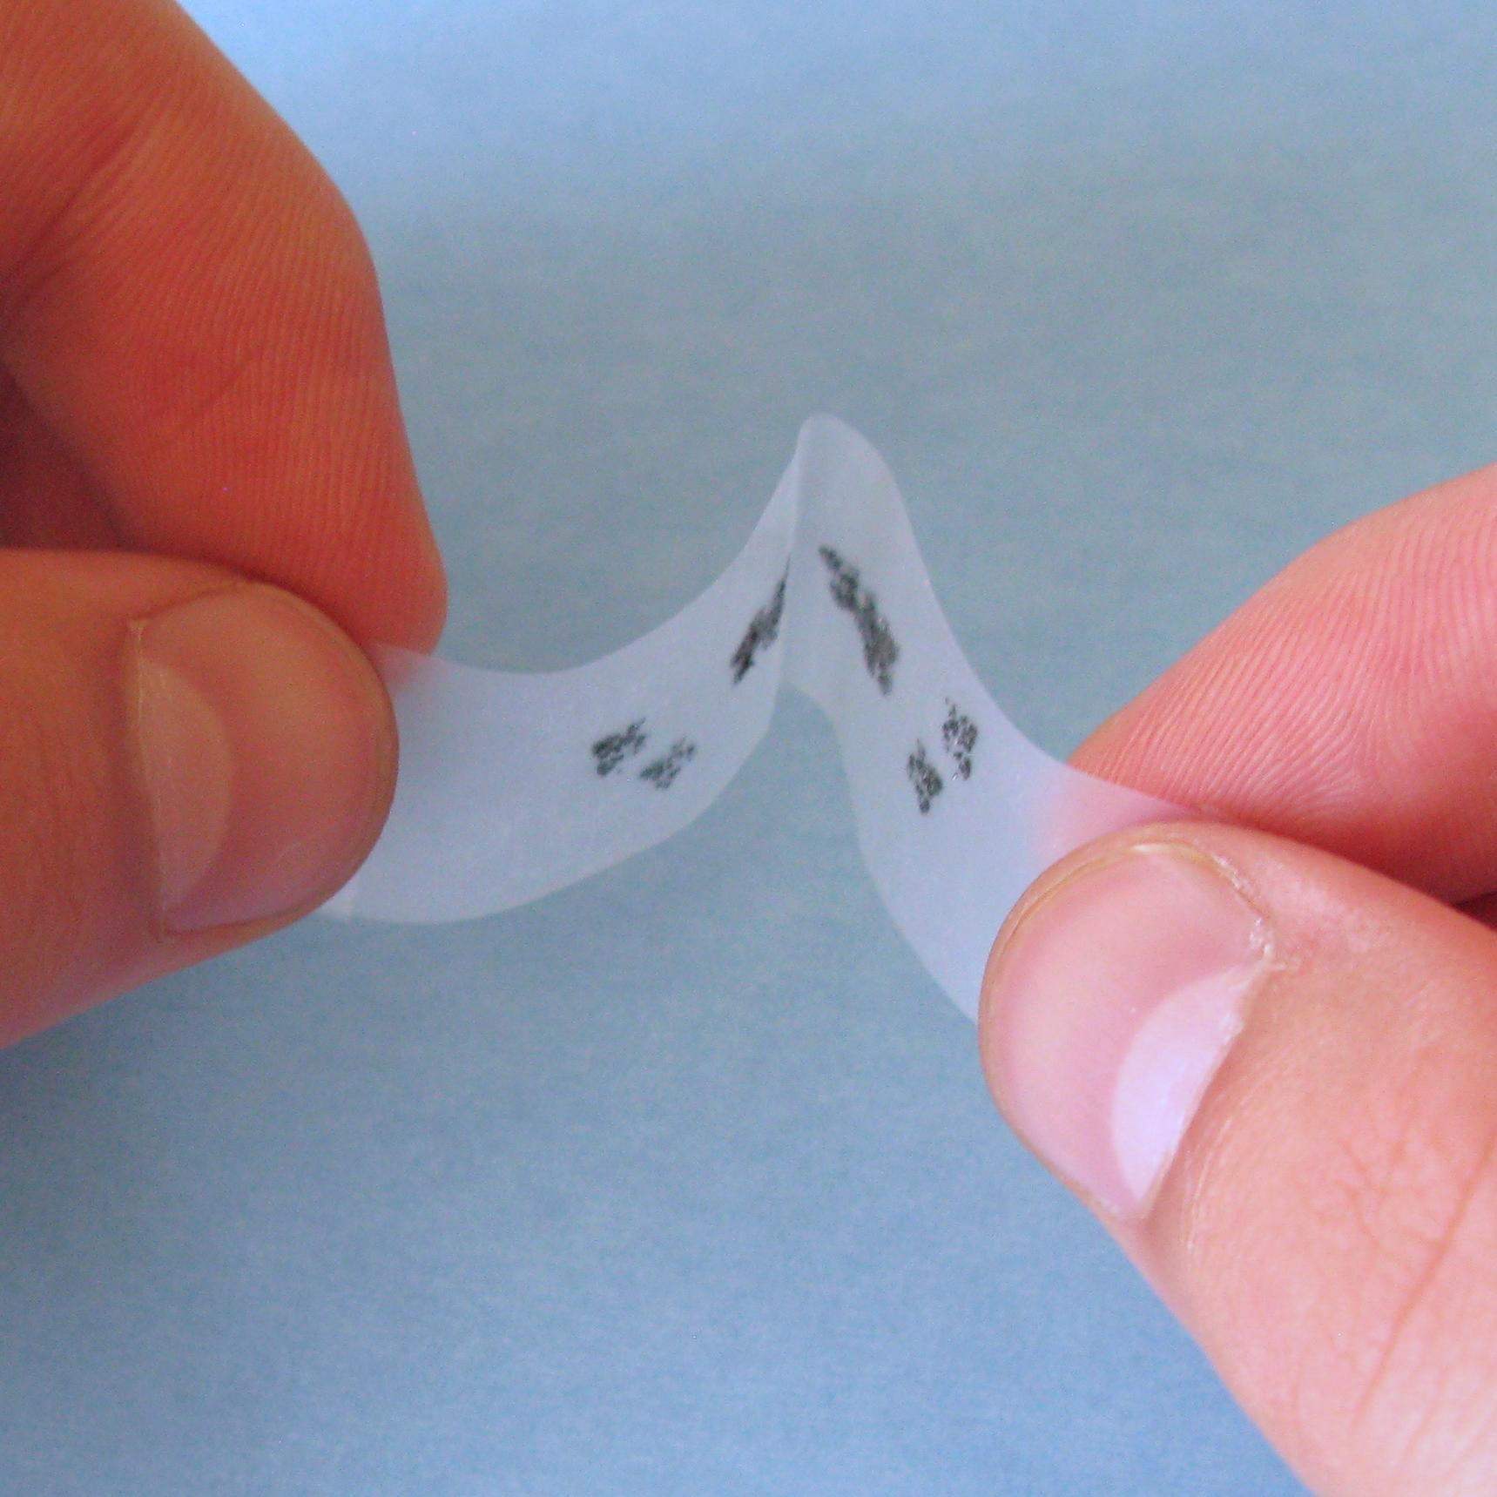

What’s going on?  You’ve made very thin layers of graphite—and maybe even some graphene, the thinnest material that exists! Graphene is a single layer of carbon atoms arranged in a honeycomb pattern.  You started with a flake of graphite, which is a mineral made of many layers of graphene stacked on top of each other. Graphite is the material in pencils, commonly called “pencil lead.” This simple technique for making graphene from graphite and tape—plus very insightful measurements of its properties—won Andre Geim and Konstantin Novoselov a Nobel Prize in Physics in 2010! | 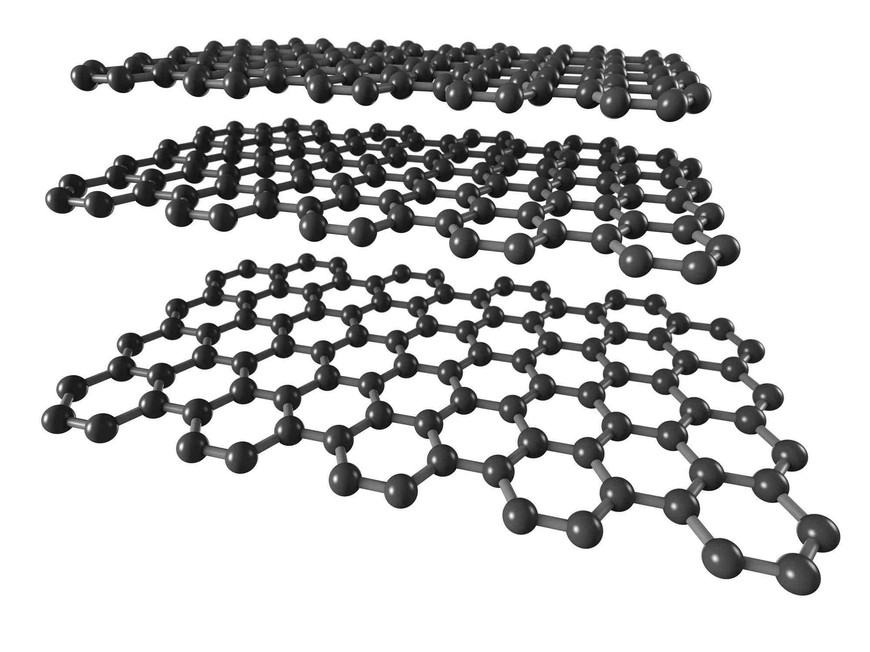  Graphite

Now try…  - Use the pencil to color in the box on your card. Be sure to fill it in completely. You’re creating a thin layer of graphite.  - Touch the two alligator clips to the layer of graphite. What happens?  What’s going on?  The light bulb lights up! The graphite on the card conducts electricity, completing the electrical circuit. Like the thicker layers of graphite on your card, the thinner layers of graphene on your piece of tape could conduct electricity. | 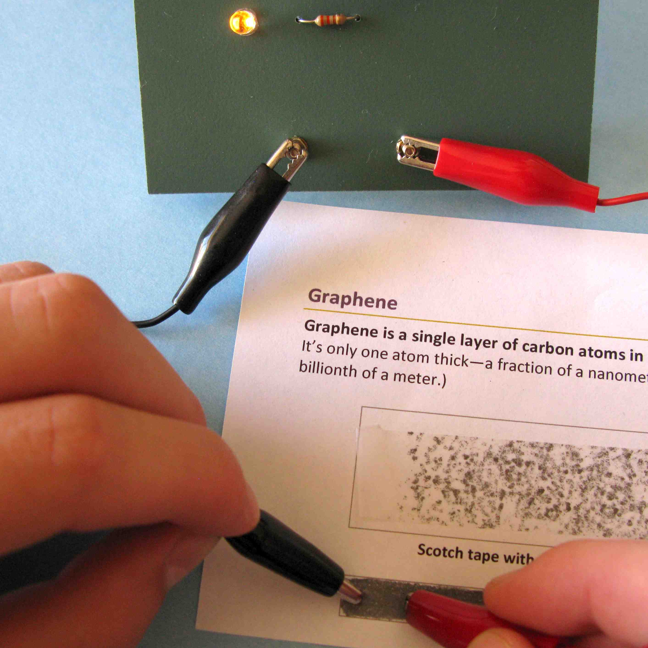
How is this nano?

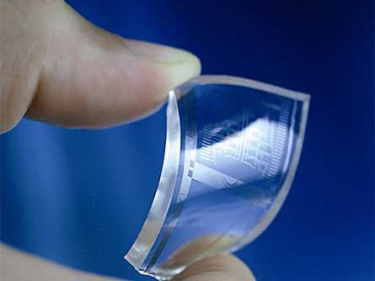  Flexible graphene circuit | Graphene is a single layer of carbon atoms arranged in a honeycomb pattern. Graphene is only one atom thick—that’s a fraction of a nanometer! (A nanometer is a billionth of a meter.)  In the field of nanotechnology, scientists and engineers make new, nano-sized materials and devices. Graphene has a lot of potential in nanotechnology because of its useful properties: it’s flexible, super-strong, nearly transparent, and conducts electricity. Computer chip manufacturers are developing circuits from graphene, by modifying it to make it a semiconductor. One day, graphene could be used to make see-through, bendable electronic displays, and tiny, fast computer chips.

Learning objectives
- Graphene is a single layer of carbon atoms arranged in a honeycomb pattern.
- Graphene can be a semi-conductor.

Materials  - Flakes of graphite  - Plastic tweezers with a pointed tip  - Scotch tape  - White activity cards (or index cards)  - Soft drawing pencils (6B is best)  - Pencil sharpener  - Battery and bulb circuit (9v battery, 9v snap connectors, 5mm LED bulb, 330 Ohm resistor, two insulated leads)  - “Graphene” image sheet  - Photocopy master for activity cards | 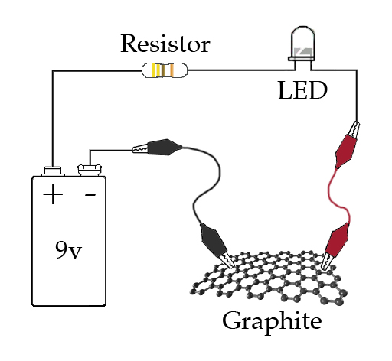Battery and bulb circuit

Graphite flakes can be purchased from www.graphene-supermarket.com (natural Kish graphite, grade 200, #SKU-NKG-0501).
Battery and bulb circuit materials can be purchased from www.radioshack.com (LED bulb #276-021, 9v battery #55039849, battery connectors #270-324, resistor #271-1113, leads #278-1156).

Note to the presenter
If you have a molecular model set, you can build a model of graphene to supplement the illustrations in this activity.

Related educational resources
The NISE Network online catalog (www.nisenet.org/catalog) contains additional resources to introduce visitors to atoms, molecules, and nanomaterials:
- Public programs include Balloon Nanotubes, Electric Squeeze, Forms of Carbon, World of Carbon Nanotubes, and Tiny Particles, Big Trouble!
- NanoDays activities include Exploring Materials—Ferrofluid, Exploring Materials—Hydrogel, Exploring Materials—Liquid Crystals, Exploring Materials—Nano Gold, Exploring Materials—Thin Films, and Exploring Structures—Buckyballs.
- Media include What Happens in a NanoLab? and Zoom Into a Computer Chip.
- Exhibits include NanoLab.

Graphene Background Information

What is graphene?  Graphene is a single layer of carbon atoms arranged in a honeycomb pattern. Graphene is only one atom thick—that’s a fraction of a nanometer! (A nanometer is a billionth of a meter.)  Andre Geim and Konstantin Novoselov created thin layers of graphite by peeling apart tiny flakes using scotch tape. When they measured their results, they were surprised to learn they could create layers of a single atom thick! Before their work, scientists didn’t think it was possible to create a sheet of carbon only one atom thick. | 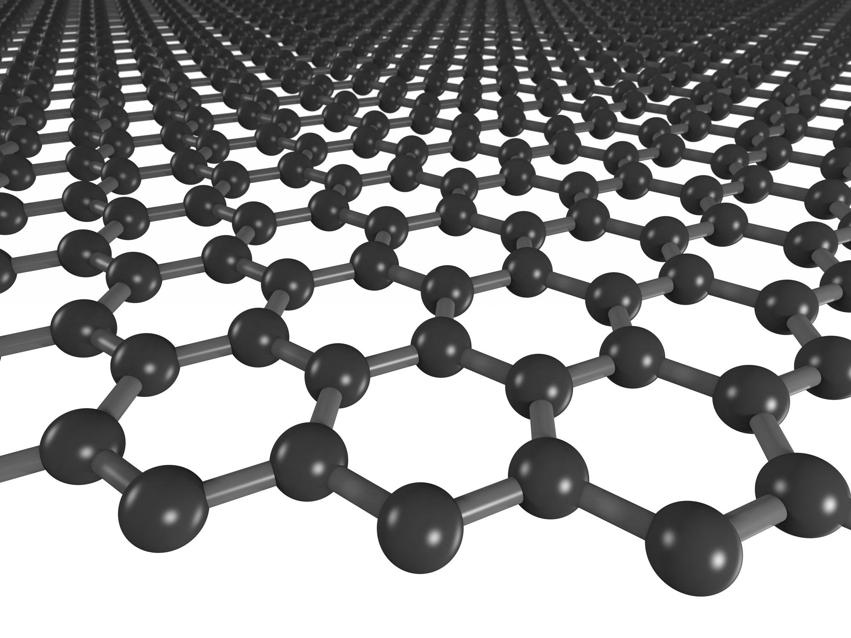  Graphene
Graphene has many exciting potential uses, and this simple method makes it possible for many scientists to study and build things from it. Geim and Novoselev won a Nobel Prize in Physics for their work in 2010.

Graphene is just one form of carbon. Carbon atoms can bond together into many different structures that have very different properties.

What other forms can carbon take?  Carbon can form diamond, the hardest natural material known on Earth. But it can also form graphite, a much softer material (commonly known as pencil “lead”). Both diamonds and graphite are made entirely from carbon. They have different properties because the carbon atoms are arranged differently at the nanoscale.  Carbon can also form two other tiny, nanometer-sized structures that are too small to see: buckyballs and carbon nanotubes. Carbon nanotubes are long, hollow tubes. They look like sheets of graphene rolled up. Buckyballs have a soccer-ball shape. | 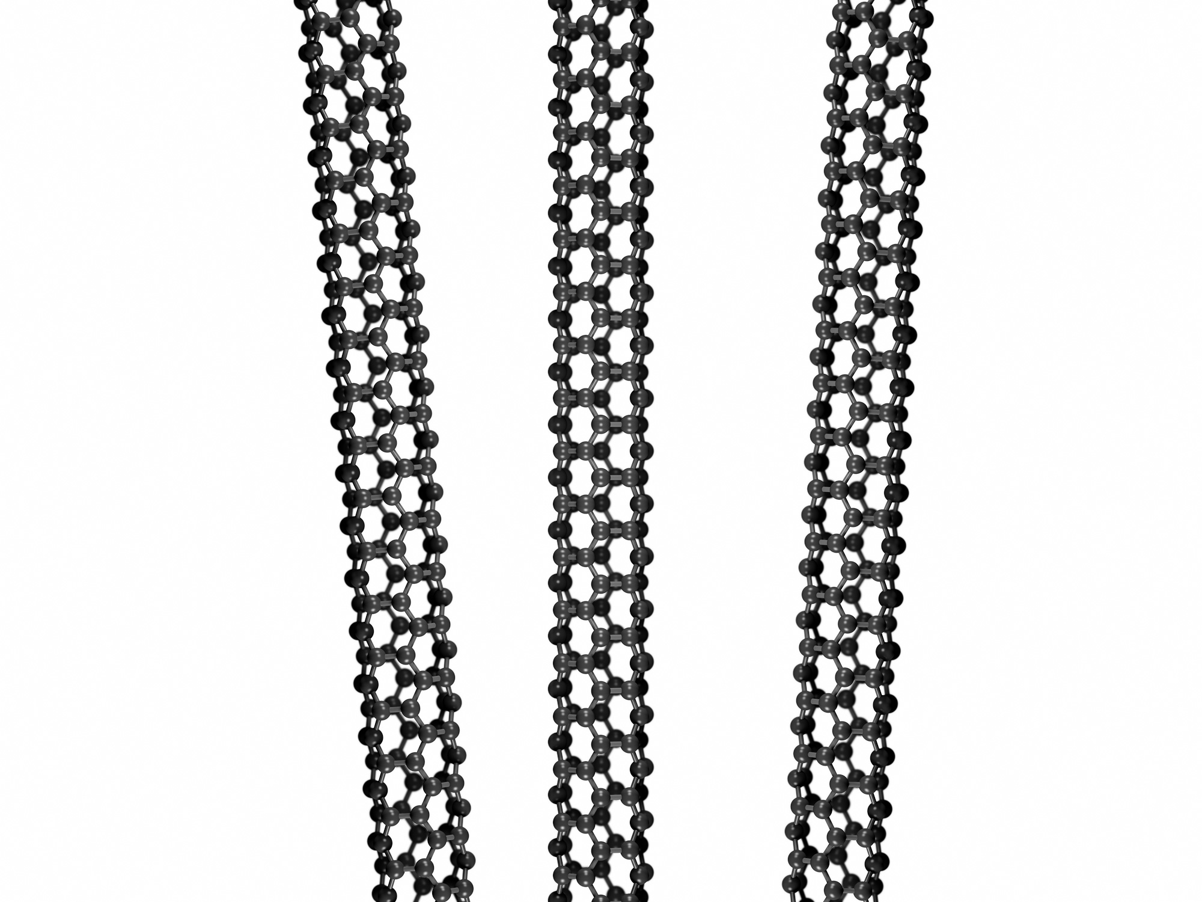  Carbon nanotubes | 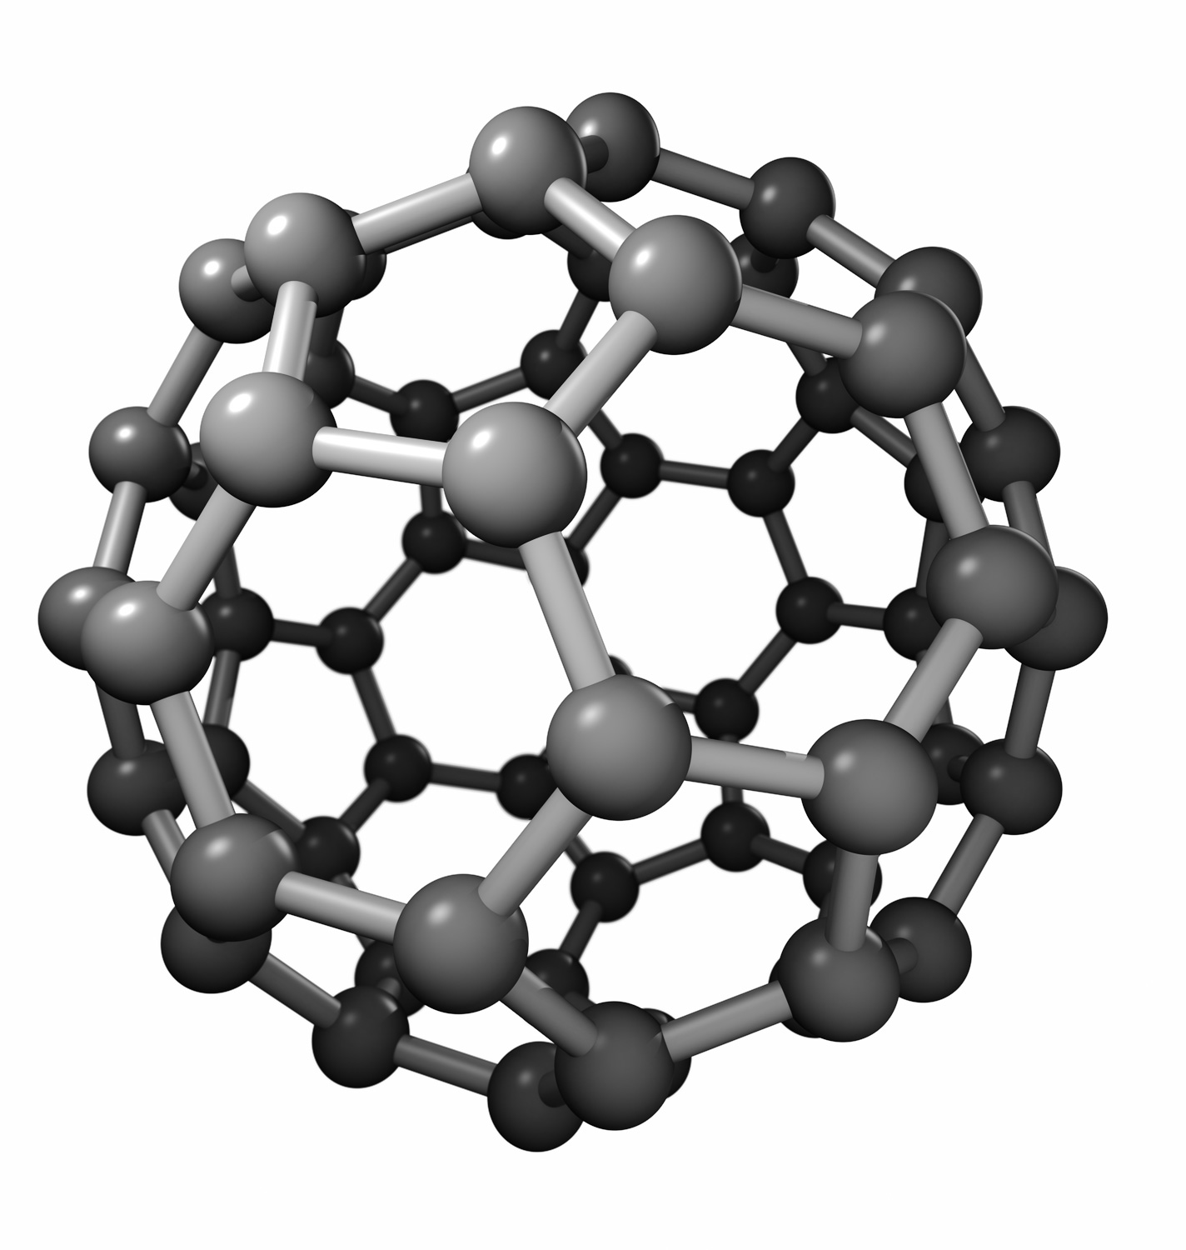  Buckyball

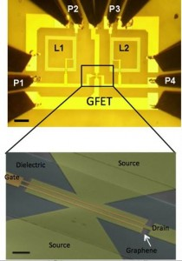  Graphene integrated circuit | How is graphene used?  Graphene’s properties make it potentially useful in many ways. It’s 100 times stronger than steel. (A thin sheet of graphene could support an elephant!) It’s also flexible and nearly transparent. And it’s an excellent conductor of electricity (slightly better than copper).  Graphene has a lot of potential in nanotechnology. IBM, Intel, Samsung, and other computer chip manufacturers are researching ways to use graphene in computer chips, by modifying it to make it a semiconductor. Researchers are also using graphene in composite materials, creating plastics that conduct electricity. Eventually, graphene might be in thin, flexible electronic components, transparent touch screens, and organic solar cells.

Credits and rights
Image of flexible graphene circuit courtesy Ji Hye Hong.
Image of graphene integrated circuit courtesy IBM.
Image of graphene sheet courtesy Jannick C. Meyer.
The background information presented in this guide was adapted from:
- “Applications Activity: Nanoarchitecture,” developed by the National Science Foundation-supported Internships in Public Science Education (IPSE) Program at the Materials Research Science and Engineering Center (MRSEC) on Nanostructured Materials and Interfaces at the University of Wisconsin-Madison. The original activity is available at: mrsec.wisc.edu/Edetc/IPSE/educators/carbon.html.
- “Carbon Nanotubes & Buckyballs,” developed by the National Science Foundation-supported Materials Research Science and Engineering Center (MRSEC) on Nanostructured Interfaces at the University of Wisconsin-Madison. The original activity is available at: mrsec.wisc.edu/Edetc/nanoquest/carbon/.
- “Nanoarchitecture: Forms of Carbon,” developed by the National Science Foundation-supported Internships in Public Science Education (IPSE) Program at the Materials Research Science and Engineering Center (MRSEC) on Nanostructured Materials and Interfaces at the University of Wisconsin-Madison. The original activity is available at: mrsec.wisc.edu/Edetc/IPSE/educators/activities/carbon.html.
 | This project was supported by the National Science Foundation under Award No. 0940143. Any opinions, findings, and conclusions or recommendations expressed in this program are those of the author and do not necessarily reflect the views of the Foundation.

Copyright 2011, Sciencenter, Ithaca, NY. Published under a Creative Commons Attribution-Noncommercial-ShareAlike license: http://creativecommons.org/licenses/by-nc-sa/3.0/us/.

