

Exploring Structures—DNA

Try this!  - Use a pipette to add a squirt of wheat germ liquid into a plastic tube. Fill it halfway.  Tip: Be sure not to get wheat germ solids in the pipette!  - Use the dropper bottle to add alcohol to the tube. Fill it almost all the way to the top. | 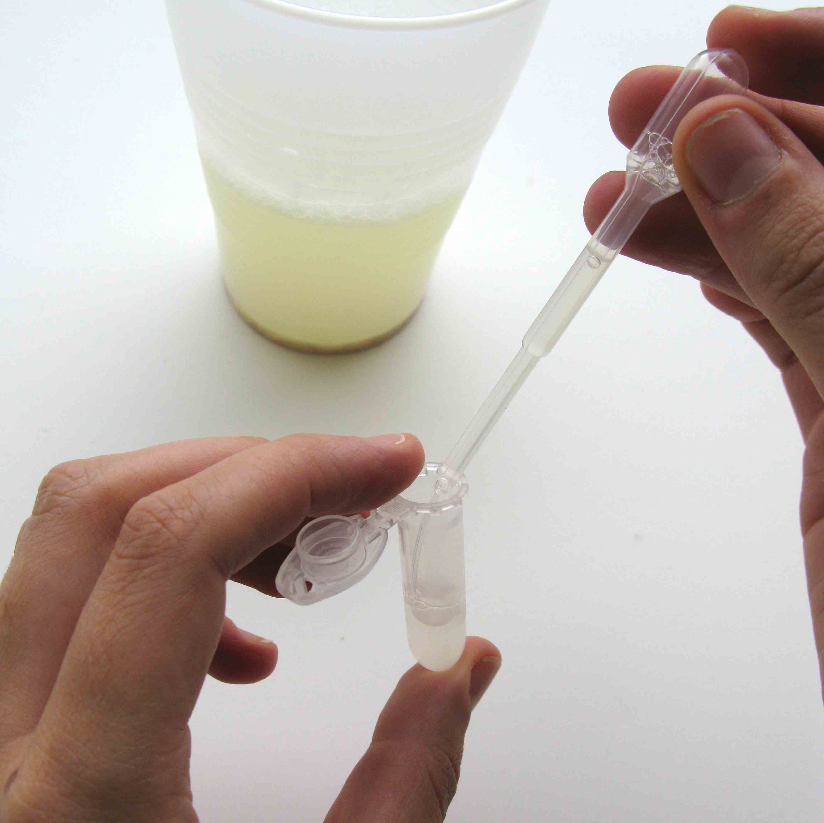 | 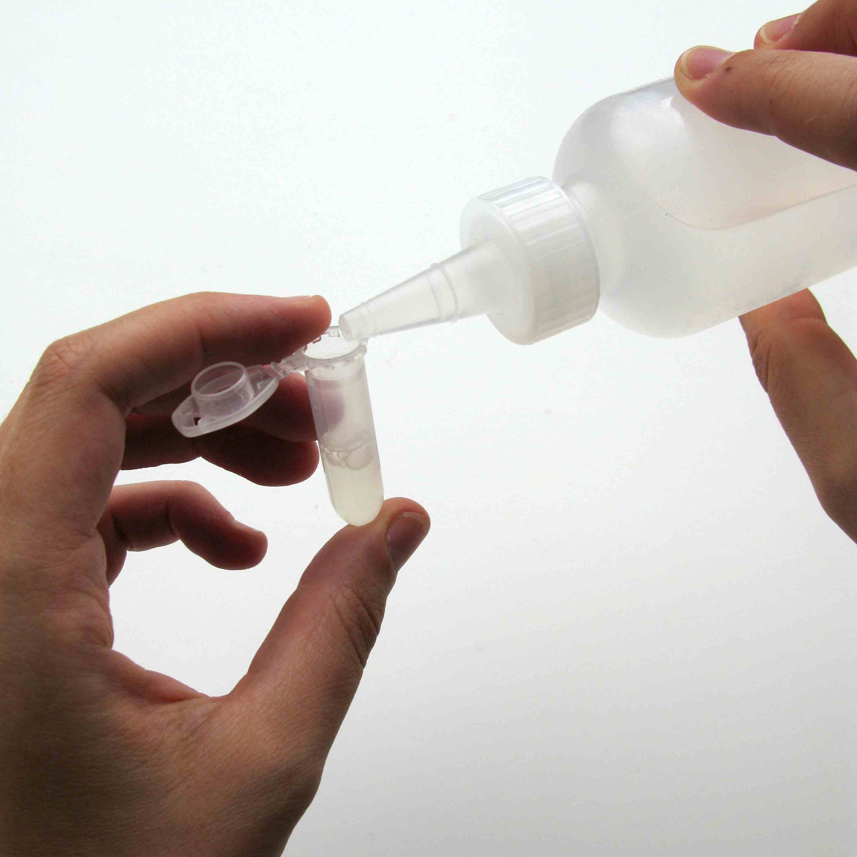

- Put a piece of yarn over the edge of the cap, and snap it shut.  - Gently rock the tube a few times, and look inside. Can you see anything forming in the tube?  - Tie the yarn—you have a DNA necklace!  What’s going on? | 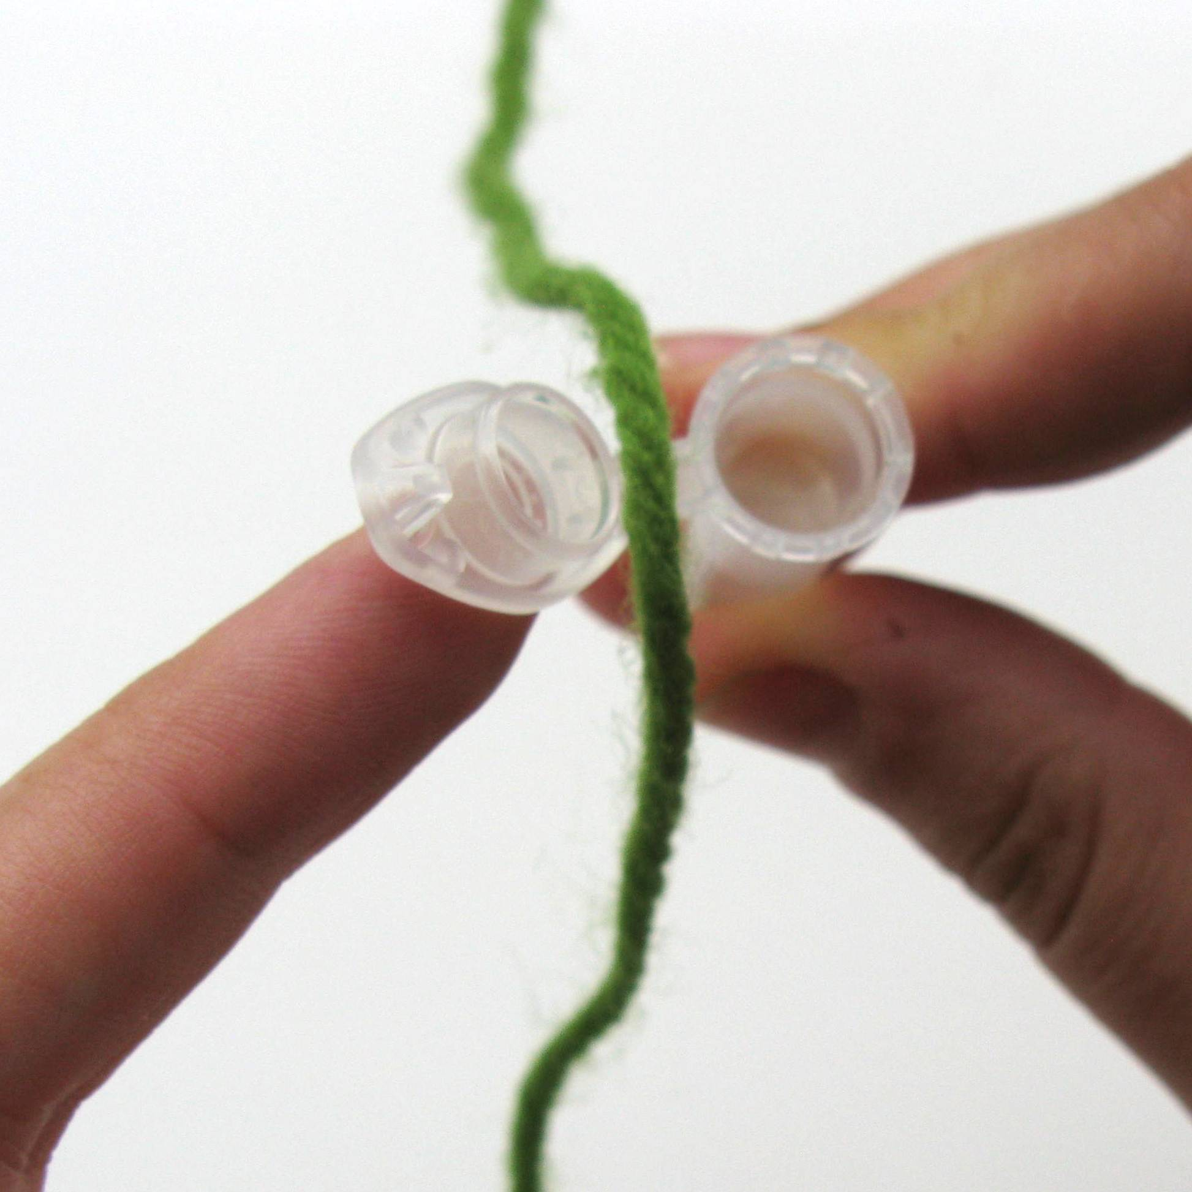 | 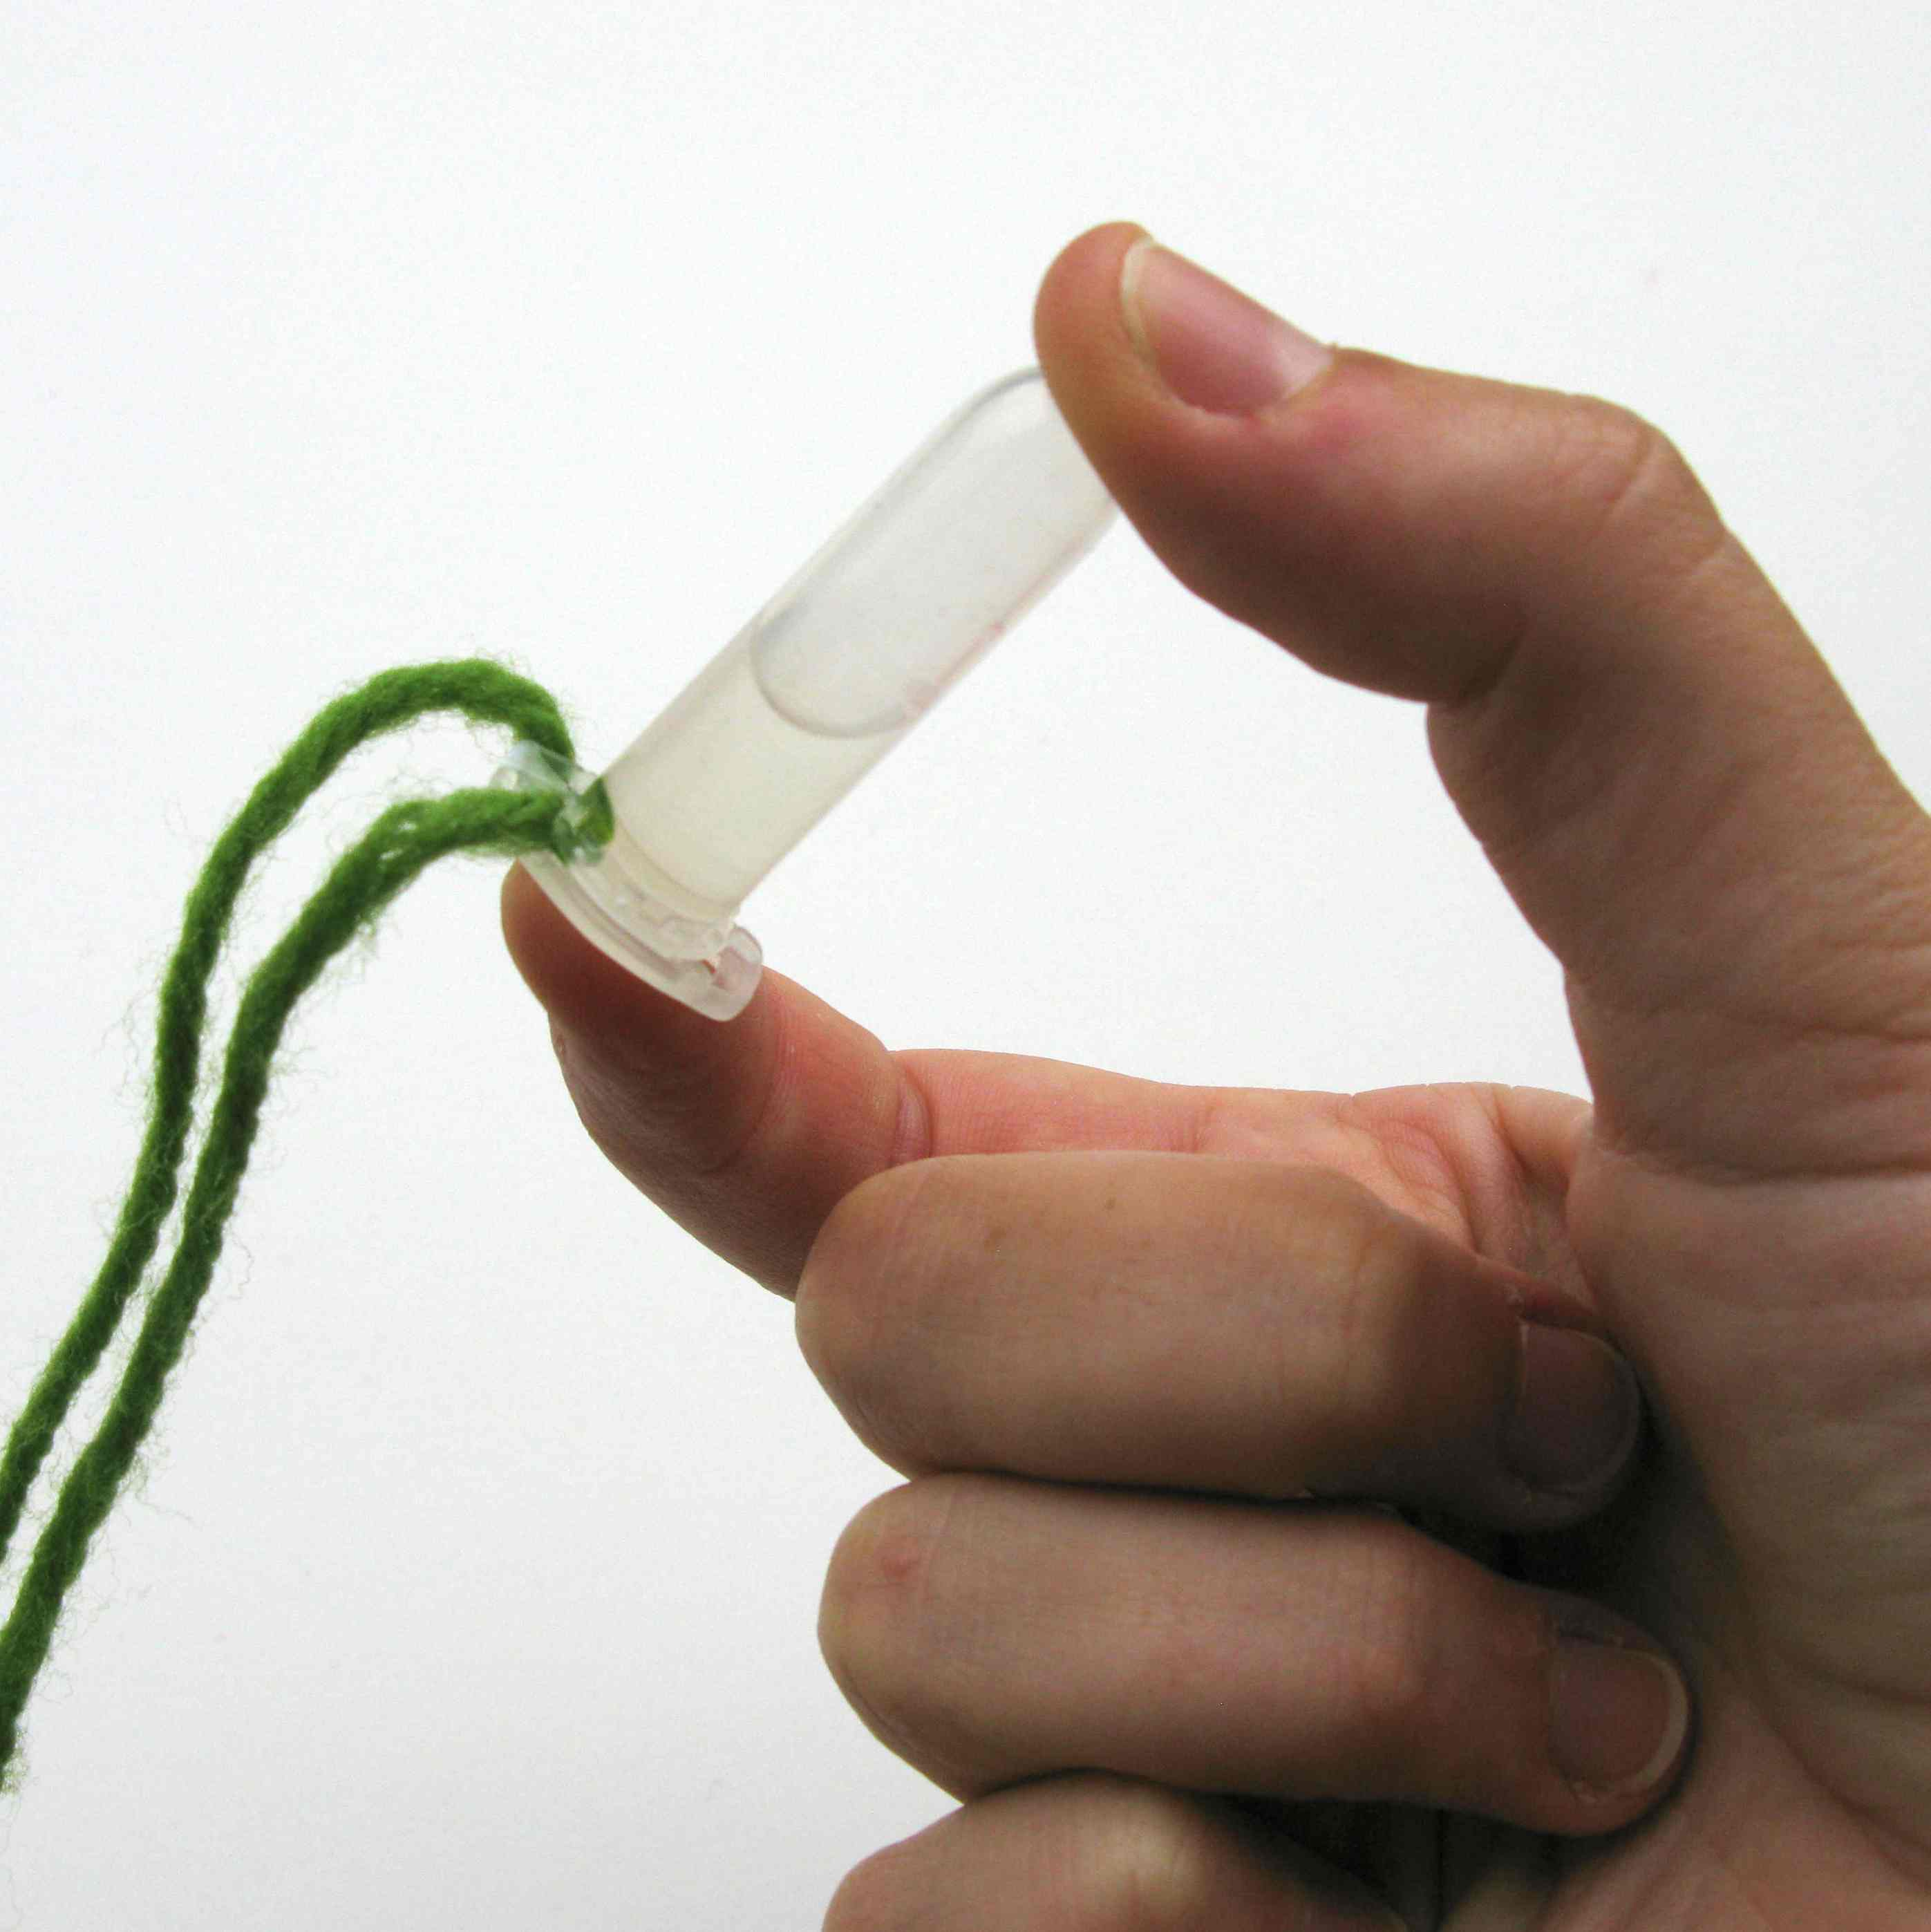

That white, slimy stuff you see is DNA! When you added the alcohol to the wheat germ, you made the DNA clump together.  DNA is in every plant and animal cell. It helps cells to grow and do their jobs. DNA is an example of the way things in nature build themselves, or self-assemble. | 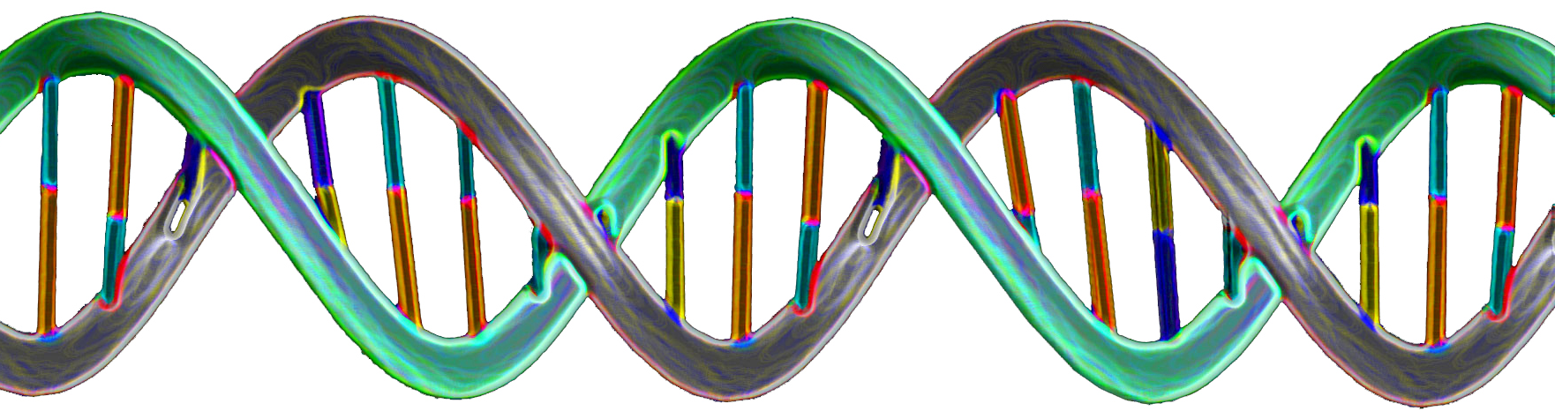  DNA  2 nm wide
How is this nano?
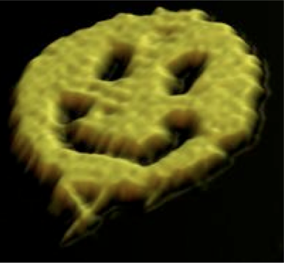  Smiley face made of DNA  100 nm wide | Self-assembly is a process by which molecules and cells form themselves into functional structures. Self-assembly occurs in nature—snowflakes, soap bubbles, and DNA are just three examples of things that build themselves.  Researchers in the field of nanotechnology are using materials that self-assemble—like DNA—to create new materials and technologies smaller than 100 nanometers in size. (A nanometer is a billionth of a meter.)  For example, at Cal Tech a researcher got DNA to fold itself up into a nano-sized smiley face! And at Arizona State University, scientists built a nano-sized spider robot that can walk along a sheet of folded-up DNA.

Learning objectives
- Self-assembly is a process by which molecules and cells form themselves into functional structures.
- Researchers in the field of nanotechnology are using materials that self-assemble—like DNA—to create new materials and technologies smaller than 100 nanometers in size.

Materials
For the activity:  - Cup of wheat germ liquid  - Dropper bottle of alcohol  - 1.5 ml microcentrifuge tubes (Eppendorf tubes)  - Pipettes (1 ml)  - Yarn  - Scissors  - Ice pack  - Small plastic bin | For the advance preparation:  - Raw wheat germ (not processed)  - Hot water  - Meat tenderizer  - Shampoo (or dishwashing detergent)  - Plastic spoon  - Isopropyl alcohol or ethyl alcohol (91%)  - Cup  - Dropper bottle

Microcentrifuge tubes are available from www.amazon.com (look for 1.5 ml tubes with snap caps).
Raw wheat germ is available from grocery stores.

Notes to the presenter
SAFETY: Do not allow visitors to ingest any of the materials!
You must prepare some of the materials ahead of time—see advance preparation instructions below.
Children and individuals with limited dexterity might need help manipulating the materials in this activity.

Advance preparation
Several hours before the activity
- Put the ice pack in the freezer.
- Put the alcohol in the refrigerator.

30 minutes before the activity
Prepare the cup of wheat germ liquid (enough for 20 visitors):
- Add ½ cup hot water to the cup.
- Add 1 spoon of wheat germ to the cup of hot water.
- Add ½ spoon of meat tenderizer to the cup.
- Add a squirt of shampoo (about a teaspoon).
- Stir well.
- Let mixture settle for 15 minutes.

Prepare the dropper bottle of alcohol:
- Fill the dropper bottle with chilled alcohol.
- Place the ice pack in the small plastic bin.
- While you do the activity, set the dropper bottle of alcohol on the ice pack to keep it cold.

DNA Background Information

What is DNA?  DNA stands for deoxyribonucleic acid. DNA is present inside the cells of every living thing. It contains the chemical instructions and genetic information to help organisms develop and function.  DNA is made of two long strands twisted together in a structure called a double helix. It looks like a long spiral ladder. DNA is only two nanometers across, but if you could unravel all the strands of DNA from just one human cell and line them up end to end, you’d have a thread two meters long! | 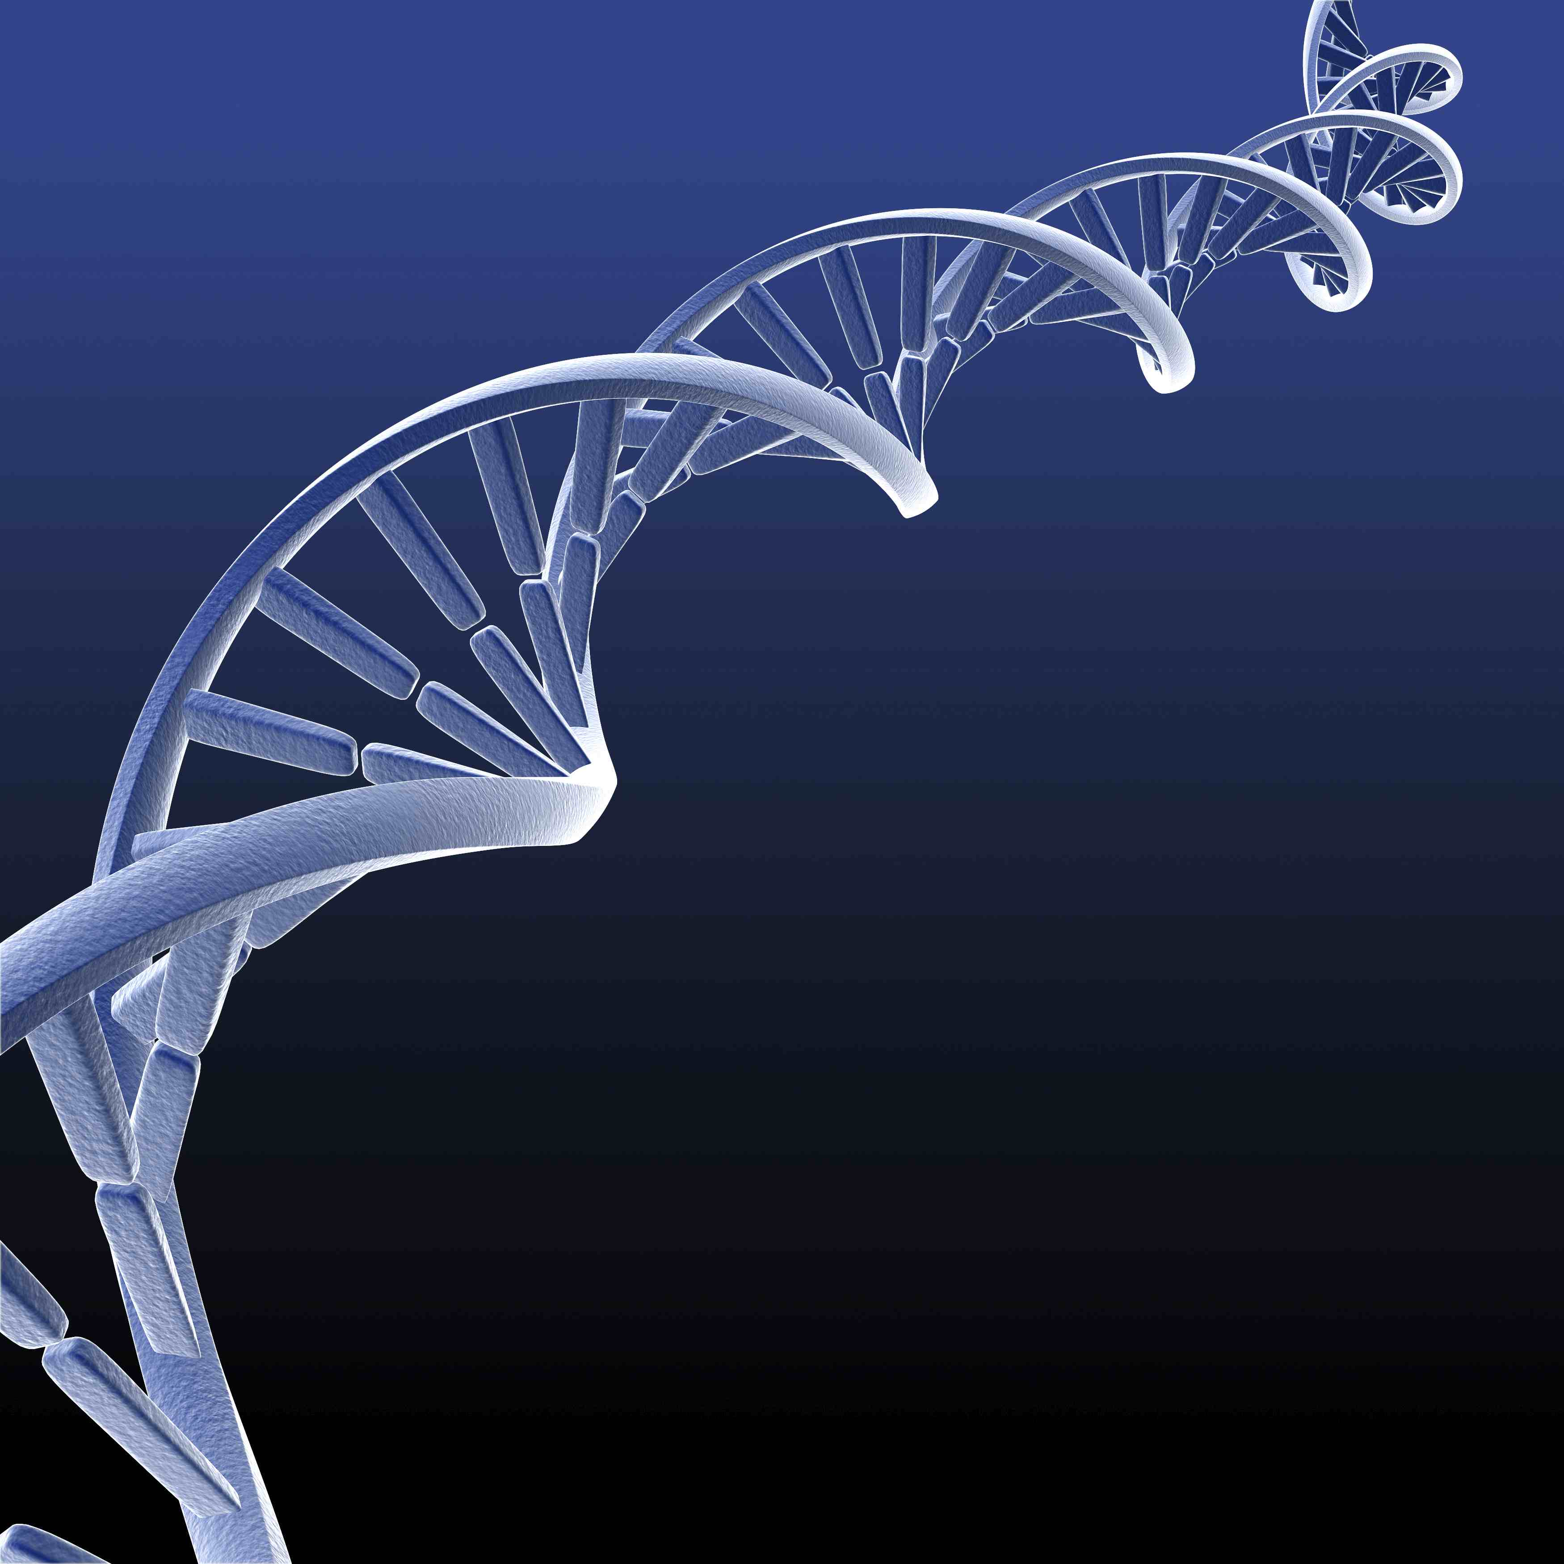
The rungs of a DNA ladder are made of four different types of molecules, called base pairs. Adenine (A) and Thymine (T) are one pair, and Guanine (G) and Cytosine (C) are the other. The base pairs always join in the same way. A and T always join together, and G and C always join together. The instructions that help our bodies grow and live are carried in the sequence of the base pairs, and are called genes.

The human genome (all of our genetic material) is contained in 46 long, thin “threads” of DNA called chromosomes. We inherit 23 chromosomes from each of our parents, for a total of 46 chromosomes. Most of our DNA (99.5%) is the same as everyone else’s, but a small amount is unique. Only identical twins have exactly the same DNA as another person.
How does DNA extraction work?
You can extract DNA from many different things, including wheat germ, which is a plant seed. In this activity, shampoo and meat tenderizer break down the cell membrane so the contents of the cell come out, including the DNA. The alcohol makes the tiny pieces of DNA precipitate, or clump together.

When enough DNA has precipitated, you can see it. But each individual strand of DNA is still too small to see—there are millions of strands of DNA in a visible clump!

How is DNA used in nanotechnology?
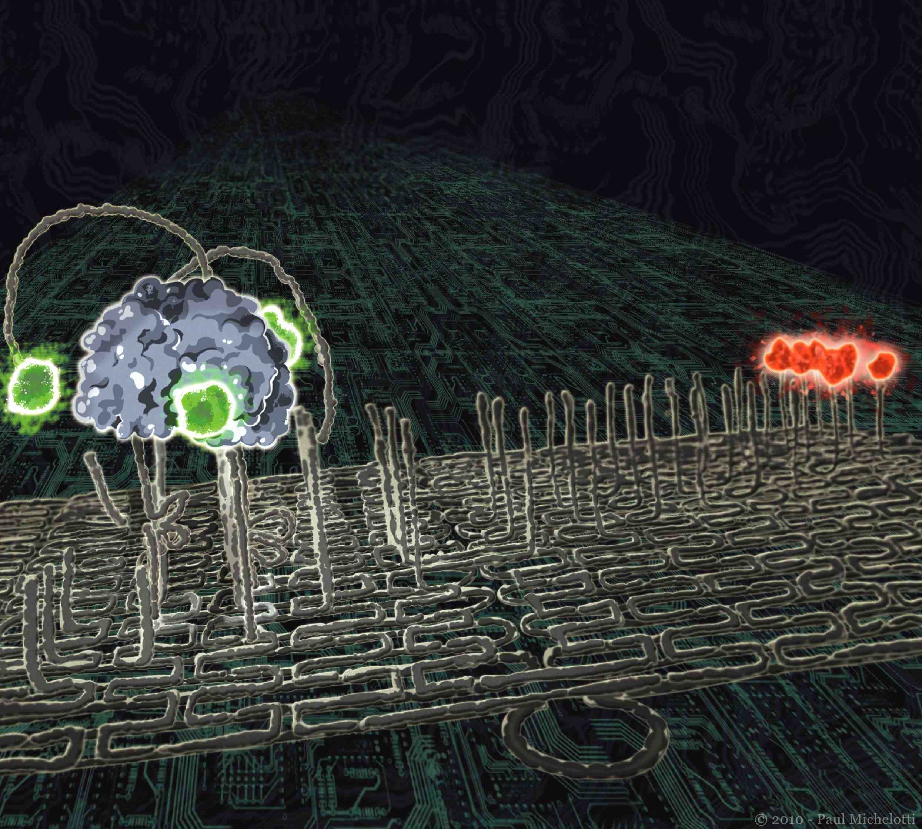  Tiny robot made of DNA  DNA is 2 nm wide | Self-assembly is a process by which molecules and cells form themselves into functional structures. Self-assembly occurs in nature—snowflakes, soap bubbles, and DNA are just three examples of things that build themselves.  Researchers in the field of nanotechnology are using materials that self-assemble—like DNA—to create new technologies smaller than 100 nanometers in size. (A nanometer is a billionth of a meter.)  For example, at Cal Tech a researcher got DNA to fold itself up into a nano-sized smiley face! And at Arizona State University scientists built a nanoscale spider robot that can walk along a sheet of folded-up DNA.

Related educational resources
The NISE Network online catalog (www.nisenet.org/catalog) contains additional resources to introduce visitors to DNA and self-assembly:
- Public programs include DNA Nanotechnology, Snowflakes: Nano at its Coolest, and Sweet Self-Assembly.
- NanoDays activities include Exploring Fabrication—Self-Assembly, Exploring Fabrication—Gummy Capsules, Exploring Size—Memory Game, Exploring Size—Powers of Ten Game, and Exploring Size—StretchAbility.
- Media include the poster and book Multimedia Zoom into a Human Hand and Zoom Into the Human Bloodstream.
- Exhibits include Creating Nanomaterials.

Credits and rights
This activity was adapted from DNA Nanotechnology, developed by the Sciencenter for the NISE Network. The original program is available at www.nisenet.org/catalog.

Colorized image of DNA by James J. Caras, National Science Foundation.

Image of DNA smiley face courtesy Paul Rothemund, California Institute of Technology.

Image of DNA spider robot courtesy of Paul Michelotti, showing research by Kyle Lund at Arizona State University.

 | This project was supported by the National Science Foundation under Award No. 0940143. Any opinions, findings, and conclusions or recommendations expressed in this program are those of the author and do not necessarily reflect the views of the Foundation.

Copyright 2011, Sciencenter, Ithaca, NY. Published under a Creative Commons Attribution-Noncommercial-ShareAlike license: http://creativecommons.org/licenses/by-nc-sa/3.0/us/.

