

Exploring Structures—Butterfly

Try this!  - Examine the blue and yellow butterflies. Try tilting the case to see the butterflies from different angles. And be sure to look at both the front and back!  - Shine the light through the butterflies, holding the light underneath the case. Do the butterflies look the same with the light passing through them?  Tip: Squeeze the mini-light to turn it on. | 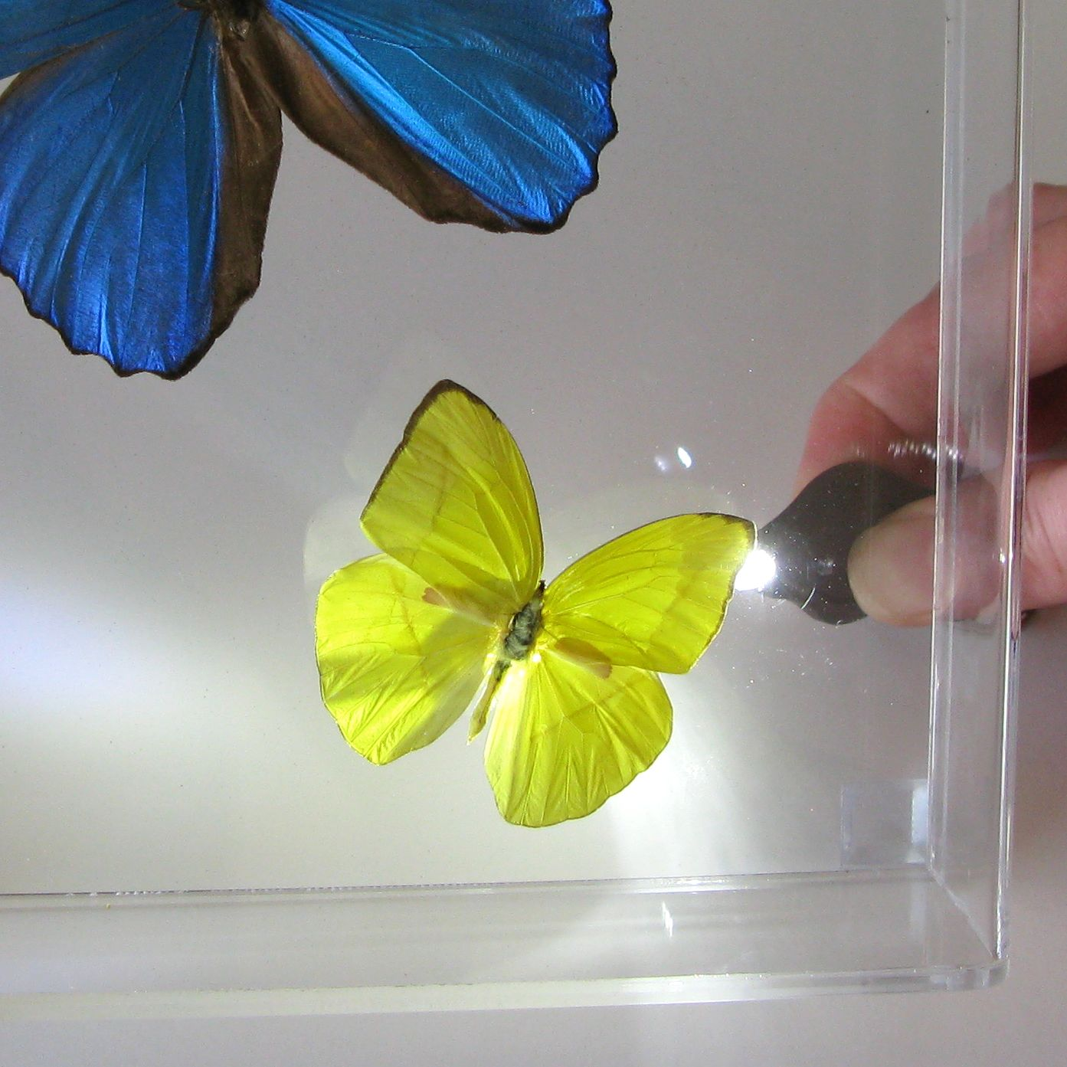

What’s going on?  When you turn on the light, the yellow butterfly stays yellow, but the blue butterfly turns brown! That’s because the yellow color comes from pigment, but the blue is created by the interference of light bouncing off tiny nanostructures.  The Blue Morpho’s wings have very small overlapping scales covered with tiny “ribs.” The size and arrangement of these nanostructures makes the wings look blue—but they’re actually transparent! There’s an air space of a few nanometers between the ribs. Light waves bouncing off the top and bottom surfaces of neighboring ribs interfere with each other. Most light waves are cancelled by the interference and only certain wavelengths—seen as colors—bounce back to your eyes. So when you look at the front of the butterfly, it’s a beautiful, iridescent blue.  When the bright light passes through the Blue Morpho’s wings, the effect is lost and you see the wings’ brown undersides. The back side of the wings is colored by pigment—so the brown side always looks brown. | 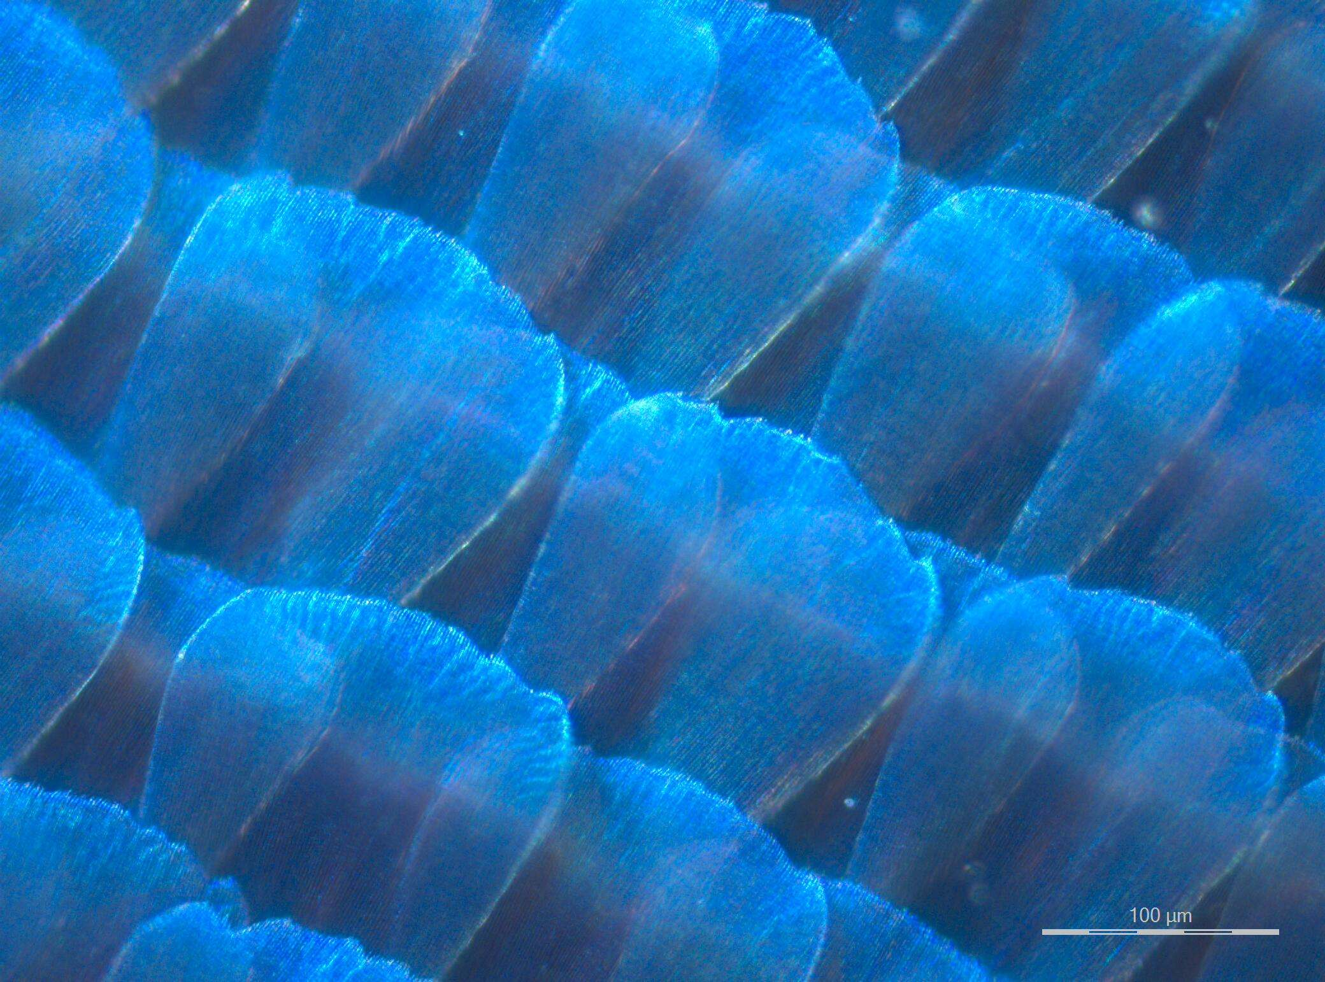  Light reflecting off the wings  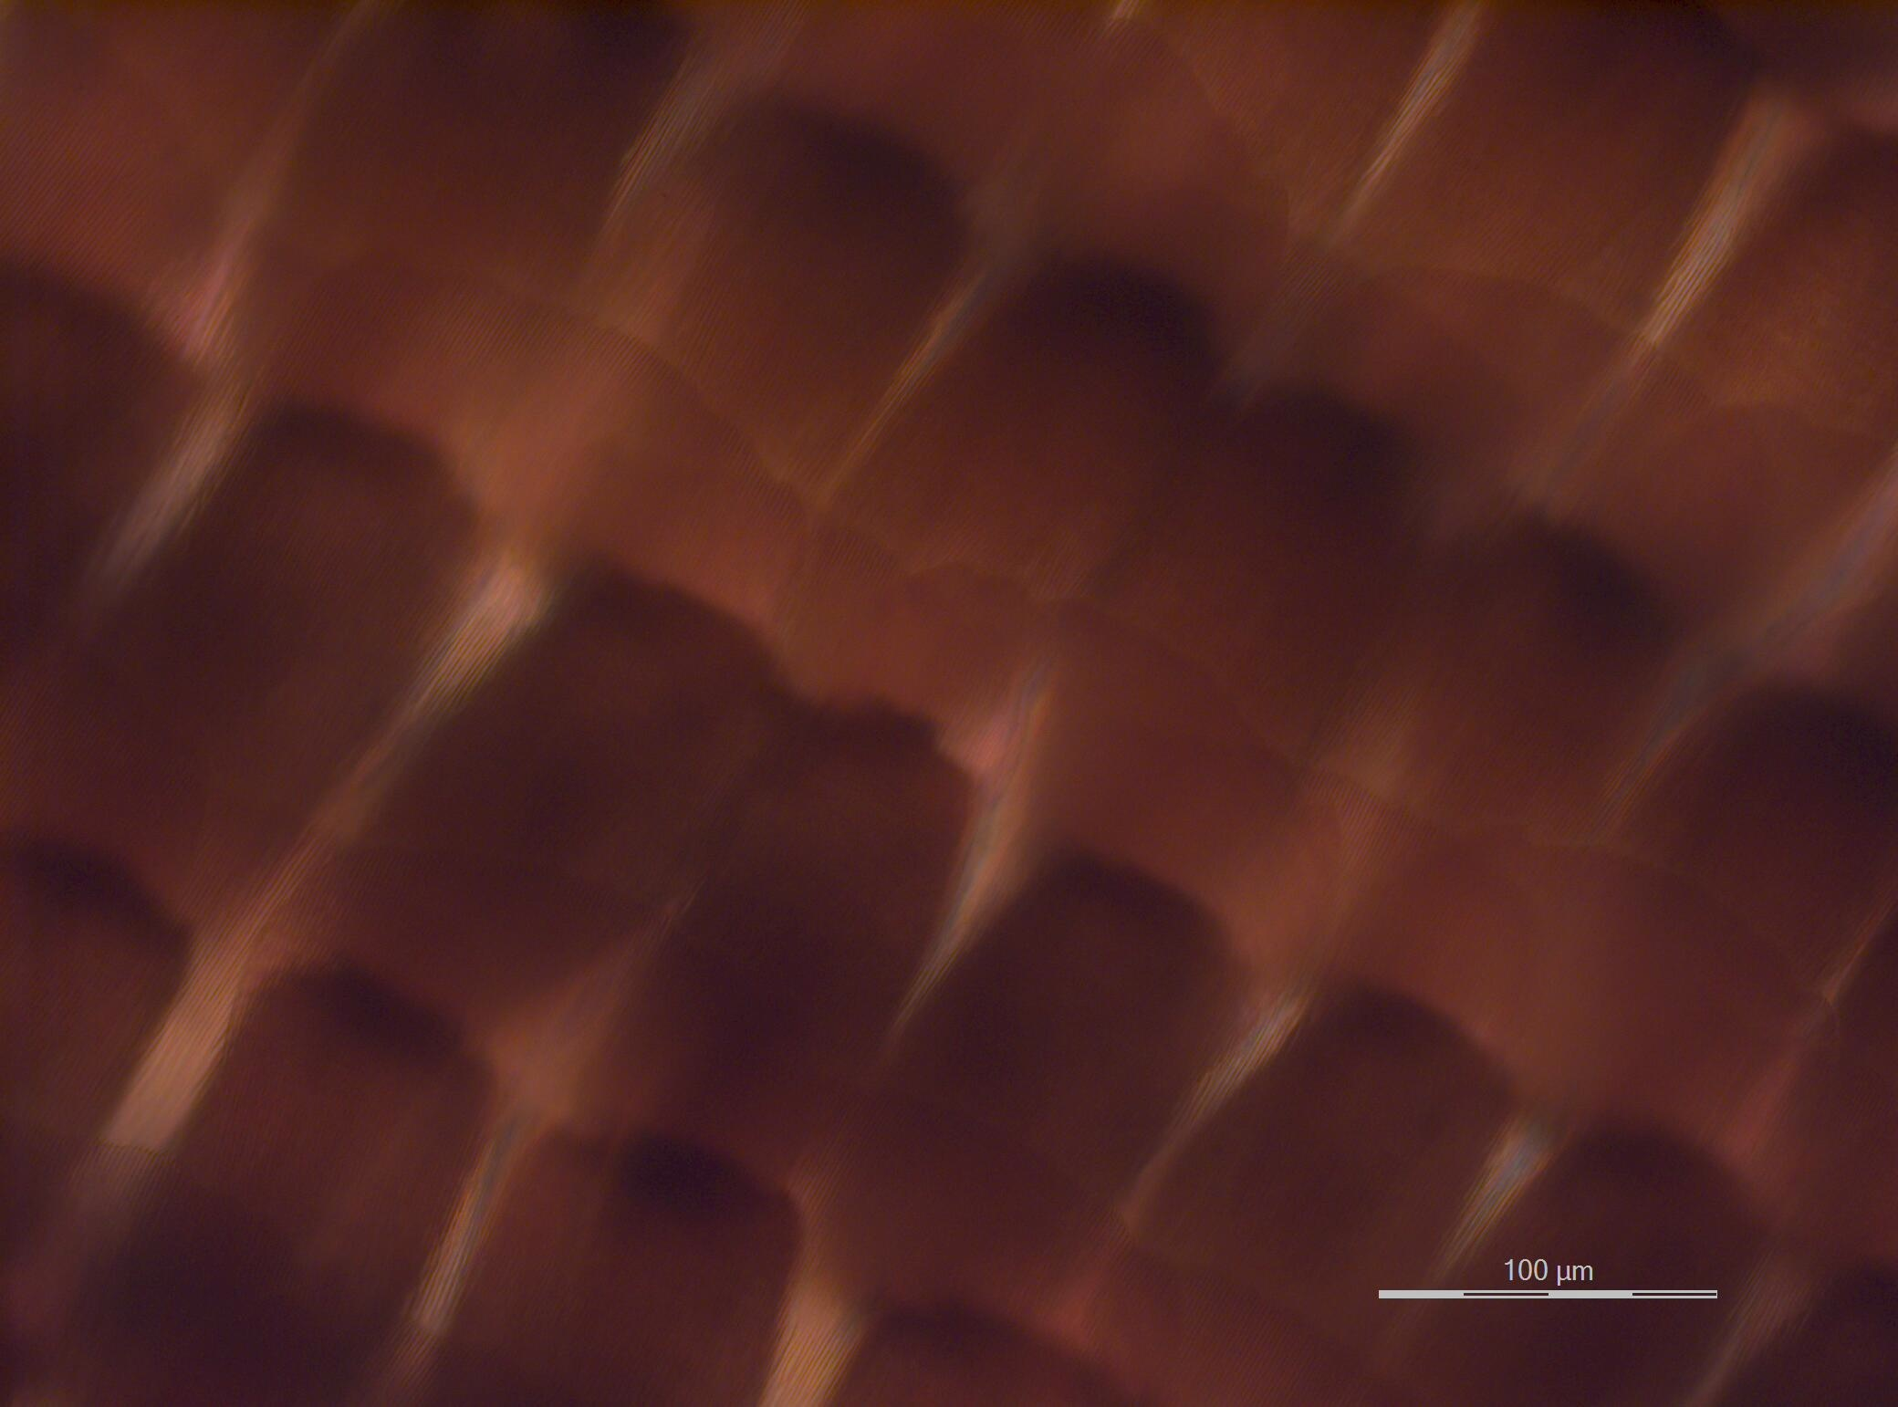  Light passing through the wings
How is this nano?
The way a material behaves on the macroscale is affected by its structure on the nanoscale. Nanotechnology takes advantage of different material properties at the nanoscale to make new materials and tiny devices smaller than 100 nanometers in size. (A nanometer is a billionth of a meter.)
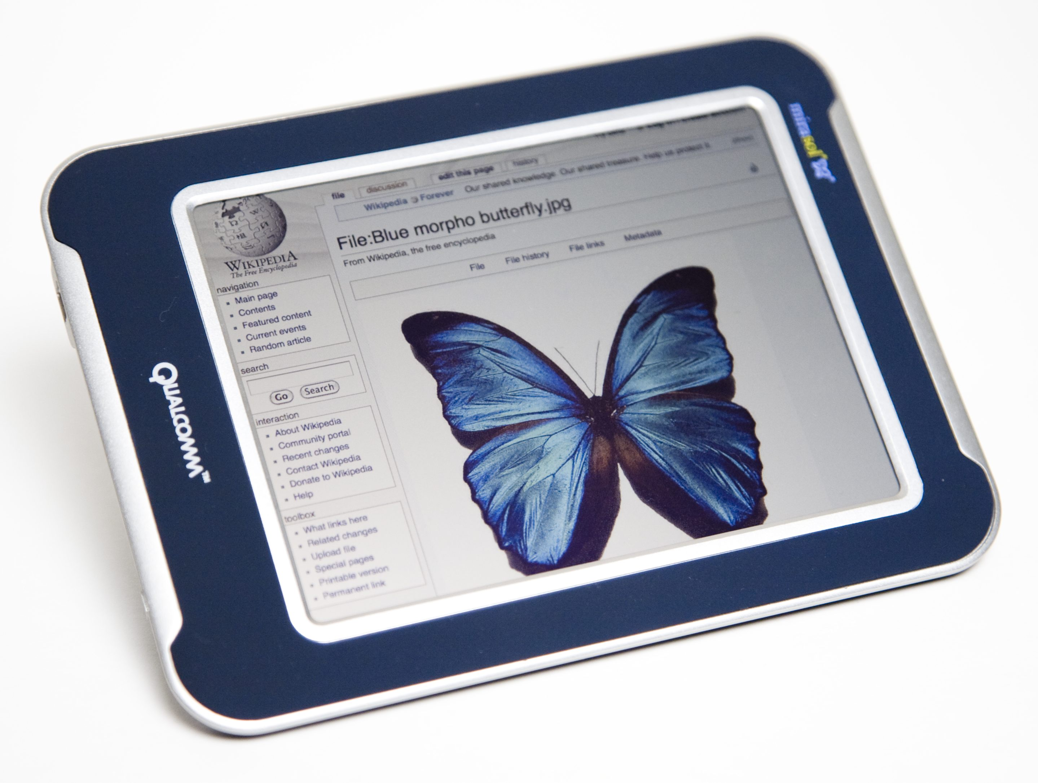  Low-energy display | Nanotechnology allows scientists and engineers to make things like smaller, faster computer chips and new medicines to treat diseases like cancer.  Some nanotechnology and nanomaterials are inspired by nature. Scientists are working on new nanotechnologies that mimic the Blue Morpho’s wings. They’ve already invented low-energy smartphone displays, paints, and fabrics that change color by changing the spacing between materials.

Learning objectives
- The way a material behaves on the macroscale is affected by its properties on the nanoscale.
- Some nanotechnologies are inspired by nature.

Materials
- Butterflies in protective case
- Mini-light
- “Blue Morpho Butterfly” image sheet

Blue Morpho and Buttercup butterflies mounted in an acrylic case are available at www.butterflyutopia.com.

Mini-lights (extra-bright LEDs) are available from www.teachersource.com.

Notes to the presenter
If you’re doing this activity near a bright window or other light source, the mini-light may not be effective. You might be able to hold the butterfly up to the window or light source to get the same effect (and not use the mini-light at all), or you might need to relocate the activity to a less brightly lit area.
Extension
Visitors can experiment further by dropping alcohol onto a Blue Morpho butterfly wing. The alcohol fills up the spaces between the nanoscale structures of the wings, so they reflect green light waves rather than blue light waves. When the alcohol evaporates, the wings look blue again.

Related educational resources
The NISE Network online catalog (www.nisenet.org/catalog) contains additional resources to introduce visitors to light and color at the nanoscale, and connections between nanotechnology and nature:
- Public programs include Biomimicry: Synthetic Gecko Tape through Nanomolding; Colors at the Nanoscale: Butterflies, Beetles and Opals; DNA Nanotechnology; Lotus Leaf Effect; and Nanoparticle Stained Glass, Sand, Plants and Pants.
- NanoDays activities include Exploring Materials—Liquid Crystals, Exploring Materials—Nano Gold, Exploring Materials—Thin Films, Exploring Products—Nano Fabric, Exploring Products—Sunblock, and Exploring Structures—DNA.
- Media include Multimedia Zoom into a Nasturtium Leaf, Zoom into the Blue Morpho Butterfly, and Zoom into a Butterfly Wing.
- Exhibits include Bump and Roll, Changing Colors, and Unexpected Properties.

Credits and rights
Image of structures in Blue Morpho wing courtesy S. Yoshioka, Osaka University.
Images of Blue Morpho wing with reflected and nonreflected light courtesy F. Nijhout, Duke University.
Low-energy display photo courtesy Qualcomm Technologies, Inc.
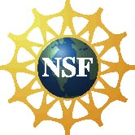 | This project was supported by the National Science Foundation under Award No. 0940143.  Any opinions, findings, and conclusions or recommendations expressed in this program are those of the author and do not necessarily reflect the views of the Foundation.

Copyright 2011, Sciencenter, Ithaca, NY. Published under a Creative Commons Attribution-Noncommercial-ShareAlike license: http://creativecommons.org/licenses/by-nc-sa/3.0/us/.

