

Blue Morpho Butterfly

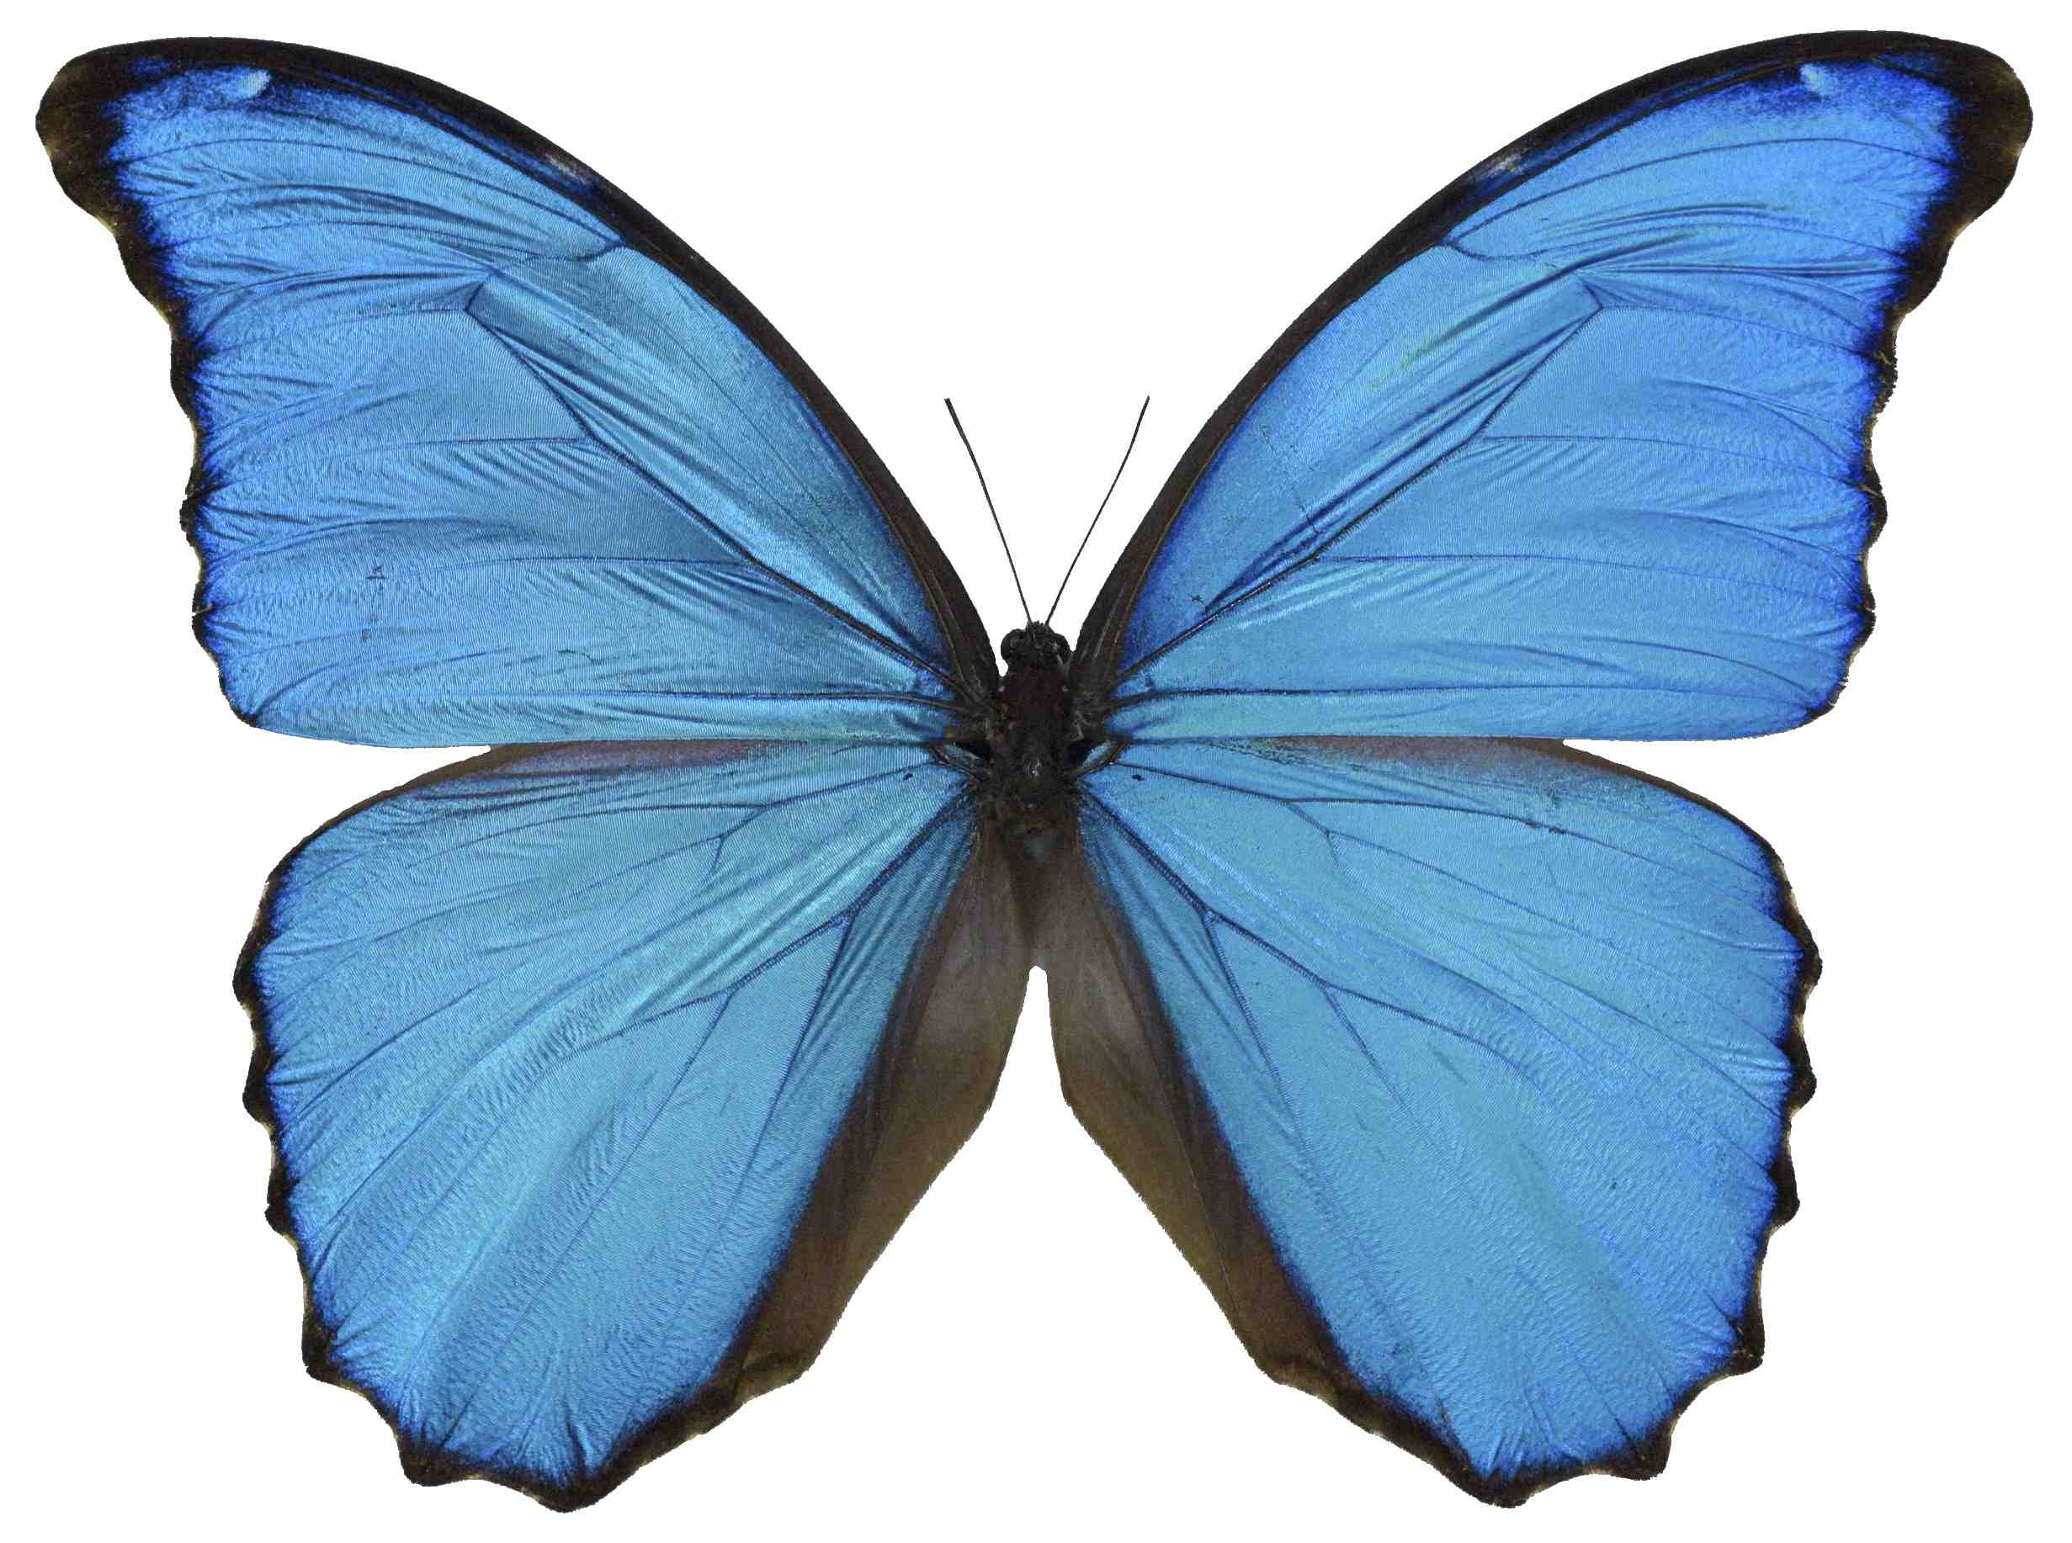
Blue Morpho butterfly

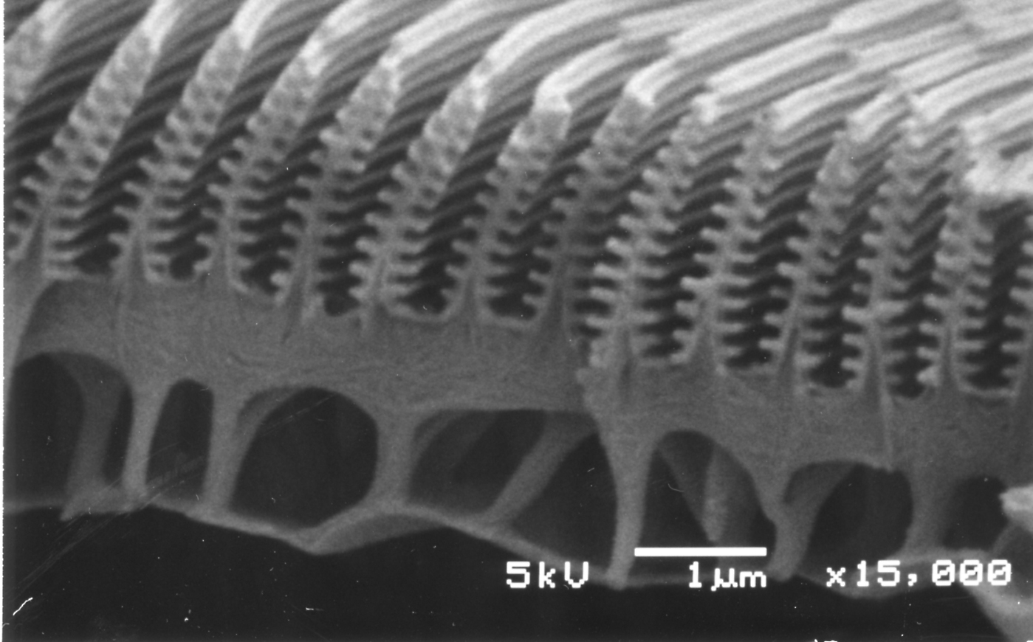
Magnified view of nanostructures in Blue Morpho butterfly wing

Blue Morpho Butterfly

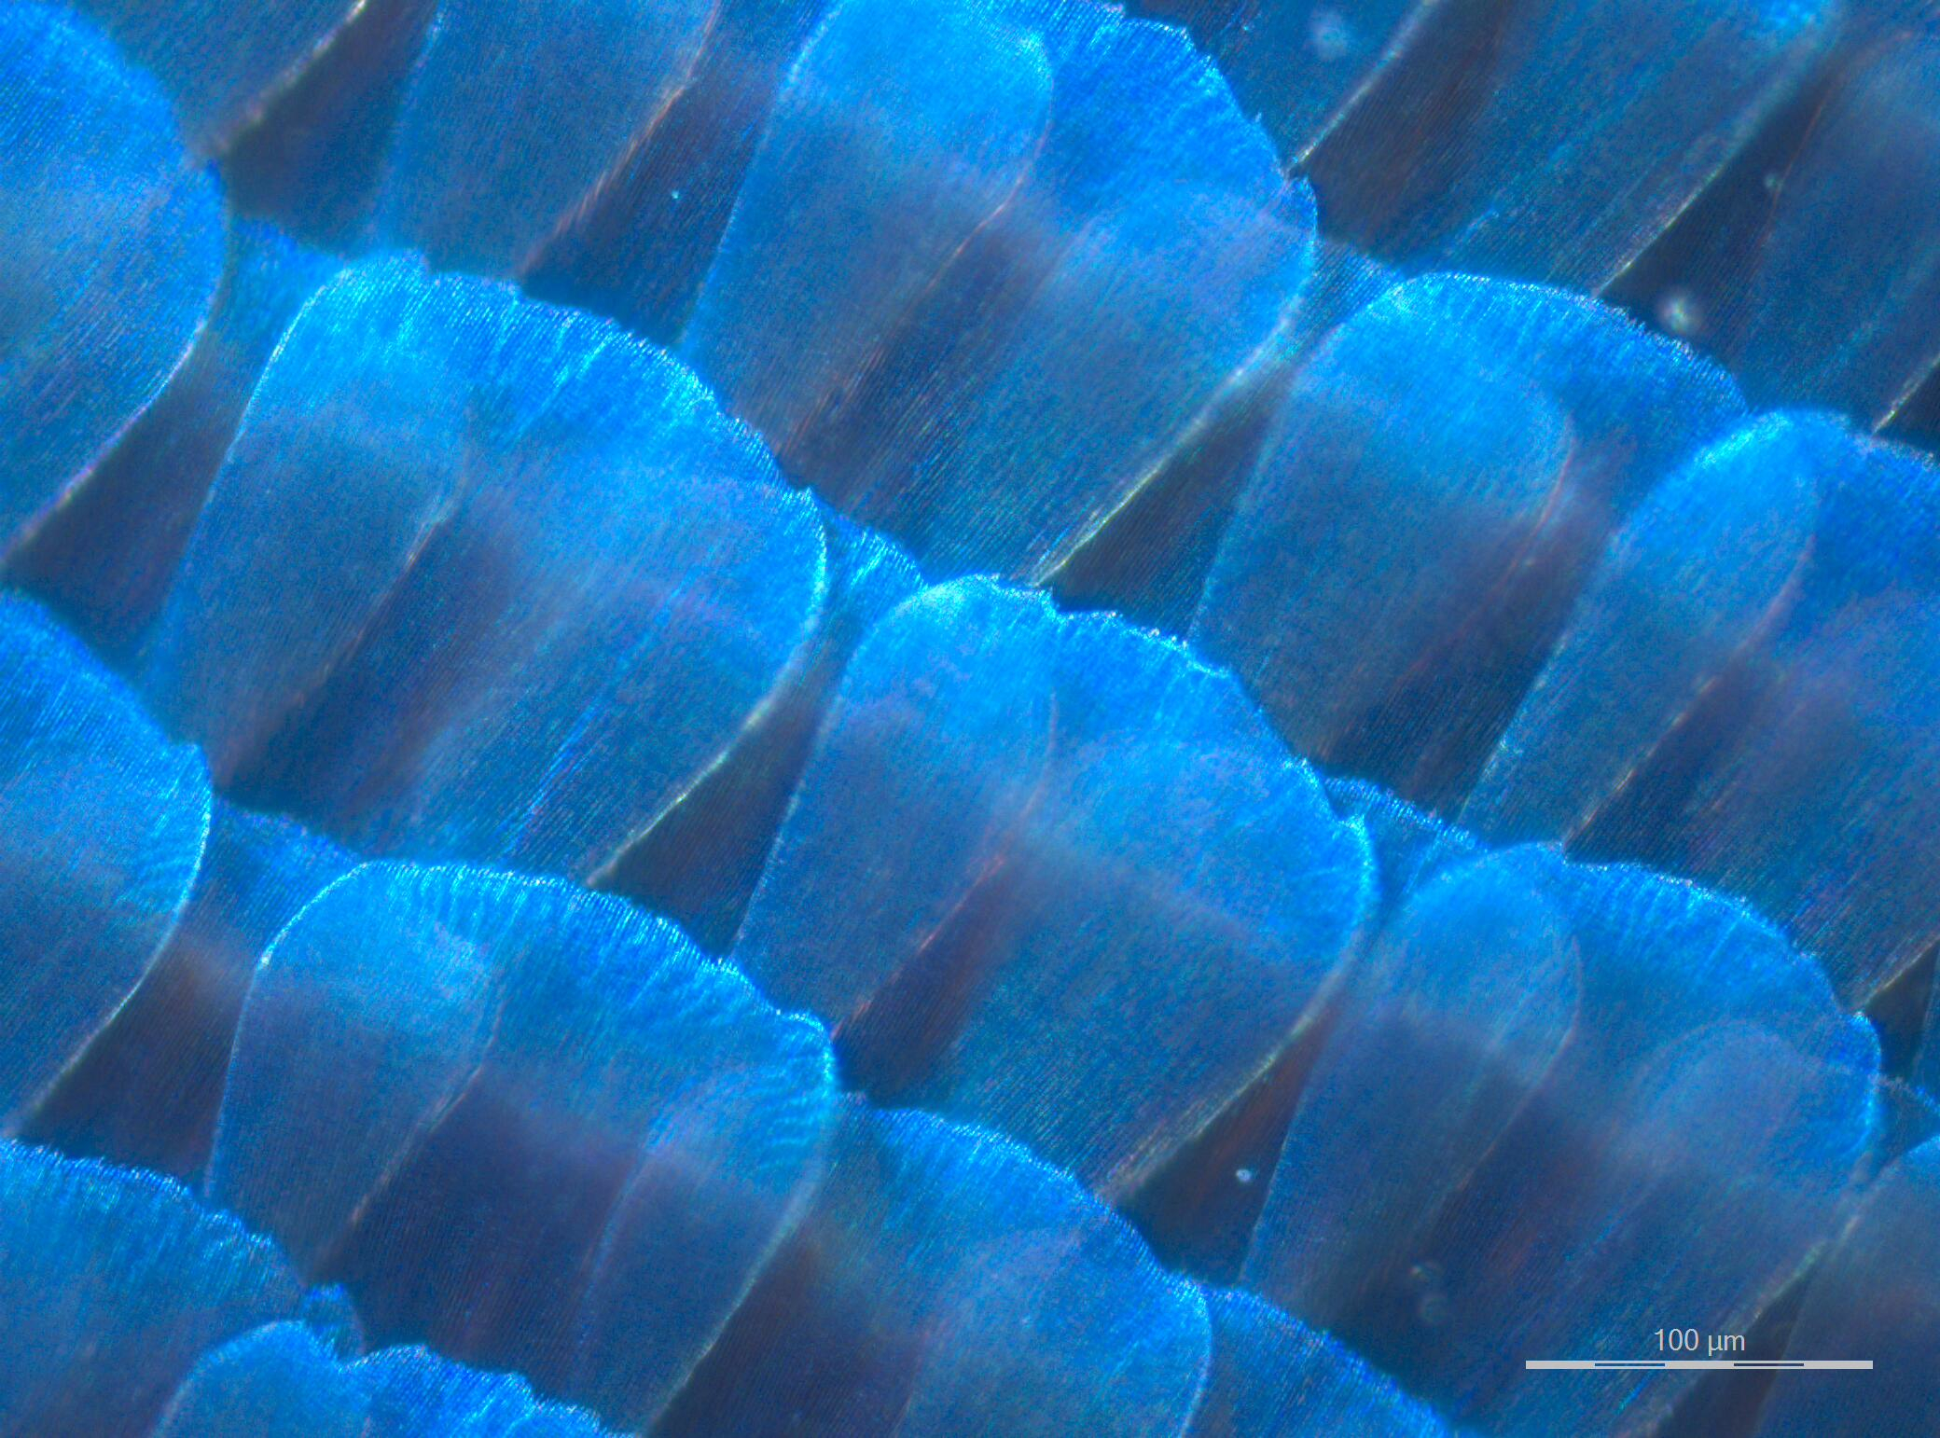
Light reflecting off Blue Morpho butterfly wing

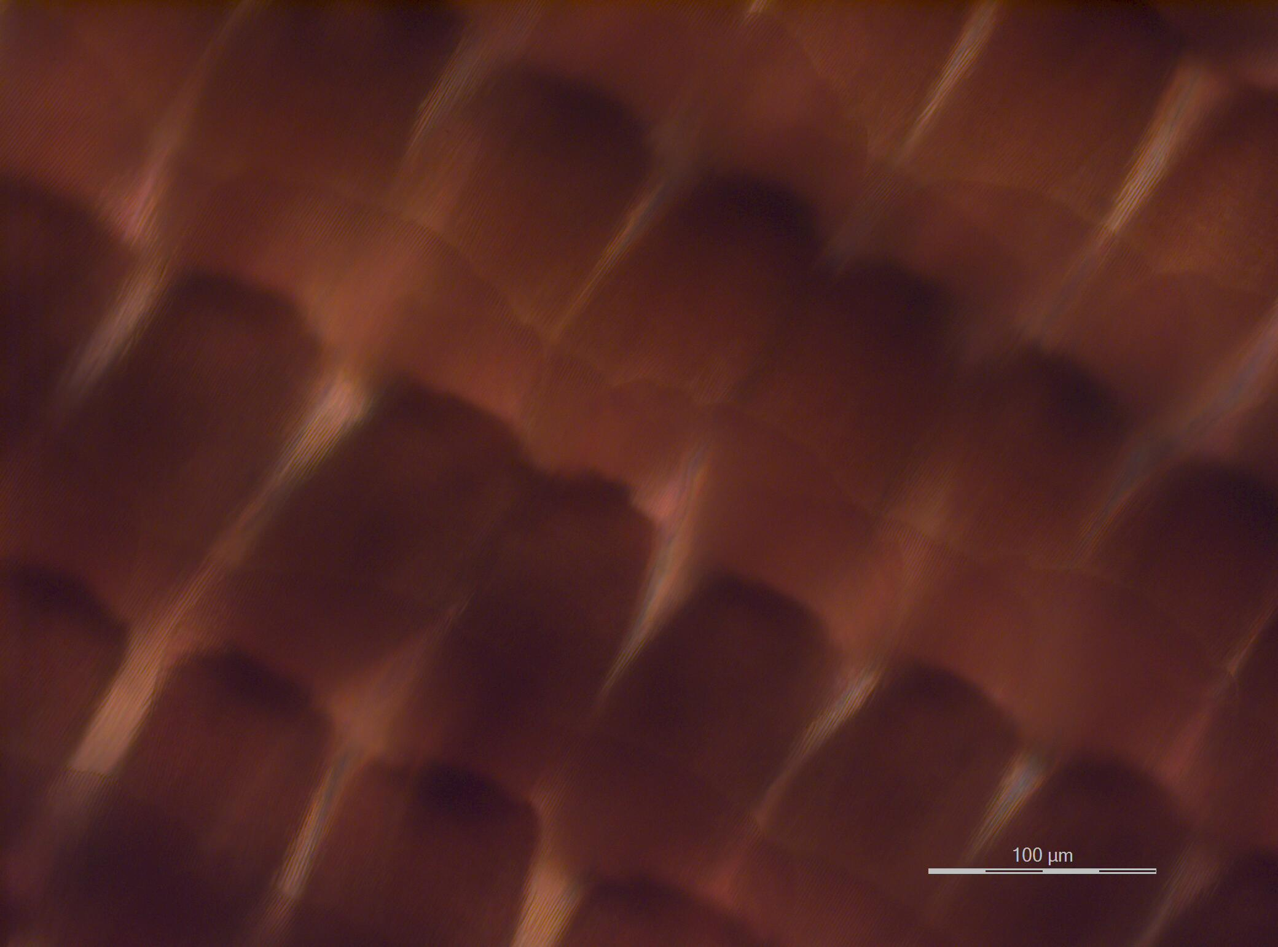
True color of Blue Morpho butterfly wing

