

Build a Giant Puzzle!

Put the pieces together to discover the nano connection!

You can make 6 different puzzles out of these blocks.

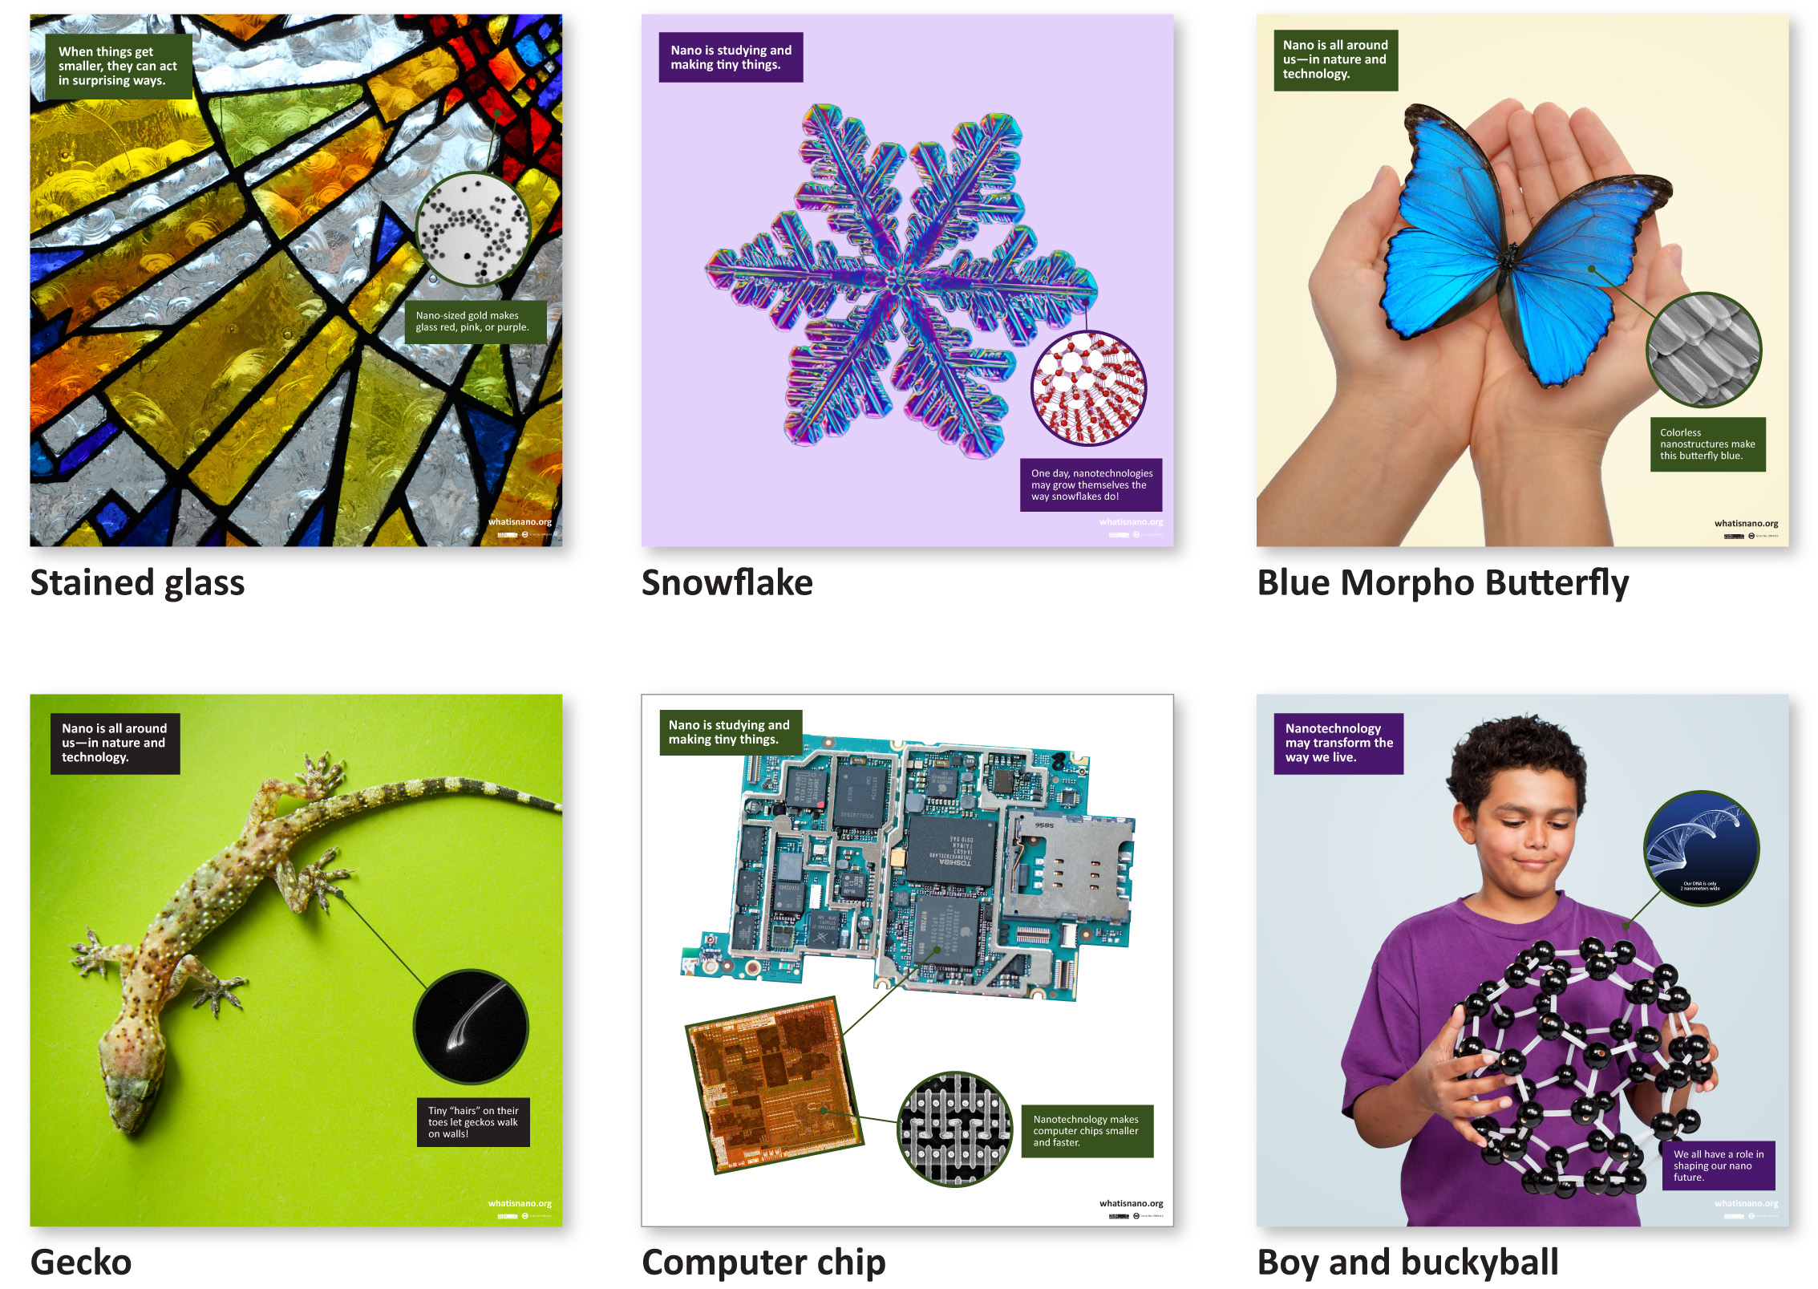

Materials
- Set of giant puzzle blocks (9 blocks)

Artwork for the puzzle block is available in the NISE Network online catalog at www.nisenet.org/catalog.

Cube boxes 8”x8”x8” are available at Uline (#S-4084).

Related educational resources
The NISE Network online catalog (www.nisenet.org/catalog) contains additional resources to introduce visitors to nanotechnology, and the topics featured in the puzzle:
- Public programs include Biomimicry: Synthetic Gecko Tape through Nanomolding, Future of Computing, Intro to Nano Cart Demo, Nano Dreams and Nano Nightmares, Nanoparticle Stained Glass, Ready, Set, Self-Assemble, Snowflakes: Nano at its Coolest!, and Wheel of the Future.
- NanoDays activities include Exploring Materials—Graphene, Exploring Materials—Nano Gold, Exploring Structures—Blue Butterfly, and Exploring Structures—Buckyballs.
- Media include Intro to Nanotechnology Video, Zoom into a Butterfly Wing, Zoom into a Computer Chip, and Societal and Ethical Implications Posters.
- Exhibits include Changing Colors, Introduction to Nanotechnology Exhibition, and NanoLab.

Credits and rights
Image of computer chip detail courtesy chipworks.com.
Image of gecko foot “hair” courtesy A. Kellar, Lewis & Clark College.
Image of nano gold particles courtesy nanoComposix.
Photo of snowflake courtesy Kenneth Libbrecht, www.snowcrystals.com.

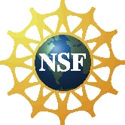 | This project was supported by the National Science Foundation under Award No. 0940143.  Any opinions, findings, and conclusions or recommendations expressed in this program are those of the author and do not necessarily reflect the views of the Foundation.

Copyright 2011, Sciencenter, Ithaca, NY. Published under a Creative Commons Attribution-Noncommercial-ShareAlike license: http://creativecommons.org/licenses/by-nc-sa/3.0/us/

