

I Spy Nano!

- Each player chooses a game board.
- Place the deck of playing cards in the center, purple side facing up (picture side down).
- Read the statement on the back (purple) side of each card, then turn it over.
- Look at the objects on the front of the card. Each game board has one of these objects on it.
- All players search their boards to find an object that’s identical with an object on the card.
- The first person to find their object says “Nano!” and takes the card.
- Play continues with the next card in the deck, until no cards remain in the center pile.
- Whoever has the most cards wins!

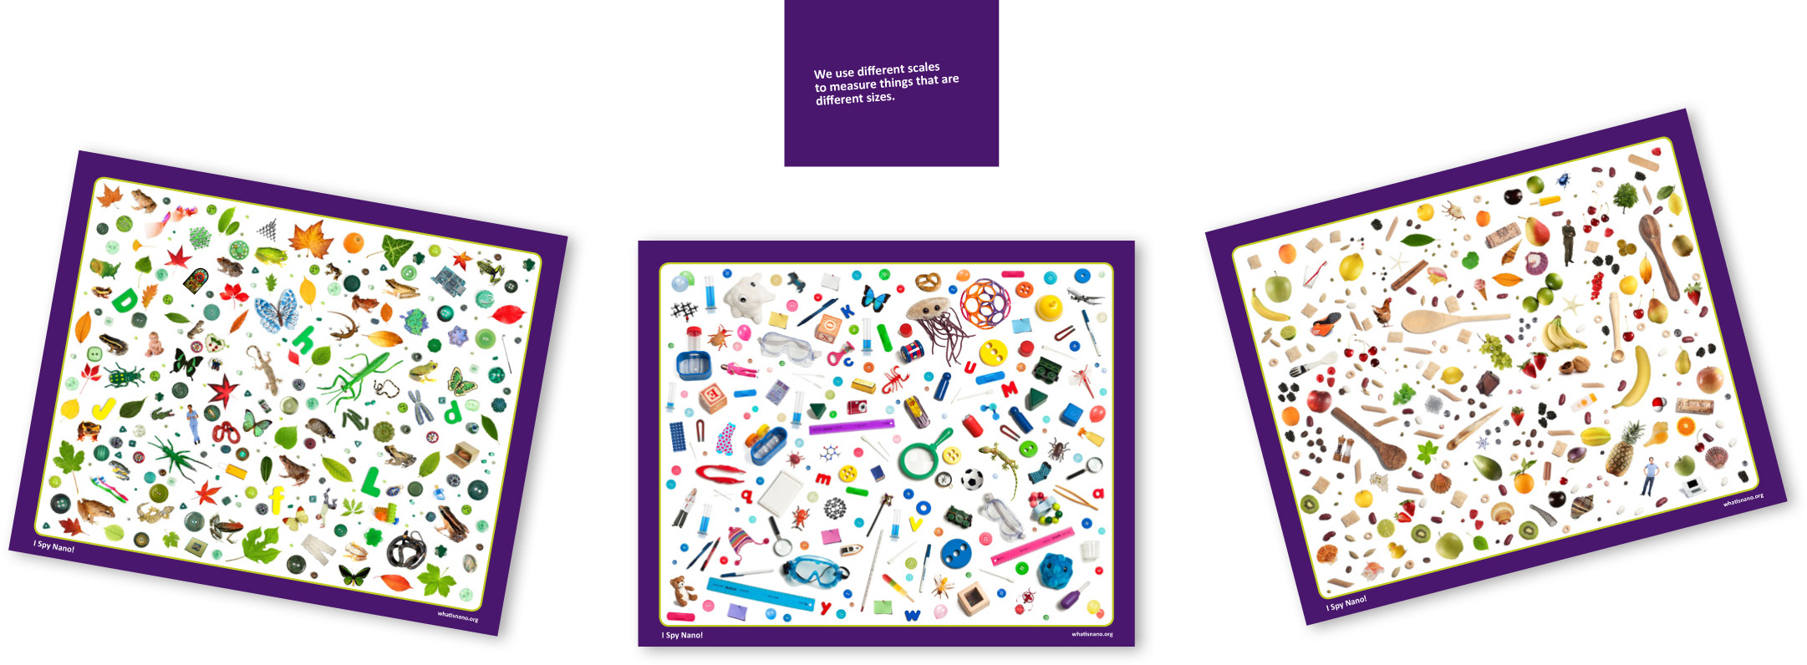

Materials
- Playing cards
- Playing boards

Artwork for the playing cards and boards is available in the NISE Network online catalog at www.nisenet.org/catalog.

Related educational resources
The NISE Network online catalog (www.nisenet.org/catalog) contains additional resources to introduce visitors to nanotechnology:
- Public programs include Attack of the Nanoscientist, Intro to Nano Cart Demo, Nano Dreams and Nano Nightmares, and Wheel of the Future.
- NanoDays activities include Build a Giant Puzzle!, Exploring Size—Memory Game, Exploring Size—Powers of Ten Game, Exploring Size—StretchAbility, and Nanotechnology—Small Science, Big Deal!
- Media include Alice in Nanoland and Intro to Nanotechnology Video.
- Exhibits include Introduction to Nanotechnology Exhibition.

Credits and rights
Image of climbing robot courtesy M. Cutkosky, Stanford University.
Image of low-energy display courtesy Qualcomm Technologies, Inc.
Track shoes courtesy Adidas.
Image of snowflakes courtesy Kenneth Libbrecht, www.snowcrystals.com.

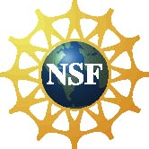 | This project was supported by the National Science Foundation under Award No. 0940143.  Any opinions, findings, and conclusions or recommendations expressed in this program are those of the author and do not necessarily reflect the views of the Foundation.

Copyright 2011, Sciencenter, Ithaca, NY. Published under a Creative Commons Attribution-Noncommercial-ShareAlike license: http://creativecommons.org/licenses/by-nc-sa/3.0/us/

