Exploring Materials—Liquid Crystals

Try this!

- Place your hand on top of one of the three liquid crystal sheets.  - Remove your hand. Can you see a handprint?  - Place the same liquid crystal sheet on top of the heat pad. What do you observe?  - Repeat these steps with the other two liquid crystal sheets. | 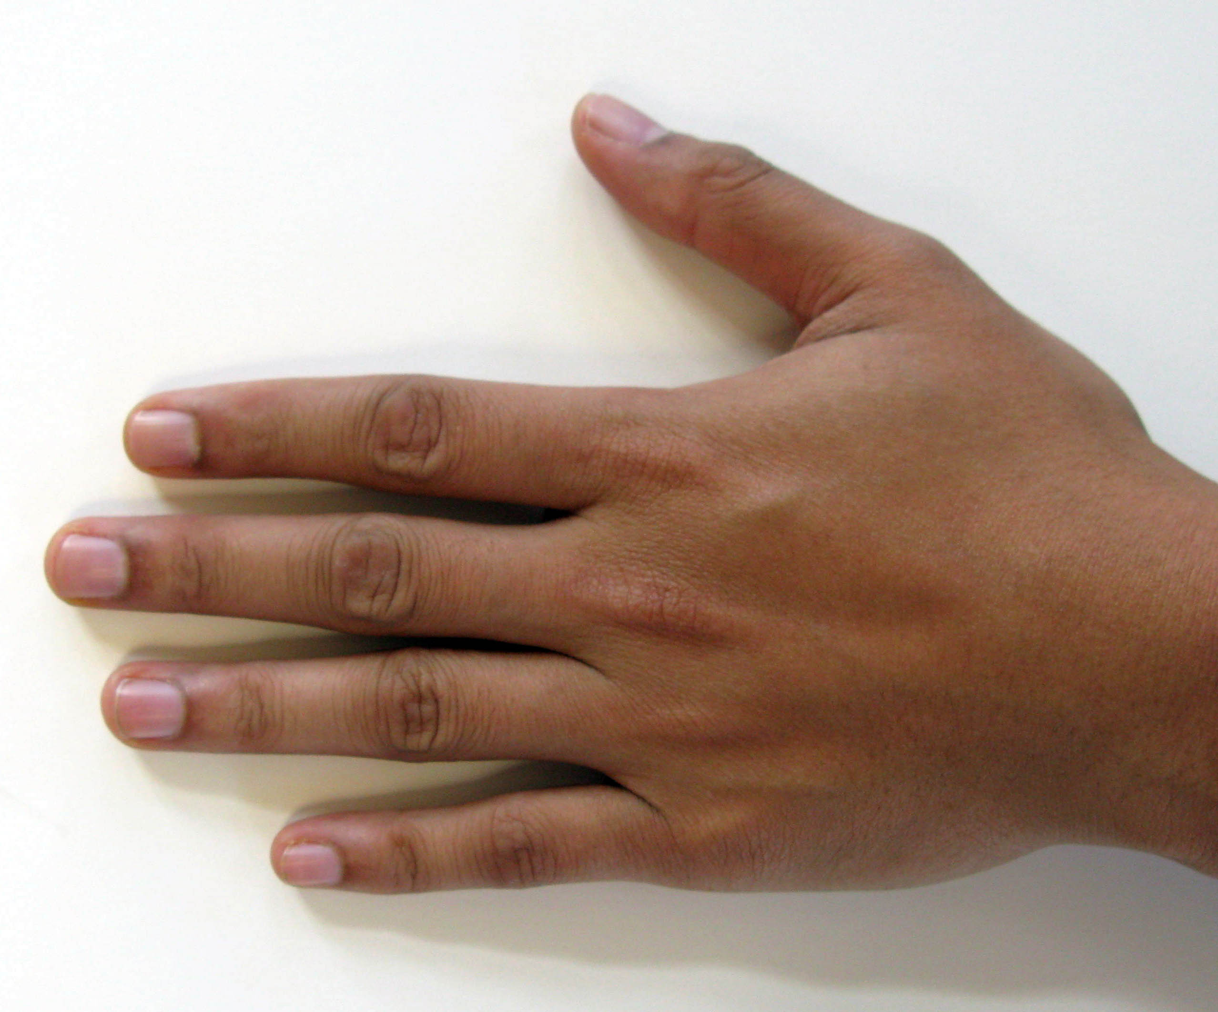  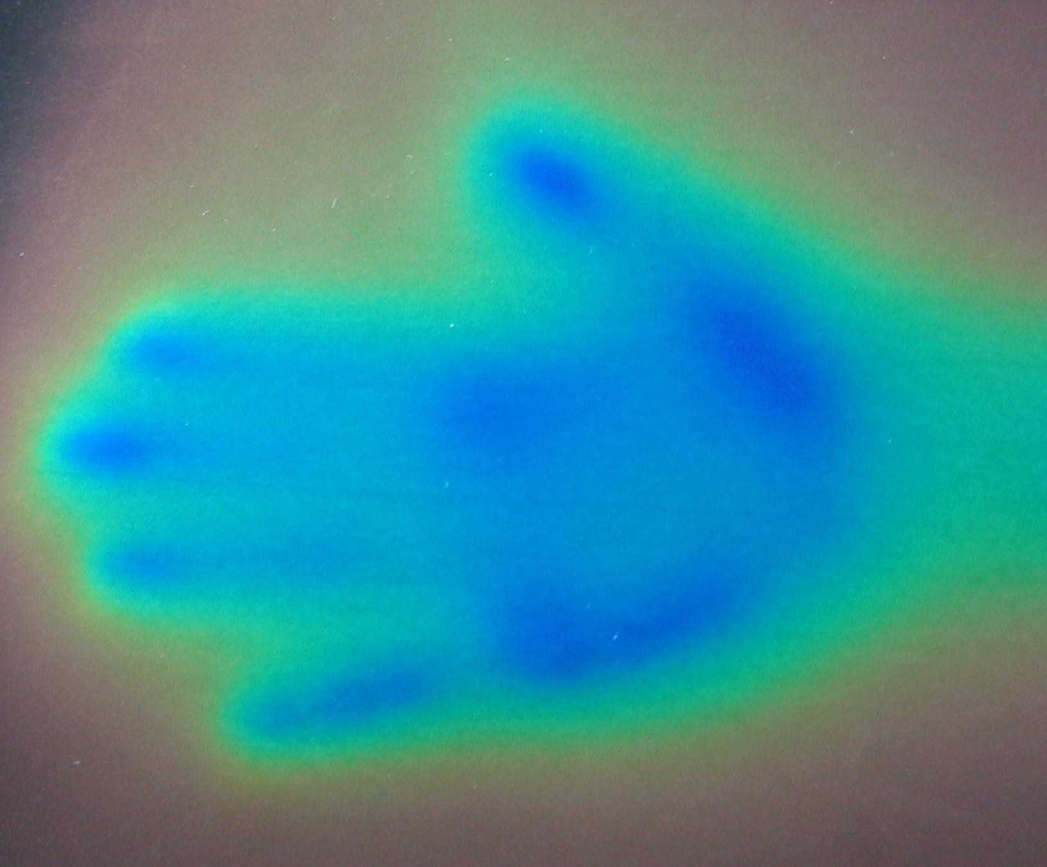

How is this nano?

Liquid crystals respond to changes in temperature by changing color. This is due to the re-arranging of molecules on the nanoscale! Each laminated sheet of liquid crystal displays a series of colors when exposed to a specific five-degree temperature range. As the temperature increases, their color changes from red to orange, yellow, green, blue, and purple.

Liquid crystals are used in cell phone displays, laptop computer screens, and thermometers.

