Try this!
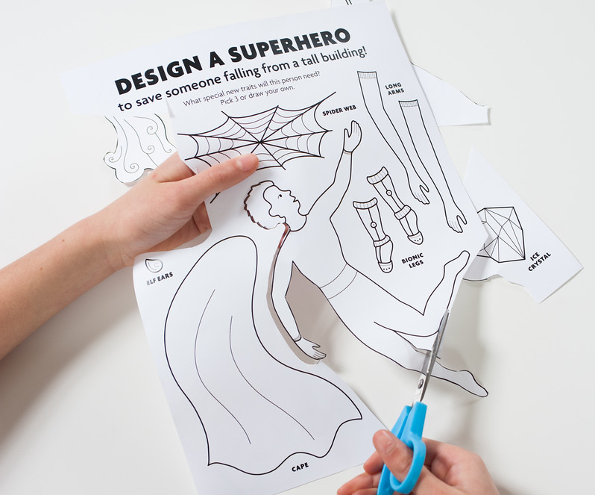
- Someone is falling from a tall building! Design a superhero to save them. Start with a regular human. What special new traits will they need?
2
1
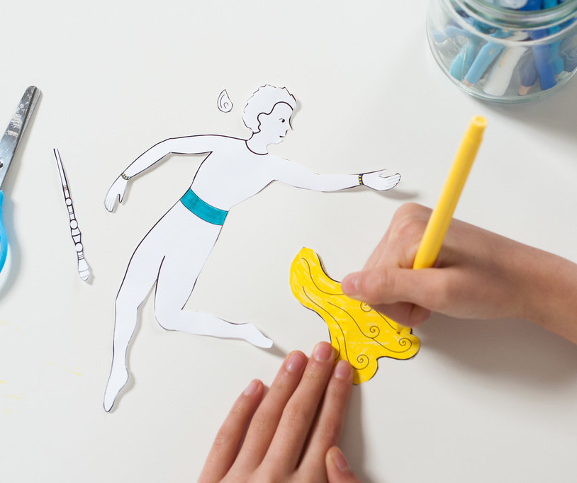
- Add up to three new traits to your human to make them into a superhero. You can cut them out of the worksheet and tape them onto the outline, or draw your own. How do these new features help your superhero save the falling person? Try it out on the background.

Now try this!
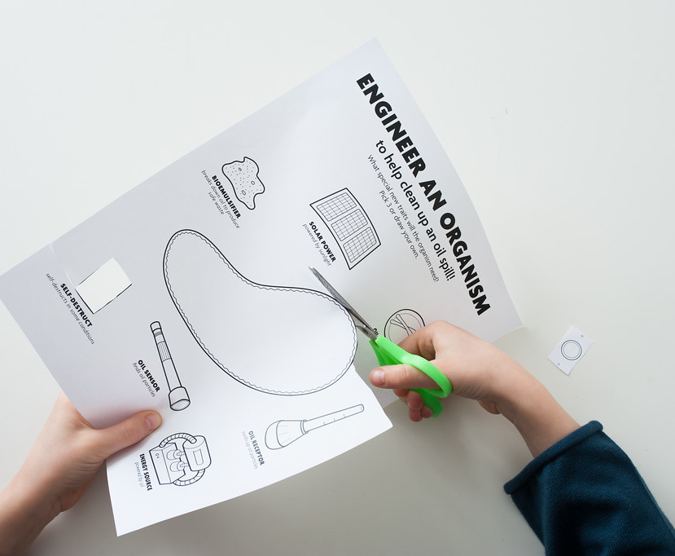
3
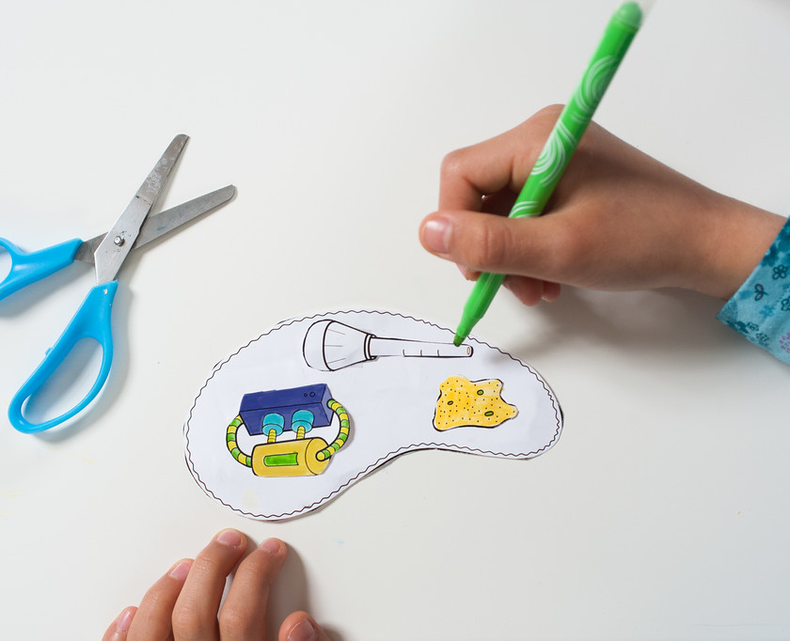
- Oh no! Now there’s been an oil spill! Make a tiny, single-celled organism to help clean up the ocean. Start with a bacterium and engineer it so it can do new things. What special traits will your microorganism need to solve this problem?
4
- Add up to three new traits to your microorganism to make it into a “super organism.” You can cut them out of the worksheet and tape them onto the outline, or draw your own. How do these new features help your super organism clean up the oil spill? Try it out on the background.

Talk about it…
How is designing a superhero similar to or different from building a microorganism to solve a problem?
What could happen if you let your super organism go in the wild? Could anything happen that you didn’t plan for?

Synthetic biologists solve problems by applying engineering principles to living materials.

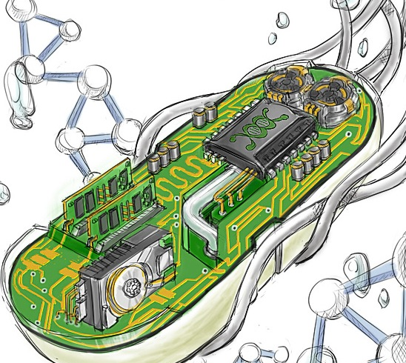
Synthetic biology uses the engineering design process. Researchers in this field design, build, and test new ideas to solve problems. Often, they use computer models to figure out what might (or did) happen.
Inventing a superhero is just pretend. But giving special traits to a human being is a little bit like engineering an organism to do something new. It’s fun to imagine what key attributes a new organism would need in order to solve a problem—and it’s also important. We’ll need lots of different ideas to solve big problems, such as making food last longer, cleaning up an oil spill, or even terraforming Mars!
- Synthetic biologists solve problems by finding new ways to modify and reprogram living parts, almost as if they’re pieces of a tiny computer.

Synthetic biologists must consider how new organisms will evolve and interact if they are introduced into the wild. Like all technologies, the products of synthetic biology have costs, risks, and benefits that could change our world.

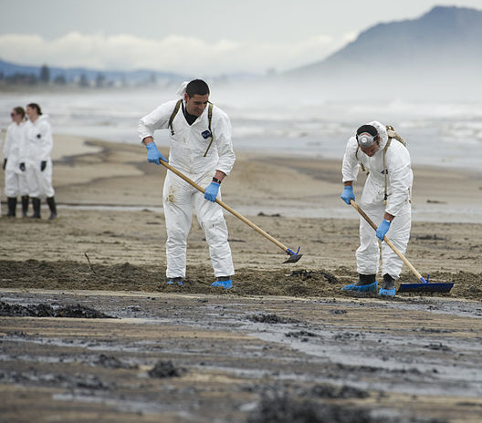
Synthetic biology is interconnected with society. When they create new technologies, scientists and engineers think about the future world they would like to live in. And when people decide to use new technologies, it can change our lives in ways that are big and small.
We can’t always predict what will happen with new technologies, but by thinking ahead and talking about them we can shape them in ways that fit our values and our vision for the future.
Scientists are experimenting with engineering organisms to clean up oil spills in more controlled and precise ways.

