Try this!

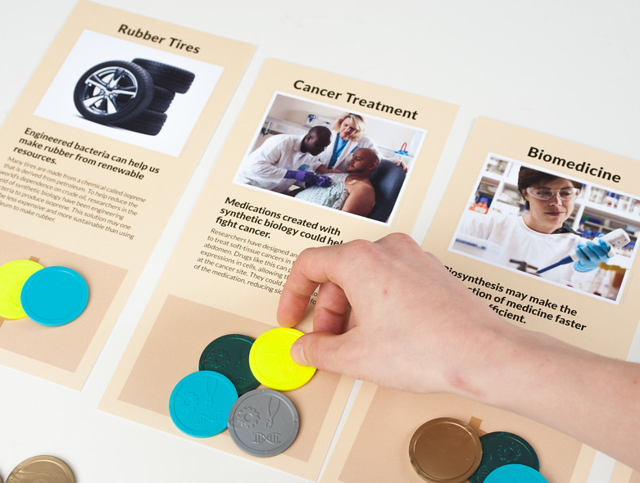
1. Imagine that you plan to invest in new biotechnologies. Look through the yellow cards to learn about some existing and future technologies. Then set them out on the table so they’re all visible.
1
Place your Tech Tokens on the technologies that you think are important and would like to see developed.

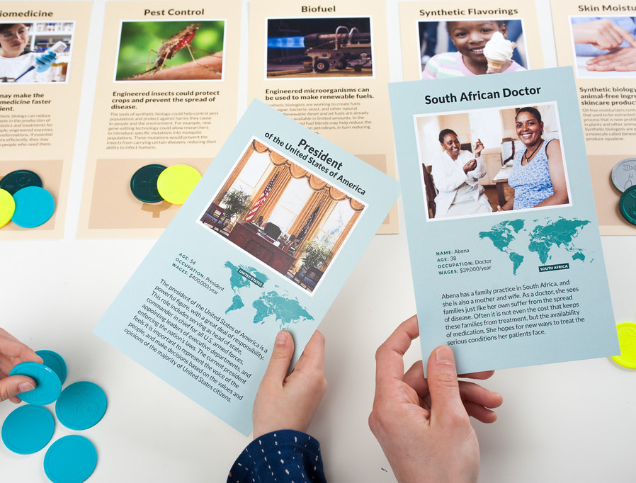
2. Now, turn the blue character cards face down, mix them up, and pick one. Pretend you’re the person on this card. Do you think they would choose to invest in the same technologies as you?
2
Put your tokens on the technologies you think that person might want to support.

(Note: Each player gets a set of 10 tokens. Be sure each person takes a different color!)

Talk about it…
Does everyone in your group value the same technologies? Why or why not?
How might some of these new technologies change the way we live? Would the changes benefit everyone equally, all around the world?

Technologies and society are interconnected.

People’s values determine which technologies are developed and used. The tokens in this game represent your potential support for new technologies. You might choose to put your tokens toward a technology that someone else in your group isn’t interested in, and you might be surprised by the things other people value. And your group’s opinions about these technologies might be very different from those of people in other parts of the world.
Every day, we make decisions related to technologies—as individuals and as a society. For example, in the US many people have strong feelings about what food they buy and eat. Some families choose organic ingredients and local produce, while others prefer conventionally grown foods. Individual priorities, business practices, and government policies all affect science and technologies.
Your decisions about which products to buy can have a big impact on technologies and systems.

Synthetic biology benefits from many voices. Researchers in this emerging field of science and engineering are addressing problems that affect all of us, in areas such as health, energy, and the environment.
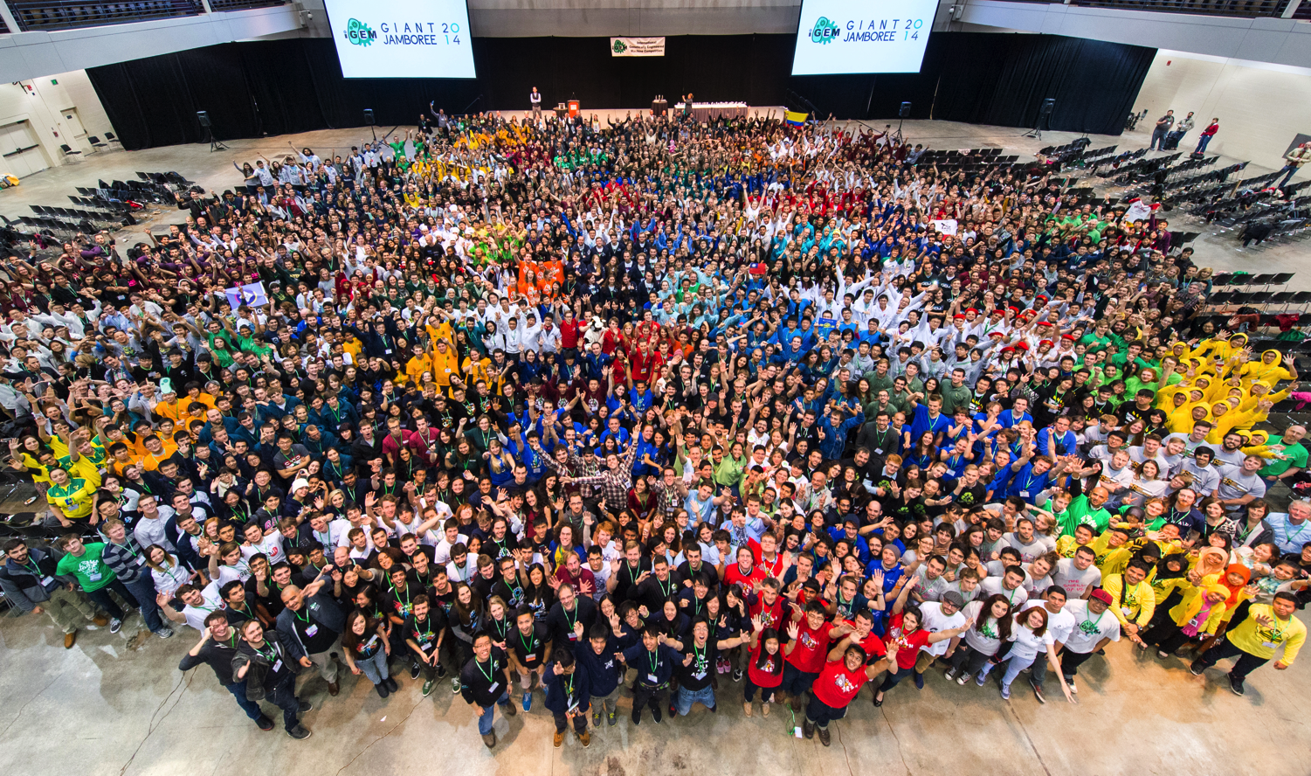
By applying the process of engineering to the tools and building blocks of biology, scientists, students, and people in community DIY (do-it-yourself) lab spaces are creating new knowledge and innovations that weren’t possible before. We all have a role in shaping new technologies.

The International Genetically Engineered Machine (iGEM) competition challenges students to consider how technology and society influence each other.

