CAST CARDS (front)
 ---------------------------------------------------------------------------------cut along solid lines

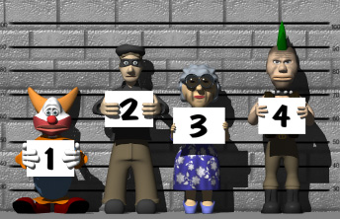

Anna Lopez



----------------------------------------------------------------------------------cut along solid lines

Tony Wayler



DETECTIVE’S BADGE

-----------------------------------------------------------cut along solid lines



