Horton Hears a Who! Storytime


Organization: Sciencenter
Contact person: Rae Ostman
Contact information: rostman@sciencenter.org

General Description
Facilitated Activity
In this story time program, visitors actively listen to Horton Hears a Who! by Dr. Seuss. Before the story is read, visitors make paper “elephant ears” to wear. After the story, they use their sense of smell to explore scent molecules that are too small to see.

Program Objectives

Big idea:

There are things that are too small to see, but we can smell some of them.

Learning goals:
As a result of participating in this program, visitors will explore the following ideas:
- There are very small things, too small for our eyes to see.
- Our sense of smell can sometimes detect tiny particles that are too small to see.

NISE Network content map main ideas:
[x] 1. Nanometer-sized things are very small, and often behave differently than larger things do.

[ ] 2. Scientists and engineers have formed the interdisciplinary field of nanotechnology by investigating properties and manipulating matter at the nanoscale.

[ ] 3. Nanoscience, nanotechnology, and nanoengineering lead to new knowledge and innovations that weren’t possible before.

[ ] 4. Nanotechnologies have costs, risks, and benefits that affect our lives in ways we cannot always predict.

National Science Education Standards:
Science as Inquiry
K-4: Abilities necessary to do scientific inquiry

Physical Science
K-4: Properties of objects and materials

Life Science
K-4: Characteristics of organisms

Table of Contents
General Description 1
Program Objectives 1
Table of Contents 2
Time Required 3
Background Information 3
Definition of terms 3
Program-specific background 4
Materials 4
Set Up 5
Program Delivery 7
Safety 7
Talking points and procedure 7
Tips and troubleshooting 8
Going further… 8
Clean Up 9
Universal Design 9

Time Required

Set-up Program Clean Up

10 minutes 25 minutes 5 minutes

Background Information

Definition of terms

Nano is the scientific term meaning one-billionth (1/1,000,000,000). It comes from a Greek word meaning “dwarf.”
A nanometer is one one-billionth of a meter. One inch equals 25.4 million nanometers. A sheet of paper is about 100,000 nanometers thick. A human hair measures roughly 50,000 to 100,000 nanometers across. Your fingernails grow one nanometer every second.

(Other units can also be divided by one billion. A single blink of an eye is about one-billionth of a year. An eyeblink is to a year what a nanometer is to a yardstick.)

Nanoscale refers to measurements of 1-100 nanometers. A virus is about 70 nm long. A cell membrane is about 9 nm thick. Ten hydrogen atoms are about 1 nm.

At the nanoscale, many common materials exhibit unusual properties, such as remarkably lower resistance to electricity, or faster chemical reactions.
Nanotechnology is the manipulation of material at the nanoscale to take advantage of these properties. This often means working with individual molecules.
Nanoscience, nanoengineering and other such terms refer to those activities applied to the nanoscale. “Nano,” by itself, is often used as short-hand to refer to any or all of these activities.

Program-specific background

In the story Horton Hears A Who!, Horton the elephant is able to hear the Whos, a community of very tiny creatures. In fact, elephants can hear lower-pitched sounds that humans and many other animals cannot. These low-frequency sounds can travel farther than sounds in the human range of hearing. They allow elephants to communicate over great distances.
Humans can use our sense of smell to detect some things are too small to see. Our sense of smell works by identifying the shape of scent molecules. Molecules are made of particles called atoms that bond together. Everything in the world is made of atoms.
Scent molecules are so small that they’re measured in nanometers. A nanometer is one-billionth of a meter! Nano-sized particles cannot be seen directly with our eyes, not even using a very powerful light microscope.
When you scratch a scented sticker, you break open small capsules that release tiny scent molecules. (In the optional balloon activity extension, tiny scent molecules from the extract are leaking out of the balloons.)

Materials

Book
English: Horton Hears a Who! By Dr. Seuss. Random House, New York, 1954.

Spanish: ¡Horton Escucha a Quién! By Dr. Seuss. Translated by Yanitzia Canetti. Lectorum, New York, 2003.

Activities
Elephant ear craft:
- Elephant ear template (one per child)
- Precut headbands (around 1 in. x 24 in.)
- Safety scissors
- Tape
- Crayons
- Scratch-and-sniff stickers

Optional extension activity, Exploring Size—Scented Balloons:
- Activity guide, available from the NISE Net online catalog: www.nisenet.org/catalog/
- Round balloons in different colors
- Variety of flavored extracts
- Balloon pump

Set Up

Advance prep: 30 minutes (or more)

Set up: 20 minutes (or more)

Review the story and plan how you will read it aloud
Horton Hears a Who! is a long book, and it can be hard for young visitors to pay attention to the entire story.
You may want to skip some of the pages. To shorten the book, you can:
- Read the beginning of the book, when Horton hears the voice from the dust speck.
- Skip some of the middle (such as the part where the monkeys snatch the Whos, the eagle throws them in the clover field, and Horton has to find them again).
- Read the end of the book where all the Whos make enough noise to be heard.
This abbreviated version of the story still makes sense, and is short enough to maintain the attention of a younger audience. If you choose to skip parts of the story, mark those sections using sticky notes or paperclips.
Children enjoy moving in response to different words. For example, you can ask children to:
- Act out the word “elephant” by holding their arm in front of their face like a trunk.
- Act out the word “listening” by holding their hand to their elephant ears.
- Act out the word “small” by curling up their bodies or making a pinching motion.

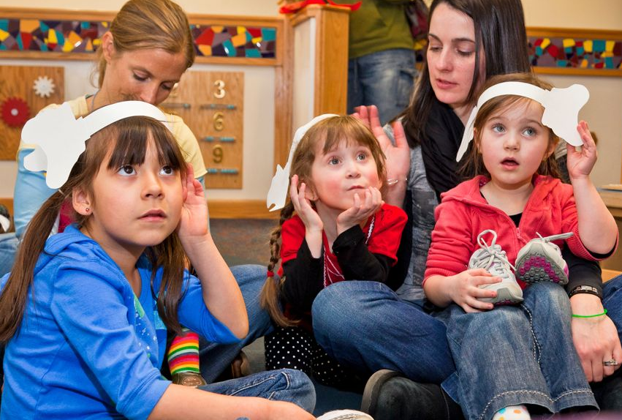

Practice reading the book out loud several times! Be sure you can read the story smoothly (skipping any pages you’ve decided not to read), while holding up the book so that children can see the illustrations. If you plan to read different characters using different voices, practice that as well. Finally, if you plan to ask children to make specific actions, practice providing prompts for them in the right places.
Prepare the elephant ear craft activity
Advance preparation:
- Make one photocopy of the “Elephant Ears” template for each anticipated visitor. (Copy only the front side of the photocopy master.)
- Make the headbands. Cut strips of paper around 1 inch wide and 24 inches long. Sturdy paper like cardstock or construction paper works best.
- Gather your crayons, scissors, and tape.

During the craft activity, young visitors will:
- Color the ears with crayons.
- Cut out the ears along the dotted lines. There is a tab for attaching the ears to the headband, but if children mistakenly cut off the tab, that’s fine.
- Put on the headband. Children will need help from an adult to wrap a headband around their head and tape it closed.
- Attach the ears to the headband using tape.
- An adult can do this while the child is wearing the headband, or the child can take the headband off to attach the ears. The ears should be attached approximately where the child’s own ears are. (It will be close enough if you attach the ears at opposite ends of the band.)
- Line up the tab on the ears with the headband and tape it in place. To make the ears more secure, wrap the tape over the tab and around the headband.

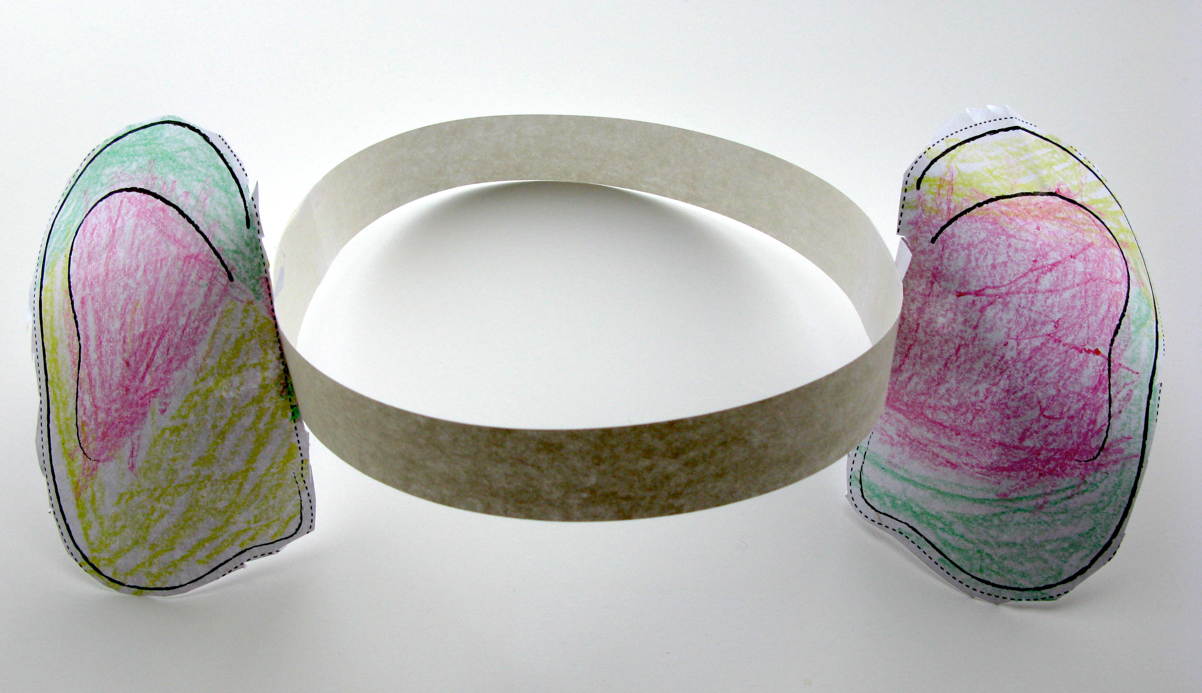

Prepare to read the story
Gather your book and scratch-and sniff stickers.

Prepare scented balloons activity (optional extension)
Review the activity guide for Exploring Size—Scent Molecules.

Just before you do the activity, add the extracts and inflate the balloons:
- Put about half a teaspoon of extract into a balloon.
- Use the pump to blow up the balloon. Tie the balloon.
- Shake the balloon a few times to encourage the extract to vaporize.
- Repeat steps 1-3 for every extract. Choose a different color balloon for each extract.

Program Delivery

Time: 30 minutes

Safety

Craft activity: Use safety scissors that are appropriate for young children. Supervise visitors in the use of the scissors and all other materials.

Optional scented balloon activity: Balloons are latex. Warn parents and visitors of possible sensitivities or allergies to latex.

Talking points and procedure

Today we’re going to read a story about an elephant. Elephants have big ears and very good hearing! Let’s make elephant ears that we can wear while listening to the story.
[Facilitate Elephant Ear craft activity]
Does everyone have elephant ears on? Great! Let’s gather around and read a story about an elephant.

Story time
I see lots of elephants in here with BIG ears for listening! Let’s read our story about an elephant. It’s called Horton Hears a Who! It was written by Dr. Seuss.
I’m going to need all of you to help me act out the story! When I read the word “elephant” can you hold your arm in front of your face like an elephant trunk?
[Demonstrate]
When I read the word “small” can you make yourself really, really small?
[Demonstrate]
When Horton the elephant is listening very closely, can you hold up your hand to your ear?
[Demonstrate]
What great elephants you are!
[Read the story.]
[Wrap up by connecting the story to tiny, nano-sized things that are too small to see.]
Do you know what? There really are things that are too small to see. Horton can sense these things with his ears.
We can use another sense to detect some of them. Let’s see your elephant trunks! We don’t have long trunks like an elephant, but we have noses. What do we do with our noses?
[Response]
We smell with our noses! We can smell tiny little things in the air that are too small for your eyes to see. These tiny little things are called molecules.
I’m going to pass out something special that will let you use your nose to smell tiny things.
[Pass out stickers]
These are scratch-and-sniff stickers.
When you scratch one of these stickers, you break off tiny little molecules that are too small to see. You can’t see those tiny molecules coming off the sticker, but you can smell them!
Those tiny scent molecules have different shapes. Your nose detects those different shapes and that’s how you smell different smells.
[Facilitate optional extension: “Exploring Size—Scented Balloons” activity]

Tips and troubleshooting

Horton Hears a Who! is a long book for young children to listen to attentively. You can make it entertaining by skipping some parts of the story, using different voices for different characters, and asking children to move in response to different words in the story. (See the Set Up section, above.)

Going further…

NISE Net has a website introducing visitors to nano: http://www.whatisnano.org/
The website includes “DIY nano” activities, videos, and games that families can try at home.

Clean Up

Time: 10 minutes

Gather materials and put them away.

Universal Design

This program has been designed to be inclusive of visitors, including visitors of different ages, backgrounds, and different physical and cognitive abilities.

The following features of the program’s design make it accessible:

1. Repeat and reinforce main ideas and concepts
- The learning objectives are presented by engaging multiple senses, including sight, hearing, and smell.
- The learning objectives are repeated throughout the story and the activity.

2. Provide multiple entry points and multiple ways of engagement
- The program engages visitors in active listening and hands-on activities.
- Physical participation is encouraged during the reading of the story to keep a young audience engaged.

3. Provide physical and sensory access to all aspects of the program
- Main ideas are presented through sight, sound and smell.
- Physical movements reinforce key aspects of the story.

To give an inclusive presentation of this program:

During the story:
- Make sure your face is visible.
- Turn the book so that children can see the illustrations.
- Allow children to sit close enough to see the illustrations.
- Pace the program so that children can follow the story.
- Consider abridging the book, omitting some sections for younger audiences.

During the craft activity and optional extension:
- Allow the activity to be self-paced, so that visitors of varying levels of interest and physical ability can finish the activity.
- Assist children as needed, so that individuals with varying abilities can do the activity.

 | This project was supported by the National Science Foundation under Award No. 0940143. Any opinions, findings, and conclusions or recommendations expressed in this program are those of the author and do not necessarily reflect the views of the Foundation.
 | Copyright 2012, Sciencenter, Ithaca, NY. Published under a Creative Commons Attribution-Noncommercial-ShareAlike license: http://creativecommons.org/licenses/by-nc-sa/3.0/us/

