Interference Acrylics: Painting with Structural Color

Organization: Lawrence Hall of Science
Contact person: Lizzie Hager-Barnard
Contact information: lizziehb@berkeley.edu

General Description

Type of program: Cart demonstration or classroom activity

In this activity, students learn about structural color while exploring interference paints. Students compare interference acrylic paints to normal acrylic paints. Students also observe how the color of the paint changes when it’s applied to different paper, or viewed from a different angle.

Program Objectives

Big idea:
Many of the colors we see are due to pigments or dyes, but other colors are due to the way light interacts with particular structures. Artists and engineers take advantage of structural color to engineer specific colors and aesthetics.

Learning goals:
As a result of participating in this program, visitors will:
- Learn how pigments and dyes make materials appear colored
- Learn what structural color is
- Learn what interference paints are made of
- Learn why the background color affects the color of interference paints

NISE Network content map main ideas:
[x] 1. Nanometer-sized things are very small, and often behave differently than larger things do.
[x] 2. Scientists and engineers have formed the interdisciplinary field of nanotechnology by investigating properties and manipulating matter at the nanoscale.
[x] 3. Nanoscience, nanotechnology, and nanoengineering lead to new knowledge and innovations that weren’t possible before.
[ ] 4. Nanotechnologies have costs, risks, and benefits that affect our lives in ways we cannot always predict.

National Science Education Standards:
[x] 1. Science as Inquiry
[x] K-4: Abilities necessary to do scientific inquiry
[x] K-4: Understanding about scientific inquiry
[x] 5-8: Abilities necessary to do scientific inquiry
[x] 5-8: Understanding about scientific inquiry
[x] 9-12: Abilities necessary to do scientific inquiry
[x] 9-12: Understanding about scientific inquiry

[x] 2. Physical Science
[x] K-4: Properties of objects and materials
[ ] K-4: Position and motion of objects
[x] K-4: Light, heat, electricity, and magnetism
[x] 5-8: Properties and changes of properties in matter
[ ] 5-8: Motions and forces
[ ] 5-8: Transfer of energy
[ ] 9-12: Structure of atoms
[x] 9-12: Structure and properties of matter
[ ] 9-12: Chemical reactions
[ ] 9-12: Motions and force
[ ] 9-12: Conservation of energy and increase in disorder
[ ] 9-12: Interactions of energy and matter

[x] 3. Life Science
[x] K-4: Characteristics of organisms
[ ] K-4: Life cycles of organisms
[ ] K-4: Organisms and environments
[ ] 5-8: Structure and function in living systems
[ ] 5-8: Reproduction and heredity
[ ] 5-8: Regulation and behavior
[ ] 5-8: Populations and ecosystems
[ ] 5-8: Diversity and adaptations of organisms
[ ] 9-12: The cell
[ ] 9-12: Molecular basis of heredity
[ ] 9-12: Biological evolution
[ ] 9-12: Interdependence of organisms
[ ] 9-12: Matter, energy, and organization in living systems
[ ] 9-12: Behavior of organisms

[ ] 4. Earth and Space Science
[ ] K-4: Properties of earth materials
[ ] K-4: Objects in the sky
[ ] K-4: Changes in earth and sky
[ ] 5-8: Structure of the earth system
[ ] 5-8: Earth's history
[ ] 5-8: Earth in the solar system
[ ] 9-12: Energy in the earth system
[ ] 9-12: Geochemical cycles
[ ] 9-12: Origin and evolution of the earth system
[ ] 9-12: Origin and evolution of the universe

[x] 5. Science and Technology
[ ] K-4: Abilities to distinguish between natural objects and objects made by humans
[x] K-4: Abilities of technological design
[ ] K-4: Understanding about science and technology
[x] 5-8: Abilities of technological design
[ ] 5-8: Understanding about science and technology
[x] 9-12: Abilities of technological design
[ ] 9-12: Understanding about science and technology

[ ] 6. Personal and Social Perspectives
[ ] K-4: Personal health
[ ] K-4: Characteristics and changes in populations
[ ] K-4: Types of resources
[ ] K-4: Changes in environments
[ ] K-4: Science and technology in local challenges
[ ] 5-8: Personal health
[ ] 5-8: Populations, resources, and environments
[ ] 5-8: Natural hazards
[ ] 5-8: Risks and benefits
[ ] 5-8: Science and technology in society
[ ] 9-12: Personal and community health
[ ] 9-12: Population growth
[ ] 9-12: Natural resources
[ ] 9-12: Environmental quality
[ ] 9-12: Natural and human-induced hazards
[ ] 9-12: Science and technology in local, national, and global challenges

[ ] 7. History and Nature of Science
[ ] K-4: Science as a human endeavor
[ ] 5-8: Science as a human endeavor
[ ] 5-8: Nature of science
[ ] 5-8: History of science
[ ] 9-12: Science as a human endeavor
[ ] 9-12: Nature of scientific knowledge
[ ] 9-12: Historical perspective

Table of Contents
General Description 1
Program Objectives 1
Table of Contents 4
Time Required 5
Background Information 5
Definition of terms 5
Program-specific terms 6
Program-specific background 7
References 9
Materials 11
Set Up 13
Program Delivery 14
Safety 14
Talking points and procedure 14
What’s Going On 17
Tips and troubleshooting 24
Common visitor questions 25
Going further… 26
Clean Up 27
Universal Design 28

Time Required

Preparation and Set-up Program Clean Up
15 minutes 15-45 minutes* 15 minutes

* The program time depends on the type of program. If done as a cart demonstration, this program can be completed in 15 minutes. If done as a classroom activity, we suggest 30-45 minutes so that more discussion and investigation can be included.

Background Information

Definition of terms

Nano is the scientific term meaning one-billionth (1/1,000,000,000). It comes from a Greek word meaning “dwarf.”
A nanometer is one one-billionth of a meter. One inch equals 25.4 million nanometers. A sheet of paper is about 100,000 nanometers thick. A human hair measures roughly 50,000 to 100,000 nanometers across. Your fingernails grow one nanometer every second.

(Other units can also be divided by one billion. A single blink of an eye is about one-billionth of a year. An eyeblink is to a year what a nanometer is to a yardstick.)

Nanoscale refers to measurements of 1-100 nanometers. A virus is about 70 nm long. A cell membrane is about 9 nm thick. Ten hydrogen atoms are about 1 nm.

At the nanoscale, many common materials exhibit unusual properties, such as remarkably lower resistance to electricity, or faster chemical reactions.
Nanotechnology is the manipulation of material at the nanoscale to take advantage of these properties. This often means working with individual molecules.
Nanoscience, nanoengineering and other such terms refer to those activities applied to the nanoscale. “Nano,” by itself, is often used as short-hand to refer to any or all of these activities.

Program-specific terms
Visible light – Visible light is light that we can see. The visible light portion of the electromagnetic spectrum extends from wavelengths of approximately 400 (blue) to 700 (red) nanometers. The radiation from the Sun also contains other types of light, such as ultraviolet (UV) and infrared (IR) light.

Pigments – Pigments are often defined as “substances that impart color to a material.” This is true, but it doesn’t really explain what a pigment is or how it produces particular colors. Pigments are a class or molecules that absorb some wavelengths (colors) of visible light. Because pigment molecules absorb certain colors of light, they change the color of the reflected or transmitted light. For example, the chlorophyll present in leaves absorbs mainly blue and red light, and as a result the leaves appear green. Wikipedia has a nice overview of pigments (link).

Dye -- Dyes are similar to pigments, in that they impart a color to a material. There are multiple ways to differentiate dyes and pigments, but many people use the term “pigments” to refer to naturally occurring molecules, while “dyes” are colorants that are synthesized by chemists.

Painting medium – The term “medium” has many meanings. In this document, we use “medium” to mean a substance that is used to change the consistency of the paint.

Structural color -- Structural color is color that results from the way light interacts with nano- or micro-scale structures in a material. It is not due to dyes or pigments. Structural color is responsible for the colors in certain species of insects, birds, fish, and rocks. Structural color also makes soap bubbles and oil slicks appear colored.

Interference colors – Interference colors are an example of structural color. These colors are produced when two or more light waves interact. The interference between the waves cancels some of the colors that make up white light, but not others. The result is that a normally colorless material, like soap solution, can appear colored.

Reflection -- When light is reflected from a surface, it bounces off the surface and continues in a straight line. Example: light reflects off a mirror

Absorption – When light is absorbed by a material, the light is transformed into another type of energy, like heat. Example: black paper absorbs most visible light

Transmission – When light is transmitted through a material, it passes through that material without changing. Example: a clear window transmits most visible light

Color flop / Flip-flop effect – Interference paints show a flip-flop effect, also known as a color flop, meaning that the color changes with the viewing angle. This phenomenon occurs because the actual interference color is visible only for specific viewing angles. At other angles other colors are seen.

Program-specific background

Origin of color
When we think about color, and where it comes from, we usually think about dyes and pigments. Our favorite crayon colors are produced by dyes, and our favorite berries get their colors from pigment molecules. These dyes and pigments are responsible for the colors of these objects. But the dyes and pigments do not contain color—they create colors because they absorb certain wavelengths of light but not others. Light that is not absorbed can be reflected or transmitted to our eyes, and this light that reaches our eyes gives the objects their apparent colors. For example, chlorophyll in green leaves primarily absorbs red and blue light. The green light is not strongly absorbed, and is reflected back to our eyes, so the leaves appear green.
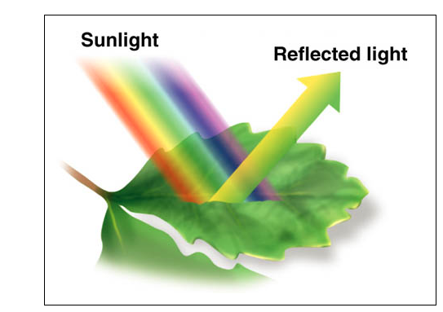
Chlorophyll primarily absorbs red and blue light, which makes leaves look green.
[Image source: http://image.wikifoundry.com/image/3/0FTA67JA0ezCxoxZvorr9w145989]

Structural color
Dyes and pigments are responsible for many of the colors we see, but not all of them. Some colors are due to structural colors, and are produced by the way that light interacts with structures in the material. An excellent example of structural color is a soap bubble. Soap bubbles are created from a clear, transparent solution containing soap and water. While this soap solution is clear and colorless, soap films and soap bubbles appear cleared. This disparity is due to the way light interacts with the structures. The soap films and soap bubbles are very thin, ranging from 10’s of nanometers to more than 1000 nanometers. Visible light has wavelengths on the same order (400-700nm), and so light reflecting from the two surfaces of the soap bubble can strongly interfere, leading to the brilliant rainbow of colors we see in bubbles.

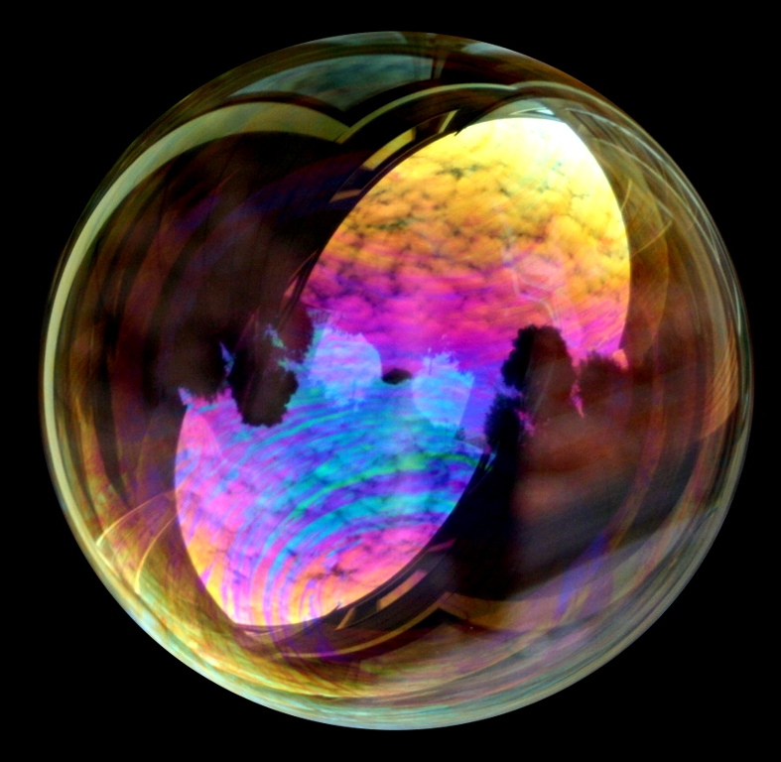
The bright colors in soap bubbles (left) and soap films are due to interference (right).
[Soap bubble: source, interference colors in bubbles: source]

Examples of structural color in nature
Structural colors are responsible for many of the brilliant colors we see in nature. The blue of the sky, the rainbow of colors in an oil slick, the bright colors of peacock feathers, the brilliant blue of a Blue Morpho butterfly, the metallic colors of certain beetles, and the glimmering colors of some fish, are all due to structural color. For more examples of structural color in nature see the References list at the end of this section.

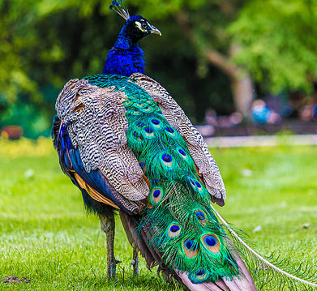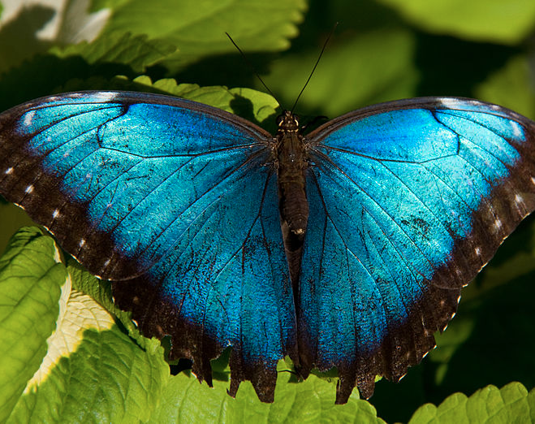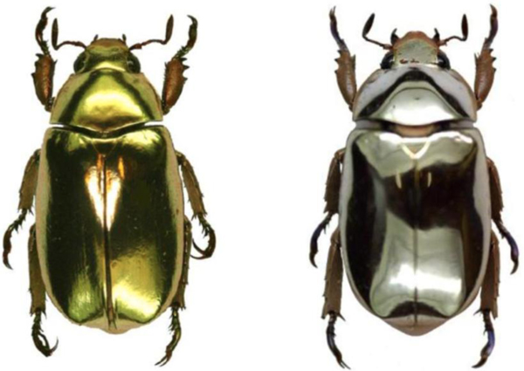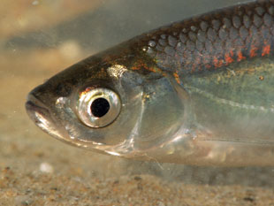
Structural coloring is responsible for the colors we see in peacock feathers, the brilliant blue of the Blue Morpho butterfly, the gold and silver bodies of the Chrysina aurigans and limbata (beetles), and the striking coloring of the Alburnus alburnus (a fish).
[Peacock photo: source, Blue Morpho butterfly photo: source, beetles photo: source, fish photo: source]

Color theory
To understand many aspects of structural color it’s important to understand how different colors of light combine. This can be confusing, because beams of light combine additively, which is opposite from the color subtraction that determines how the colors of crayons or markers mix.
For this activity, the most important thing to understand is that light from the Sun or a lamp consists of all colors, but for simplicity we can think of this white light as a combination of red, green, and blue light. So if we remove the blue light from the white light, what’s left is green and red light. And because light combines additively, if this combination of red and green light reaches our eyes, the mixture will look yellow to us.
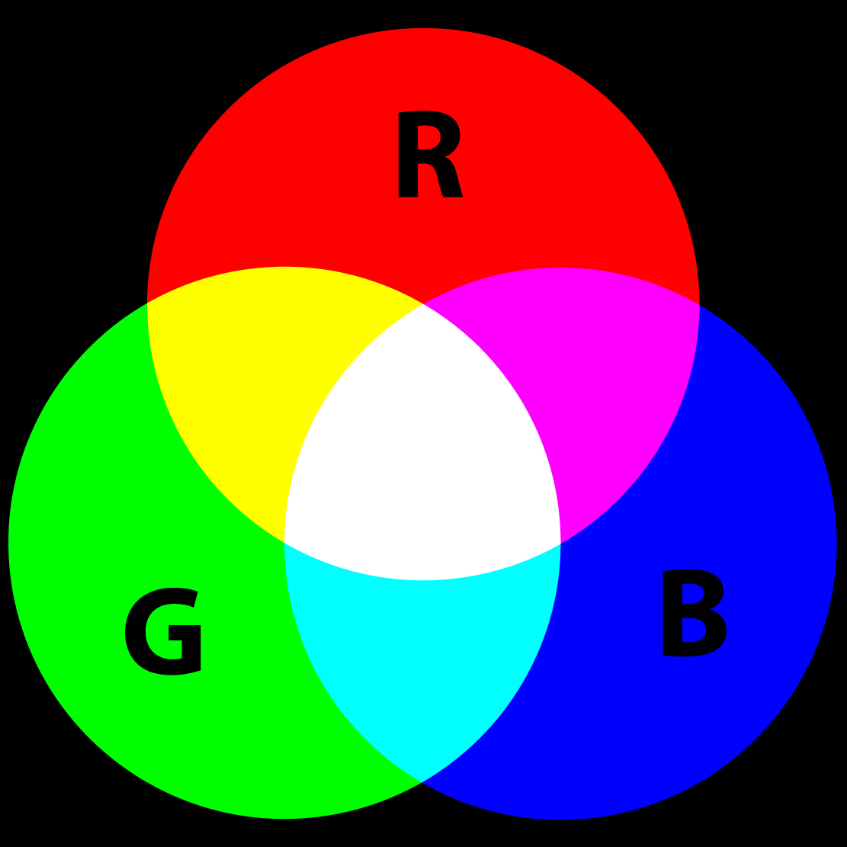
Schematic of additive color, showing the colors produced when red, green, and blue light are combined.

References
Color addition and subtraction:
- Color Subtraction. http://www.physicsclassroom.com/class/light/Lesson-2/Color-Subtraction
- Color Addition. http://www.physicsclassroom.com/class/light/Lesson-2/Color-Addition
- Color Theory. https://cs.nyu.edu/courses/fall02/V22.0380-001/color_theory.htm

Structural color:
- Structural Colors in Nature. http://www.uvm.edu/~dahammon/Structural_Colors/Structural_Colors/Introduction.html
- Structural Coloration. http://en.wikipedia.org/wiki/Structural_coloration

Thin film interference:
- Thin-film interference. http://en.wikipedia.org/wiki/Thin-film_interference
- Thin Film Interference. http://www.physicsclassroom.com/class/light/Lesson-1/Thin-Film-Interference
- Interference in Thin Films. http://farside.ph.utexas.edu/teaching/302l/lectures/node152.html
- Thin Films. http://hyperphysics.phy-astr.gsu.edu/hbase/phyopt/thinfilm.html
- Interference Phenomena in Soap Bubbles. http://micro.magnet.fsu.edu/primer/java/interference/soapbubbles/
- Thin Film Background Information. http://nisenet.org/sites/default/files/catalog/uploads/MaterialsFilm_guide_5oct14.pdf

Interference paints overview:
- Structural Special Effect Pigments: Technical Basics and Applications. Google books link
- Klein, Georg A. Industrial Color Physics. Google book link
- Bubbles. http://www.webexhibits.org/causesofcolor/15E.html
- Three-Dimensional Color - Unlocking the Secrets of Interference Pigments - A Tutorial by Carmi Weingrod. http://www.danielsmith.com/content--id-108
- The New Generation of Physical Effect Colorants. http://www.osa-opn.org/home/articles/volume_19/issue_2/features/the_new_generation_of_physical_effect_colorants/#.VTV2Rq3BzRY
- Interference Paints. http://handprint.com/HP/WCL/pigmt4.html

Working with interference acrylics:
- Golden Artist Colors: Interference and Iridescent Acrylics. http://www.goldenpaints.com/technicalinfo_iridint
- The Acrylic Book: A Comprehensive Resource For Artists. Liquitex. https://www.liquitex.com/acrylicbook/
- Liquitex: Interference Colors. http://www.liquitex.com/InterferenceColors/

Materials

Materials:
- Paper
- White paper
- Black paper
- Colored paper (optional)
- Paints and a medium
- Acrylic paint, colored
  - example: Golden Acrylics, Cobalt Blue-- fluid version or heavy body version
- Acrylic paint, black (optional)
- example: Golden Acrylics, Bone Black-- fluid version or heavy body version
- Interference acrylic paint
- example: Golden Acrylics, Interference Blue (Fine)-- fluid version or heavy body version
- Gel medium
- example: Liquitex Gloss Medium and Varnish
- Painting supplies
- At least 2 paint brushes (you’ll need more than 2 if you’re setting up stations)
- A palette knife (optional)
- Extra bottles for holding paints and medium (if you’re setting up stations)
- Surface for mixing paint
- Water, soap, and paper towels for cleaning brushes and mixing surface
- Optional extras for extension activity
- Thin plastic sheets
- example: Acrylic Clear Sheets
- Light box or iPad

Choosing materials:
When purchasing the colored acrylic paint and interference acrylic paint, it’s best to choose similar hues so that the comparisons are more clear. For example, we purchased blue acrylic paint and blue interference acrylic paint.
There are many different kinds of gel mediums and thinners. Our research indicated a gel or gloss medium would work the best. We thought the gloss medium was the easiest to work with, as it was easier to mix into the paint.
Many of these materials are available in a variety of sizes, so it’s best to estimate how many visitors would do this activity before you purchase materials. Also, you will be using much more medium than any of the paints, so keep this in mind when purchasing your supplies. (Liquitex recommends using the medium and interference paint in a 8:1 or 9:1 ratio.)

Material sources:
Most of the materials needed for this activity would be available at any art store that sells acrylic paints. However, not all stores carry interference acrylic paints. We purchased our materials from Blick Art Supplies, a chain with stores in many states in the United States. Other stores that carry interference acrylic paints are: Michaels, Utretcht Art Supplies, Artist & Craftsman and Amazon. From our research, the two main producers of interference acrylics are Golden and Liquitex. For our tests we used Golden paints, but we also read good reviews about Liquitex products.

Note about costs:
The interference acrylic paint is quite expensive for its volume, but from our tests each student only needs 1 gram of the medium/paint combination. Assuming a conservative 1:6 ratio of interference paint to acrylic medium, each student only uses ~0.17 grams of the interference acrylic. Based on this amount, 1 ounce (~44 grams) of the interference paint could be used for more than 250 students, as long as you use it within its shelf life, which according to Liquitex is 5-7 years (http://www.liquitex.com/PB1ColMenu.aspx?pageid=304&id=2226).

Set Up

Time: 15 minutes

Before doing this activity, try it once to make sure everything works as you expect. This will help give an understanding of how much paint you will need.
If desired, cut the paper into pieces. A little interference acrylic paint goes a long way, so it’s difficult to paint even thin, even layer onto a tiny piece of paper. So, we recommend that the pieces of paper be no smaller than 3 inches by 3 inches.

Make sure you’re ready to go before you start painting because the paints dry quickly.
If you are doing this activity as a classroom activity and you’re going to have stations, you need to split up the paints and medium into the extra bottles. You don’t want to just pour the paints on a dish because they dry quickly.
If you’re doing this activity as a cart demo over a long period of time, you want to keep most of the paint in bottles, not on the mixing surface. You also want to keep the brushes in water and minimize the amount of paint you pore onto the mixing surface, as any unused paint will dry fairly quickly and be unusable.

Program Delivery

Time: 15 minutes (cart demo) or 30-45 minutes (classroom activity)

Safety
If you are using normal water-based acrylics, as recommended, the safety issues are minimal. Just make sure young kids don’t eat the paint.
If you’re using oil-based acrylics, it’d be best to do this activity in a well-ventilated location.

Talking points and procedure
Applying the paints:

Preparing
As mentioned several times, it’s important that you have all materials ready, since the paint tends to dry out quickly. Similarly, once the students begin the activity they should attempt to complete it fairly quickly, so make sure they understand all the steps before they get started.

Mixing paint and medium
Mix the paint and medium. For our paint and medium, we found a ratio of 1 part paint to 6 to 8 parts medium worked well. (Liquitex recommends using the interference paint and medium in a 1:8 or 1:9 ratio.) The exact ratio doesn’t seem to be important, so you can just eyeball it.

Applying paint
Apply a thin layer of paint to each type of paper (see figure below). We recommend applying one type of paint to each type of paper before switching to the other paint, to avoid accidentally contaminating the paintbrush. (You don’t want to accidentally use the same paintbrush for the regular acrylic paint and interference paint, because even a small amount of interference paint will change how the normal acrylic paint looks.)

When applying paint, try to pick up a very small amount of paint with your paintbrush, because a little goes a long way. And try to use long slow brush strokes. This is especially important for the interference acrylic paint, because the brushstroke can affect how the mica particles are oriented.

(white paper)
normal acrylic paint

(white paper)
interference acrylic paint

(black paper)
normal acrylic paint

(black paper)
interference acrylic paint

(green paper)
normal acrylic paint

(green paper)
interference acrylic paint

Schematic of the suggested paint/paper combinations.

Multiple coats
We’ve noticed that applying multiple coats of paint makes the brilliant colors of the interference acrylics even brighter. We recommend that you apply a single coat to each of the pieces of paper and then apply a second coating, so that you give the first coat a chance to dry.

Comparing the results:
Encourage the students to look at their swatches and make observations. This activity is a great opportunity for open-ended inquiry, but if you like you can suggest that the students describe the appearance of each swatch by characterizing its (1) color, (2) opacity, (3) shimmer, (4) tendency to change color with the viewing angle, etc.

Optional extension
As a fun extension to this activity, you can drop a little paint on a small piece of clear acrylic sheet, and then quickly press another small piece of acrylic on top to create a paint sandwich. (Apply pressure evenly for best results.) After the paint dries (after about 30 minutes to 1 hour), you can observe the importance of the background color by using a light source like a light box or an iPad. Hold the painted acrylic over the light source and toggle the light on and off to observe the effect of the background.
Note: if you’re going to do this extension, make sure the paint is thoroughly dried so you don’t drip any paint on the light source.
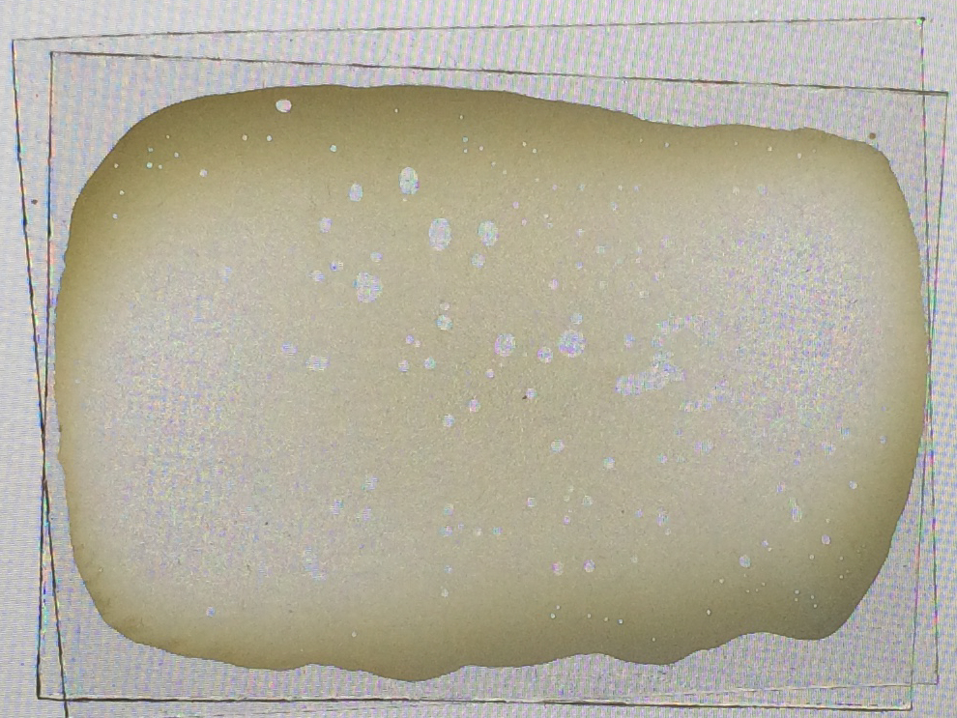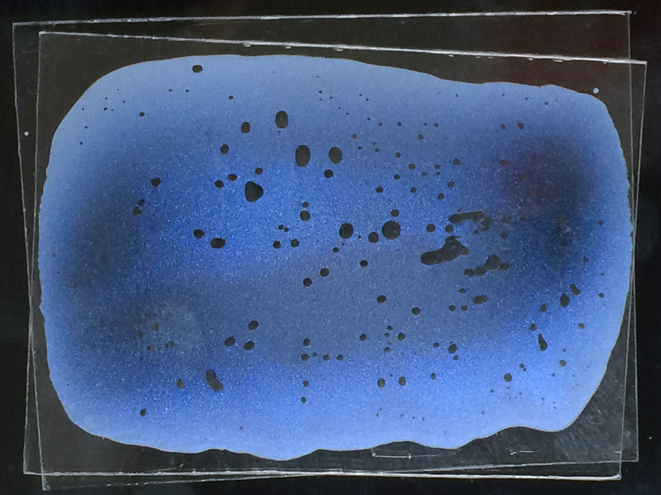
Photographs from optional extension. When the iPad is on and light shines through the paint, the paint appears light yellow. But when the iPad is turned off and the background is black, the paint appears a vibrant blue.

Discussion:
You can have a discussion before, during, and/or after this activity. During this discussion you can cover material from the Background section of this document as well as the What’s Going On section (see below).
We suggest that you do this activity as an inquiry-based activity, and that you don’t tell the students what to expect. Let them investigate what happens when they paint the regular acrylic paint and the interference acrylic paint onto the different papers. Then encourage them to brainstorm explanations for what they observe.

Talk about how dyes and pigments make objects look colored
Explain that colored objects appear colored because of the way light interacts with the objects. For example, red apples look red because the pigment molecules in the apples mostly absorb blue and green light, and reflect red light back to our eyes.

Introduce structural color
Discuss what structural color is and examples of structural color in nature. Ask if anyone can give an example of structural color.

Introduce interference acrylic paint
Explain that acrylic paint is usually colored because of dyes or pigments. But today the students are going to explore interference acrylic paints. Explain what interference paints are, and how they get their colors.

Elicit observations
As discussed above, we encourage you to do this activity as an inquiry-based activity. After the students have explored the paints and seen how the paints look different on different paper, you can ask them to give you their observations. If the students aren’t offering observations you can asking prompting questions, such as:
- What did you notice?
- What do you think could be going on?
- Did the acrylic paint look the same as the interference acrylic paint?
- Did the color of the paper make a difference?
- What happened to the color of the paint when you tilted the paper?
- Did tilting the paper have more of an effect for the black paper, or the white paper?

After you give the students a chance to brainstorm theories, you can explain why the paints look different and why the background color makes a difference.

What’s Going On
Interference paints: what they’re made of
Interference paints contain small particles of mica coated with titanium dioxide. These TiO₂-mica-TiO₂ particles are usually 10–100 microns across. The thickness of the mica layer is roughly 500 nanometers, while the TiO₂ layers are usually 60–200 nanometers thick. A layer of TiO₂ approximately 85 nanometers thick produces a red color, while one around 130 nanometers produces a blue color.

“Interference pigments”: bad terminology
Many art companies refer to the TiO₂-mica-TiO₂ particles as “interference pigments” (example), which can be confusing. By the standard biology definition, pigments are molecules that absorb certain colors (wavelengths) of light (see Glossary). Since TiO2-mica-TiO2 particles are not molecules, they cannot be pigments. Instead, these art companies are using the term more loosely, to indicate that the paints owe their colors to these particles, similarly to how normal acrylic paint owes its color to a dye or pigment.

Interference paints: how they work
When interference acrylic paints are applied as thin layers, they can take on brilliant colors. These colors are produced because of the way reflected light interferes and cancels particular colors. When incident light hits the top of a TiO₂-mica-TiO₂ particle, part of the light reflects off the top TiO₂ layer and part of the light travels into the particle. This process repeats at each of the other three interfaces (TiO₂-mica, mica-TiO₂, and TiO₂-air).

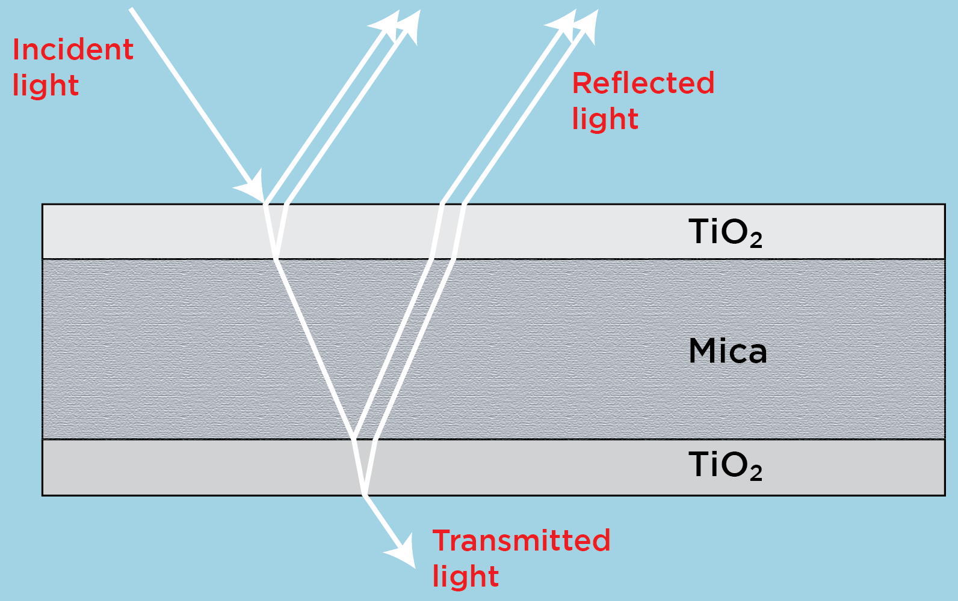
Schematic showing how light interacts with TiO₂-mica-TiO₂ particles.

Because the thicknesses of the TiO₂ and mica layers are in the nanoscale range, the visible light that is reflected from these particles can strongly interfere. This interference can be constructive or destructive. If a particular wavelength (color) of light interferes destructively, this color is cancelled. This process produces the brilliant colors and metallic appearance of the interference paints.
To understand how this interference can produce colors, it might help to revisit how pigment molecules make objects look colored. Light from the Sun or a lamp (a.k.a. white light), is made up of all colors. This light doesn’t look colored because the sum of all the colors is white. (For example, if white light travels through a piece of glass, none of the light is absorbed, so the mirror looks clear.) But if one or more colors are absorbed by the pigment molecules, the reflected (and/or transmitted light) is no longer white, and the object looks colored.
With this understanding, we can appreciate how the interference between reflected light waves makes interference acrylics appear colorful. When light reflected from the TiO₂-mica-TiO₂ particles interferes destructively, that light is removed from the white light, and the resulting light now appears colored.
To learn more about how thin film interference produces colors, consult the References list.

Schematic showing how light interacts with a blue interference acrylic paint.

The above schematic shows how a blue interference acrylic paint interacts with incident white light. The light hitting the particle reflects off the four interfaces and this reflected light undergoes strong interference. At the reflection angle, the interference color—blue—is visible. The rest of the light passes through the transparent TiO₂/mica/ TiO₂ particles. The ultimate appearance of the interference paint depends on the viewing angle and the paper color, as will be discussed next.
The color of an interference acrylic paint depends on which wavelengths (colors) of light interfere constructively. The kind of interference (constructive versus destructive) that occurs for a particular wavelength depends on the path length of the light through each layer. This path length depends on the angle of the light and also each layer’s thickness (see “Interference in Thin Films” in References list). This dependence on the TiO₂ layer thickness provides engineers a simple way to tune the color of these paints. A large library of interference paint colors can be created, as can be seen at http://www.impactcolorsinc.com/Optique-Iridescence/.
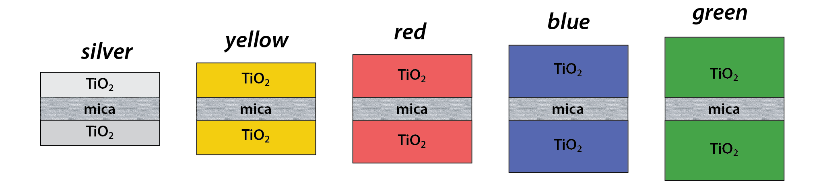
Top: Schematic showing how the color of the interference pigment depends on the thickness of the TiO₂ layers. (Note: the ratio of mica to TiO₂ layer thickness is not to scale. In reality the mica is thicker than the TiO₂ layers)
Bottom: Microscopy image of TiO₂-mica-TiO₂ particles from various interference paints. [Photo is from BASF: source]

Interference pigments: why the background and viewing angle matter
Interference pigments look very different when applied on black versus white paper. To understand why this is the case, we need to think about what happens to the light that is transmitted (not reflected) through the TiO₂-mica-TiO₂ particles.
To delve into this, let’s take the example of an interference blue acrylic paint. The interference paint reflects blue light, while the rest of the light (green and red) —is transmitted through the translucent particles. If the interference acrylic is applied to black paper, the green and red light are absorbed by the paper. As a result, blue light is the only color of light that is reflected. This blue color is strongly visible at the angle of reflection, but not at other angles. At angles other than the angle of reflection, the paint looks grey-blue. (A natural assumption would be that the paint would look blue at the reflection angle, and black everywhere else. But at angles other than the reflection angle the paint actually appears blue-grey because light is scattered at the edges and corners of the TiO₂-mica-TiO₂ particles).
When the paint is applied to white paper, its appearance is pretty different. The transmitted red and green light is not significantly absorbed by the white paper, and is instead reflected. The reflected light doesn’t all travel in the same direction. Instead, the light is reflected at a wide range of angles due to the surface roughness of the paper. The combination of this reflected red and green light looks yellow to our eyes. As a result, yellow light is visible at most viewing angles, while the blue interference color is only visible at the angle of reflection. When the paper is tilted, the paint’s color changes from yellow to blue. The way the color changes when the paper is tilted, from the interference blue to its complementary color, yellow, is referred to as the flip-flop effect.
(Note: At the angle of reflection, blue light, as well as green and red light, are all being reflected. But much more blue light is reflected at this angle, compared to green and red light. As a result, at the angle of reflection the paint looks blue)
Schematic showing how light interacts with a blue interference acrylic paint on (left) black paper and (right) white paper.

(a) (b) (c)
Photos showing how the background and angle affect the appearance of a blue interference paint. (a) Interference paint applied on clear plastic that is placed over a split black/white background. The part of the interference paint swatch that is above the black background is much more visible than the part over the white background. (b)/(c) Blue interference paint applied to white paper looks dull yellow at certain angles (b) and shimmery blue at other angles (c). (Colors are more vibrant in person; accurate colors are difficult to capture with photographs.)

Interference pigments: colored backgrounds
Understanding what happens when an interference paint is applied on a colored background is trickier. To investigate the effect of the background color, consider how light would interact with interference blue paint applied to green paper.
When light hits a blue interference paint, blue light is reflected. Red and green light passes through the paint and hits the green paper. The red light is absorbed by the paper, but the green light is not, so the green color of the paper is reflected. As a result, at most angles the paint looks the same color as the paper. Based on this, one would assume that the paint would blend into the paper at most angles, but look blue at the angle of reflection. But from observation it becomes clear that at the angle of reflection the paint appears bluish-green. So the question is, why?
What has not been considered so far is what happens to light that doesn’t interact with a TiO₂-mica-TiO₂ particle, and instead travels directly down to the paper. In the case of black paper, this light is absorbed, so it doesn’t affect anything. For white paper, all of this (white) light is reflected, so it doesn’t affect the color, but it does affect how saturated/bright the paint looks. In other words, this reflected white light combines with the reflected blue or yellow light, making the blue and yellow colors more muted they are on the black paper.
For green paper the light that travels directly down to the paper is also very important, as it affects the color at the angle of reflection. Light that doesn’t interact with a TiO₂-mica-TiO₂ particle is scattered from the green paper at many angles, including the angle of reflection. So, there is also a significant amount of green light being reflected at the angle of reflection. As a result, at the angle of reflection the blue interference color is superimposed over the color of the paper, and the result is that the paint looks bluish-green. At all other angles only green light is reflected, so the paint is almost invisible.
Schematics showing how light interacts with blue interference pigments applied to different papers. Top row: colors produced when light hits the pigments. Bottom row: colors produced when light doesn’t hit the pigments, and travels directly to the paper.

Photos of blue interference acrylic paint applied on green paper. At most angles, the blue color of the interference acrylic paint is not very visible on green paper (left). However, at certain angles, a shimmery blue color is superimposed over the green background (right). (Colors are more vibrant in person; accurate colors are difficult to capture with photographs.)

Tips and troubleshooting
Try this activity ahead of time, to make sure that the medium you have will work well. Also, trying the activity ahead of time give you a chance to determine whether you want to add a small amount of black paint or not.
Make sure you use different paintbrushes for the regular acrylic paint and the interference acrylic paint.
If the interference paint seems to have white dots or clumps, its probably not getting mixed well enough. To fix this problem, try to mix the paint with the medium more before painting it on. Or, try using more medium. Also, make sure that you’re applying only a small amount of paint and using long brush strokes.
If color of the interference acrylic paint isn’t very strong, even on black paper, you can add a very small amount of black acrylic paint. Golden Artist Colors recommends adding black paint to interference paint at a ratio of 1:100, or even less.

Adapting activity for younger children
Young kids love painting, so they will enjoy this activity. However, most of the science will be far too advanced for them. Emphasize the big points, and try to spark their curiosity. For example, you could ask them if they’ve ever noticed that bubbles have colors. You could explain that a bubble’s coloring is surprising, since a bubble solution is not colorful. You could add that scientists and engineers have developed different ways of controlling an object’s color. Sometimes they create specific chemicals, while other times they try to change the structure (shape) of the material. Finally, you could mention that scientists often try to copy things in nature—like birds, fish, and bugs—when they are trying to develop new methods for coloring something.

Working with interference acrylics
Here is a selection of excellent references that offer tips on working with interference acrylics:
- Liquitex: Interference Colors. http://www.liquitex.com/InterferenceColors/
- The Acrylic Book: A Comprehensive Resource For Artists. Liquitex. https://www.liquitex.com/acrylicbook/
- Golden Artist Colors: Interference and Iridescent Acrylics. http://www.goldenpaints.com/technicalinfo_iridint

Common visitor questions
Where can I buy this stuff? How much does it cost?
Tell the visitor where you bought your materials and provide a cost estimate.

Why do the paints look different?
Explain that the normal acrylic paint looks colored because it contains a dye or pigment that absorbs certain colors of light. The interference acrylic, on the other hand, owes its color to the way light interferes when it reflects off the surfaces of the TiO₂-mica-TiO₂ particles. See the Background and What’s Going On sections for more information.

Why does the background color matter?
The background color matters because it changes what happens to the light that passes through the mica particles. See the What’s Going On section for more information.

What are interference pigments used for? What are interference pigments used for?
Artists like interference paints because they impart a metallic, 3D-effect. They also like how they catch the light. Here are a few examples of artwork created with interference acrylics:
- https://www.flickr.com/photos/sharlena/5851065666
- https://www.flickr.com/photos/origamijoel/8218447478
- https://www.flickr.com/photos/melisande-origami/3354159138

Ford also used interference pigment paint on a Puma produced in the late 1990s.
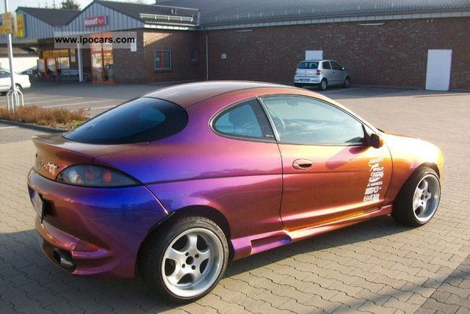
Ford Puma with interference paint [Car photo: source]

Going further…

There are a number of excellent NISE activities related to light and how light interacts with different materials.

Exploring Materials - Thin Films is a hands-on activity in which visitors create a colorful bookmark using a super thin layer of nail polish on water. They learn that a thin film creates iridescent, rainbow colors.

Exploring Structures - Butterfly is a hands-on activity in which visitors investigate how some butterfly wings get their color. They learn that some wings get their color from the nanoscale structures on the wings instead of pigments.

Exploring Products - Sunblock is a hands-on activity comparing sunblock containing nanoparticles to ointment. Visitors learn how some sunblocks that rub in clear contain nanoparticles that block harmful rays from the sun.

Exploring Materials - Polarizers is a hands-on activity in which visitors use two polarizing sheets and overlapping layers of transparent tape to see how polarizers affect light. They learn that researchers are using nanotechnology to improve existing materials, in this case polarizing filters.

Exploring Properties - Invisibility is a hands on activity in which visitors investigate how glass objects can be "hidden" in some liquids. They learn that researchers can use nanotechnology to engineer new materials that interact with light in special ways.

Exploring Materials - Nano Gold is a hands-on activity in which visitors discover that nanoparticles of gold can appear red, orange or even blue. They learn that a material can act differently when it’s nanometer-sized.

Colors at the Nanoscale: Butterflies, Beetles and Opals is an activity where museum visitors will be exposed to the term ‘Photonic Crystals’. They will see and explore some of the well-known photonic crystals in nature and will also be able observe one method that scientists use in trying to replicate this process.

Clean Up

Time: 15 minutes

Clean the paintbrushes and mixing surfaces as soon as possible after completing the activity. (Information on cleaning acrylic paintbrushes can be found at http://www.art-is-fun.com/how-to-clean-paintbrushes.) If you don’t clean the brushes and other paint surfaces quickly, the paint--especially the interference paint--will dry out and become very difficult to remove.

Universal Design

This program has been designed to be inclusive of visitors, including visitors of different ages, backgrounds, and different physical and cognitive abilities.

The following features of the program’s design make it accessible:

[X] 1. Repeat and reinforce main ideas and concepts
- Explicitly state overarching main idea and supporting concepts visually and aurally.
- Actively engage visitors with the content visually, aurally, and tactilely.
- Deliver one core concept at a time.
- Repeat core concepts frequently during the program.
- Punctuate the delivery of key ideas by presenting them visually, aurally and tactilely.
- Check in with the audience along the way.

[X] 2. Provide multiple entry points and multiple ways of engagement
- Enable learners to enter at different places and take away different messages.
- Actively engage audience members in the program.
- Ask questions that encourage visitors to relate the content to their everyday life.
- Connect the content to a range of prior experience and everyday life examples.
- Use multiple analogies to represent the same idea.
- Engage more than one sense when delivering jokes and special effects.

[X] 3. Provide physical and sensory access to all aspects of the program
- Speak slowly and provide extra time for people to process important ideas.
- Provide auditory descriptions of models and images.
- Provide tactile models that are easy to handle and manipulate.
- Use color and/or tactile designs to impart meaning on models and images.

To give an inclusive presentation of this program:
- Ask your students questions and check in with them along the way to make sure they’re engaged and with you.
- Relate the topics to things visitors are familiar with
Developed for the NISE Network with funding from the National Science Foundation under Award Numbers 0532536 and 0940143 and for University of California Berkeley with funding from the National Science Foundation under award Number 1055938. Any opinions, findings, and conclusions or recommendations expressed in this product are those of the authors and do not necessarily reflect the views of the Foundation.
Published under a Creative Commons Attribution-Noncommercial-ShareAlike license: http://creativecommons.org/licenses/by-nc-sa/3.0/us/

