Stained-glass Art

Nano-sized gold and other metals have been used to color stained glass since the Middle Ages. Although traditionally made in flat panels and used in windows (often in culturally or religiously important buildings), modern stained-glass artists also create abstract panes, structures, and sculptures.

DragonFly TV video clip on the process of making stained-glass:
http://www.youtube.com/watch?v=kaRLAbiF-VQ

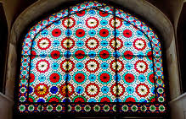  Stained-glass window in a mosque, Yazd, Iran | 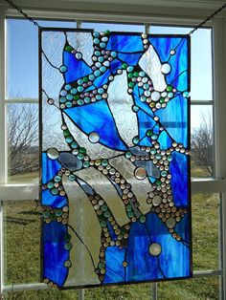  Modern stained-glass art, Corning Museum of Glass, Corning, NY

