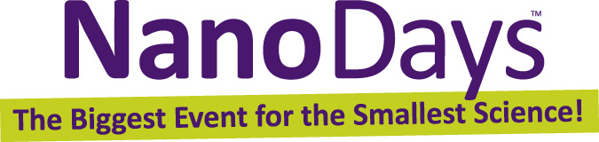  My Name in Binary Code  Computers use binary code to store information. Binary code can be represented by any two symbols, such as 1s and 0s or full and empty circles.  Make a binary code representation of your name (or nickname). For each row, fill in a letter and the corresponding binary code. Leave the circle empty for 0 and fill it in for 1.  Name Binary Code  ___  ___  ___  ___  ___  ___  ___  ___  Letter Binary Code Letter Binary Code  a 01100001 n 01101110  b 01100010 o 01101111  c 01100011 p 01110000  d 01100100 q 01110001  e 01100101 r 01110010  f 01100110 s 01110011  g 01100111 t 01110100  h 01101000 u 01110101  i 01101001 v 01110110  j 01101010 w 01110111  k 01101011 x 01111000  l 01101100 y 01111001  m 01101101 z 01111010  Upper case letters start with 010 (instead of 011).  whatisnano.org |  | My Name in Binary Code  Computers use binary code to store information. Binary code can be represented by any two symbols, such as 1s and 0s or full and empty circles.  Make a binary code representation of your name (or nickname). For each row, fill in a letter and the corresponding binary code. Leave the circle empty for 0 and fill it in for 1.  Name Binary Code  ___  ___  ___  ___  ___  ___  ___  ___  Letter Binary Code Letter Binary Code  a 01100001 n 01101110  b 01100010 o 01101111  c 01100011 p 01110000  d 01100100 q 01110001  e 01100101 r 01110010  f 01100110 s 01110011  g 01100111 t 01110100  h 01101000 u 01110101  i 01101001 v 01110110  j 01101010 w 01110111  k 01101011 x 01111000  l 01101100 y 01111001  m 01101101 z 01111010  Upper case letters start with 010 (instead of 011).  whatisnano.org

