Atomic Force Microscopes

Atomic force microscopes, or AFMs, are a kind of scanning probe microscope. AFMs have a probe tip mounted on the end of a cantilever. When the tip is near the sample surface, the cantilever is deflected, or moved, by a force. AFMs can detect many kinds of forces, including physical contact, electrostatic forces, and magnetic forces. The deflection is measured by a laser that is reflected off the top of the cantilever and into an array of photodiodes. AFMs can detect tiny deflections—as small as a fraction of a nanometer!

To analyze a sample, the AFM tip is moved back and forth across the surface many times. A computer program combines the data and creates an image.

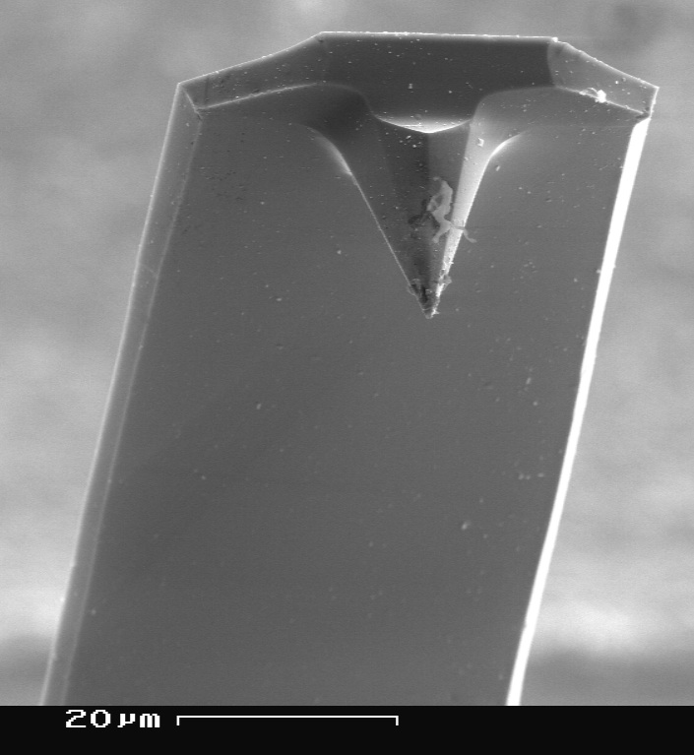  Magnified image of an AFM tip | 