Exploring Tools—Transmission Electron Microscopes

Try this!
- Shine the flashlight down the plastic imaging tube. With the flashlight on, look in the viewing window under the tube. What shadow shapes do you see?
- Based on the shadow shapes, can you guess what the objects look like?
- Take the large tube off so you can see the objects. Did you guess right?
- Now try to build a sample from play dough to create the same shadow. When you shine the flashlight on it, do you get the same shadow? Try making some other shapes!
What’s going on?
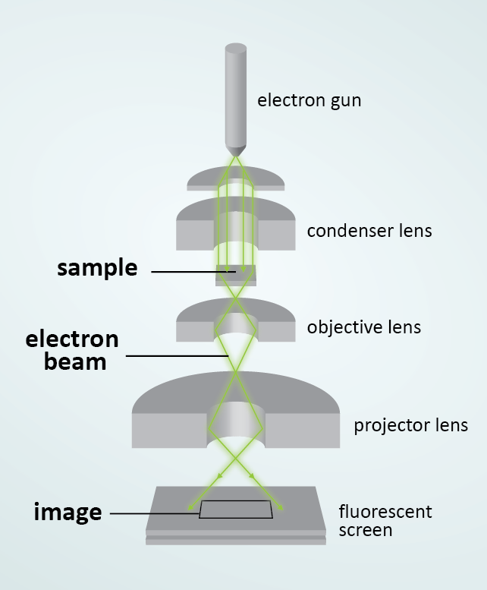  Transmission Electron Microscope (TEM) | The imaging tube is a model for a transmission electron microscope (TEM). TEMs allow scientists to image nanometer-sized features (a nanometer is a billionth of a meter). TEMs can even produce images that show the locations of individual atoms!  In a TEM, a high-energy electron beam is focused at a sample. Researchers observe how the electron beam changes after it goes through the sample. The electron beam needs to penetrate the sample, so TEM samples have to be very thin. If a sample has a regular, crystalline pattern, scientists can use the TEM to produce images that provide information about the structure. Scientists can also use special detectors to determine what elements, like carbon or iron, are in the sample.  The model uses a flashlight, but TEMs use an electron beam. Electron beams, unlike visible light, can be focused into much smaller spots, allowing scientists to look at smaller features.  When we shine the flashlight on objects in the plastic tube model, we can see their shadow in the viewing window. While we can see the shadow, we lose some information about exactly how the
sample looks. Is it tall or short? Is it solid? Or does it have a hole in the middle? Some objects may have the same shadow but look quite different in 3D. With the TEM, scientists have developed ways to overcome this challenge, such as imaging their samples from different angles, or thinly slicing a sample and imaging each slice.
How is this nano?
Scientists use special tools and equipment to work on the nanoscale. Transmission Electron Microscopes (TEMs) allow researchers to detect and make images of individual atoms and other features that are too small to see with other tools.  The invention of transmission electron microscopy was a breakthrough in the field of nanotechnology. Once scientists could create pictures of nanoscale objects and features, they could begin to study and understand this super-tiny scale. | TEM image of Silicon Nitride

Learning objective
Scientists use special tools and equipment to work on the nanoscale.

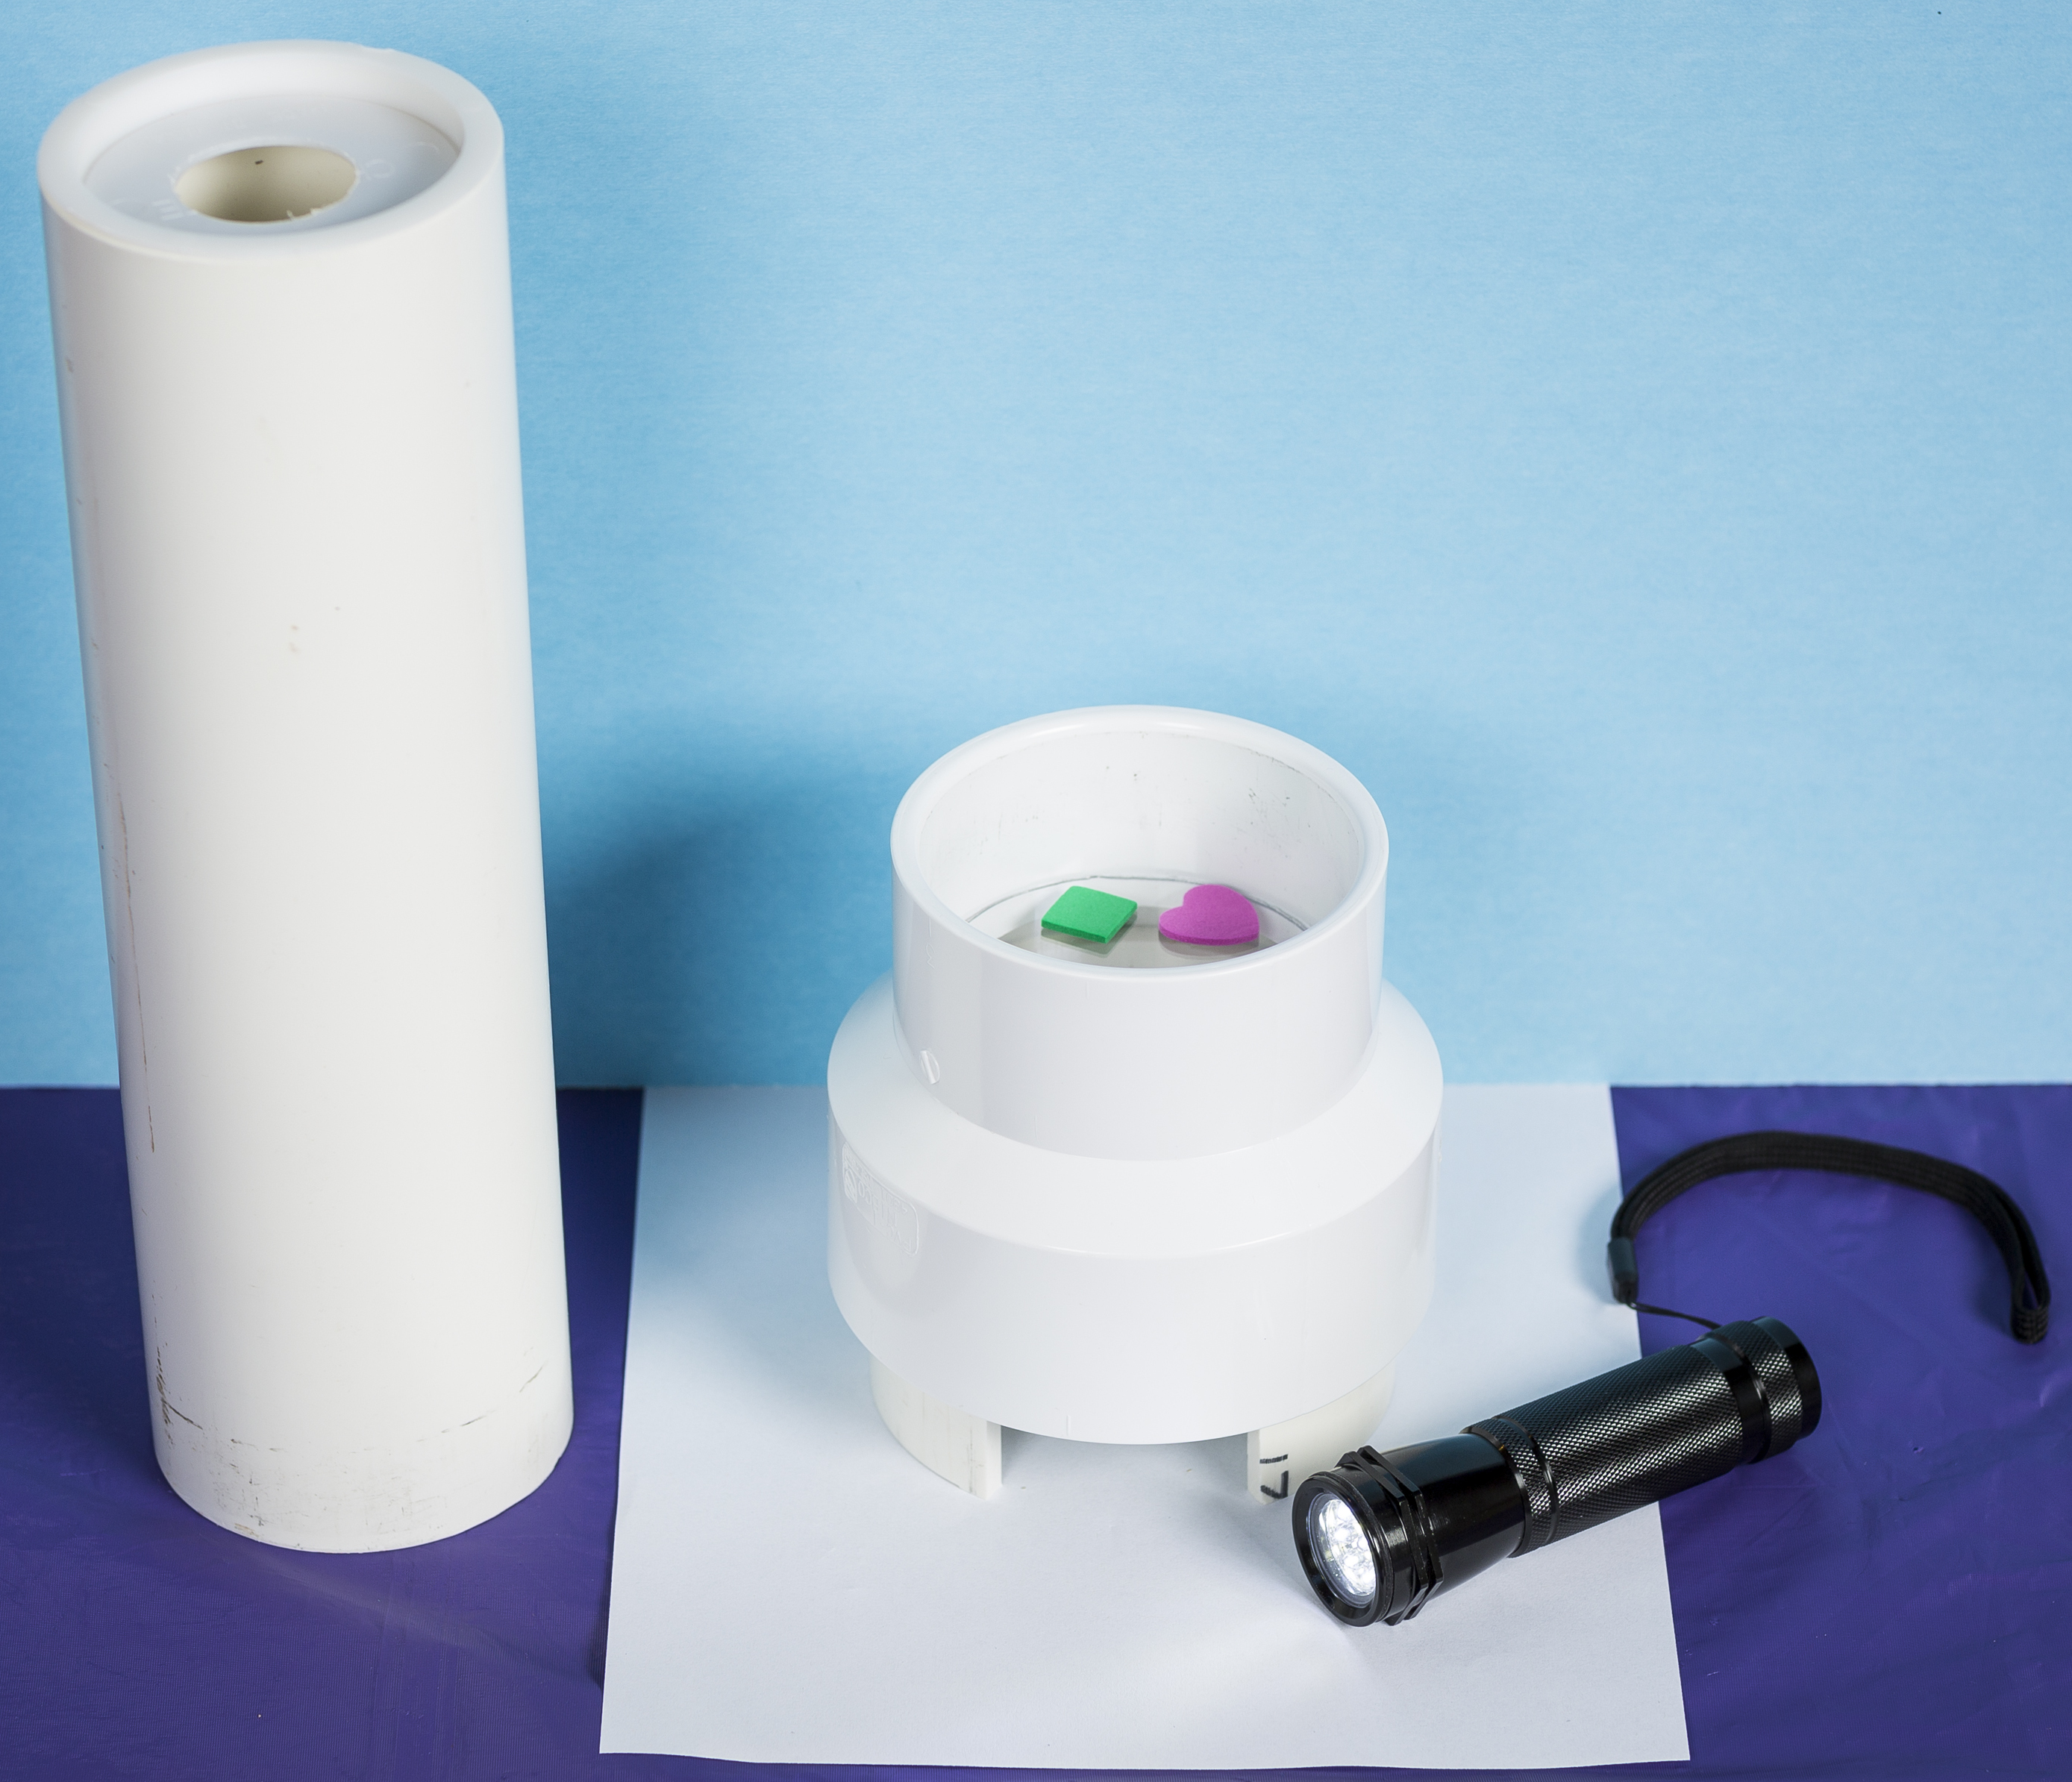
Materials
- Imaging tube
- Small foam pieces
- Play dough
- Flashlight
- Piece of plain white paper
- “Comparing Microscopes” image sheet
- “Comparing Microscopes Background”
The imaging tube consists of a 3” dia. x 11” PVC pipe, a 4” dia. x 3” PVC pipe (with a 2” wide notch cut out), a 3” x 4” PVC coupling, a 3” dia. PVC end cap (with a 1 ¼” hole drilled in the center) and a 3 ¼” dia. clear acrylic disk.
Imaging tube parts are available through home improvement stores, such as Lowe’s, www.lowes.com.

Notes to the presenter
Since this demo relies on creating shadows, it is very sensitive to ambient light. For best results, do not have this station near a window or other sources of bright light. You can also place a piece of white paper under the imaging tube so the shadows show up better.

Brighter flashlights produce shadows with more detail.
Related educational resources
The NISE Network website (www.nisenet.org) contains additional resources to introduce visitors to nanotechnology and the tools researchers use to study and make things that are too small to see:
- Public programs include Attack of the Nanoscientist; Cutting it Down to Nano; Intro to Nano; Ready, Set, Self-Assemble, and Tiny Particles, Big Trouble!
- NanoDays activities include Exploring Size—Powers of Ten Game, Exploring Tools—Mystery Shapes, Exploring Tools—Special Microscopes, and Exploring Tools—Mitten Challenge.
- Media include the video What Happens in a Nano Lab?
- Exhibits include Creating Nanomaterials and NanoLab.

Credits and rights
TEM image of Silicon Nitride courtesy James LeBeau, NC State University.
TEM image of Silica and Silicon courtesy Pinshane Huang, Cornell University.
Illustrations by Emily Maletz.

This project was supported by the National Science Foundation under Award No. ESI-0532536. Any opinions, findings, and conclusions or recommendations expressed in this program are those of the author and do not necessarily reflect the views of the Foundation.

Copyright 2014, Sciencenter, Ithaca, NY. Published under a Creative Commons Attribution-Noncommercial-ShareAlike license: http://creativecommons.org/licenses/by-nc-sa/3.0/us/.

TEM Background Information

What are transmission electron microscopes?
Transmission electron microscopes (TEMs) are a type of electron microscope. TEMs are similar to light microscopes, but they are able to image very small structures because they use electrons instead of light. While light microscopes can only image features that are larger than 200 nanometers, the best TEMs can show features that are smaller than 1 nanometer! (A nanometer is a billionth of a meter.)
Scientists use TEMs because they can provide very detailed images. TEMs can also identify the structure of ordered, crystalline materials. TEMs, as well as other electron microscopes, may also employ detectors that can identify the atomic composition of a sample.

How do they work?
TEMs direct an electron beam at a sample and detect the electrons that are transmitted through the sample. A TEM works similarly to a shadow puppet show. In a puppet show, the puppet is illuminated by a bright light and we see the shadow projected onto the wall. In a TEM, the sample is like the puppet and the electron beam is like the bright light. In a TEM, the resulting “shadow”—the transmitted image—is then displayed so that researchers can analyze it.
Unlike in a shadow puppet show, where the puppet blocks the light to create a shadow, in a TEM the electron beam passes through the sample. The “shadow” that’s created isn’t really from blocking the electrons, but rather from interfering with them. When an electron beam passes through a sample, the atoms can deflect the beam creating a “shadow” in the projection. Heavier atoms deflect the beam more and will appear darker than less heavy atoms.

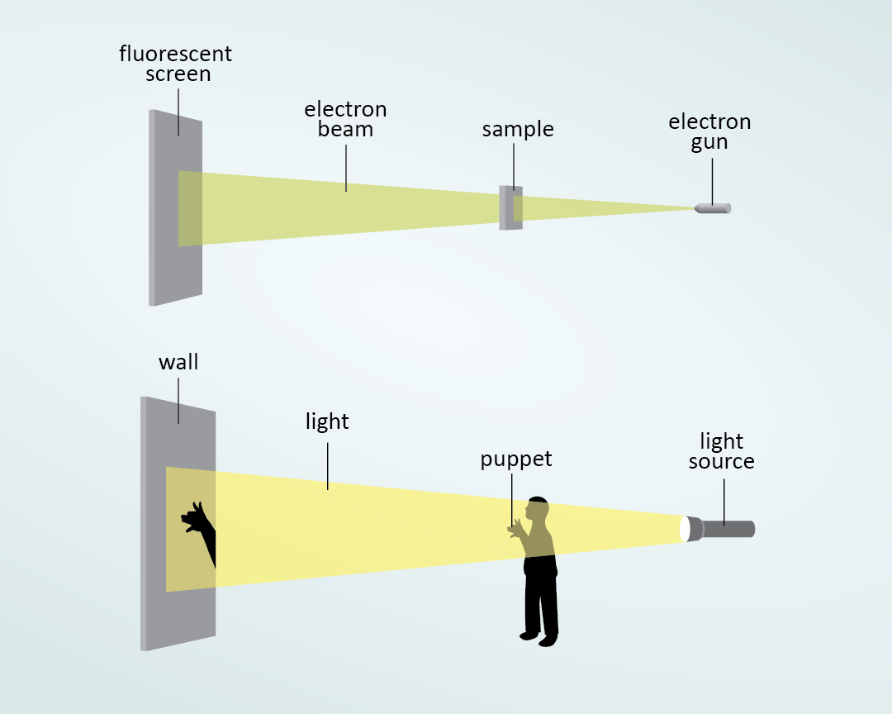  TEMs work similarly to shadow puppets | 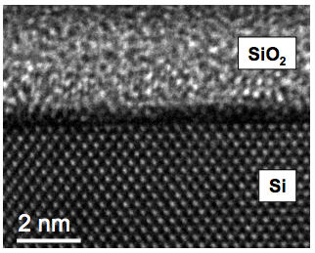  TEM image of Silicon Dioxide and Silicon

