

Exploring Size—Scented Balloons
Try this!
- Smell the balloons. Each one has a flavored extract inside it.  - Can you identify all the different scents? Match the balloon colors with the scents listed on the poster.  - Why do you think you can smell the extracts through the balloon?  What’s going on?  Tiny scent molecules are leaking out of the balloons. They’re too small to see, but you can smell them!  Your sense of smell works by identifying the shape of scent molecules. Molecules are made of particles called atoms that bond together. Everything in the world is made of atoms, including the balloon you’re holding and the scented air inside it. | 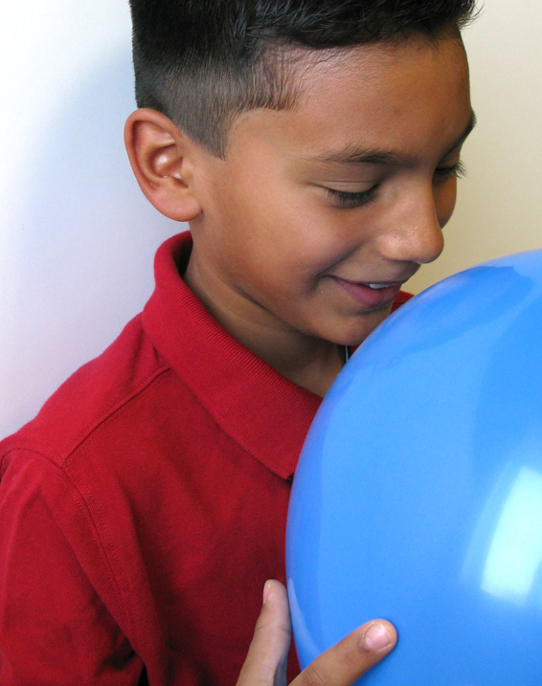

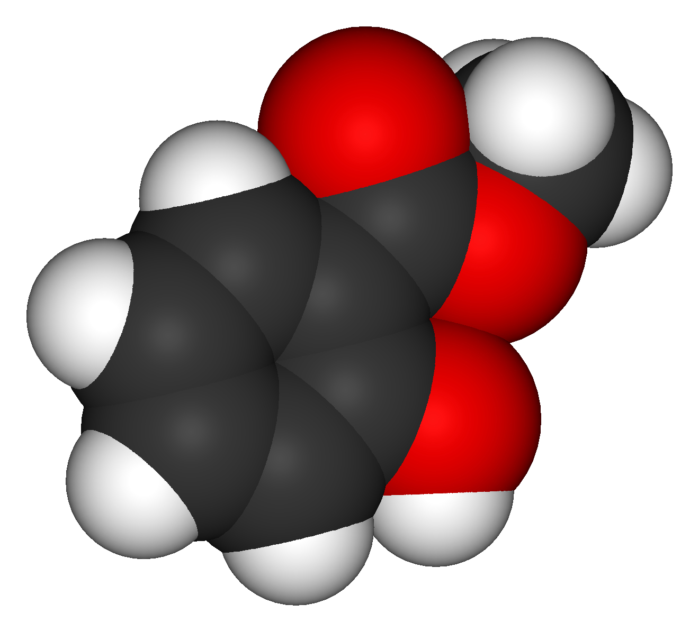  Molecular model of wintergreen oil | Scent molecules are so small that they can travel through the balloon membrane. In fact, they’re so tiny that they’re measured in nanometers! A nanometer is a billionth of a meter.  Air gradually leaks out of a tied balloon because the molecules inside the balloon move through the pores of the balloon’s skin, in a process known as diffusion. Air always diffuses from areas of higher pressure to areas of lower pressure. An inflated balloon has greater air pressure than the air around it, so the air inside the balloon gradually escapes.

How is this nano?
A nanometer is a billionth of a meter. That’s very, very small—too small to see with just your eyes. We can use our sense of smell to explore the world on the nanoscale, because we can smell some things that are too small to see.
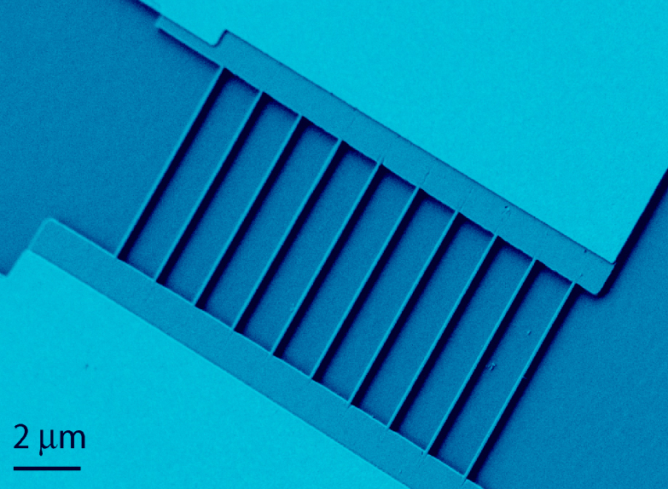  Biosensor with silicon nanowires | Nanoscale science focuses on the building blocks of our world, atoms and molecules. Scientists use special tools and equipment to detect and manipulate tiny, nanometer-sized particles.  In the field of nanotechnology, scientists and engineers make new materials and tiny devices. Researchers are creating tiny, nanometer-sized sensors that can detect very small concentrations of chemicals. Some of them work the way your nose does: by detecting the different shapes of molecules in the air.
Learning objective
A nanometer is a billionth of a meter.

Materials
- Round balloons in different colors
- Variety of flavored extracts
- Balloon pump
- “Match the Scent” poster
- “Key” sheet
- Wet- or dry-erase marker
- Latex warning sign

Preparing the balloons
Add the extracts and inflate the balloons just before you do the activity:
- Put about half a teaspoon of extract into a balloon.
- Use the pump to blow up the balloon. Tie the balloon.
- Shake the balloon a few times to encourage the extract to vaporize.
- Repeat steps 1-3 for every extract. Choose a different color balloon for each extract.
Prepare the key and poster:
- Fill in the key, indicating the scent you put in each color balloon.
- Fill in the poster, jumbling the order of the scents so you can play a matching game with visitors.

Notes to the presenter
SAFETY: The balloons are latex. In addition to posting the included sign, you may wish to verbally warn visitors of possible sensitivities or allergies to latex.
Just before doing this activity, prepare the balloons (see instructions above). The scents will last a few hours.
If you prefer not to use balloons, you can put the extracts into flexible squeeze bottles and label the bottles with colored stickers. Visitors should squeeze the bottles gently as they sniff.

Related educational resources
The NISE Network online catalog (www.nisenet.org/catalog) contains additional resources to introduce visitors to the nanoscale and nanometers:
- Public programs include Cutting it Down to Nano and Shrinking Robots!
- NanoDays activities include Exploring Size—Measure Yourself, Exploring Size—Memory Game, Exploring Size—Powers of Ten Game, Exploring Size—Scented Solutions, Exploring Size—StretchAbility Game, and Exploring Size—Tiny Ruler.
- Media include the poster and book How Small is Nano?, Image Scaler Software, Intro to Nano, Multimedia Zoom into a Human Hand, Multimedia Zoom into a Nasturtium Leaf, Scale Ladder, Zoom into a Butterfly Wing, Zoom into a Computer Chip, and Zoom into the Human Bloodstream.
- Exhibits include At the Nanoscale and Three Drops.

Credits and rights
This activity was adapted from “Odors Aloft,” in No Hassle Messy Science with a Wow: Chemistry in the K-8 Classroom, published by the Oregon Museum of Science and Industry, 1998 and 2007. The original activity is available at: http://www.omsi.edu/sites/all/FTP/files/chemistry/NH-PDF/NH-E19-OdorsAloft.pdf

Photo of biosensor courtesy Raj Mohanty, Boston University.

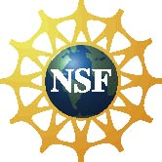 | This project was supported by the National Science Foundation under Award No. ESI-0532536. Any opinions, findings, and conclusions or recommendations expressed in this program are those of the author and do not necessarily reflect the views of the Foundation.

Copyright 2010, Sciencenter, Ithaca, NY. Published under a Creative Commons Attribution-Noncommercial-ShareAlike license: http://creativecommons.org/licenses/by-nc-sa/3.0/us/

