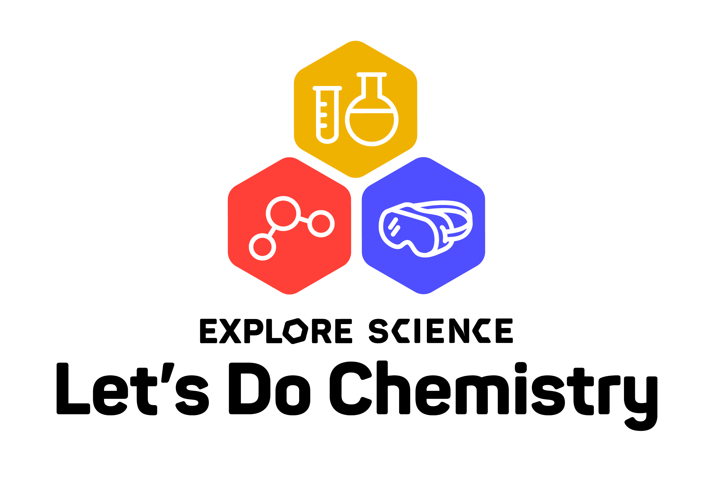
Your logo here

Date:
Contact:
Phone:
Email:

Celebrate Explore Science: Let’s Do Chemistry at [name of your organization]!
[Insert your local Let’s Do Chemistry event location, dates, and specific activity information here].
The Explore Science: Let’s Do Chemistry event at [name of your organization] is part of a nationwide festival of educational programs about ways to experiment, explore, and tackle challenges with chemistry.

Chemistry is all around us—it’s in the air we breathe, the food we eat, the clothes we wear, the medicines we take, and much more. But many people don’t see this field of science as personally relevant or interesting.

Through exciting experiments and engaging conversations with scientists, the Explore Science: Let’s Do Chemistry event will get participants thinking about chemistry connections in their everyday lives, and unlock their confidence to discover, create, and problem-solve with chemistry. Participants can launch a mini rocket with a chemical reaction, create foggy bubbles with dry ice, solve a colorful mystery, make their own dye from bug parts, and much more. With the right attitude, no challenge is too big for chemistry!
[Insert information about other special activities that your location may host, information about local partnerships and collaborations, ACS National Chemistry Week connections, and any other event-specific information.]
Led by the Museum of Science, Boston, Arizona State University, and the American Chemical Society, the Explore Science: Let’s Do Chemistry events are part of a nationwide initiative to stimulate interest, a sense of relevance, and feelings of self-efficacy in chemistry among public audiences. The Explore Science: Let’s Do Chemistry kits are developed and distributed by the National Informal STEM Education Network (NISE Net). Together NISE Network partners are celebrating chemistry at over 250 museums and institutions across the country.

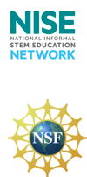
_______________________________________________________________
The National Informal STEM Education Network (NISE Network) is a national community of informal educators and scientists dedicated to fostering public awareness, engagement, and understanding of current science, technology, engineering, and math (STEM).

This project is based on work supported by the NSF under work supported by the National Science Foundation under Grant Number DRL 1612482. Any opinions, findings, and conclusions or recommendations expressed in this material are those of the author(s) and do not necessarily reflect the view of the National Science Foundation.

For more information about NISE Net or to download a digital Explore Science: Let’s Do Chemistry toolkit please visit: www.nisenet.org.

