**Try this!**

|  |  |
| --- | --- |
| 3  2  1 | Make some craters! Drop a marble from one meter (about 3 feet) above the sand mixture. What do you observe?  Now experiment by dropping more marbles and oddly shaped pebbles into the bucket. Do pebble craters look different from marble craters? Try dropping them from different heights and different angles, too!  Use a special tool to make even more observations. Shine the UV light into the bucket. Do you see anything new? |

*Studying the surface of a planet or moon can reveal its history and composition.*

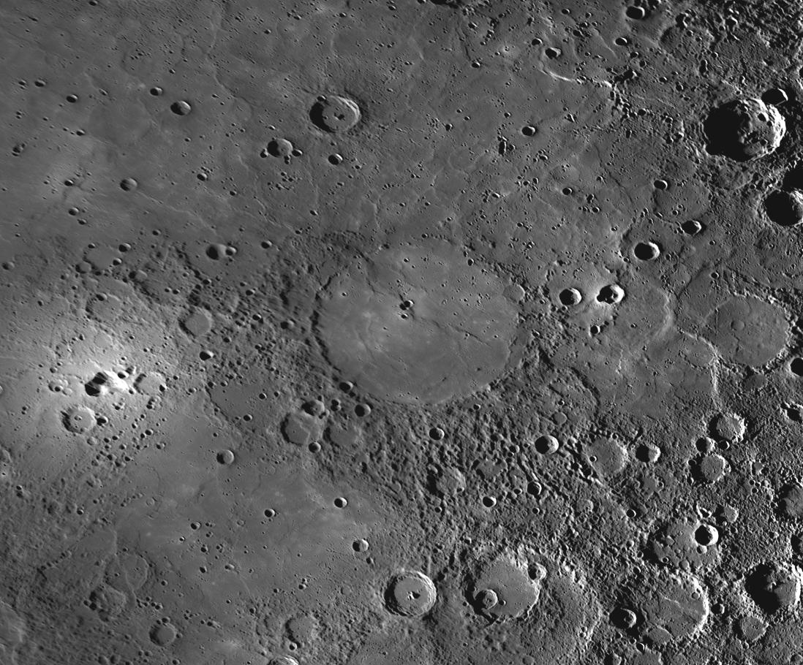**Impact craters form when a meteorite collides with the surface of a moon or planet (or other body in space).** In this activity, the marbles and pebbles dropping into the sand represent meteorites crashing into the surface and making different kinds of impact craters.

Craters are found all across the solar system. They are more common on worlds that do not have a thick atmosphere, such as the Moon. A dense atmosphere, like Earth’s, actually prevents most asteroids, comets, and meteoroids from reaching the surface. Friction between an object and the thick air causes the object to burn up or get smaller as it passes through the atmosphere.

**The Copland impact crater on Mercury.**

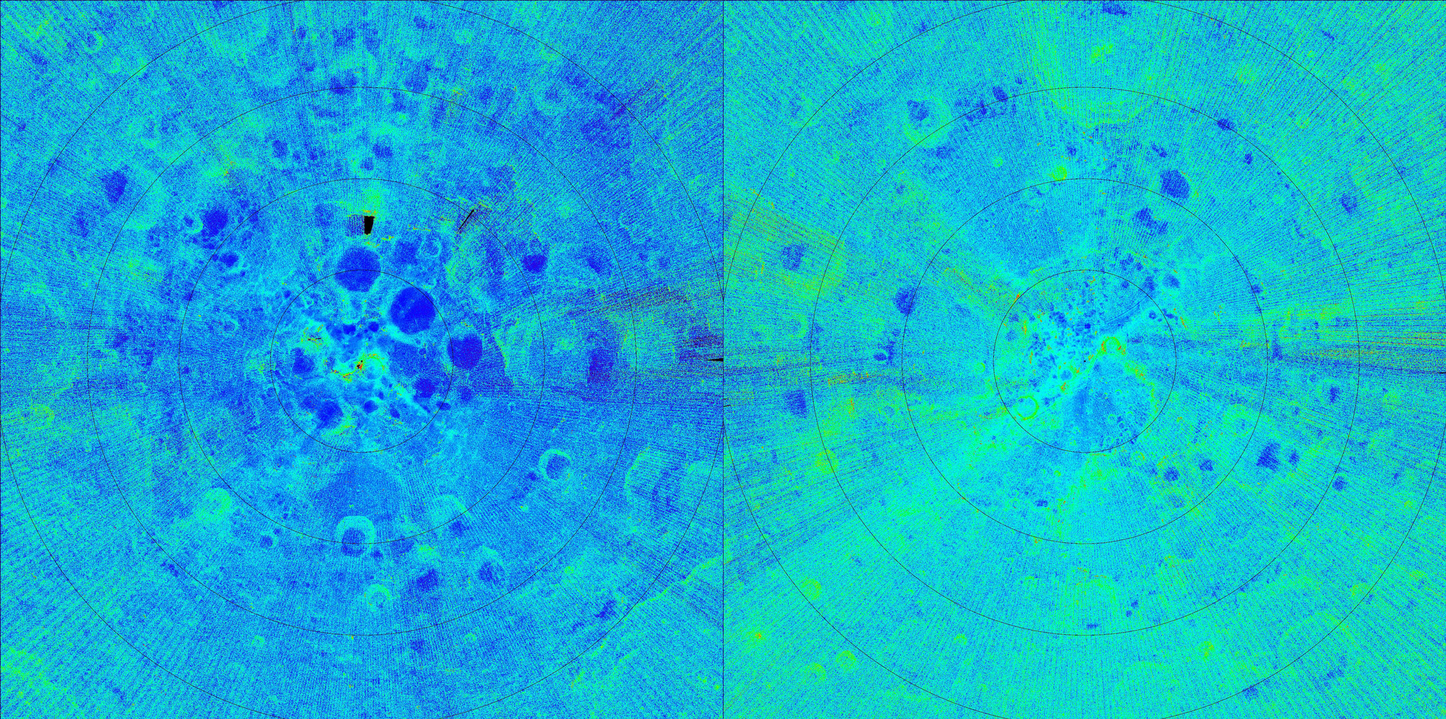**Scientists use tools to find and observe craters and learn more about the geologic processes on planets, moons, asteroids, and other worlds.** Observations and images of a crater provide a snapshot into the geologic layers of a world. Even working remotely, scientists can learn more about the planetary landscape, what it’s made of, how it formed, and the forces that shape it.

NASA’s Lunar Reconnaissance Orbiter mapped the Moon over many years, paying particular attention to the cratered surface. A special ultraviolet instrument helped reveal new information about the Moon, including frost in some of its craters.

**An ultraviolet image of the Moon’s craters.**