**Try this!**

|  |  |
| --- | --- |
| 2  3  1 | Slip the sling over the wooden rod. Make two balls of playdough that are about the same size. Stick one onto each end. Hang the rod and playdough from the string and slide the sling until you find the point where the rod balances. Tip: The sling might not be in the center when the rod is perfectly balanced.  Keeping the rod balanced, stretch out your arm so that you’re holding it away from your body. Gently nudge one of the balls, so that the rod spins around. What do you notice? Tip: Ask for help to get the balls spinning. It’s a little tricky!  Now try making one ball bigger and one smaller. Move the sling so that everything balances again, and try spinning the rod. Is anything different? Tip: You can move the sling into one of the balls if needed. |

*Objects in the universe interact in complex but predictable ways.*

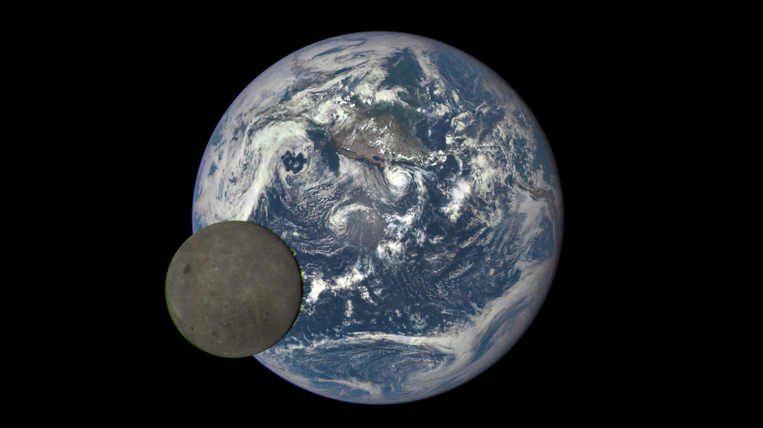**Stars, planets, moons, and other objects in space orbit around each other because of gravity.** In this activity, you created a spinning model of two objects orbiting. They are actually orbiting around a shared *center of mass.* A center of mass is the exact middle of all the material, or mass, of an object or collection of objects. This shared center of mass, where the rod balances on the sling in the model, is called the *barycenter*. If the two objects are about the same size, the barycenter lies roughly halfway between the two objects. If one object is smaller and the other object is bigger, then the barycenter is closer to—sometimes even within—the bigger object.

**A NASA camera shows a rare view of Earth and the Moon from 1 million miles away.**

All mass exerts a gravitational force. Earth pulls on the Moon, and the Moon pulls on Earth. Gravity causes Earth and the Moon to orbit their shared center of mass. This point is inside Earth, but not exactly at Earth’s center. For shorthand, we say that the Moon orbits Earth, but, more precisely, they both orbit a shared point—the barycenter!

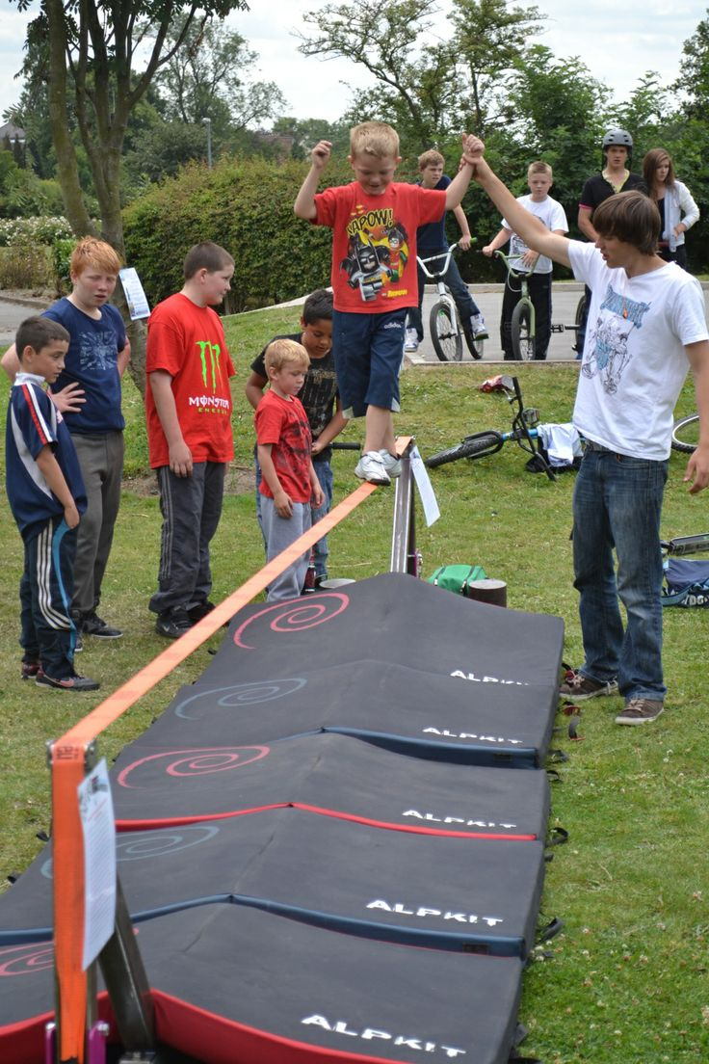**NASA scientists use what we know about the laws of physics to make new predictions and discoveries.** Objects throughout the universe move in dynamic but predictable ways. Scientists understand the concept of a barycenter because of observable phenomena. They use this idea to launch and guide spacecraft or understand the complex interactions between orbiting moons, planets, and galaxies.

Every planet, star, and moon has a center of mass. And so does your very own body! While we may not always notice it, our own center of mass helps us balance. It keeps our bodies stable as we walk, move, and play.

**Being aware of their center of mass helps kids balance.**