**Try this!**

|  |  |
| --- | --- |
| 3  2  1 | Follow the step-by-step instructions to make a paper model of a *sounding rocket* used in space science research.  Use the stickers to add a *science payload*. What research questions will the rocket help you explore? What tools do you need? Add at least one communication tool and one data collection tool to your rocket.  To launch, slide your rocket onto the tubing at the end of the stomper bottle. Aim it carefully—be sure to point it away from people! Your rocket should hit the poster in the red arch target—below the satellite but above the weather balloon—at just the right altitude for a sounding rocket. Stomp down with one foot to make it fly! |

**Safety note!** An adult should help to aim the rocket away from other people. Stomp using just one foot. Do not run up to or jump on the bottle.*Some rockets carry science tools—not scientists—into space!*

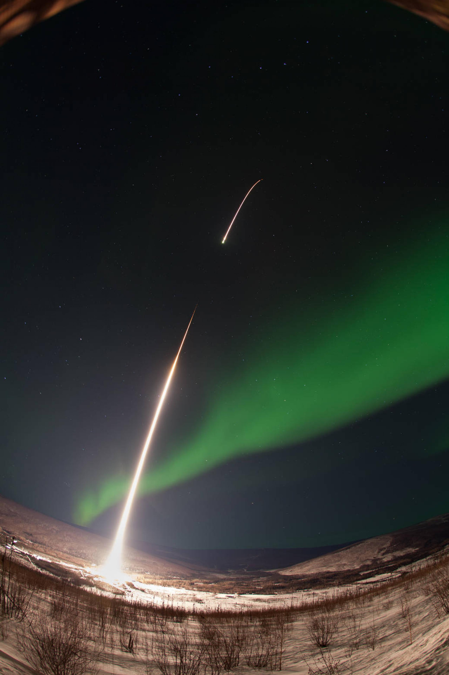***Sounding rockets* take quick, low-flying trips into space.** In this activity you made a paper model of a special kind of spacecraft called a sounding, or research, rocket. We tend to think of rockets carrying astronauts into space, but many rockets only carry scientific instruments. Scientists on the ground can use these instruments to explore Earth, the solar system and beyond.

Sounding rockets follow an arc-like path into near-Earth space and then fall back under a parachute. They travel to an area of space that is too high for weather balloons, but lower than the path of most satellites.

**We use some sounding rockets to learn more about *aurora borealis* over the Arctic.**

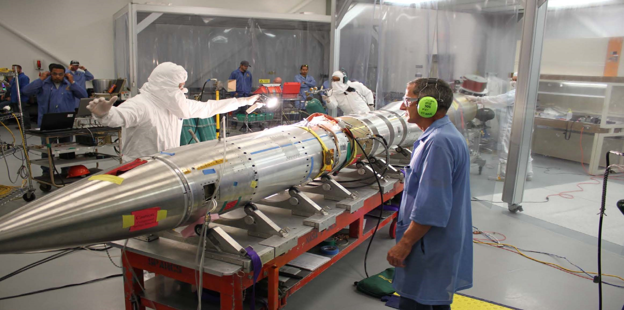**Scientists use many different kinds of spacecraft to make new discoveries.** Like satellites, weather balloons, and airplanes, sounding rockets help teams of NASA scientists and engineersput scientific instruments into space.These rockets are designed as simply as possible. They usually have two main components: a solid-fuel rocket booster and a *science payload* (the special scientific tools needed for the mission).

After launch, the rocket booster separates from the payload and falls back to Earth. Meanwhile, the science payload continues into space and can be used to help scientists answer their research questions. The payload spends just 5 to 15 minutes in space before falling back to Earth. This brief time is just long enough for scientists to get the measurements they need. Scientists have used sounding rockets to study X-rays from the Sun, meteorite impacts on Jupiter, the behavior of materials in microgravity, and much more!

**Researchers used the Hi-C science payload to study the Sun’s corona.**