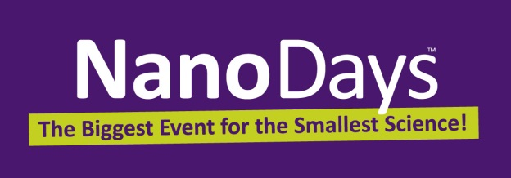
Subject: NanoDays Volunteers - share your feedback with us for a chance to win a $50 Amazon giftcard!

Dear NanoDays Volunteer,
Thank you for agreeing to participate in this year’s [Name of your insitution] NanoDays event! We know how valuable your time is, and we couldn’t host NanoDays without you – our success is definitely a team effort.
The Nanoscale Informal Science Education Network (NISE Net) has asked us to invite you to complete a short survey about your volunteering experience with NanoDays. The purpose of the survey is to better understand the ways that NanoDays events work to engage the public in nanoscale science, engineering, technology, and societal topics. By contributing this information, you can help improve the understanding of both NanoDays events across the nation and how we communicate nano concepts to the public.
After volunteering at our local NanoDays event, you can access the survey by clicking on this link: http://nisenet.org/NanoDays_Volunteer_Survey.
If you finish this survey by April 18th, 2014, you will be entered into a drawing to win one of twenty $50 Amazon.com gift cards!
Thank you in advance for completing this survey, and for your essential contribution to a successful NanoDays event.

Sincerely,
[Your signature] & the NISE Network

Subject: NanoDays Volunteers - share your feedback with us for a chance to win a $50 Amazon giftcard!

Dear NanoDays Volunteer,

Thank you for your participation at this year’s [Name of your institution] NanoDays event! We know how valuable your time is, and we couldn’t host NanoDays without you – our success is definitely a team effort.

[As we mentioned in an earlier email,] the Nanoscale Informal Science Education Network (NISE Net) has asked us to invite you to complete a short survey about your volunteering experience with NanoDays by April 18th, 2014. The purpose of the survey is to better understand the ways that NanoDays events work to engage the public in nanoscale science, engineering, technology, and societal topics. By contributing this information, you can help improve the understanding of both NanoDays events across the nation and how we communicate nano concepts to the public.

You can access the survey by clicking on this link: http://nisenet.org/NanoDays_Volunteer_Survey.

If you complete the survey by April 18th, 2014, you will be entered into drawing to win one of twenty $50 Amazon.com gift cards!

Thank you again for completing this survey, and for your essential contribution to a successful NanoDays event.

Sincerely,
[Your signature] & the NISE Network

