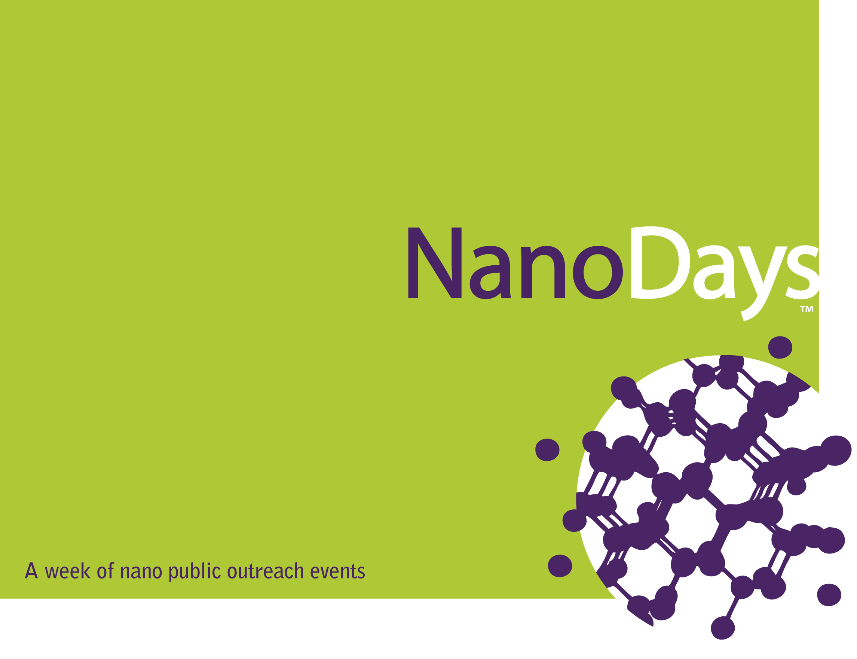

NanoDays Planning Guide

by Susan E. Koch, Ph.D.
Science Museum of Minnesota
Draft October 9, 2007

The Nanoscale Informal Science Education Network

The Nanoscale Informal Science Education Network (NISE Net) is a national community of researchers and informal science educators dedicated to fostering public awareness, engagement, and understanding of nanoscale science and technology. The network is currently funded by a five-year cooperative agreement between the National Science Foundation and the Museum of Science, Boston, and the Museum's core partners: the Science Museum of Minnesota and the Exploratorium. The NISE Net is working to produce three things:
- A catalogue of educational exhibits, programs, media, and forums that are aimed at raising public awareness, understanding, and engagement with nano.
- A network of science centers and research centers that has an increased capacity to work together to raise public awareness, understanding, and engagement with nano.
- Knowledge that can be useful to those engaged in informal education efforts to raise public awareness, understanding, and engagement with nano.

This guidebook was prepared with funding from the National Science Foundation under Cooperative Agreement #0532536 (CFDA #47.076). Any opinions, findings, and conclusions or recommendations expressed in this report are those of the authors and do not necessarily reflect the views of the Foundation.

Copyright 2007 Science Museum of Minnesota, St. Paul, MN.

We encourage you to copy, adapt, or distribute this guidebook and/or the text and images contained in it for educational, non-profit purposes. The elements of this guidebook are available for downloading in common electronic formats from www.nisenet.org, and are contained on the CD that accompanies the NanoDays kits. When making copies or excerpts, please use the copyright credit above. If adapting the contents, please cite the guidebook as a source.

NanoDaysTM is trademarked by North Carolina State University; we use the term with permission.



Table of Contents
Introduction 5
Strategy for NanoDays 2008 5
What We Hope to Learn 6

Planning Your NanoDays Event 7
Why Hold Public Outreach Events? 7
Public Awareness of Nanoscale Science and Technology 9
Messages for Public Awareness and Understanding 11
Planning Schedule 13
Communicating With the Public About Nano 15
Evaluation of Your NanoDays Event 16
Ideas for NanoDays Events 18

Nano Resources 23
What Is Nanoscale Science, Engineering, and Technology? 24
Nano Applications in Consumer Products 26
Nano Applications in Energy 27
Nano Applications in Medicine 29
Nano Applications in Electronics 31
Societal Implications of Nanotechnology 34
Selected Books About Nano 37
Nano Web Resources 39

NanoDays Marketing Materials 41
NanoDays Style Guide 42
Suggested Layouts 46
NSF Guidelines 51
Press Release Template 53

NanoDays Kits 54
Eligibility for a NanoDays Kit 55
Contents of the NanoDays Kit 56
Documenting Your NanoDays Event 57

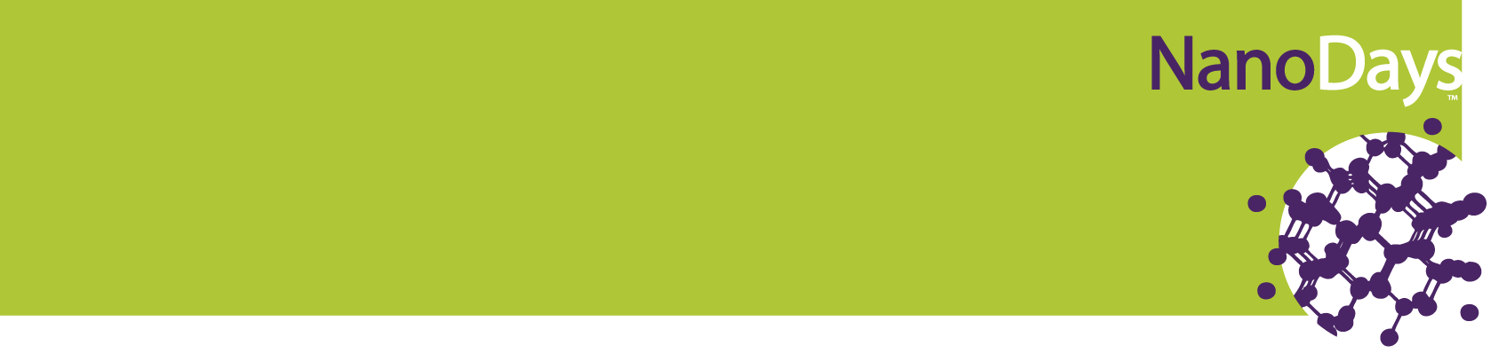

Introduction

The Nanoscale Informal Science Education (NISE) Network is a national community of researchers and informal science educators dedicated to fostering public awareness, engagement, and understanding of nanoscale science and technology. We are organizing NanoDays as a week of nano public outreach events. While several communities have conducted NanoDays events in prior years, we will be prototyping the first nationwide week of events March 29–April 6, 2008.

Strategy for NanoDays 2008
For our first year, NanoDays 2008 will be a collection of local events that is centrally facilitated (by NISE Net) in order to:
"NanoDays has been a huge hit with teachers, parents and students from across North Carolina. Students learn about cutting edge science, possible new careers, and get to visit science labs and meet the researchers. It is a great way for us to recruit students to the University as well as educate the public about the new discoveries being made." —Professor Gail Jones, NC State University
- Leverage planning and marketing resources
- Encourage local experimentation
- Build locally grounded national public awareness of nano
- Leapfrog our understanding of effective nano public outreach by learning efficiently from each others’ experimentation
NanoDays 2008 will reflect the unique complement of nano resources in each community. NISE Net will contribute facilitation and support materials that institutions can quickly customize for their own needs. We’ll also maintain a website in which we can all share our NanoDays plans and documentation.
You’ll notice that this guidebook prescribes very little about the exact nature of your NanoDays event, and that’s done for a reason. There is no one kind of public event that is most successful, and we believe that a local community is in the best position to figure out what’s best given its unique situation and public.

What We Hope to Learn
The 2008 NanoDays is a prototype of the bottom-up, locally driven strategy described above. The prototype is designed to help answer these questions:
- Will ISEs and research centers around the country conduct nano public outreach events, using their own resources, if we facilitate and support the planning, presentation, and documentation of those events?
- What kinds of partnerships support, or grow up around, these events?
- What kinds of public events do communities conduct? What works about those events, and what could we do better next time? What would communities like to do next?
- What are the best cost-effective strategies for supporting the planning, presentation, and documentation of local nano public outreach events?
- What should we do next? We’ll use our experience in 2008 to plan future years:
- Does a loosely organized set of local public outreach events engage the public in significant ways?
- Does the bottom-up approach build a base for more centralized, nationally coordinated events in the future? Or should we stick with the bottom-up model?
- If we stick with this model, how should we systematically evaluate the public impact of unique local events?

Planning Your NanoDays Event

This section provides some guidance and tools for those of you who are new to nano public outreach. We outline a simple, systematic approach to public outreach that starts with identifying goals and audiences, considers the current circumstances and knowledge of those audiences, and then outlines events that could respond effectively to those circumstances. We strongly encourage partnerships among informal science educators, researchers, and engineers because such partnerships form a potent combination: a sophisticated understanding of how to engage the public, paired with a deep background in the science and technology of nano.

Why Hold Public Outreach Events?
There are many reasons for conducting public outreach events, but they all boil down to a basic desire to share your passion for science with others. Your NanoDays event can be your vehicle for spreading your excitement and insights about nano around your community.

- Inform the public about nano. Business executives, policymakers, educators, and consumers will be making important decisions about nano science and technology applications in the coming years, and the more informed the public can be about nano, the better those decisions are likely to be. Your NanoDays event can initiate and/or contribute to the community discussion about nano issues.
NanoDay in New York 2007 was a tremendous success for us this year for a myriad of reasons, including the tremendous support we received from the speakers, science fair collaborators, volunteers, and the participating schools. However, the enthusiasm and energy radiated from the students made all the difference. It was clear that there is a great need for events such as NanoDay. Students from all over the country have a strong desire to learn and engage with the extraordinary, no matter the size, and will respond avidly when given the chance. —Fransciso Monar, Columbia University

- Get kids interested in science. Your NanoDays event is an opportunity to showcase what’s great about science and science careers. Don’t miss the opportunity to communicate with young people and their families about what it’s like to be a scientist, how scientists prepare for their careers, and how the kids and their families can learn more about opportunities in science.
- Increase public support for funding of science education and research. Government funding supports lots of basic and applied research as well as science education (both formal and informal). Your public outreach event helps taxpayers see what they are paying for and feel good about the investment they are making in science.
- Build your audience. For museums and libraries, public outreach events can be good ways to get the attention of audiences that have not yet become regular visitors. For research institutions, these events can attract students to the university. As you plan your NanoDays event, think about how that event can be designed as a path to the other science education experiences you offer.
- Develop new perspectives. If your everyday world is centered on students, museum visitors, or scientists, you can get in a rut—the same settings, the same people, the same conversations. An outreach event gives you a chance to shake things up, to communicate in new places and in new ways with new people. It can help you remember why you took this job in the first place, and it can challenge you to think and communicate outside the box.
- Build skills and relationships. The experiences you gain as you plan and deliver your NanoDays event can help build skills and relationships that carry back to your classroom, office, or museum floor. You might develop better explanations or visuals, or find a partner from another institution that can help you with other projects.

Public Awareness of Nanoscale Science
and Technology
As you plan your NanoDays event, it’ll be helpful to think about your audience. What have they already heard about nano? What do they understand about the nanoscale? Do they care about nano? What aspects of nano are most interesting to them?

In 2005, NISE Net commissioned a review of published documents about public awareness of nanotechnology. This review showed that the U.S. public has low awareness of nanotechnology, although attitudes toward nanotechnology are generally positive.

Awareness
- Less than half of the adult population in the United States, Canada, and the UK had heard of the term nanotechnology.
- No more than 20% could provide some sort of definition.
More recent surveys indicate that these numbers are not changing rapidly, despite the increasing coverage of nanoscience and technology in the popular press.

Attitudes
People’s attitudes about nanotechnology are generally positive. While there are concerns, the majority of those surveyed felt that benefits outweigh risks.
- Perceived major benefits: medical improvements and a cleaner environment.
- Perceived major risks: loss of personal privacy, and possible risks to human health and the environment.
- Half of Americans support the use of nanotechnology, even though they may know little about the topic. Exposure and attention to science news in newspapers, television, and the web have significant positive relationships to support for nanotechnology.
- Perceived need for regulation: Half the people surveyed recommended more stringent governmental regulation.

Understanding
The public’s understanding of the nanoscale is very limited. The 1997 and 1999 Science and Engineering Indicators indicate that only about 13% of adults can define “molecule,” and most adults cannot say whether atoms are made of molecules or molecules are made of atoms. Misunderstandings among students have been more extensively researched. For example, high school students rarely understand the constant motion of atoms, and few understand that there is empty space between the molecules in a gas. Many assume that the properties of a macroscale substance mirror the properties of its molecules, such that ice, for example, is made of cold, hard molecules. Without a good grasp of basic nanoscale concepts, it will be difficult for the public to understand even the popular press’s discussion of nanoscale science and engineering.
So you have your work cut out for you! As you plan your NanoDays event, think about the audience you’re trying to reach, the impact you’re trying to have, and the background your audience brings to your event. Check out the sources cited here if you want to learn more about what the public already knows and believes about nanoscale phenomena.

Messages for Public Awareness
and Understanding
When you begin to think about introducing your audience to nano, it can quickly get overwhelming—there’s so much to tell! Here’s a list of messages that NISE Net is working on to capture the ideas we’d like to communicate in our exhibits, programs, and public forums for the general public.

- Nano is in many realms and is both everyday and cutting edge. We all use products that have nanotechnology in them, but there are also exciting ideas about what might be developed in the future to solve what are currently intractable problems. Products range from the ordinary here-and-now (tough floor coatings, dental repair materials) to truly innovative applications of the future (scavenger cells, space elevator).
- Where will nano go? Nano science and technology can take a number of paths into the future. No one is sure which paths will become reality and how nano and society will interact in the future. A look at some historical examples of scientific and technological innovations can help us imagine some of these unknowns. Examples of past science and technological innovations include particle physics, molecular biology, plastics, computers, and communications.
- Nano means working at super small scales to manipulate materials to exhibit new phenomena. How small is the nanoscale? Particles at the nanoscale are smaller than a typical bacterium such as E. coli (which is ~ 3 micrometers), but larger than atoms (which range from 0.1 nm to 0.5 nm). Nanotechnologies are driven by the behaviors of small collections of atoms and take advantage of special properties at the nanoscale. New tools have made it possible to study and work at the nanoscale.
- It’s different down there! Scale matters. Gravity becomes less important, while electrostatics, friction, increased surface area, and molecular motion become very important at the nanoscale. This gives us big problems if we continue to base our thinking on our macroscale experiences and use our macroscale rules, but it also provides us with big opportunities if we exploit what’s unique at the nanoscale.
- Nano is a people story. Many different kinds of people (including scientists, engineers, technicians, and students) work in interdisciplinary teams to investigate nano and make nano products. The potential of nano science, technology, and engineering are greatly broadened by nano’s interdisciplinary nature. Artists, philosophers, policy analysts, and social scientists are also involved in studying nano and its roles in our society.
- How will nano affect you? Nanotechnology has many social and political implications that are important for us to consider in advance. Possible important issues include job shift, health ethics, toxicity, privacy, security, the human/machine interface, environmental safety, and environmental cleanup.
The National Center for Learning and Teaching in Nanoscale Science and Engineering has also been working on a set of “big ideas” around which nano curriculum could be developed. Here is an early draft of those big ideas—a more complete version will be available soon.
- Size and Scale. Concepts of size and scale form the cognitive framework used to make sense of nanoscale phenomena.
- Matter. All matter is composed of atoms.
- Dominant Forces. The forces that govern interactions tend to change with the scale of the objects involved.
- Properties of Matter. The properties of matter can change with scale. In particular, as the materials approach the nanoscale in size, they often exhibit unique functionality and properties. The source of these unique properties may be surface- or bulk-related.
- Models. Models help us understand, visualize, predict, hypothesize, and interpret data about natural and manufactured nanoscale objects and phenomena, which by their very nature are too small to see.
- Tools. Recently developed tools allow the investigation, measurement, and manipulation of matter, leading to the development of new understandings and the creation of new structures. These tools drive the scientific progress in nanoscale science and technology.
- Technology and Society. Nanotechnology is driven by the processes of science and engineering to solve problems. The products of nanotechnology may impact our lives in both positive and negative ways.
- Self-Assembly. Under certain conditions, some materials can spontaneously assemble themselves into organized structures at a lower equilibrium state. This process provides a useful means for manipulating matter at the nanoscale.

Planning Schedule
Here’s a general schedule to help you plan your NanoDays event.

December 2007
- Make contact with individuals and institutions that might be interested in organizing a NanoDays event in your community. These could include:
- Museums
- University researchers and research centers
- Libraries
- Schools
- Local technology corporations
- Government agencies (economic development, environmental management, pollution control, workplace safety)

- Once your institution has decided to help organize a NanoDays event, email nanodays@nisenet.org to sign up for your NanoDays kit and add yourself to our mailing lists.
- Schedule a kickoff meeting to organize your event. Here are some topics for the agenda:
- What are your goals for holding a NanoDays event?
- Who is your target audience?
- What kinds of events would reach this audience and meet your goals?
- Which event makes the most sense?
- Who will lead the planning of the event? Who else will be involved?
- How will the collaborators communicate?
- If funding is needed to support the event, where will it come from?
- Next steps

- Choose a date and add your event to your institution’s calendar.

January 2008
- Your NanoDays kit will arrive in January. If necessary, circulate the materials among your collaborators.
- Finalize the decision about the type of event to be conducted, and create a plan. This can include:
- A brief description of the event
- A budget (and fund-raising plan, if necessary)
- An outline of the event goals, and a plan for evaluating how well the event meets the goals, if appropriate
- A list of tasks and identification of who is responsible for what
- A schedule with the major milestones for preparation
- A marketing strategy

February 2008
- Carry out the event plan:
- Identify, invite, and finalize speakers and presenters
- Schedule venues
- Create marketing materials

- Post your event plan on nisenet.org so others can see what you’re doing.

March 2008
- Implement your marketing plan.
- Make final preparations for evaluation of your event, if appropriate.

March 29–April 6, 2008
- Conduct your NanoDays event!
- Document your event (with pictures, video, verbal descriptions, etc.). Collect copies of programs, posters, and any newspaper or media coverage of your event.

May 2008
- Meet with your planning team to discuss your event, review any evaluation information that was collected, and talk about what you’ll do differently next year.
- Write a short summary of the successes of your event and send it to decision-makers within the participating institutions, as well as sponsors and volunteers. Include a thank-you note for their support.
- Post documentation of your event on nisenet.org.

Communicating With the Public About Nano
Only a small percentage of the population knows anything about nanoscale science or technology. Here are a few pointers for communicating with the public about such an unfamiliar topic:

- Define a limited set of learning goals—two or three main points that you’d like people to walk away with.
- Know your audience. Ask a quick question, or take a quick poll. The more you know about your audience, the better you can adapt your presentation to their interests.
- Relate your topic to something familiar. Use comparisons to everyday experiences. Explain how the topic relates to something that’s been in the news or in popular culture.
- Keep the message simple. Your audience might not know an atom from a molecule or the difference between 10⁻⁹ and 10-9. Define your terms, and avoid jargon and acronyms. Check in with your audience periodically to see if they are following you.
- Test out your presentation on a few friends or members of your family. Their feedback will help you prepare for a public audience.
- Use simple visuals that reinforce and clarify your message. These can include posters, physical models, pieces of equipment, and nano products.
- Use several modes of presentation: Lectures, group discussions, inquiry activities, games, role-plays, experiments, etc.
- Involve the audience in the processes of science wherever possible. Create a hands-on opportunity to interact with real phenomena, products, models, or equipment. Do an experiment in front of the group. Ask them to guess what’s going to happen ahead of time, or to explain the results after the experiment.
- Show yourself. The audience really wants to know you as well as nano, so make eye contact, smile, and let them know who you are. Include personal stories about your work life and your career decisions, if appropriate.
- Prepare the audience for unexpected loud noises or bright lights.
- Remember that your outreach event is only one exposure that people will have to nano—it’s not the end of their learning. Help them connect to other opportunities for more exploration.

Evaluation of Your NanoDays Event
Evaluating your NanoDays event has several benefits. It can help clarify your goals, provide information that you can use to improve your event next year, gain funding or sponsorship for projects, and inform your understanding of your audience and the impact of your work.

There are typically three kinds of evaluation for public programs: front-end, formative, and summative. Front-end evaluation involves gathering background information about your audiences or learning settings so you can best design educational programs or products that will have maximum impact. Formative evaluation involves periodic testing of your educational products with audiences during the development process so you are constantly informed by real-world evidence about the products’ effectiveness. Summative evaluation involves final testing of your products once they’re finished to find out what ultimate impact they have. All three kinds of evaluation are useful for different reasons, and we encourage you to consider evaluation as part of your event planning. Additionally, NISE Net evaluators will be conducting surveys or interviews for the formative and summative evaluation of NanoDays. You may be contacted by evaluators asking for your feedback about the usefulness of our materials and facilitation and background information about your event.

Evaluation Resources
There are great resources available to help you think about evaluation of your event.
- The website www.informalscience.org has a variety of useful resources, including a searchable annotated bibliography at http://www.informalscience.org/knowledge/index.html, and museum-related evaluation reports at http://www.informalscience.org/tools/case_studies.html.
- The National Science Foundation also has created a guidebook on project evaluation for researchers called “The User-Friendly Handbook for Project Evaluation,” available at http://www.nsf.gov/pubs/2002/nsf02057/nsf02057_1.pdf.
If you’re new to presenting public-outreach events, you’ll probably want to begin with a fairly simple summative evaluation that gives you audience feedback on your event. We’ve provided a simple form that you can use to collect such information. Feel free to add questions and adapt this form to your needs. Don’t let the form get too long or too detailed, though; focus on the issues you’re most concerned about. If you aren’t sure what you want to know, ask your audience for their general impressions of the event and what they learned. Then you can use their answers to formulate more specific questions in next year’s form.

Sample Event Evaluation Form
[Your event name here]

We are hoping to conduct more events like this in the future. Your feedback will help us plan those events and improve the experience for participants. Thanks!

1. The topic of this presentation was: ____________________________________.

Strongly agree: 4
Agree: 3
Disagree: 2
Strongly disagree: 1

2. The topic was interesting to me. | 1 | 2 | 3 | 4
3. The presenter provided useful information about the topic. | 1 | 2 | 3 | 4
4. The presenter was engaging. | 1 | 2 | 3 | 4
5. I understood the concepts presented. | 1 | 2 | 3 | 4
6. The handouts helped me understand the presentation. | 1 | 2 | 3 | 4
7. The presentation was about the right length. | 1 | 2 | 3 | 4
8. The logistics for this event (registration, parking, finding the room, etc.) went smoothly. | 1 | 2 | 3 | 4
9. The setting for this event was comfortable. | 1 | 2 | 3 | 4
10. The presentation had the right balance of lecture format, discussion, and questions. | 1 | 2 | 3 | 4
11. I enjoyed this event. | 1 | 2 | 3 | 4
12. I would recommend future events like this to my friends and colleagues. | 1 | 2 | 3 | 4

13. What did you like most about this presentation?

14. What should we change if we hold similar events in the future?

15. Please share any additional comments.

Thank you very much for your feedback!

Ideas for NanoDays Events
Here is a list of ideas to spark your thinking about your NanoDays event. The more you can tailor your event to the unique strengths and resources of the nano-related work in your community, the more compelling it will be to the public. Nano can be technical and esoteric, so don’t be afraid to include some wacky activities to engage people who might otherwise be intimidated by cutting-edge science.

- Conduct a day (or week!) of nano-related programs and demonstrations at the local science museum, research center, public library, or other community facility. Ideas for programs and demonstrations can be found on nisenet.org/programs. The programs could be delivered by a combination of museum staff; faculty from local colleges, universities, and high schools; retirees from corporate research labs; and other volunteers.
- Host a public presentation by a local nano scientist, business executive, consumer advocate, or policymaker. Your local university can recommend appropriate scientists, or you can contact the Materials Research Society for help locating an appropriate speaker. Your state may also have a nano business alliance that could be helpful. The Woodrow Wilson Center has put together a national webmap of nano-related companies, research centers, and government and educational organizations at: http://www.penmedia.org/maps/mappage.html.
- Have an Open House at a nano research center. The Open House could include tours of laboratories, demonstrations and lectures by research faculty, and group activities led by students, faculty, or volunteers from local museums (like building “carbon nanotubes” out of balloons—see nisenet.org/programs/balloons).
- Host a public forum. Invite the public to learn about nanoscale science and engineering, and then participate in small-group discussions about the social implications of nanotechnology. Instructions for conducting a nano public forum are available on nisenet.org, and a printed workbook is included in the NanoDays kits. For additional topic ideas, check out http://www.nanocafes.org/.
- Invite the public to your local museum or community center to help build a molecular model. Choose a type of molecule, identify and collect building materials, and give participants a chance to get involved in the building process. Depending on your resources, your molecular structure can be complex or simple (for some examples, see http://www.mrs.org/s_mrs/doc.asp?CID=7511&DID=193747#nanoscape).
- Set up a local speaker’s bureau. Identify five or six nano experts who are willing to speak at local civic, cultural, and educational meetings about their nano-related research and its implications. Write descriptions of the speakers and their talks, and market their availability at meetings of civic leaders.
- Conduct a nano T-shirt, poster, or refrigerator-magnet design contest. Establish a review committee, and offer a small reward for the best submission. Market the contest in local schools, science teachers’ association meetings, science centers, and after-school programs. Print the winning T-shirt, poster, or magnet designs and distribute them at nano-related events.
- Put together a nano comic or joke contest. Gather competitors at an informal public location and have them show their comics and tell their jokes. Let the audience decide who’s the funniest. This could work particularly well with a professional nano audience that has extensive “insider” understanding of nano.
- Arrange for nano researchers to visit local junior high or high schools to talk about nanoscale science in science classes or science fairs. Alternatively, set up a “shadow a nano professional” day, and match students with nano researchers who can give personalized tours of labs and talk about their work lives. You can also offer this shadowing opportunity as a prize for science fair winners at local schools.
- Have a nano film festival. Set some basic criteria, and invite or assign students or the public to create short films that illustrate nanoscale phenomena. Establish a review committee to choose the best films, and show them at an awards event. For an example, see http://www.mrs.org/s_mrs/doc.asp?CID=6961&DID=176115.
- Conduct a nano “analogy slam” patterned after poetry slams. A poetry slam is an informal competition (often taking place in a bar or community gathering place) at which people get up and perform their original poetry and are rated (1–10) by the audience. (See http://www.poetryslam.com/ for more information on poetry slams). At an analogy slam, participants stand up and perform their analogies—the metaphors and comparisons they use to capture the scale and behavior of nano phenomena—and are rated by the audience. At a professional science event, the contestants could be impromptu; at a public event, you’d want to invite the contestants ahead of time.
- Organize a public debate on a nano-related topic. Should nano-engineered particles be identified in the list of ingredients on consumer product labels? Should university safety procedures be revised to take nano particles into account? Should local communities have a say in decisions about the location and nature of nano research complexes? Formulate a question that’s relevant to your local community, identify speakers for pro and con, and publicize the event.
- Conduct a "materials imagineering" contest. If you could invent a material with any properties you wanted, what would you invent? A super-strong material? One that is super-resistant to heat? A material that is lighter than air? What would that material be used for? What would you call it? Choose winners in several categories: creativity, practicality, economic viability, etc.
- Have a "systems imagineering" contest. Biological systems can do amazing things: Silkworms eat leaves and turn them into silk, and pigs eat garbage and turn it into bacon. If you could invent a system to transform one material into something else, what would you invent? (Keep in mind that you can't change the types of atoms you started with: You can't turn oxygen into gold, but you can rearrange the atoms you start with into new molecules.) Choose winners based on theoretical rigor, practicality, and creativity.
- Conduct an essay contest. What do you think is the most important problem that nano science and technology should be trying to solve, and why? How should the public be involved in policy decisions about nanoscale science, and why? An essay contest could be incorporated with several of the other events in this list, either to prepare participants ahead of time or to extend their learning afterward.
- Have a nano artist activity or show. The number of scientists and artists working on nano art and scientific visualization is growing. You could work with one of them to create an activity or show for the public about nano and the processes of scientific visualization. Explaining the many levels of interpretation implicit in any molecular image is a great way to introduce audiences to the basics of the nanoscale. Such an event could be connected with one of the national or regional conferences on scientific visualization.
- Conduct a teacher professional development workshop for teachers in the city/region/state. Coordinate it with your local or state science teachers’ association, the local science center, university researchers, and local nano businesses. Contact the National Center for Learning and Teaching in Nanoscale Science and Engineering for help: NCLT@northwestern.edu.
- Borrow the formats of popular TV shows. For fun, consider doing a nano take-off on a popular TV show (Molecular Myth Busters; Survival of the Nano-Savvy; Science Idol). Use the format to draw people into thinking and learning about nano in a silly way.
- Have a nano fiction-writing contest. Nanotechnology creates many new possibilities, with risks and benefits that are still uncharted. Science fiction writers have always piqued our thinking about the implications of new technologies, and encouraging people to wrestle with these implications in fiction is a great way to engage them. A fiction-writing contest could also be a great way to start new partnerships with your writing department, local library, or community writers’ workshops.
For more ideas about your NanoDays event, check out the website for the Cambridge Science Festival: http://www.cambridgesciencefestival.org/. This is the biggest science festival in the United States, with all kinds of events and activities. The festival also has lots of sponsors, volunteers, and an incredibly science-rich community to help out. Use it as a source of inspiration—maybe someday your NanoDays event will be this big!

Nano Resources

Most people are still unfamiliar with nanoscale science and engineering, and they haven’t thought about its implications for society. There are some great materials available to help inform people about nano, and we’ve listed a few of them here in order to save you the trouble.
You can use these materials to extend your own understanding of nano, and to help prepare speakers or teachers who will participate in your events. You can also copy and/or edit the short introductions we’ve written and provide them as background for participants, potential funders, or your own institutional colleagues. While none of these short pieces does justice to the true complexity of this topic, they can be handy tools to introduce people to what nano is all about. For more in-depth treatments, check out the web resources listed at the end of this section.
The author would like to thank Ellyn Hament and Judith Brand from the Exploratorium in San Francisco, who prepared the introduction to nano and the descriptions of nano’s applications and social implications that you will find on the following pages.

What Is Nanoscale Science, Engineering,
and Technology?
During the second half of the 20th century, scientists and engineers learned to observe, measure, and manipulate individual atoms and molecules. The areas of research related to these activities—the interdisciplinary fields known as nanoscale science, engineering and technology—are leading to the creation of materials, devices, and products that many scientists believe will dramatically change our daily lives.
To understand nanotechnology, you have to think small. Nanotechnology and nanoscience involve extremely tiny objects that are measured in a ridiculously small unit of measurement, the nanometer. A nanometer is one-billionth (1/1,000,000,000) of a meter—really, really small.

Small Compared to What?
Here are a few facts that may help you begin to understand how small a nanometer is:
- The size of a nanometer compared to a meter is like the size of a marble compared to the earth.
- The head of a pin is a million nanometers in diameter.
- Ten hydrogen atoms in a row fill a distance of one nanometer.
But don’t worry if you can’t imagine a nanometer. You’re not alone!

Small Is Different
Nanoscale science, engineering, and technology generally deal with objects having dimensions of between one and a hundred nanometers. This incredibly small size scale is the cornerstone for why this world is so interesting to researchers. When materials are this tiny, they can have exciting new properties that we don’t see in our everyday, macroscale world. Nanoparticles of familiar materials look and behave in unfamiliar ways.
For example, consider a gold bar about the size of a brick stored in the Fort Knox Bullion Depository. It has an opaque yellowish color and it melts at 1,948° F (1,064° C). If you were to cut the bar into two pieces—or two hundred pieces—those properties wouldn’t change. But gold particles at the nanoscale melt at just a few hundred degrees Fahrenheit, and they can be red, blue, or a variety of other colors.

The interactions of the few atoms that make up a nanoparticle determine its physical and chemical properties as well as how the particle interacts with light. Some properties, such as the various colors of gold nanoparticles, may change significantly depending on the nanoparticle’s size. The implication of this rather strange-seeming nanoscale phenomenon is clear: Desirable properties and behaviors can be obtained by controlling the size of nanoscale structures.
You might wonder why some properties of gold nanoparticles (like the fact that they are multi-colored) don’t match what we see at the macro scale. That’s because the properties of a gold bar, or just a small piece of it, result from the collective behavior of millions or trillions of atoms. The interactions among individual atoms are averaged out.

Nanotechnology and the Economy
The amazing potential to develop fundamentally new materials and applications has inspired governments and corporations around the globe to invest in nanotechnology research and development. In the United States, the 2007 investment by the federal government, through the National Nanotechnology Initiative, is about $1.4 billion, while the investment of U.S. industries exceeds that amount.
It’s estimated that, by 2015, nanotechnology-based products will contribute $1 trillion to the world economy. About 2 million people will be employed by nanotech industries by that date, and perhaps another 5 million people will work in related areas.

Regulation and Oversight
When any new technology first appears, it’s difficult to predict or even imagine all the possible consequences it might pose for the environment, for the health of living things, and for human societies. With the anticipated explosion of nanotech-based products in the coming years, it’s imperative that new testing and safety standards be established. Although some work has been done in this area, even many strong proponents of nanotechnology caution that much more needs to be done, and done soon—before thousands of new products hit the shelves.

Nano Applications in Consumer Products
A wealth of consumer products containing nanoscale materials is currently available. The Woodrow Wilson International Center for Scholars has developed an inventory that, as of July 2007, listed more than 500 products identified by their manufacturers as nanotechnology-based. The following is a sampling.

- Clothing. A number of major manufacturers make what are often called nanopants. A coating of liquid-repelling nanosized “fuzz” makes cotton clothing stain resistant.
- Sports equipment. Sporting goods manufacturers are using nanotechnology in a variety of ways. Some new tennis racquets employ carbon nanotubes, which are lightweight but many times stronger than steel.
- Sunscreen. Zinc oxide and titanium dioxide, which offer protection from ultraviolet radiation, are found in many sunscreens but make them thick and white. Nanoparticles of these ingredients, though, create a product that’s transparent.
- Food and food packaging. Nanoparticles are being added to food products to improve taste and nutrition, and to food packaging to extend the shelf life and safety of products.
- Cultured diamonds. If a tiny diamond chip is surrounded by vaporized carbon at just the right temperature and pressure, particles from the vapor that land on the chip will grow the diamond, one atom at a time, into a respectable number of carats. These diamonds have many potential applications in devices such as computers, lasers, and cell phones. But expect to see them in jewelry stores, too, where they should sell for significantly less than mined diamonds—from which they’re virtually indistinguishable.
- Computer components. New computer processors have chips with nanoscale-length transistors. They offer significantly faster performance compared to previous generations, with the additional benefit of low power use.
- Appliances. Silver at any size has antimicrobial properties. At the nanoscale, these properties are enhanced due to a nanoparticle’s ease at interacting with small pathogens. Manufacturers are adding silver nanoparticles to refrigerators to keep food fresher longer and to washing machines to sanitize clothing.
- Dietary supplements. Nanosized vitamins and minerals, sometimes called nanoceuticals, are said to be absorbed better than conventional supplements.

Nano Applications in Energy
Many scientists are working on applications to reduce our dependence on fossil fuels and the carbon dioxide emissions that are causing global warming. Nanotechnology is likely to provide a number of ways to approach this goal. Here’s a brief look at some of the possibilities.

Electricity from Sunlight
Free and abundant, clean and green, sunlight is the most promising source for producing electricity. We currently have photovoltaics, or solar cells, typically made from silicon wafers, that can be assembled into arrays to meet the power needs of a house or other structure. But a roof-sized set of solar cells is expensive. Nanotechnology innovations may soon bring down the cost or improve the efficiency of these light-powered batteries. Two bright ideas follow:
- Thin film solar cells. Thin films of silicon or other semiconductors that are about 200 nanometers thick are deposited on a substrate. (One process that accomplishes this is akin to silk screening.) Only a small amount of semiconducting material is needed, so the manufacturing cost is low. To date, these solar cells are less efficient than those currently in use, but even with less efficiency the net cost of electricity might still be lower. In addition, a variety of materials can be used for the substrate, including flexible plastic or even textiles, making thin film solar cells pliable and, if desired, portable as well.
- Quantum dot solar cells. Researchers are investigating whether quantum dots—particles with nanoscale diameters—can improve solar cell efficiency. Current solar cells typically make use of about 25% of the sunlight that strikes them because the silicon or other semiconducting material only converts certain wavelengths of light to electricity. One potential improvement would be to construct a semiconductor from quantum dots of varying sizes. That’s because the size of a particular quantum dot determines how it interacts with light. Different dots could convert energy from different wavelengths, perhaps doubling the current efficiency.

Light from Electricity
A semiconductor device invented in the 1960s, the LED (light-emitting diode) converts electricity into light. The LED is prized for its low energy use and long life. Look for quantum dot LEDs (QLEDs) to be found in many new applications. Blue LEDs coated with a film of cadmium selenide nanocrystals (a form of quantum dots) will produce a warm white light, similar to highly inefficient incandescent bulbs. Quantum dots may also be the future of high-resolution flat screen displays. Quantum dots generate their own light when stimulated with electricity, unlike liquid crystal displays (LCDs), which require backlighting. Quantum dot displays have the potential to be extremely thin and bright.

Running on Hydrogen
The space shuttle uses hydrogen fuel cells to generate electricity. With water vapor as the by-product, the astronauts’ drinking water is provided as well. So why don’t we have electric cars that run on hydrogen, releasing only nonpolluting water vapor into the air? Actually, there are experimental cars like this, but significant problems in producing and storing hydrogen need to be overcome before mass production could be considered.
Hydrogen is produced by chemically extracting it from water (or other compounds), which requires a lot of energy. But solar cells enhanced with nanoscale materials such as quantum dots may make the process of splitting water into hydrogen and oxygen economically viable.
Hydrogen storage is problematic for cars because hydrogen’s energy for its volume is low, and cars have limited space. About six pounds of hydrogen gas could take a car 300 miles, which is the distance you might drive on a tank of gasoline. But the space the hydrogen gas would fill, at normal temperature and pressure, would equal the space taken up by about four cars! Researchers are looking at a variety of ways that nanostructures might store hydrogen more compactly. One technique involving carbon nanofibers would reduce the space needed by a factor of a thousand.

Nano Applications in Medicine
When people hear the word nanomedicine—the application of nanometer-sized technologies to medical science—they often imagine futuristic scenarios in which impossibly small robots voyage into our bloodstreams on search-and-destroy disease-fighting missions. Actually, nanomedicine is already with us (albeit somewhat less dramatically), and it has been for years.
Look no further than your local drugstore, where pregnancy tests rely on gold nanoparticles to reflect red light—or not—and thereby reveal the presence of pregnancy-related hormones in a woman’s urine. While you’re at the drugstore, you can also pick up sunscreen containing transparent nanoparticles of zinc oxide or insoles infused with silver nanoparticles to kill bacteria.
But the high hopes for nanomedicine extend far beyond the drugstore. Medicine and nanotechnology are a natural pairing because life itself is a nanoscale phenomenon. Where biology is concerned, the nanoscale is where the action is—amino acids, proteins, DNA, viruses—all are measured in nanometers. The study (and perchance the cure) of disease will increasingly take place where disease begins—at the cellular and sub-cellular levels.
That nanomedicine operates at the same scale as our component proteins is cause for caution as well as excitement. If little is known so far about the potential for nanoscale medicines to heal, even less is known about their potential to harm. Future research will necessarily walk a careful line, pursuing our hopes for nanomedicine while addressing justifiable concerns.
Among the highest hopes for nanomedicine is nothing less than a cure for cancer. Equally promising is the possibility of extremely targeted and controlled drug delivery, using nanoscale encapsulation methods that are designed to release their medicine at just the right time and place. Nanostructures also seem destined to assist with diagnosis of disease, bringing improvements in imaging and detection of the body’s subtlest biochemical signals.
So far, many of the most intriguing ideas in nanomedicine are still under development. That said, plenty of nanomedical technologies are available right now, or will become available in the next few years. Tiny robots in your bloodstream remain just fantasy, but the reality of nanomedicine may turn out to be no less amazing.

Nanomedicine Highlights
- Nanostructures such as carbon nanotubes and gold nanoshells both show promise not only in treating cancer, but also in allowing early, precise, and noninvasive detection of cancer. These nanostructures can be made to selectively attach to—and destroy—cancerous cells.
- The FDA has approved a nano-engineered synthetic bone that is almost as strong as stainless steel and, unlike steel, gradually gets restructured by the body to make real bone. Applications of the synthetic bone include an injectable bone filler, screws for holding grafted ligaments in place, and other orthopedic hardware.
- Nanoparticle contrast agents—liquids injected into the body to make certain tissues more visible during diagnostic imaging—greatly improve the resolution of imaging technologies such as ultrasound and MRI, making it possible to see inside the body with much greater detail.
- The “nano napkin” is a paper towel that detects harmful bacteria. The nanoscale fibers of the napkin are treated with a dye that turns yellow when the towel touches a surface contaminated with E. coli bacteria.
- Dendrimers are nanosized treelike molecules with a dense, bushy structure. Promising “smart” drug delivery capsules, dendrimers can be designed to conceal drugs within their branches, then change shape and release the drug only when and where it’s needed.
- A topical gel billed as a “liquid condom” blocks the transmission of HIV as well as other sexually transmitted diseases, including herpes and Chlamydia. Nanostructures in the gel bind to the surfaces of viruses, making them unable to attach to (and thereby infect) cells in the body.
- Glowing nanoscale “tags” called quantum dots are helping researchers pinpoint disease sites and identify pathogens. Made from nanosized bits of semiconductor, the dots attach only to certain targets, such as a flu virus or cancerous cell, and glow with a specific color to indicate their presence.
- Diabetics may soon be able to monitor their blood sugar using a tattoo. The tattoo uses an “ink” of ultra-tiny fluorescent beads injected under the skin that change color in response to changing blood sugar levels.
- Researchers have developed a “flesh welder” that could someday be used to join together tissues cut during surgery. A liquid containing gold-coated nanoshells is dribbled into the severed tissue, and then heated with an infrared laser that seals the tissue together.

Nano Applications in Electronics
You know the drill. You buy a computer, and even before there’s time for a thin layer of dust to collect on it, it’s already obsolete; a dinosaur compared to the newer, faster models with 10 times the memory.
This is industry market-setting in action. Industry has been pushing for many years to double computer power every 18 months in order to continue on this path of increased computer speed and power – and increased revenue. This roadmap decision by industry, coined “Moore’s law,” even though it’s not actually a law, has resulted in computers continually shrinking in size even as they beef up in memory: A one-ton hard disk stored five megabytes in 1954, but now a thousand times as much data—five gigabytes—can be stored on a chip weighing less than an ounce.
This “the best gifts come in small(er) packages” approach has held sway for 40 years. But technologists warn that we are about to hit the wall. Further miniaturization of the computer chip faces some serious challenges. As chips get smaller, problems mount. Heat builds up, electricity leaks across tiny junctions and causes malfunctions, and manufacturing becomes increasingly sensitive to the least environmental impurities. Making smaller, faster chips using current methods will soon become both unmanageable and (the true death knell) unprofitable. In short, it seems that in a few years, the golden days of the information era will be over.
Or will they? Nanotechnology promises to come to our rescue and revolutionize the electronics industry, ultimately by replacing the stuff we think of as electronics—semiconductor transistors and metal wires—with any number of exotic, surprising, and unthinkably tiny successors.
So far, the research efforts are exciting but scattered among a wide range of possibilities, including computers based on carbon nanotubes (that look like nano-sized straws made out of carbon atoms), computers in which single molecules function as switches and memory units, computers that function using light instead of electricity, and even computers that use DNA to store data.
In the distant future, the manufacture of electronics may start to seem more like chemistry, as invisible molecular components suspended in liquids are allowed to self-assemble on unseen surfaces. Your distant-future computer may be just as unrecognizable: a thin roll-up sheet that serves triple-duty as keyboard, screen, and processor, feather-light and powered by nano-engineered solar cells.
But if nanotechnology somehow manages to keep us progressing upward on the steep curve set by industry, one thing about your new, distant-future computer will remain the same: it too will be obsolete shortly after you get it home.

Nanocomputing Highlights
- Magnetic nanodots may soon help shrink the size of computer memory. Today’s computer memory mostly relies on magnetic materials. Researchers have demonstrated that information can be stored in a similar fashion but much more densely using magnetic nanodots, tiny bits of magnetic material just 10 nanometers across.
- Carbon nanotubes—cylinders of with the same structure as graphite (the stuff used for pencil lead) that can have a wall thickness of just one carbon atom—show great promise in a wide range of electronics applications. Depending on the structure, they can function as either conductors or semiconductors, and therefore could function in place of wires or current transistors at speeds a thousand times faster while using much less power.
Two useful aspects of carbon nanotubes are their great strength and their ability to efficiently conduct electric current. Nanotubes also have an Achilles’ heel that may actually be useful: their electrical properties are extremely sensitive to chemicals in the environment. The first widespread application of nanotubes may turn out to be extremely sensitive chemical detectors.
- Molecular electronics means using individual molecules to store and control the flow of data, potentially providing the most space-efficient computing power imaginable at sizzling processing speeds. Researchers have recently demonstrated that individual molecules can be made to serve as either transistors or wires, the two bread-and-butter components of an electronic circuit. Unlike ordinary metal wire, wire made from strings of molecules is superconducting and generates no heat, the bane of microelectronics everywhere.
- Quantum dots—nanosized bits of semiconducting material—may help make laptop computer screens that are brighter and more vibrant than current LCD screens. Quantum dots are unique in their ability to glow with different colors depending on their size. Engineers have also created prototype flat-panel displays using carbon nanotubes spread in a thin film under glass. Flexible displays are in the works as well, using nanotubes as part of a composite material.
- Truly wireless computers—that is, computers that “go wireless” on the inside as well as on the outside—may be an option in the future. Researchers in Europe are working on a system that could boost computer speeds by eliminating wires within circuits. The system generates tiny amounts of microwave energy. These microwaves could carry signals in place of traditional wires, and increase processing speeds up to 500 times.
- Computing with DNA is a possibility that researchers are seriously investigating. The long strings of bases that carry our genetic information can be tailor-made to carry other types of information as well. Not only is DNA “data” extremely compact, it can easily be replicated and manipulated using existing technologies, and needs little power. One trouble spot is the tendency of mutations to appear as DNA is read and copied, creating an error rate a thousand times worse than today’s magnetic data storage systems.

Nano and Society
“Technology is neither good nor bad—nor is it neutral,” noted Dr. Melvin Kranzberg, a technology historian, in one of his six laws of technology. Nanotechnology is no exception. Already, this burgeoning field is leading to the creation of new materials, processes, and products. Many people believe that current and future nanotechnology-related innovations will have profound and far-reaching effects on society.

It’s nearly impossible to predict all the future innovations that nanotechnology will trigger, or all the ripple effects that may occur as a result. However, it is possible—and, many people believe, imperative—to focus on broad areas where previous technological advances have influenced our lives. These areas, which include economics, the environment, health, and safety, will surely be affected by nanotechnology.
Many scientists, legislators, and concerned citizens believe that thinking about the consequences of nanotechnology before they occur will help us to create, rather than react to, our nano future. As former National Science Foundation Director Rita Colwell said at the National Nanotechnology Initiative Workshop in 2003, “We need to anticipate and guide change in order to design the future of our choice, not just one of our making.”

Economics
Nanotechnology is expected to have a huge impact on economics worldwide, bringing with it a slew of new products, manufacturing processes, and jobs. Reports from the National Nanotechnology Initiative indicate that nanotechnology could be used in nearly half of all new products by 2013, and could create 7 million jobs, directly or indirectly related to nanotechnology, by 2015. In the United States, there’s a growing push to educate students in science, technology, engineering, and math to meet the anticipated need for a large nanotechnology-trained workforce.

Environment
Nanotechnology holds both promise and potential risk for the environment. The Environmental Protection Agency (EPA) sees possible benefits from nano in several areas. These include cleaning and “greening” the environment through environmental monitoring and detection of toxic or pathogenic substances, cost-effective and quick environmental cleanup, and green manufacturing and energy generation (processes that don’t produce pollutants).
Where’s the risk? It probably lies in the toxicity of certain nanoparticles and nano-related manufacturing processes, which carry with them the potential for pollution and health risks. Many groups, including the International Consortium for Environment & Nanotechnology Research, are actively researching the effect of nanomaterials and nanomaterial manufacturing on the environment. Currently (September 2007), nanoscale silver particles are the only nanoparticles regulated by the EPA.

Health
If only a few of the proposed advances in nanotechnology-based medicine come to fruition, we may see revolutionary medical progress. Nanotechnology could bring major improvements in diagnostics, targeted drug delivery, and bone repair and regeneration. Scientists are also examining ways to pinpoint and destroy pathogens and cancer cells, to weld tissue, and to create synthetic bone. There’s even the potential for blocking the transmission of the HIV virus using a topical gel. Obviously, the health benefits would be enormous.
Improved water remediation is another area where nanotechnology could be a huge boon to human health. Researchers are investigating a myriad of ways to apply nanotechnology to water purification, including portable filtration systems that could be set up in remote areas and improvements to large-scale water treatment plants.
A large number of different nanoscale materials are the subjects of water-purification experiments, including nanoparticles that can kill pathogens or capture pollutants such as metals, and tiny carbon nanotubes used as filters. Many government agencies, scientists, and concerned citizens are calling for rigorous testing of these new nanomaterials to make certain that they won’t inadvertently contribute to the very problem they’re trying to solve.

Safety
It’s important to note that different nanotechnology products and processes carry with them different levels of risk. A tennis racquet frame made from carbon nanotubes probably carries very little risk when you use it (though it may carry more risk when it’s manufactured). But silver nanoparticles, increasingly used as an antibacterial agent in washing machines, socks, and other products, may kill beneficial bacteria and aquatic organisms, and may harm human health. For these reasons, silver nanoparticles are now (September 2007) regulated by the EPA, but they’re the only nanoparticles to be regulated so far. Many nano-based products (sunscreens with nanoparticles of zinc oxide, for example) continue to come to market unregulated and with unknown safety risks.
In the United States, the Environmental Protection Agency (EPA) is charged with regulatory responsibility for protecting human health and the environment. The Food and Drug Administration (FDA) is responsible for promoting public health by regulating many—but not all—foods, drugs, medical devices, biologics (vaccines, etc.), animal feeds and drugs, cosmetics, radiation-emitting products, and “combination products” (drug-delivery products, for example, like a transdermal patch; combination products are expected to be a big area for nanotechnology applications). Both agencies are actively supporting nanotechnology research and investigating their regulatory responsibilities.
Beyond government agencies and regulations, several research centers (Rice University’s Center for Biological and Environmental Nanotechnology, for example) and organizations (such as the Natural Resources Defense Council), are looking closely at nano-related safety issues, and are raising questions, conducting research, or making recommendations.
According to Mihail C. Roco, senior advisor for nanotechnology to the National Science Foundation and a key architect of the National Nanotechnology Initiative, “Nanotech does pose new challenges to risk governance. Internationally, more needs to be done to collect the scientific information needed to resolve the ambiguities and to install the proper regulatory oversight.” The hope is that research and appropriate regulations will be in place sooner rather than later, and will safeguard the environment and humans from any potential nano-related risks.

Selected Books About Nano

Books for Adults
Allhoff, Fritz, Patrick Lin, James Moor, and John Weckert. Eds. Nanoethics: The Ethical and Social Implications of Nanotechnology. Hoboken, NJ: John Wiley and Sons, Inc., 2007.
A collection of academic essays on the social implications of nanotechnology. Many articles focus on various aspects of communication and prediction about nanotechnology.
Berube, David M. Nano-Hype: The Truth behind The Nanotechnology Buzz. Amherst, NY: Prometheus Books, 2006.
Written by a professor at the University of South Carolina who studies the societal aspects of nanoscale science and technology, this book explores the political, social, and economic motivations behind the positive and negative “hype” around nano in the research, government, consumer, and corporate spheres. Berube calls for building a deliberative public that is motivated and informed enough to make responsible decisions about nanotechnology research, applications, and policy.
Booker, Richard and Earl Boysen. Nanotechnology for Dummies. Hoboken, NJ: Wiley Publishing, Inc., 2005.
Like the rest of the Dummies series, this book provides an introduction to nanoscale science and nanotechnology in materials, information, and health. Includes a chapter on the business of nanotechnology, but lacks coverage of the social implications of nano.
Foster, Lynn E. Nanotechnology: Science, Innovation, and Opportunity. Upper Saddle River, NJ: Prentice Hall, 2006.
This compilation of essays covers the industry of nanotechnology, including its technological and economic drivers, the major players, the business promise, and the social, ethical, and regulatory challenges raised by nano applications.
Hall, J. Storrs. Nanofuture: What’s Next for Nanotechnlogy. Amherst, NY: Prometheus Books, 2005.
This somewhat academic introduction to nano includes descriptions of nanoscale science; nanobiotechnology; molecular machines; and nanotechnology applications in information science, consumer goods, transportation, space flight, robotics, and medicine. Assess the hype in most of these fields and the social/ethical implications of the applications discussed. A useful introduction for someone with some science background or a motivated lay reader.
Jones, M. Gail, Michael Falvo, Amy Taylor, and Bethany Broadwell. Nanoscale Science Activities for Grades 6–12. Arlington, VA: National Science Teachers Association Press, 2007.
A great resource for formal or informal science educators, this book provides instructions and materials lists for activities designed to introduce students to various aspects of nanotechnology, including scale, tools, nanoscale properties and behaviors, applications, and social implications. Provides student response sheets, templates for creating materials, discussion questions, and additional resource lists.
Ratner, Mark A. and Daniel Ratner. Nanotechnology: A Gentle Introduction to the Next Big Idea. Upper Saddle River, NJ: Prentice Hall, 2003.
Chemistry professor Mark Ratner and entrepreneur Danial Ratner explain the science and tools of nanotechnology and the impacts of nano applications in materials, sensors, biostructures, energy, optics, magnets, fabrication, electronics, and modeling. A useful introduction for someone with some science background or a motivated lay reader.
Sargent, Ted. The Dance of Molecules: How Nanotechnology is Changing Our Lives. NY: Thunder's Mouth Press, 2006.
A somewhat poetic introduction to nanotechnology and the transformations it may bring to health, the environment, and the information sector.
Understanding Nanotechnology: From the Editors of Scientific American. NY: Warner Books, 2002.
This collection of essays by noted nanotechnology researchers and engineers discusses nano in medicine, space exploration, communications, and manufacturing. Most of the essays include some discussion of the background science, the possible applications, and the obstacles that must be overcome to make those applications possible.
Williams, Linda and Wade Williams. Nanotechnology Demystified. NY: McGraw-Hill, 2007.
This is a very readable introduction to nanoscale science, technology, applications, and social and environmental impacts. Each chapter has a short quiz at the end, with answers at the back of the book. Appropriate for interested readers with no science background.

Books for Youth

Eames, Charles and Ray Eames. Power of Ten: A Flipbook. W H Freeman & Co., 1998. Reading level: All ages. 154 pages.
Wells, Robert E. What's Smaller Than a Pygmy Shrew? Morton Grove, IL: Albert Whitman & Company, 1995. Reading level: Ages 4–8. 31 pages.
Johnson, Rebecca L.. Nanotechnology (Cool Science). Minneapolis, MN: Lerner Publications 2005. Reading level: Ages 9–12. 48 pages.
Maddox, Dianne. Science on the Edge–Nanotechnology. Blackbirch Press, 2005. Reading level: Ages 9–12. 48 pages.
Brezina, Corona. Careers in Nanotechnology (Cutting-Edge Careers). New York, NY: Rosen Publishing Group, 2007. Reading level: Ages 9–14. 64 pages.
Jefferis, David. Micro Machines: Ultra-Small World of Nanotechnology Science Frontiers. New York, NY: Crabtree Publishing Company, 2006. Reading level: Ages 9–12. 32 pages (magazine format).

Nano Web Resources
There are lots of resources about nanoscale science and technology in the popular press, academic journals, and on the web. Here’s a short list of resources available on the web that can provide more information on the topics introduced above.

Discover Nano. An introduction-to-nanotechnology website from the Nanoscale Science and Engineering Center at Northwestern University. http://www.discovernano.northwestern.edu/index_html
Exploratorium Podcast. “Nano on the Market: Consumer Products Using Nanotechnology,” which includes an interview with Julia Moore and Evan Michelson from the Woodrow Wilson International Center for Scholars, and an essay by science journalist Philip Ball, who discusses whether nanotechnology-based products should have a special label. http://qt.exploratorium.edu/podcasts/nise/NISE-SmallTalk-Consumer.mp3
Exploring the Nanoworld. A website with extensive resources for nano science educators from the Materials Research Science and Engineering Center on Nanostructured Interfaces at the University of Wisconsin–Madison. http://mrsec.wisc.edu/Edetc/
International Council on Nanotechnology. ICON is a global collaboration of business, governmental, and science organizations that focuses on nano risk assessment, research, and communication. It is managed by Rice University’s Center for Biological and Environmental Nanotechnology. The website includes an extensive database of resources about nanotechnology’s environmental, health, and safety risks and benefits. http://icon.rice.edu/research.cfm
Molecular Workbench. A useful site that allows users to create simulations of molecular behavior to explore connections between macro and micro phenomena. http://workbench.concord.org/
NANO. NANO was a participatory art exhibition and collaboration between the Los Angeles County Museum of Art and a UCLA team of nanoscience, media arts, and humanities experts that took place in 2004. This website shows the variety of aesthetic experiences that were explored in the exhibition. http://nano.arts.ucla.edu/index2.php
NanoEd Resource Portal. This website contains information about research and educational collaborations among nano scientists and educators. Sponsored by the National Center for Learning and Teaching in Nanoscale Science and Engineering. http://www.nanoed.org/ See also http://www.nclt.us/nclt.html
Nanoreisen. An amazing website about zooming into the nanoscale, sponsored by the German Federal Ministry for Education and Research. Presented in four languages. http://www.nanoreisen.de/
NanoSense. A website about nano science and technology curriculum development by the Center for Technology in Learning, SRI International. http://nanosense.org/
National Nanotechnology Initiative. This website covers the NNI’s (federal) multi-agency approach to research and governance issues around nano. http://www.nano.gov/
NISE Net. A website by the Nanoscale Informal Science Education Network that contains links to nano resources, outreach news, and nano informal science collaborators. http://nisenet.org
Project on Emerging Nanotechnologies. Woodrow Wilson International Center for Scholars. PEN organizes web-based and live events focusing on the social implications of nanotechnology research and applications. http://www.wilsoncenter.org/index.cfm?fuseaction=topics.home&topic_id=166192
Small Times. This online magazine tracks micro and nanotechnology manufacturing applications, tools, and materials. http://www.smalltimes.com/
U.S. Food and Drug Administration. This website features the FDA’s current work on nanotechnology. http://www.fda.gov/nanotechnology/

NanoDays Marketing Materials

We’ve put together these resources to support your marketing of your NanoDays event. We’ve designed everything to be as “plug-and-play” as possible by using templates, common software platforms, and simple instructions for adding your information and logos to generate attractive posters, banners, T-shirts, and other marketing materials.
We hope that you will use these resources so that your event helps us build toward a national awareness and a common “brand” for NanoDays and nano public outreach that we can all benefit from. However, if you’d rather use your own established materials and logos, that’s fine, too.
All of the artwork shown on the following pages is available in electronic format on the NanoDays CD in your kit, or online at nisenet.org/nanodays. For questions regarding the usage of the NanoDays logo or other marketing materials, please send an email to nanodays@nisenet.org.

NanoDays Style Guide

Writing Guidelines
We are using the trademarked term “NanoDays” courtesy of the North Carolina State University, which owns the trademark. For questions about the NanoDays trademark, contact Prof. Gail Jones at: gail_jones@ncsu.edu. When referring to NanoDays in writing, please use the capital “N” and the capital “D,” with other letters lower-case, and include the “TM” when you can. Save “NanoDaze” for comedy and satire opportunities, please.
If you refer to the Nanoscale Informal Science Education Network (NISE Net) in writing, please capitalize the “NISE” and the “N” in Net: NISE Network, or NISE Net.

Logos
If you use the NanoDays logo, please keep the elements (the molecule and the “NanoDays” text) together as a unit, and try to match the green and purple (the color specs are listed below). For black-and-white printing, the logo reproduces well in grayscale (100% black and 50% gray, or 100% black).

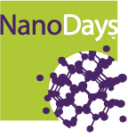
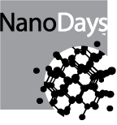
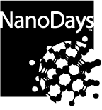

We designed the logo to include a “tag line” that you can use to customize the logo for your own event. Here are some examples:
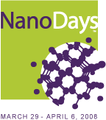
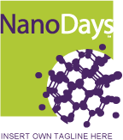

To add the tag line, paste the logo into your word processing or graphic design software and type your tag line below the logo using the Arial Regular font in purple (see below for color and font guidelines).

Color Specifications
Green, purple, and white are the primary colors of the NanoDays color palette. Tints from 100% to 10% work well to give you a range of design options.
NanoDays Green:
PMS: 584  HEX: B0C736 | C: 36  M: 5  Y: 100  K: 0 | R: 176  G: 199  B: 54

NanoDays Purple:
PMS: 269  HEX: 4A2565 | C: 84  M: 100  Y: 28  K: 18 | R: 74  G: 37  B: 101

Fonts
The NanoDays font is Bell Gothic Std. Bold
Bold:

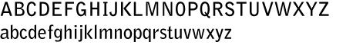

Black:



Arial may be used as an alternate if necessary.
Regular:

ABCDEFGHIJKLMNOPQRSTUVWXYZ
abcdefghijklmnopqrstuvwxyz

Bold:

ABCDEFGHIJKLMNOPQRSTUVWXYZ
Abcdefghijklmnopqrstuvwxyz

Additional Graphic Elements
This buckyball, carbon nanotube, and silicon molecule line art can be used in many ways.
They can add visual interest to backgrounds, headers, and layout templates. When using these elements, use the NanoDays color palette where possible. Other molecules or molecular structures can be rendered in a similar manner.
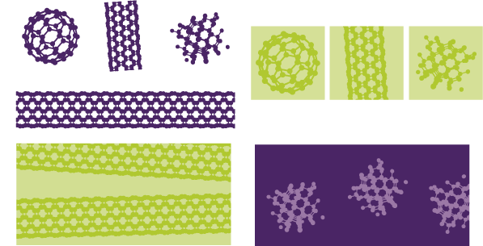

Suggested Layouts

Report or Folder Cover
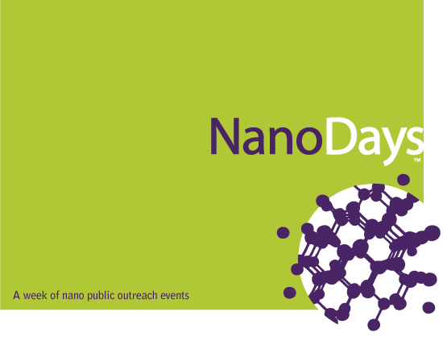

T-Shirts

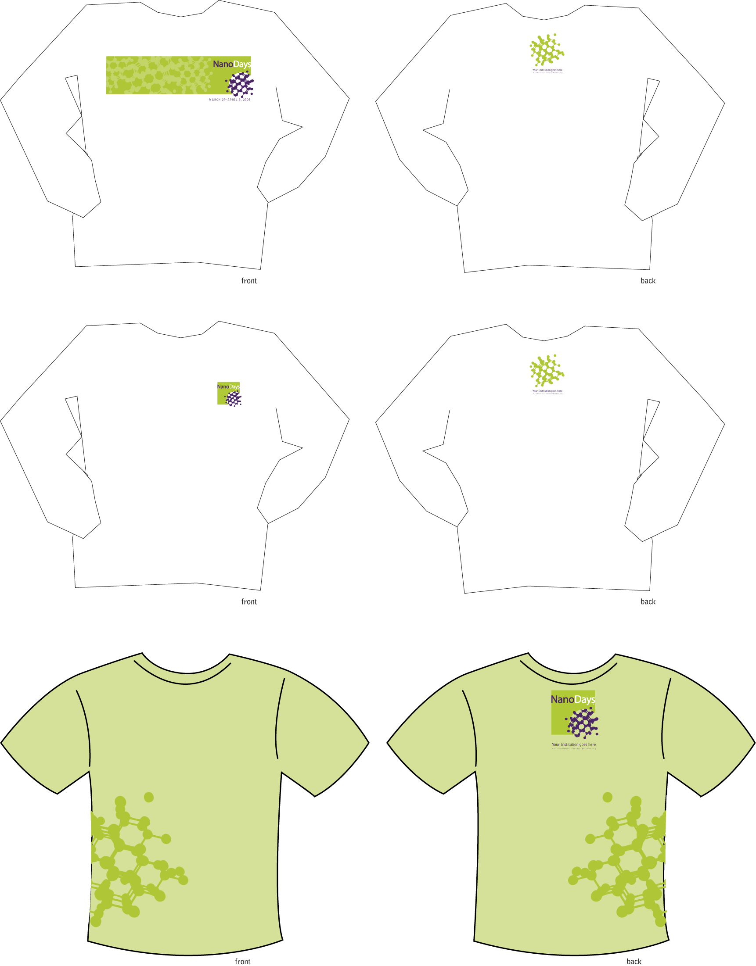

Letterhead and Envelope
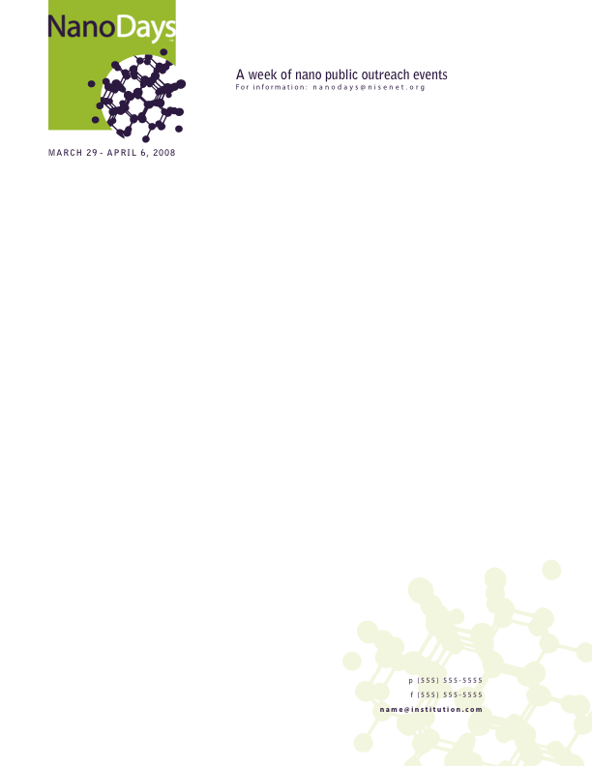


Powerpoint Templates

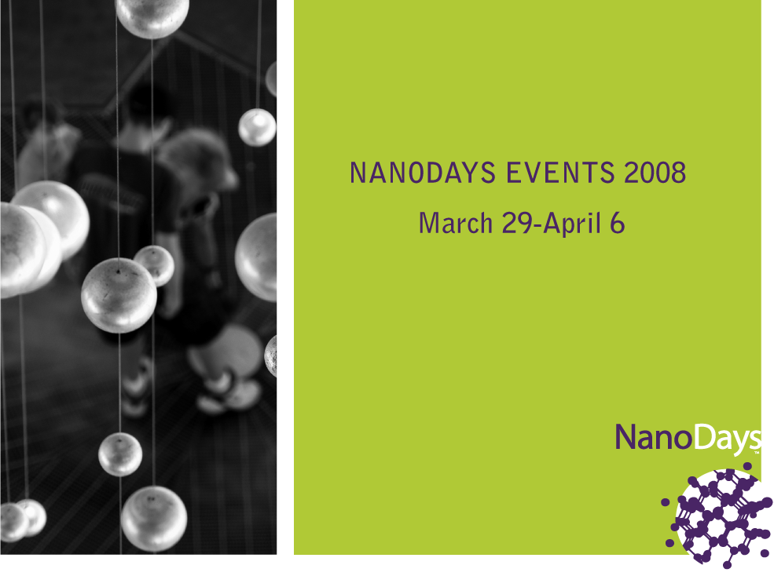
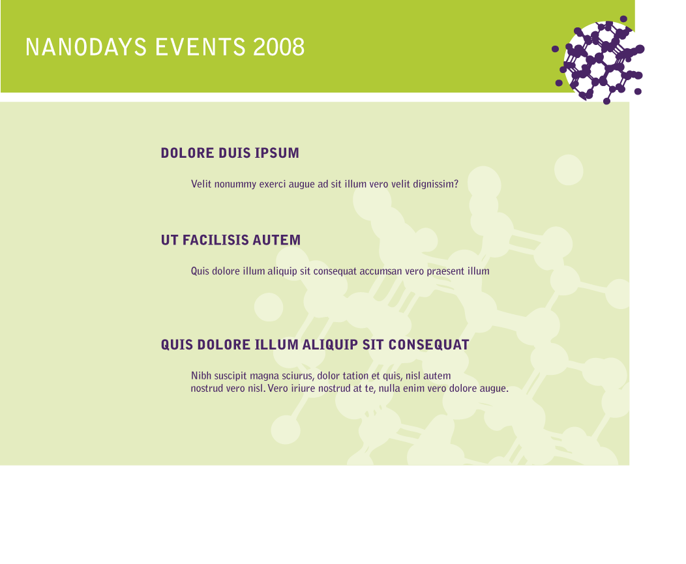
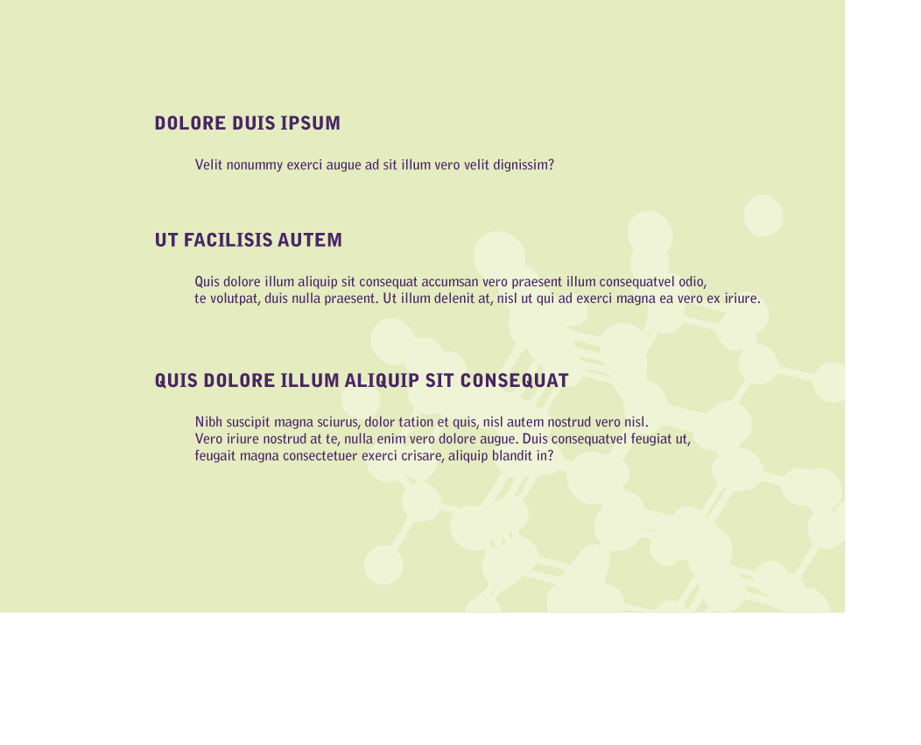
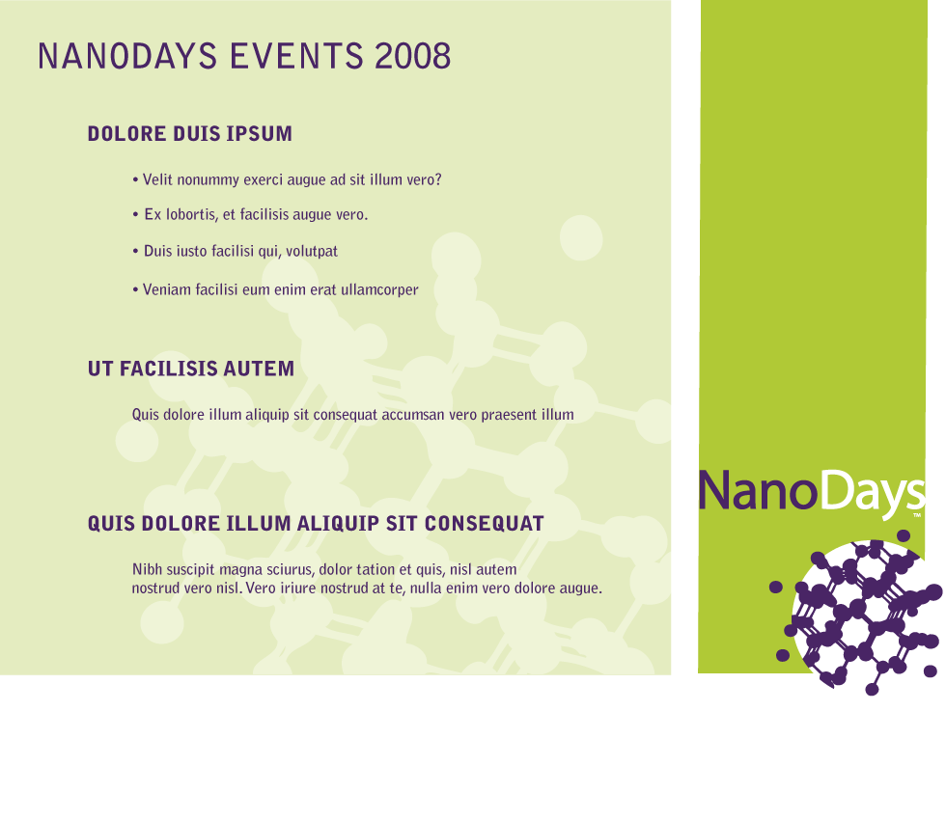

Posters
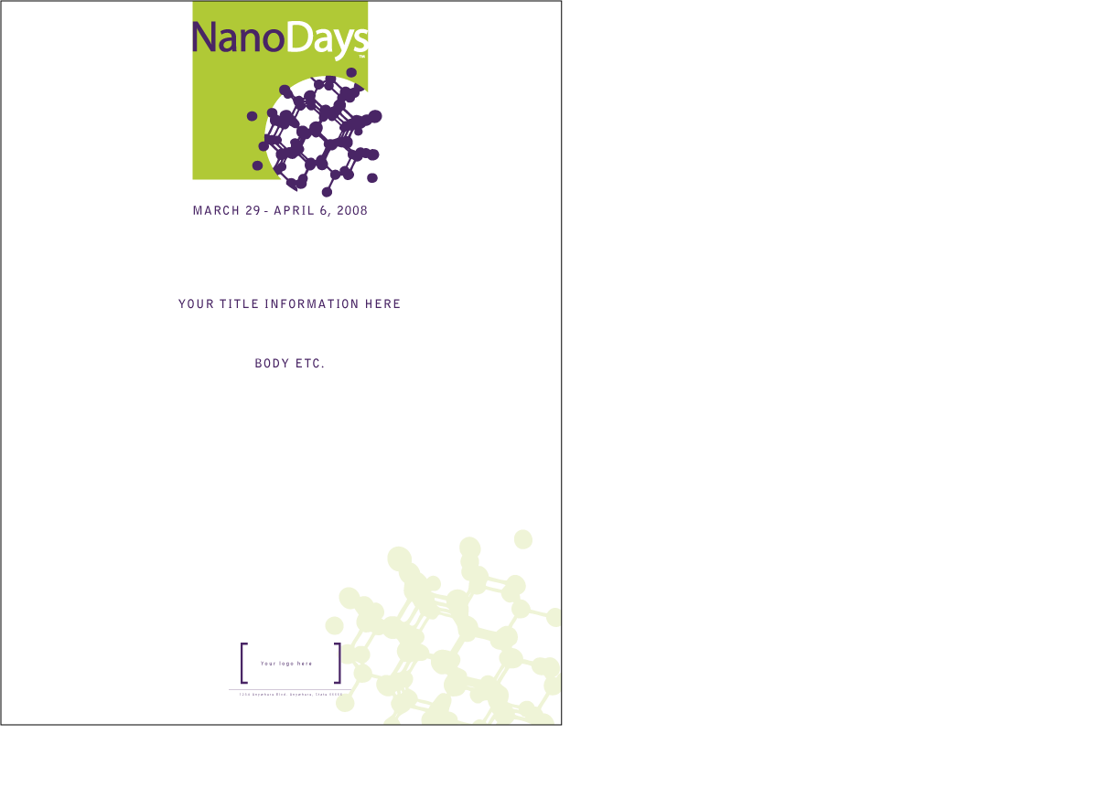

Banners
A generic NanoDays banner is included in your NanoDays kit. If you would like to print additional banners that include customized information, it’s easy to do. Use the banner template on the CD, then send your art to one of the many online banner-printing companies or take it to your local printer. A 3’ x 5’ banner (plastic, with grommets) could cost $100–$150.

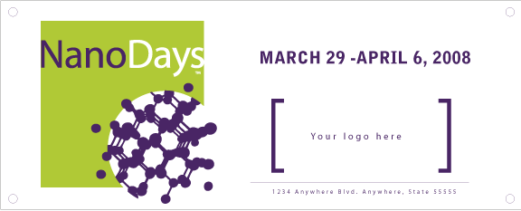

NSF Guidelines
NISE Net, NanoDays, and the creation of this kit are funded under grant #ESI-0532536 by the National Science Foundation. Although your event might not receive direct NSF funding, if you use our kit materials, you should follow NSF guidelines for acknowledging NSF support in deliverables you produce that are based on the kit materials.
Statement for deliverables:
This project [report, lecture series, video] was based on work supported by the National Science Foundation under Grant No. ESI-05322536.

Additional statement for publications:
Any opinions, findings, and conclusions or recommendations expressed in this [project] are those of the authors and do not necessarily reflect the views of the Foundation.

The NSF logos are available in a variety of colors and file formats that can be downloaded from: www.nsf.gov/policies/logos.jsp. Here are two basic ones:

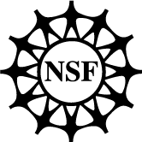
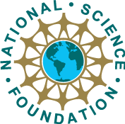

Press Release Template
Here’s a template for a press release for your NanoDays event. If you’re looking for more ideas for your press release, check out this link to dozens of current press releases about nano events of all kinds: http://www.nanotech-now.com/current-months-press.htm. The NNI’s news page also contains links to many useful news resources about nano: http://www.nano.gov/html/news/home_news.html.

FOR IMMEDIATE RELEASE:

Contact: Contact Name
Title
Institution
Telephone Number
Fax Number
Email Address
Institutional Web Address

Headline

City, State, Date — Introductory paragraph should include the who, what, where, when, why of your event.

Paragraph 2:

Subsequent paragraphs can include background on nano (see the “Resources” section of this Guidebook for ideas), more detailed description of your event, explanation of why the event is important or newsworthy, and quotes from relevant experts or speakers scheduled to give presentations at your event.

Paragraph 3

Paragraph 4

If your press release is longer than one page, put this at the bottom of each page:

-more-

At the top of the next page, put a short version of the headline in Bold Headline, page 2.

At the end:

# # #

For more information, contact: Contact Name, email address, phone number.

One-paragraph description of your institution: mission, history, role in your community.

NanoDays Kits

NISE Net has put together a kit of materials to help you plan and deliver your NanoDays event. The kit is geared to the needs of institutions that are new to public outreach, but we’ve tried to include materials and information that would be useful for more experienced institutions, too.
We are prototyping the kits in the fall of 2007. They will be shipped in early January. There will be no charge for the kits, although our limited budget could mean that we won’t have a kit for every institution that wants one. You can sign up to express your interest in receiving a kit by contacting nanodays@nisenet.org.

Eligibility for a NanoDays Kit

There are five requirements to be eligible to receive a kit:

- Your institution must be an informal education institution (e.g., a museum, library, after-school center, etc.) or a research institution that works in the field of nanoscale science. If you do not meet this criterion, contact us at nanodays@nisenet.org and we will help you locate a qualifying institution in your community with whom you can collaborate on your event.
- You must agree to conduct a NanoDays event during March 29–April 6, 2008. (If you’ve already scheduled your nano outreach event for a different time, talk to us—we can probably work this out).
- Your event must be targeted to the general public (or some segment thereof).
- You must agree to post documentation of your event on nisenet.org by May 9, 2008 (see below for expectations about documentation).
- You must be willing to respond to NISE Net evaluators' surveys or interviews for the formative and summative evaluation of NanoDays. Evaluators may contact you for your feedback about the usefulness of our materials and facilitation and background information about your event.
- While not an absolute requirement, we strongly encourage you to collaborate with at least one other institution in your community to plan and conduct your event.

Contents of the NanoDays Kit
- Nanodays Planning Guidebook (the document you’re reading now)
- Instructions, graphics, and supplies to deliver four table-top nano demonstrations to 100 visitors:
1. Nano materials: Ferrofluid activity
2. Nano materials: Liquid Crystal activity
- Nano scale: Solutions activity
- Nano scale: Measurement activity
- Nano properties: Forces
- Nano properties: Reactions

- Six books about nanoscale science for both youth and adults
- A large (3’ x 5’) NanoDays banner
- Bringing Nano to the Public: A Collaboration Opportunity for Researchers and Museums, by Dr. Wendy Crone.
- A CD with electronic templates for the following marketing materials:
- News release
- Nano clip art
- NanoWeek logo in various sizes and colors
- Ready-to-print poster layout
- Ready-to-print banner
- Ready to print T-shirt art
- Labels in three sizes, nametag, business card
- Letterhead
- Envelope

- A DVD produced by the Science Museum of Minnesota containing two 10-minute plays about the social implications of nanotechnology.
- 100 fold-up paper buckyballs
- DECIDE Nanotechology Game
- How to Hold a Nano Public Forum (draft), by Brad Herring

Documenting Your NanoDays Event
Documenting your NanoDays event might feel like extraneous work, but it’s actually quite valuable to have copies of your marketing materials, a few photos of the event, a short description of what happened, and a summary of your thoughts about the event. When the documentation is all pulled together in one place, either in print or in an electronic file, you’ll use the material over and over—for grant proposals and activity reports, fund-raising meetings, performance reviews, institutional marketing materials, etc. It’ll also be useful for planning next year’s event!

Documentation of your event can take many forms, based on the nature of the event:
- Photographs of planning sessions, set-up, the event itself, and take-down afterward. These can be useful if you decide to make a quick video about your event, or just for a scrapbook you can show to funders and collaborators. You’ll need to upload at least two photos of your event to nisenet.org if you received a NanoDays kit from NISE Net.
- Marketing materials. If you send a press release or put up posters, make copies for your files. Clip copies of newspaper stories about your event, and if you do any television or radio interviews, ask the station for a copy of the show.
- Video footage of the event. This can be challenging because the light and sound in most public places is not conducive to great recordings. However, with a little planning you might be able to get enough footage, even with your own home video camera, that you can give the flavor of the event and the reactions of some participants.
- Evaluation data. Your efforts to gather information from your audience or participants can yield data that can contribute to a better understanding of your event and its impact.
- Written summaries. As you plan and conduct your event, you’ll find yourself writing several descriptions of the event—the two-sentence version, the one-paragraph version, and the one-page version, if not more. Save these; they’ll come in handy for final reports to funders, review committees, your boss, etc. You’ll also need to upload one to nisenet.org (as part of the documentation requirement for receiving a NanoDays kit).

NanoDays Documentation Requirements
For those of you who received a NanoDays kit, we have set two simple documentation requirements:
- Upload at least two photos taken during your outreach event to show us what you did. Make sure at least one of them includes some of the public that attended.
- Fill out a short description of your event. We will have this set up as an online form, but here’s an example of the information we’ll be asking for:

NanoDays Event Summary
Summary description (one phrase): A public lecture by three local experts on applications of nanotechnology in medicine.

Date: April 3, 2008

Location: Mallette Hall Auditorium, Some State University

Professionals involved in the organization and presentation of the event: Organized by Prof. Cheryl Smith, Dept. of Chemical Engineering, SSU, and Prof. Robert Jones, Dept. of Internal Medicine, SSU School of Medicine. In collaboration with Fred Hanson, Dir. Of Education, Local Science Center.

Featured speakers or presenters, if applicable: Dr. Marion Elman, Professor Emeritus of SSU; Dr. Jennifer Kelig, researcher at NanoTekno Industries; Bryon Jelson, Dept. of Public Safety and Health.

Marketing/Communication about the event: We posted a notice of the event in the local museum’s newsletter to its members, and in the university newspaper. We also put up posters about the event in the Chemical Engineering and Internal Medicine departments.

Description of the public served: Forty-two adults and four children attended our public lecture. Most of the participants were members of the local museum. Three were graduate students at SSU.

What went well about our event: The presentations were very informative, and the attendees expressed appreciation and excitement about the content. It was a great turnout for our first effort. The logistics went very smoothly. It was good to get to know the local museum a little; we have lots of ideas for other ways we could collaborate in the future.

What we’d do differently next time: Our presenters were a bit too technical for some participants; next time we’ll try to gear the presentations to a more lay audience. We also noticed that the question-and-answer period was the most popular part of the evening, so next time we’ll try to set this up as half-lecture, half-discussion so that there is more opportunity for conversations. We’d also like to market the event more effectively—we think we could have gotten a much bigger turnout if more of the public had known about it. Finally, we might try to set up a for-children activity during the lecture; we weren’t expecting people to bring their kids, and the kids were fidgety because the lecture was over their heads. This might even attract more participants, because they wouldn’t have to worry about childcare.

Documentation Photo #1 | Documentation Photo #2
 | [

Photo Release Form
Most institutions require that some kind of photo release form be signed in order for you to circulate photos from your event in any way. Whether or not this is a formal policy in your institution, you should always ask for permission before photographing participants, especially children. Getting signed releases gives you the flexibility to use your photos in newsletters, reports, and other settings. Here is a sample form you can use (although you should check to see if your institution has a specific form that they’d like you to use).
Photo Consent and Release

I, ______________, hereby authorize the [Institution] to photograph, audiotape, and/or videotape me and grant the [Institution] the right to use my photograph, audio recording, video recording, or any reproduction or modification thereof (the “Photograph,” “Audio,” and/or “Video”), in any manner or medium throughout the world an unlimited number of times in perpetuity for non-profit educational purposes.

I understand that I will not receive any monetary compensation for the permissions I am granting herein. I hereby waive any right of inspection of approval of the uses to which the [Institution] may put the Photograph, Audio, and/or Video. I acknowledge the [Institution] will rely on this permission and hereby release and discharge the [Institution] from any and all claims and demands arising out of or in connection with the Photograph, Audio, and/or Video, or the exercise of the permissions granted here, including any and all claims for libel, invasion of privacy, or emotional distress.

I understand that I cannot withdraw my consent after I sign this form and that this consent and release is binding on me and my heirs, legal representatives, and assigns.

Yes No (please check)

____ ____ I grant permission for Photographs to be collected and used by [Institution]

____ ____ I grant permission for Audio be collected and used by [Institution]

____ ____ I grant permission for Video to be collected and used by [Institution]

Date: _________________________ Signature: ________________________________

Address: ________________________________________________________________

Telephone Number: _______________________________________________________

If the individual named above is under 18 years of age, please complete the following:

I am the parent or legal guardian of the individual named above, and I hereby sign this Media Consent and Release on behalf of such individual in accordance with the statements above.

Name: __________________________________________________________________

Date: _________________________ Signature: ________________________________

Address: ________________________________________________________________

Telephone Number: _______________________________________________________

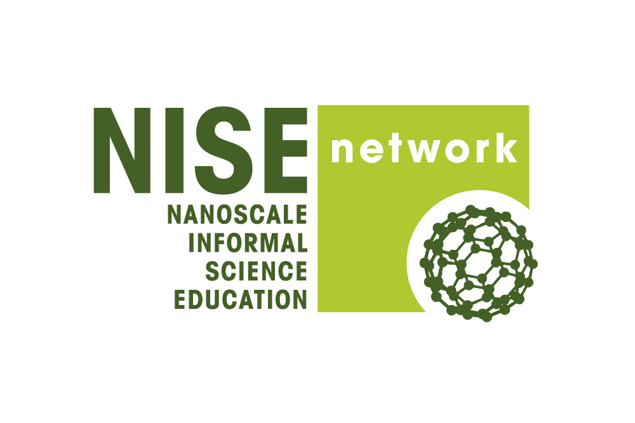 | 

We use the term nano as shorthand for nanoscale science, engineering, and technology.
Flagg, Barbara. Nanotechnology and the Public: Part I of Front-End Analysis in Support of Nanoscale Informal Science Education Network. Multimedia Research, Bellport, NY, 2005. Available at http://www.informalscience.org/evaluation/report_view.php?id=149].
Peter Hart Research Associates. Awareness of and Attitudes Toward Nanotechnology and Federal Regulatory Agencies. Prepared for the Project on Emerging Nanotechnologies, Woodrow Wilson International Center for Scholars, Washington, D.C., September 25, 2007. Available at http://www.nanotechproject.org/138/9252007.
Berkheimer, Glenn, Charles Anderson, and Steven Spees. “Using Conceptual Change Research To Reason About Curriculum.” AAAS Project 2061. Available at http://www.project2061.org/events/meetings/textbook/science/Berkheimer.htm. Novick, S. , & J. Nussbaum, “Pupils' understanding of the particulate nature of matter: A cross-age study.” Science Education, 65(2), 1981, p.187–196.
Miller, Jon D. “Public Understanding of, and Attitudes Toward, Scientific Research: What We Know and What We Need to Know,” Public Understanding of Science, Vol. 13, No. 3, 2004, p. 273–294. Available at http://pus.sagepub.com/cgi/content/abstract/13/3/273.
This is a draft of the main messages being developed by NISE Net to guide decisions about the educational content of our products; it will continue to be revised.
National Center for Learning and Teaching in Nanoscale Science and Engineering. See their website at http://www.nclt.us/news/news_docs/NCLT_Nano_Workshop2.pdf.
From an April, 2007 interview with Dr. M.C. Roco at Rice University. Available at http://www.media.rice.edu/media/NewsBot.asp?MODE=VIEW&ID=9459.
From National Nanotechnology Initiative—Past, Present, Future. Dr. M.C. Roco. National Science Foundation and National Nanotechnology Initiative, Washington, D.C., 2007. Available at www.nano.gov/NNI_Past_Present_Future.pdf.
A Nanotechnology Consumer Products Inventory. Project on Emerging Nanotechnologies, Woodrow Wilson International Center for Scholars, Washington, D.C. Available at http://www.nanotechproject.org/index.php?id=44&action=intro.
Mihail Roco, Scientific American, August 2006, p. 39.

