Nano 101 for Staff: G. Zenner Petersen Version


Organization: University of Wisconsin-Madison (UW) Materials Research Science and Engineering Center (MRSEC) on Nanostructured Interfaces

Contact person: Greta M. Zenner Petersen

Contact information: gmzenner@wisc.edu, 608-890-2268

General Description

Presentation for staff/educator training

This power point presentation is a training aid for museum educators and other informal science professionals. It provides audience members with a broad overview of the field of nanotechnology, including the nanometer size scale, sample applications, the people conducting nanotechnology research, the tools for imaging and manipulating materials at the nanoscale, and the future of nanotechnology. It is NOT intended for a general public audience on a museum floor, although portions of it have been used with visitor audiences. This program is written from the viewpoint of an education-outreach professional from an academic research institution. This program assumes some basic level of science literacy.

Program Objectives

Big idea: Nanotechnology is a diverse, emerging field that works on an extremely small size scale to learn about and develop materials with new properties. Nanotechnology is already impacting our lives through everyday applications and is predicted to transform many areas of society, technology, medicine, engineering, and science.

Learning goals:
As a result of participating in this program, audience members will learn that:
- The nanometer size scale (nanoscale) is extremely small.
- The small size of the nanoscale requires a different set of research tools and microscopes.
- Nanotechnology and its applications currently exist, but there is also tremendous potential for dramatic future advancements and impacts.
- Nanotechnology is interdisciplinary and diverse in its approaches and participants.

NISE Network Main Messages:
[ ] 1. Nanoscale effects occur in many places. Some are natural, everyday occurrences; others are the result of cutting-edge research.
[ X ] 2. Many materials exhibit startling properties at the nanoscale.
[ X ] 3. Nanotechnology means working at small size scales, manipulating materials to exhibit new properties.
[ X ] 4. Nanoscale research is a people story.
[ X ] 5. No one knows what nanoscale research may discover, or how it may be applied.
[ X ] 6. How will nano affect you?

Time Required

Set-up Program Clean Up
10 minutes 30-35 minutes 5 minutes

Nano 101 for Staff: G. Zenner Petersen Version

Table of Contents
General Description 1
Program Objectives 1
Time Required 2
Table of Contents 3
Background Information 4
Materials 4
Set Up 5
Step 1: 5
Program Delivery 7
Safety: 7
Procedure and Discussion: 7
Tips and Troubleshooting: 7
Common Visitor Questions 7
Going Further… Error! Bookmark not defined.
Clean Up 8

Background Information

No additional information is needed for presenters beyond what is included in the script and the PowerPoint.

Materials

Computer

LCD projector

Screen or white/light area to serve as a screen

One SPM demo magnet (see Figure 1a and http://www.nisenet.org/catalog/programs/exploring-tools-spm)

SPM fridge magnets, one for each member of the audience (see Figure 1b and http://www.nisenet.org/catalog/programs/exploring-tools-spm, http://mrsec.wisc.edu/Edetc/cineplex/STM/index.html, and/or
http://mrsec.wisc.edu/Edetc/SlideShow/slides/scanning/fridgemagnetprobe_mov.html)

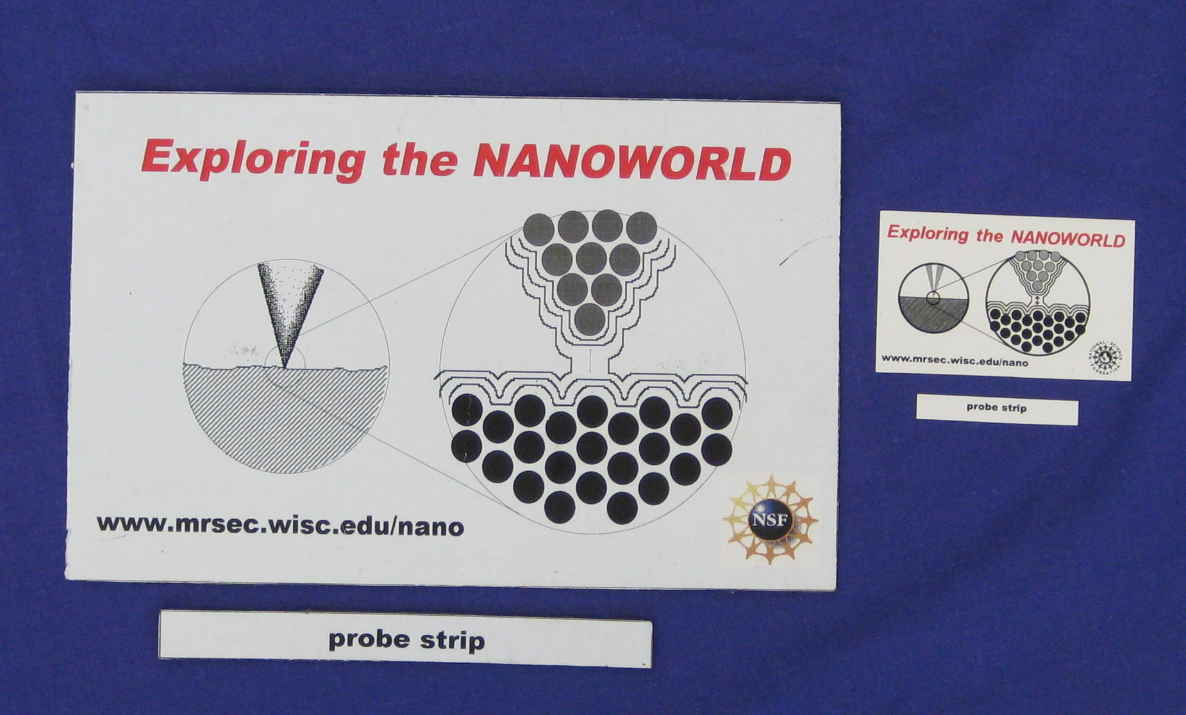
Figure 1. a) The large demo SPM magnet, approximately 6” x “9”, and probe strip. The presenter uses this set.
b) The smaller SPM fridge magnet, approximately 2” x 3.5”, and probe strip. The audience members use these sets.
a)
b)

One refrigerator magnet, with a strip cut off one side (see figure 2, set-up, and script)

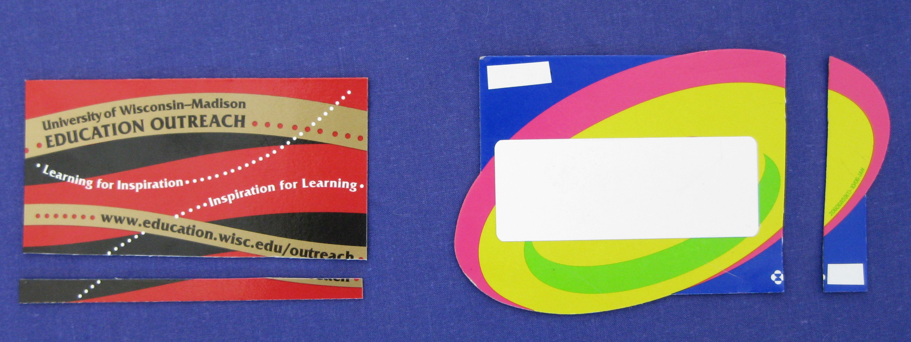
Figure 2) Homemade SPM magnets. Probe strips are cut perpendicular to the direction in which the magnetic field lines run. The magnet on the left (a) has vertical magnetic field lines, so a probe strip was cut off the bottom (horizontal).
The magnet on the right (b) has horizontal magnetic field lines, so a probe strip was cut off the side (vertical).
a)
b)

Set Up

Time: 10 minutes

Step 1:
Find a cheap refrigerator magnet. Figure out the direction in which the magnetic field lines run. To do this, run one of the SPM fridge magnets (or another fridge magnet of your choice) over the cheap fridge magnet and see which way feels “bumpy”. Make sure to run the magnets back to back, so black side to black side. Cut a strip off one of the sides that is perpendicular to the field lines. For clarification, see Figure 3. A short movie of the cutting is available online at http://mrsec.wisc.edu/Edetc/SlideShow/slides/scanning/cutmag_mov.html (Quicktime needed).

Figure 3. If the magnetic field lines run horizontally, (a), cut a vertical strip off one of the sides.
If the magnetic field lines run vertically, (b), cut a horizontal strip off the top or bottom.
a)
b)
= North
= South

Step 2:
Modify PPT file to include information relevant to you, your institution, and your audience. For example, on the title slide (slide 1), include your name and your affiliation. On slide 11, you can substitute an image of a geographic area recognizable by your audience. On slide 32, check to see if you need to rotate the images to accurately reflect the orientation of the magnetic field lines for your magnet. (Most magnets have the field lines running horizontally, but occasionally some are vertical, as in Figure 3b.)

Step 3 (day of):
Hook up computer and projector. Open presentation file.

Step 4 (day of):
Place piles of small SPM fridge magnets around speaking area, or put one magnet at each place a person might sit. Keep the large demo magnet and the homemade SPM magnet where you will be standing.

Program Delivery

Time: 30-35 minutes

Safety:
No safety precautions needed.

Procedure and Discussion:
To lead this presentation for educator training, follow the script notes, replacing information relevant to your institution as necessary. For example, do not say that you are Greta Zenner Petersen from the University of Wisconsin-Madison. Instead, identify yourself and the institution you represent. If necessary, include a couple sentence about what your institution does, if your audience is not likely to be familiar with it.

Perhaps more challenging, feel free to replace the image of Arlington National Cemetery with a picture of a geographic area of greater relevance or significance for your target audience. If you do, be sure to choose something that is approximately 1.5 square miles, which is equivalent to a square area approximately 1.2 miles on each side. Possibilities include college or university campuses, small towns, lakes, parks, etc. Multiples of geographic areas also work, such as “an area equivalent to three campuses of XYZ College in Anytown, PA.”

More information is included in the script than is necessary – or possibly even effective – to discuss during the actual presentation. The script is overly thorough; pick and choose details and specifics that are of greatest interest to you, your audience, and your institution. If you include all of the information in the script, the presentation will run closer to 40 or 45 minutes.

Tips and Troubleshooting:
When leading the magnet activity, guide audience members through it using three senses – seeing, feeling, and hearing. Also encourage audience members to confer with each other regarding their observations. This promotes interaction and engagement, and helps those who, for whatever reason, may not be able to feel or see or hear the bumpiness themselves.

Common Visitor Questions:

Can you tell us more about nanotech applications? Nanotech risk? Nanotech fundamentals? Etc.?
This particular presentation is intended to serve only as an introduction and overview to nanotechnology. Encourage your audience members to take part in further training about nanotechnology and/or experiment with other nanotech activities and programs, such as those listed on the NISE Net Catalog.

Clean Up

Time: 5 minutes
Close down your presentation and computer. Pick up and put away demo magnets and extra magnets. Pick up and throw away (or keep, if desired) used magnet pieces.

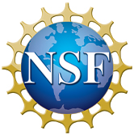
This project was supported by the
National Science Foundation under Grants No. ESI-0532536 (NISE Net) and DMR-0520527 (UW MRSEC). Any opinions, findings, and conclusions or recommendations expressed in this material are those of the authors and do not necessarily reflect the views of the National Science Foundation.

