Nanotube Models

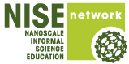
Organization: Children's Museum Of Houston
Contact person: Kimberly Garlock
Contact information: kgarlock@cmhouston.org
(713) 535-7232

General Description

Type of program:
“Nanotube Models” is a facilitated tabletop program aimed at educating the public about the properties and applications of carbon nanotubes. Visitors will be able to use Molecular Visions model kits to build carbon nanotubes. The models can be started by museum staff and added onto by visitors, or pre-built to be used as a display. The models can also be accompanied by other NISE Net programs that focus on carbon nanotubes to increase the engagement and enhance the models.

Program Objectives

Big idea:
Carbon nanotubes are a form of carbon that have unique structure and properties for which scientists are discovering many applications.

Learning goals:
As a result of participating in this program, visitors will be able to:

- Identify the molecular structure of a carbon nanotube.
- Understand the unique properties of a carbon nanotube.
- Understand a variety of uses for carbon nanotubes.
  - Electrical conductivity
  - Water desalination

NISE Network content map main ideas:
[ ] 1. Nanometer-sized things are very small, and often behave differently than larger things do.

[ ] 2. Scientists and engineers have formed the interdisciplinary field of nanotechnology by investigating properties and manipulating matter at the nanoscale.

[ x ] 3. Nanoscience, nanotechnology, and nanoengineering lead to new knowledge and innovations that weren’t possible before.

[ x ] 4. Nanotechnologies have costs, risks, and benefits that affect our lives in ways we cannot always predict.

National Science Education Standards:
[ ] 1. Science as Inquiry
[ ] K-4: Abilities necessary to do scientific inquiry
[ ] K-4: Understanding about scientific inquiry
[ ] 5-8: Abilities necessary to do scientific inquiry
[ ] 5-8: Understanding about scientific inquiry
[ ] 9-12: Abilities necessary to do scientific inquiry
[ ] 9-12: Understanding about scientific inquiry

[X] 2. Physical Science
[X] K-4: Properties of objects and materials
[ ] K-4: Position and motion of objects
[ ] K-4: Light, heat, electricity, and magnetism
[X] 5-8: Properties and changes of properties in matter
[ ] 5-8: Motions and forces
[ ] 5-8: Transfer of energy
[X] 9-12: Structure of atoms
[X] 9-12: Structure and properties of matter
[ ] 9-12: Chemical reactions
[ ] 9-12: Motions and force
[ ] 9-12: Conservation of energy and increase in disorder
[ ] 9-12: Interactions of energy and matter

[ ] 3. Life Science
[ ] K-4: Characteristics of organisms
[ ] K-4: Life cycles of organisms
[ ] K-4: Organisms and environments
[ ] 5-8: Structure and function in living systems
[ ] 5-8: Reproduction and heredity
[ ] 5-8: Regulation and behavior
[ ] 5-8: Populations and ecosystems
[ ] 5-8: Diversity and adaptations of organisms
[ ] 9-12: The cell
[ ] 9-12: Molecular basis of heredity
[ ] 9-12: Biological evolution
[ ] 9-12: Interdependence of organisms
[ ] 9-12: Matter, energy, and organization in living systems
[ ] 9-12: Behavior of organisms

[ ] 4. Earth and Space Science
[ ] K-4: Properties of earth materials
[ ] K-4: Objects in the sky
[ ] K-4: Changes in earth and sky
[ ] 5-8: Structure of the earth system
[ ] 5-8: Earth's history
[ ] 5-8: Earth in the solar system
[ ] 9-12: Energy in the earth system
[ ] 9-12: Geochemical cycles
[ ] 9-12: Origin and evolution of the earth system
[ ] 9-12: Origin and evolution of the universe

[ ] 5. Science and Technology
[ ] K-4: Abilities to distinguish between natural objects and objects made by humans
[ ] K-4: Abilities of technological design
[X] K-4: Understanding about science and technology
[ ] 5-8: Abilities of technological design
[X] 5-8: Understanding about science and technology
[ ] 9-12: Abilities of technological design
[X] 9-12: Understanding about science and technology

[X] 6. Personal and Social Perspectives
[ ] K-4: Personal health
[ ] K-4: Characteristics and changes in populations
[ ] K-4: Types of resources
[ ] K-4: Changes in environments
[ ] K-4: Science and technology in local challenges
[ ] 5-8: Personal health
[ ] 5-8: Populations, resources, and environments
[ ] 5-8: Natural hazards
[X] 5-8: Risks and benefits
[X] 5-8: Science and technology in society
[ ] 9-12: Personal and community health
[ ] 9-12: Population growth
[ ] 9-12: Natural resources
[ ] 9-12: Environmental quality
[ ] 9-12: Natural and human-induced hazards
[ ] 9-12: Science and technology in local, national, and global challenges

[ ] 7. History and Nature of Science
[ ] K-4: Science as a human endeavor
[ ] 5-8: Science as a human endeavor
[ ] 5-8: Nature of science
[ ] 5-8: History of science
[ ] 9-12: Science as a human endeavor
[ ] 9-12: Nature of scientific knowledge
[ ] 9-12: Historical perspective

Table of Contents
General Description 1
Program Objectives 1
Table of Contents 4
Time Required 5
Background Information 5
Definition of terms 5
Program-specific background 6
Materials 8
Set Up 9
Program Delivery 9
Safety 9
Talking points and procedure 10
Tips and troubleshooting 12
Common visitor questions 13
Going further… 13
Clean Up 13
Universal Design 13

Time Required

Set-up Program Clean Up

60+ minutes 15 minutes 10 minutes

Background Information

Definition of terms

Nano is the scientific term meaning one-billionth (1/1,000,000,000). It comes from a Greek word meaning “dwarf.”
A nanometer is one one-billionth of a meter. One inch equals 25.4 million nanometers. A sheet of paper is about 100,000 nanometers thick. A human hair measures roughly 50,000 to 100,000 nanometers across. Your fingernails grow one nanometer every second.

(Other units can also be divided by one billion. A single blink of an eye is about one-billionth of a year. An eyeblink is to a year what a nanometer is to a yardstick.)

Nanoscale refers to measurements of 1-100 nanometers. A virus is about 70 nm long. A cell membrane is about 9 nm thick. Twenty hydrogen atoms are about 1 nm.

At the nanoscale, many common materials exhibit unusual properties, such as remarkably lower resistance to electricity or faster chemical reactions.
Nanotechnology is the manipulation of material at the nanoscale to take advantage of these properties. This often means working with individual molecules.
Nanoscience, nanoengineering and other such terms refer to those activities applied to the nanoscale. “Nano,” by itself, is often used as short-hand to refer to any or all of these activities.

Program-specific background

Forms of Carbon
Carbon is found in all living things and is one of the most abundant elements on our planet.
- Carbon atoms can attach, or bond, to one another in several different ways to create different materials with varying properties.
- Forms of carbon include diamonds and graphite at the macroscale. On the nanoscale carbon can form in fullerenes (“buckyballs”) and carbon nanotubes (CNTs).
- Carbon is most stable when it has formed four bonds. To achieve this, it must sometimes form multiple bonds with another atom. This may require the carbon to form double or triple bonds.
  - All the bonds in diamond are single bonds.
  - Graphene sheets and CNTs contain a mix of single and double bonds.
  - Fullerenes, or “buckyballs,” contain a mix of single and double bonds.

Atomic Structure
The properties of carbon are determined by the atomic arrangement of the carbon atoms.
- Diamond- The hardest know natural material is composed of four tightly bonded carbon atoms in a tetrahedron. This tripod shape is very strong.
- Graphite- Graphite, the substance found in pencils, is composed of carbon atoms tightly bonded to each other in a honeycomb pattern. Each “sheet,” called graphene, has strong bonds; however, the bonds that connect sheets are rather weak. This allows the sheets of graphite to easily slip and slide past each other like the graphite found in a pencil.
- Fullerenes- Otherwise known as a buckyball, a fullerene is a group of carbon atoms in the shape of a soccer ball. Named for the famous architect Buckminster Fuller who popularized the geodesic dome, the most common buckyball is 60 carbon atoms bound together with a mixture of single and double bonds. Other fairly common buckyballs are composed of 70, 72, 76, 84, and even 100 carbon atoms. The carbons are bonded together in a pattern of hexagons and pentagons that form a sphere.
- Carbon Nanotubes- CNTs look like a single sheet of graphene is rolled into a cylinder; however, CNTs are not formed from sheets of graphene. Carbon nanotubes can be found naturally in places like the soot from burnt materials. Scientists have developed a variety of ways to form carbon nanotubes, all of which include a heat source, a carbon source, and a catalyst which is usually a metal particle like iron or nickel. The properties of the CNTs are determined by the way the sheet was rolled. The three types of CNTs are called, “armchair,” “zigzag,” and “chiral.” CNTs can be either single-walled, which are one layer of carbon atoms thick or multi-walled which are several single-walled nanotubes rolled inside each other.

Properties of Carbon Nanotubes (CNTs)
CNTs’ unique nano-structure gives them some unusual and interesting properties.
- Electrical Conductivity: CNTs can be either semi-metals, metallic or semi-conducting in their electrical behavior, depending on their chirality, or degree of twist when they are rolled. CNTs conduct electricity much more efficiently than copper wires because of the unique shape of the nanotube.
- Mechanical (tensile) strength: CNTs are incredibly strong. Based on small scale experiments and theoretical calculations, a one-inch thick rope made of CNTs is predicted to be 100 times stronger than steel, while only weighing 1/6th as much.
- Thermal Conductivity: CNTs are excellent conductors of heat when heat is traveling down the axis of the CNT. However when trying to conduct heat across the tube (through the walls) their conductivity drops dramatically. When only considering their properties down the axis, their conductivity is predicted to be 10x higher than silver, which has the highest thermal conductivity of any metal. Metals conduct heat through the movement of electrons which are impacted by scattering, while CNTs conduct heat by the movement of electrons through a process known as ballistic transport. Ballistic transport is the movement of electrons with negligible amounts of resistance due to scattering.

Applications of Carbon Nanotubes (CNTs)
Electrical Conductivity: CNTs can be either metallic or semi-conducting in their electrical behavior, depending on their chirality, or degree of twist when they are rolled. CNTs conduct electricity much more efficiently than copper wires because of the unique shape of the nanotube. In a copper wire, tens of thousands of electrons are trying to travel through the wires path at the same time, often bumping into each other. Copper wires allow electrons to move up down, forwards, even backwards. When they bump into other electrons they are slowed down because the collisions cause the electron to lose energy. This effect is called scattering, which can generate a lot of heat and wastes energy. CNTs on the other hand are hollow, and the graphene-like molecular structure only allows electrons to travel in two dimensions. This two-dimensional pathway decreases the chances of electrons bumping into each other, therefore less energy is lost and less heat is produced. Less waste means higher efficiency. Because of their higher efficiency and nano size, CNTs are being used to make very small electronics, such as computer chips and transistors.

Water Desalination: Clean water has always been a global issue. CNTs may be the solution to cheaper and faster water desalination. Scientists have successfully imbedded CNTs into membranes, making the pores nano-sized. Salt water is then passed through a tube-like membrane called a hollow fiber. The membrane allows water to pass through, but not the waste, such as salt, sediment, or bacteria. Membrane distillation offers several advantages over traditional osmosis techniques: it’s clean, non-toxic, and can be carried out at much lower temperatures.

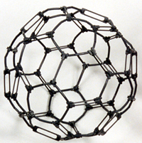
Materials
- (4+ kits) Kit #7b, Fullerene C-60 with double bonds ($12.00 ea., shipping included)
  - http://www.darlingmodels.com/Specialized-Molecular-Model-Kits/Kit-7b-Fullerene-C-60-with-double-bonds/prod_17.html
  - One time purchase. Models can be re-used.
  - Buckyball kit is used to make the CNT and graphene models.
- Molecular Structure Graphics
  - Diamond
  - Graphite
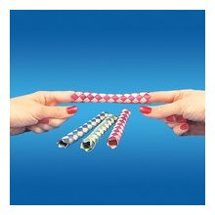
  - Buckyball
  - Nanotube
- Small ball about 2 inches in diameter.
- Chinese Finger Trap

Optional Materials
- iNanotube app for I-pad
  - Check out the iNanotube app to explore carbon nanotubes even more. You can change the diameter and angle of your nanotube by clicking on the icon in the upper right hand corner. By doing this you can change the electrical properties of the nanotube.
  - http://itunes.apple.com/us/app/inanotube/id419294263?mt=8
- Small molecular models of 4 forms of carbon (molymods are a good option that can be purchased at Amazon.com)
  - Diamond
  - Graphite
  - Buckyball
  - Nanotube
- Exploring Size- Ball Sorter Nano Days Program
  - http://www.nisenet.org/catalog/programs/exploring_size_-_ball_sorter_nanodays_2012
  - Nesting sieves with three screen sizes
  - Small balls in three sizes
  - Container for balls
- Exploring Materials- Graphene Nano Days Program
  - http://www.nisenet.org/catalog/programs/exploring_materials_-_graphene_nanodays_2012
  - Flakes of graphite
  - Plastic tweezers with a pointed tip
  - Scotch tape
  - White activity cards (or index cards)
  - Soft drawing pencils (6B is best)
  - Pencil Sharpener
  - Battery and Bulb Circuit (9v battery, 9v snap connectors, 5mm LED bulb, 330 Ohm resister, two insulated leads)
  - “Graphene” image sheet
  - Photocopy master for activity cards

Set Up

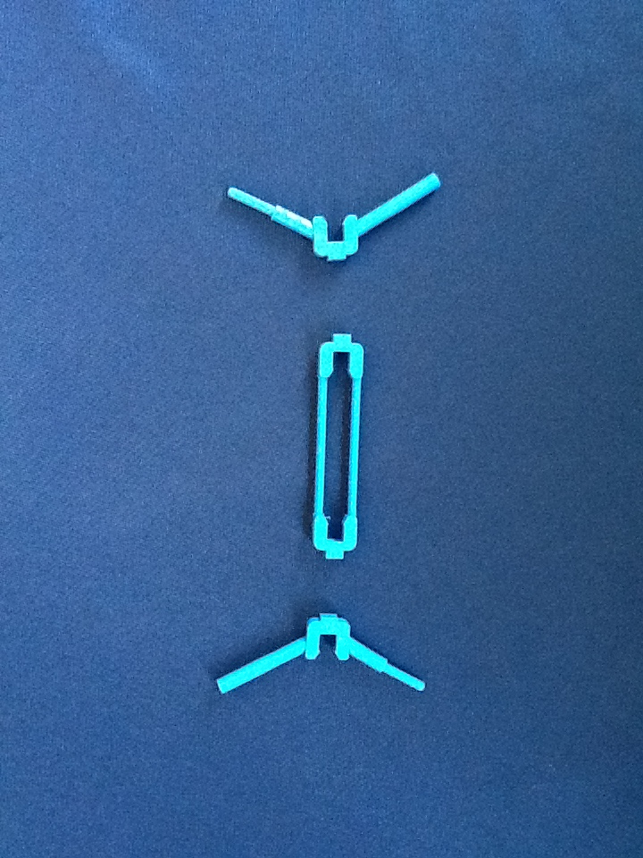
Time: 60+ minutes

Step 1: Assemble the double bonds. (15 minutes per model set)
- For each double bond piece, you will need 2 branch pieces. See diagram 1.
Diagram 1
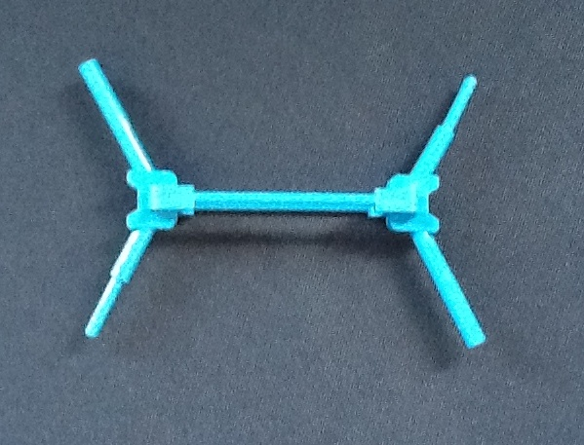
- Click one branch into the left side of the double bond so that the tube is on the top and the rod is on the bottom. See diagram 2.
- The second branch needs to be the opposite when it is assembled with the rod on top and the tube on bottom. See diagram 2.
  - The pieces fit together very tightly, make sure they are clicked in all the way.
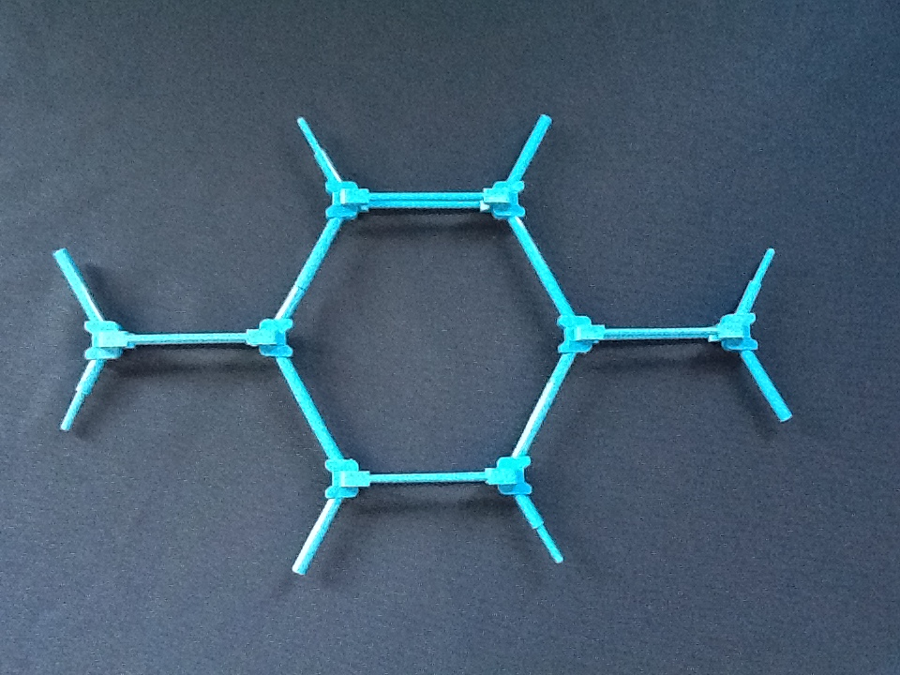
  - Once this step is finished, it will not need to done again. The molecules can be taken apart at the end of the program, however leave them in this form, one double bond with two branches.
Diagram 2
Step 2: Assemble a model of graphene.
- Snap the model pieces together forming a sheet that is about 4 hexagons by 4 hexagons. See diagram 3 and 4.
Diagram 3

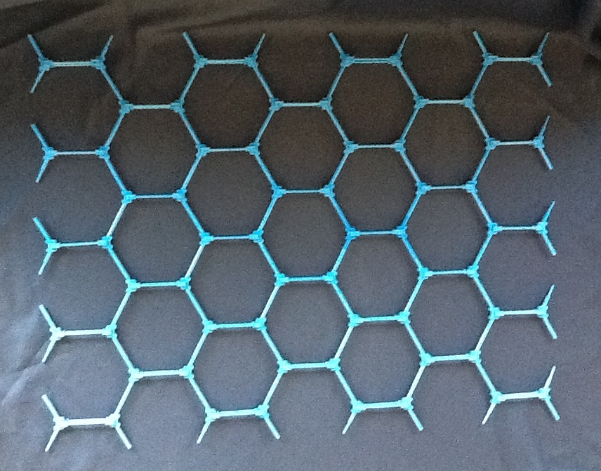
Step 3: Review background information about Carbon Nanotubes.
- Review information about Carbon Nanotubes.
- Review additional resources if necessary.

Program Delivery

Time:
Diagram 4
10 minutes

Safety
General safety precautions.

Talking points and procedure
- Start the program with a brief introduction of the four main types of carbon.
  - Show the visitors the graphic of the molecular structure of diamond, graphite, a buckyball, and a nanotube.
  - Ask visitors to point out the forms of carbon they are familiar with such as the pencil and diamond graphics.
  - Optional: Pass around the molecular models of each type of carbon (extra supplies needed) for examination and encourage visitors to compare and contrast the models (shapes and formations)
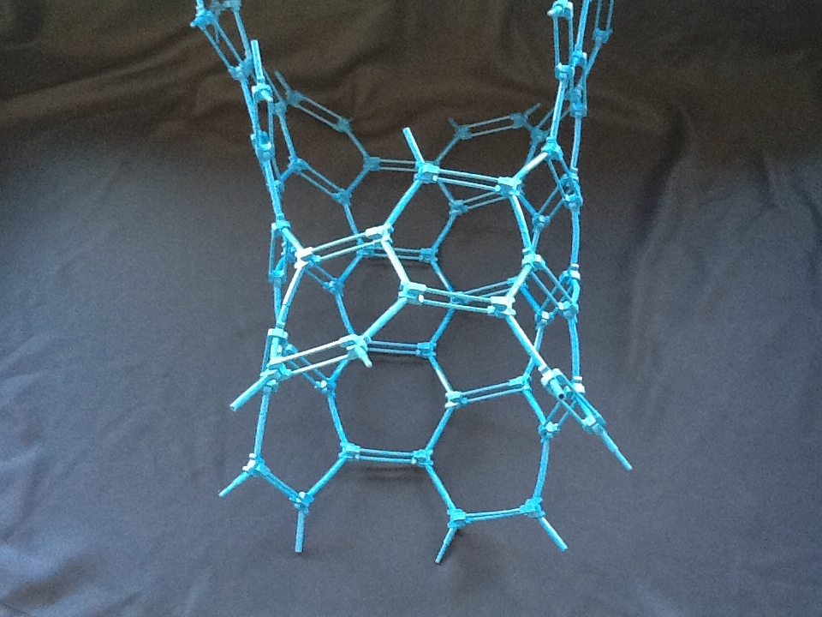
- Next show them the pre-built sheet of graphene.
  - Explain that graphene is a single sheet of graphite, just one atom thick.
- Have a visitor help you roll the sheet of graphene into a CNT. See diagram 5.
Diagram 5
  - Be sure to tell the visitors that this is not how CNTs form. See background information (pg 6) to clarify this process.
  - Have visitors describe the model – what makes it different from the images/models of the other carbon molecules? What does its shape resemble? How could that shape be used?
- Tell the visitors about the unique properties of CNTs
  - Electrical Conductivity
    - Have a visitor roll a ball down the center of the nanotube model.
    - Ask the visitor if the ball was able to make it from one end to the other.
    - Ask the visitor if the ball bounced off anything while traveling from one end to the other.
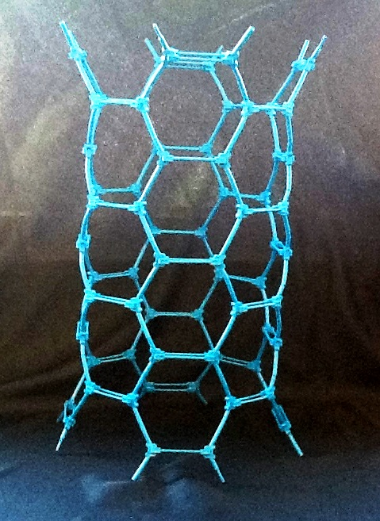
    - Explain how the ball is an electron. It is able to flow through the carbon nanotube at a fast rate without any interference or scattering unlike a metal that regularly runs into other electrons. All this running into each other results in loss of energy, making CNTs better conductors.
  - Mechanical (tensile) strength
    - Have the visitor place their fingers in the Chinese finger trap.
    - Tell them to try and pull their fingers out.
    - Have them describe what happens to the finger trap as they try to pull their fingers free.
Diagram 6
    - Explain that the shape and ability of the finger trap to slightly change its shape make it very strong. Tell them that the shape and properties or carbon nanotubes also make them very strong because they can also change their shape when pulled from either end, making them able to withstand a lot of pulling from the ends.
  - Thermal Conductivity
    - Have a visitor roll a ball down the center of the nanotube model.
    - Ask the visitor if the ball was able to make it from one end to the other.
    - Ask the visitor if the ball bounced off anything while traveling from one end to the other.
    - Next have the visitor try to roll the ball through the sides of the carbon nanotube.
    - Ask the visitor if the ball was able to go through the walls of the carbon nanotube.
    - Explain how the ball is an electron. It is able to flow through the carbon nanotube at a fast rate without any interference or scattering. Since electrons conduct heat energy, that makes them very good conductors of heat. However, the ball was not able to travel through the walls, just like electrons cannot travel through the walls of the carbon nanotube, not because the electrons are too big, but because in real carbon nanotubes, there are electrons all around the outside that prevent the electrons from entering. So, while CNTs can conduct heat down the tubes, they cannot do it across the tube.

- Tell the visitors about the unique applications of CNTs
  - Electrical Conductivity: Computer Chips & Nano Sized Transistors, Water Desalination: Filters with Nano sized pores. Check out optional program addition #2 for a real life application of water desalination.
  - May add additional applications if desired.
- Allow the visitors to build onto the carbon nanotube model, or start their own. See diagram 6.

  - Interact with the visitors by asking questions and giving them some interesting Did You Know’s about CNTs.
    - Carbon is derived from the Latin work “carbo” meaning charcoal.
    - The average carbon nanotube is one nanometer in diameter. If you had 10 million nanotubes next to each other it would be the same as one centimeter.
    - Carbon nanotubes are much lighter than steel, yet much stronger!
    - Some manufactures have added carbon nanotubes to clothing creating fabrics that are water, stain, and tear resistant.
    - Carbon nanotubes are the hardest substance mankind has ever discovered.

Optional Program Additions:
For the most engaging program, I would recommend combining all of the optional programs into the Carbon Nanotube Models program. Each program gives a different way of engaging visitors with CNTs, broadening the accessibility of the program.
- iNanotube App: This app gives a 3 dimensional look at a carbon nanotube. It allows you to show the different angles that the CNTs are rolled at and how that can change their properties (from metallic to semi-conducting).
- Using this app while the visitors are building their own carbon nanotubes will give them a closer look at the structure of a carbon nanotube.

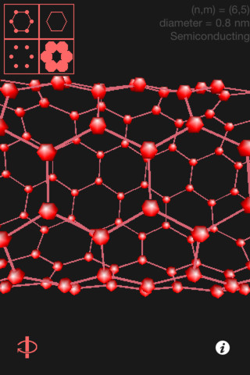
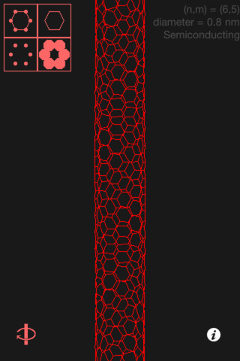
- Exploring Size- Ball Sorter Nano Days Program: This program really adds a hands-on aspect to better explain the role of CNTs in water desalination.
  - Have this program set up next to where the visitors are building their carbon nanotube. Encourage them to participate in the ball sorter activity to better understand a real world application of carbon nanotubes.
- Exploring Materials- Graphene Nano Days Program: This program is a great way to show the electrical conductivity properties of graphite, and talk about graphene. It is optional to showcase different forms of carbon, however beneficial.
- Have this program set up next to where the visitors are building their carbon nanotube. Encourage them to participate in the graphene activity to better understand electrical conductivity properties of carbon.

Tips and troubleshooting
- The pieces of the Darling kit can be difficult to snap together the first time. We STRONGLY urge you to pre-snap the double bonds in advance for any age group.
- Having a nanotube example pre-made is advised to help younger kids follow the assembly pattern.
- The nanotube can be made with a larger diameter (start with 4+ hexagons in width). The smaller the diameter, the harder it is to get the tube shape.

Common visitor questions
What do we use carbon nanotubes for?
Carbon nanotubes are used to make highly conductive wires and transistors. They have also been used in sporting equipment such as tennis rackets and bicycle frames to increase their strength while decreasing their weight.

Are carbon nanotubes blue?
No. Our model is blue, however carbon nanotubes are black.

Are carbon nanotubes formed from graphene sheets?
No. Carbon nanotubes are formed through self-assembly when there is a carbon source, heat source, and metal catalyst available.

Going further…
Here are some resources you can share with your visitors:
- Forms of Carbon is a NISE Net Program that can give you additional information about the different forms of carbon.
  - http://www.nisenet.org/catalog/programs/forms_carbon
- Carbon Nanotubes and Hockey Sticks is an article about the use of CNTs in sporting equipment.
  - http://www.nisenet.org/node/3456
- A Cure for Cancer is an article about how CNTs are being used to help target cancer cells to deliver drugs to fight the disease.
  - http://www.nisenet.org/a-cure-cancer

Clean Up

Time: 4 minutes per model set.
When you are ready to take apart the model Nanotube, carefully take each piece apart. Remember to keep the double bounds and branches assembled so that you will not have to reassemble them next time.

Universal Design

This program has been designed to be inclusive of visitors, including visitors of different ages, backgrounds, and different physical and cognitive abilities.

The following features of the program’s design make it accessible:

[X] 1. Repeat and reinforce main ideas and concepts
- The key ideas are communicated visually, and reinforced verbally and tactilely.

[X] 2. Provide multiple entry points and multiple ways of engagement
- The program allows for multiple entry points and ways of engaging through guided discussion and hands-on activities.
  - The presenter verbally explains the structure of CNTs.
  - Visitors can visually see the model of the CNT.
  - Visitors can physically feel the structure of the CNT model.
  - Visitors can physically engage in building the CNT.
  - Visitors can read about the CNTs on the accompanying poster.
- The program relates CNTs to at least two real world applications.

[X] 3. Provide physical and sensory access to all aspects of the program
- The presenter builds the first few hexagons of the nanotube while verbally explaining the process to visitors. This allows the visitors to both hear and see the building process. They can also feel the model of graphene that has been previously built.
- Program is delivered on a table, allowing access to at least 3 sides.
- Models are lightweight to accommodate visitors with limited strength.

To give an inclusive presentation of this program:
- For visitors with limited dexterity, models can be pre-fabricated and then passed around to be explored.
- For visitors whom are blind or have low vision, models can be handled to allow a tactile experience.

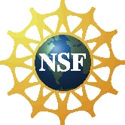 | This project was supported by the National Science Foundation under Award No. 0940143. Any opinions, findings, and conclusions or recommendations expressed in this program are those of the author and do not necessarily reflect the views of the Foundation.
 | Published under a Creative Commons Attribution-Noncommercial-ShareAlike license: http://creativecommons.org/licenses/by-nc-sa/3.0/us/

