 |  | 
Leading Improv Exercises

Improv exercises empower educators to facilitate positive, learning conversations with visitors. Incorporating improv exercises into staff and volunteer training helps create a supportive and upbeat environment for educators to practice and strengthen essential skills.

Why implement improv exercises?  - Prepare staff to hold learning conversations with guests rather than reciting scripts.  - Warm up critical skill sets required for guest interaction/guest facilitation.  - Empower staff to think on their feet and respond in the moment.  - Focus on integrating guest feedback into presentations.  - Foster teamwork.  - Prepare staff to ask guest questions and better tailor content based on guest responses.  - Foster creativity.  - Generate laughter and create a fun, supportive, positive work environment.  - Position staff to be equals with guests, rather than being “the expert.” | 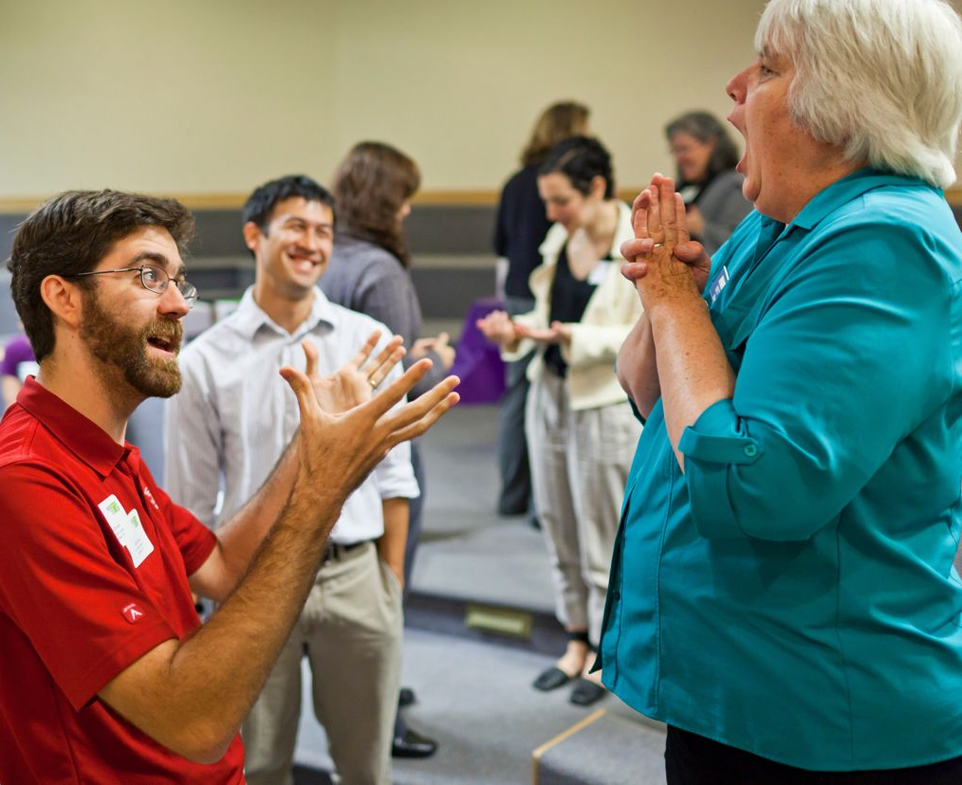

How do you implement improv exercises at your institution?

Prepare leaders:
- Set up internal structures (such as ongoing meeting times) for your leaders to learn how to lead exercises in a “safe play” environment (i.e. to try exercises out on other leaders).
- Allow leaders adequate time to practice explaining and setting up exercises.
- Make sure leaders participate in and facilitate all aspects of improv professional development: learning, playing, leading, and debriefing exercises.

Implement with staff and volunteers:
- Select a physical space that is conducive for playing a game (adequate space, appropriate for loud noise levels).
- Match the size of the group with the game (different games work for different size groups).
- To build the energy of the group, leaders should lead with energy.
- Create a supportive positive environment (“yes-and” and “your first choice is right”).
- Be sure the participants and the team understand why they’re doing improv exercises.
- Debrief each game by asking the players how the skills sets relate to their jobs and their daily work.
- Be inclusive and mindful of different skills sets within a team.
- Allow time for questions and discussion.
- Positively reinforce great performance at individual and group level.
- Celebrate team achievements, acknowledging skills practiced.

Establish ground rules for participants:
- Remain work appropriate.
- Support all teammates and the group.
- The game is about the group, not the individual being funny.
- Say “yes-and” to each other and the ideas shared.
- Bring positive energy.
- Give 100%.
- Let go of judgment.
- Have fun.
- Ask your leader for help if you need it.
- If individuals choose to exclude themselves from playing an exercise, they should also leave the area.

Institutionalize improv at your institution:
- Develop routines for everyone to play and lead exercises.
- Rotate days so all team members can participate in exercises.
- Play one game per week to cycle through all team members.
- Tailor exercises to your institution.
- Tailor exercises to your mission and vision.
- Ensure leaders are strong at leading and debriefing exercises and can help explain why we use improv exercises in the workplace.

What resources are available to help educators implement improv exercises?
- Find improvisation classes in your community. Send leaders to learn exercises as part of their professional development.
- Local organizations including Comedy Sportz, Second City, iO Theater, and community theatres might offer classes for further instruction, as well as additional exercises you can use.
- The International Museum Theatre Alliance (IMTAL) can help you learn about theatrical techniques in museum settings, including improv: http://www.imtal.org/
- Each game can be adapted in many ways. Your team can create new exercises and build on existing exercises.
- Contact your NISE Net regional hub leader to find partners who are using improv with their teams.

 | This project was supported by the National Science Foundation under Award No. 0940143. Any opinions, findings, and conclusions or recommendations expressed in this document are those of the author and do not necessarily reflect the views of the Foundation.

Copyright 2012, Museum of Science & Industry, Chicago IL.

