 |  | 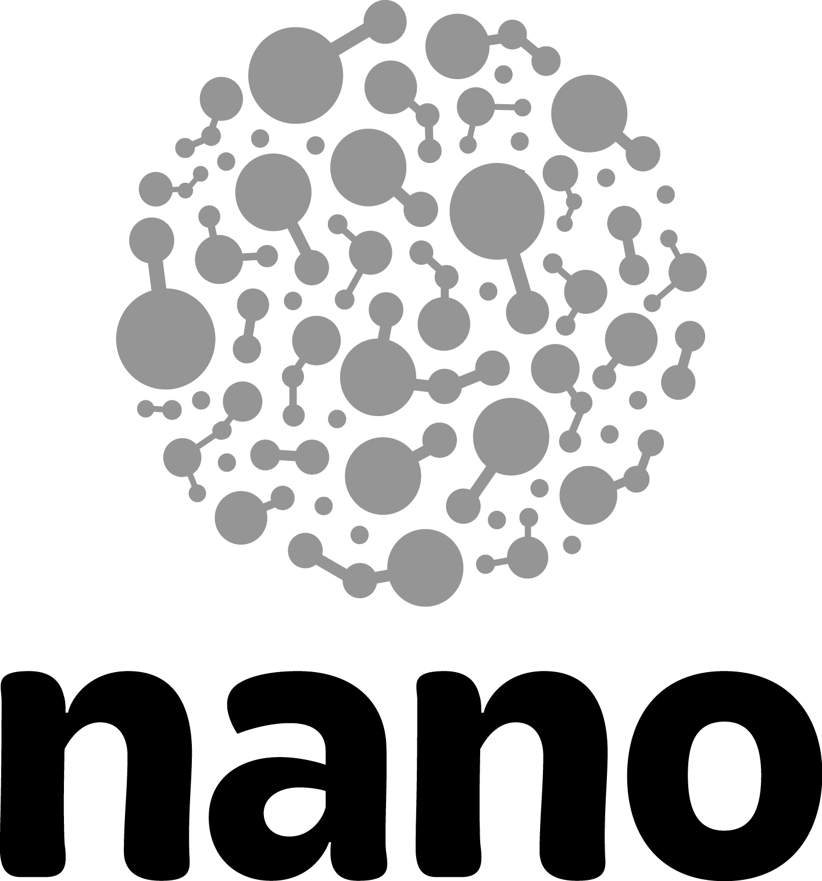
“Positive Conversations” Improv Exercise

This exercise focuses on accepting ideas and positively messaging guest concerns about nanotechnology. The group splits into two-single file lines, Line A and Line B. The first participant in Line A steps forward, asking the “guest” about their thoughts on nanotechnology. The first person from Line B steps forward and provides a negative concern about nanotechnology. The person from Line A reacts with a positive response that accepts the guest’s idea and reinforces related science. Immediately the person from Line B accepts the response. The next participants in line step forward, and repeat the process.

Skill sets  Accepting Offers, Quick Thinking, Creativity/Inventiveness, Positive Messaging | Time to implement  12-15 minutes | Number of participants  8-10 per small group

Exercise flow
- Divide the larger group into smaller groups.
- Designate a section of the room for each group to gather.
- Have the group create two single file lines, Line A and Line B. (Angling the lines in a “V” formation helps everyone to see the front conversation.)
- Explain that first person in Line A steps forward as a facilitator and politely engages a guest about their thoughts on nanotechnology.
- Demonstrate the behavior by saying, “What are your thoughts about nanotechnology?”
- Explain that the first person from Line B then steps forward and responds as a guest. Encourage the group to use responses heard while working with real guests. The guest response should be focused on concerns surrounding the societal and ethical implications of nanotechnology.
- Ask for a volunteer to give an example of a guest response they have heard before. (“We don’t know how all these little things are going to affect the environment” or “We’re manipulating atoms, there’s no telling how that’s going to affect our bodies.”)
- Explain that the person in Line A (facilitator) responds positively to the guest’s statement, reinforcing the positive influences of nanoscience. The person from Line B (guest) immediately accepts the response and agrees with the facilitator. Emphasize the idea of supporting teammates in the exercise versus playing the argument.
- Demonstrate the behavior using the volunteer’s suggestion.
- Explain that once the exchange is complete, the two people move to the back of the opposite line and the next two participants step forward. (Line A moves to the back of Line B. Line B to the back of Line A.)
- Ask if the group has any questions before starting the exercise.
- Begin playing the exercise. Continue to play until all have participated or until time allows.
- Stop and quickly debrief.

Debrief questions
- What patterns emerged in the exchanges between guest and facilitator as we played the exercise?
- What elements did all of the positive responses have in common?
- How might these elements impact our messaging with guests?
- What were some of the responses that we might realistically be able to use with guests?

Additional debrief questions (Accepting Offers/Energy):
- What did you notice about the energy of the group during this exercise?
- How and when did the energy shift during the exercise?
- How did the group’s immediate acceptance of the response affect the energy of the exercise?

Tips
Side-coach the group away from overly negative responses or continued arguments from the “guest” line. If necessary, stop the exercise and quickly redirect the full group.
Encourage the full group to agree with energy.
Emphasize the importance of supporting teammates versus playing the argument… accept and agree.

Variations
Small teams (fewer than 5 people): Ask participants to write down possible guest responses onto individual slips of paper. Place the slips of paper into a container. Ask one participant to act as the guest, while the other participants work together as the facilitator. One of the facilitators asks the question "What are your thoughts about nanotechnology?" The person playing the guest draws a random slip of paper and reads aloud the guest response. One of the participants playing facilitator responds to the statement positively and reinforces the value of nanoscience. After the exchange the participant who responded as the facilitator takes on the role guest and the other participant joins the facilitators. Continue the exercise flow encouraging all participants to take on both roles.

Small teams (5-8 people): Ask the full group to assemble in a single file line. Have the first person step forward, turn and face the rest of the line. This participant takes the role of facilitator (Line A in the exercise flow on the front page). The next person in line takes the role of guest. (Line B in the exercise flow on the front page) Use the same exercise flow as outlined on the front page. The participant playing the facilitator role responds positively and reinforces the value of nanoscience. After the exchange the participant playing the facilitator moves to the back of the line and the person acting as the guest moves into the facilitator role.

Extended role-play: Use the same flow as above, but provide a longer exchange between guest and facilitator. The participant in Line B now has the opportunity to rebut the first facilitator response. The facilitator has the opportunity to engage the “guest” with questions to uncover areas of learning and to help positively message the guest concerns. Allow the extended role-play to continue for 20-30secs (roughly 5-10 line exchange).

 | This project was supported by the National Science Foundation under Award No. 0940143. Any opinions, findings, and conclusions or recommendations expressed in this document are those of the author and do not necessarily reflect the views of the Foundation.

Copyright 2012, Museum of Science & Industry, Chicago IL.

