 |  | 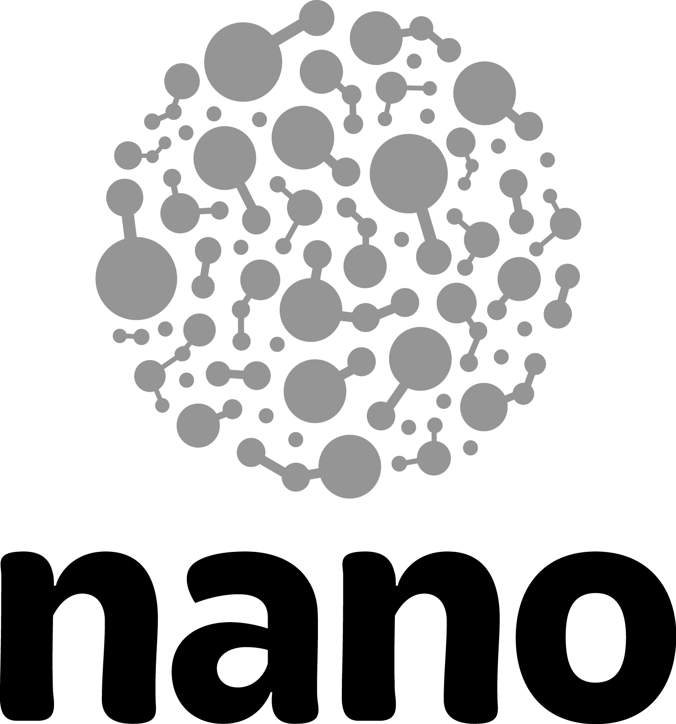
“The Self-Assembly 500” Improv Exercise

This exercise builds energy and team unity. Participants secretly pick two electrostatic partners - a polar partner and a polar opposite. These partners represent the forces at work during self-assembly. Then they attempt to keep their polar opposite between them and their polar partner while moving around an open space.

Skill sets  Energy, Listening/Awareness, Teamwork,  (Non-Verbal Behavior) | Time to implement  3-6 minutes | Number of participants  8-100 people

Exercise flow
- Have the group gather in a large circle.
- Ask each participant to look around the circle and privately decide on one person who they will consider “Person A.”
- Next ask each participant to select another person, again secretly, and label that person, “Person B.”
- Make sure that everyone has selected two people.
- Inform the participants that Person A is their polar opposite - the person with an opposing electrostatic charge. Person B is their polar partner- the person with the same electrostatic charge.
- Explain that their goal, when you say “go”, is to keep their polar opposite positioned between them and their polar partner at all times.
- Before people start to move, remind them to walk and remain aware of their teammates, so that no injuries occur in the group.
- Explain that when they hear “freeze” everyone should stop exactly in place.
- Begin the exercise.
- Allow the group to move around for a minute or so, then call freeze.
- Explain to the group that scientists have now changed the charges of their electrostatic partners. Person B is now their polar opposite and they should try to keep that person between themselves and the other person at all times.
- Remind the group to stop when “freeze” is called.
- Have the group begin to move around again.
- Stop the group and quickly debrief.
- If time allows, have the group switch back to their original protector. Explain that in this round “switch” with replace “freeze” when they hear switch they should instantly switch their electrostatic partners.
- Start the exercise and play as time allows or the energy of the group is consistent.

Debrief questions
- What did you observe as we played the exercise?
- Who thinks they know who selected them as an electrostatic partner? Who knows both the people?
- What clues helped you to identify your partners?
- How can we use similar clues to help us engage with visitors in conversation more effectively?
- How does this exercise relate to NISE Net content? What other ways could we make it relate to nano?

Tips
Make any necessary physical accommodations for individual participants before you begin.

Remind people to walk, not run.

Variations
Small teams: This exercise won’t work for groups of fewer than five people.

Content change: Substitute the terms “electrostatic partners” for other content (“eclipse, sun, and moon”).

Charge substrates: Use the same flow as above. Introduce areas within the playing area that represent charged substrates. When a player makes contact with the substrate, they must stay in place for 15 seconds. This creates fun moments and a great conversation about manipulation of molecules using electrostatic self-assembly.

 | This project was supported by the National Science Foundation under Award No. 0940143. Any opinions, findings, and conclusions or recommendations expressed in this document are those of the author and do not necessarily reflect the views of the Foundation.

Copyright 2012, Museum of Science & Industry, Chicago IL.

