

“Cell Phone Rules” Training Guide

During the “Cell Phone Rules” training activity, participants discuss the rules and etiquette they follow for using their cell phones at home, work, school, and other places. This facilitated discussion helps participants reflect on the ways that we negotiate with technologies and make decisions about how they will be part of our lives.

Time  20 minutes  Materials  - Large sheets of paper and markers to take notes (optional)  Overview  - Group discussion (15 minutes)  - Review the “big idea” (5 minutes)  Group Discussion | 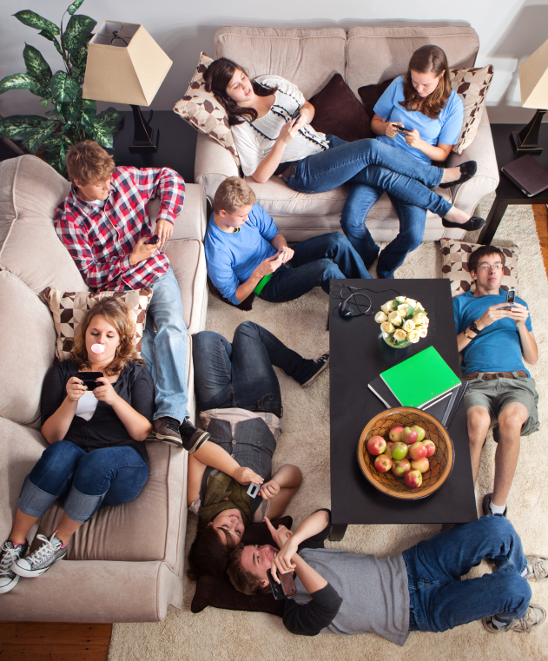
This discussion works best in small groups, but can also be done in a large group. Ask individuals to share their personal rules for cell phones with the group. Below are some questions you might suggest to seed the discussion. (Groups don’t need to consider or address all these questions to get the point of the activity.)

At home

Is it OK to check your phone at the dinner table?

Is it OK to check your phone while you’re watching videos or doing other things with your family?

Is it OK to take your phone to bed?

At work

Is it OK to check personal messages or email on your phone while you’re at work?

Is it OK to interrupt a meeting to answer your phone?

Is it OK to discreetly check email on your phone during a meeting?

It OK for two people to have a side conversation via text while they’re at a meeting?

At school

Are you allowed to have your phone in class? What about at lunch?

Is it OK for your phone to ring in class? Can you answer it?

Is it OK to check messages or email while you’re in class?

Is it OK to use your phone to look up answers while you’re in class?

Hanging out with friends

Is it OK to text other people or check Facebook while you’re hanging out with friends?

Is it OK for two people to have a side conversation via text while they’re hanging out with a bigger group?

In public

Is it OK to text during a movie?

Is it OK to answer your phone in a public restroom?

Is it legal (and OK) to use your phone while driving?
Wrap Up
After about 10 minutes, have the small groups report back on some of the rules they agreed or disagreed about. Together, spend about 5 minutes talking about how cell phones—and our rules for using them—affect our relationships with other people. Below are some suggested talking points.

What are some of the rules you have for cell phones?

We have different rules for different contexts and situations (home, school, work). Some rules are social norms or etiquette, while other rules are law.

Who came up with those rules?

Some rules we suggest and enforce ourselves, while others are imposed on us. This varies by context.

What values are promoted by those rules?

Rules ensure that different values are privileged when we use (or don’t use) a technology. They’re also a way to control the effects that a technology has on us.

Are these rules set in stone?

Many rules for using technologies change through time. This has certainly been the case with cell phones. They’re still being integrated into our daily lives, so we’re still negotiating the rules for how they’re used.

Are there ways to get around the rules?

How do people get around cell phone rules to achieve their own goals?

Big Idea
This training activity explores Nano & Society Big Idea 2:
Technologies affect social relationships
- Technologies often change the relationships between people.
- Technologies affect the way we interact with family members, people in our community, and people around the world.
- People negotiate with each other and with new technologies to maximize their own values.

- New technologies are often accompanied by changes in cultural norms.
- We are all actively involved in developing acceptable behaviors related to technologies.
- These new norms will not reflect everyone’s values equally.

 | This project was supported by the National Science Foundation under Award Nos. 0940143 and 0937591.  Any opinions, findings, and conclusions or recommendations expressed in this document are those of the author and do not necessarily reflect the views of the Foundation.

Copyright 2012, Sciencenter, Ithaca, NY.

